 | AGENCE DU PERIGORD  1, Voie de la Vallée SAINT-CYPRIEN  05 53 28 96 75 - agenceduperigord@gmail.com

Superb village house with patio. Lots of character, beautiful finishes. For those who like it!
Situé à MONTIGNAC  Prix: 349,800 €  Réf. : MP113518 | 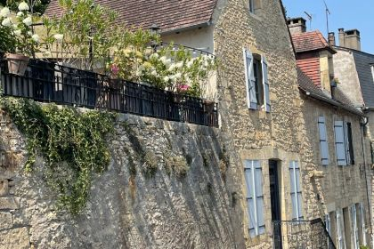

 | 3 Chambres |  | 3 Bathrooms
 | Surface habitable : 175 m² |  | Terrain : 173 m²

Descriptif
In the heart of the historic centre of MONTIGNAC-LASCAUX, this superb atypical house of about 175 m² living space has a lot of character. It has all the architectural elements of the Périgord (stone sink, inglenook fireplace, adobe floor, etc.). All the volumes are comfortable and bright for a town house. It offers a large living room with open kitchen, a large office, 3 bedrooms with bathroom/shower room...Very rare in the centre, a nice patio with a small pool. The icing on the cake: a rented, independent flat of 80 m² (no nuisance for the main house) ensuring a rental income. Easy parking or possibility of a garage nearby. Unique!!!

Caractéristiques principales
Type: House / Character property  Piscine 1 | Etat: Very good  Surf. habitable: 175 m²  Terrain: 173 m²  Séjour: 59 m²  Terrasse: 50 m²  Hamlet | 3 Chambres  3 Salles de bain  6 Pièces  1 Bureau  Chauffage: City Gas

Détails complémentaires
GROUND FLOOR:  - Utility Room  - Office  - Boiler room  - Corridor  - Open plan living area  - WC  1ST FLOOR:  - 3 Bedrooms  - Landing  - WC  ENERGY REPORT:  -  HEATING:  - Gas central heating | OTHER EQUIPMENT:  - Double Glazing  - Mains drainage  SERVICES:  - Nearest airport :  - Nearest motorway :  - Nearest shops :  - School  - Railway Station  - Hospital  - Broadband  LAND:  - Swimming Pool  WEB OPTIONS:  - Scrolling

DPE
Classe énergétique : | Classe GES :

Photos

