LARGE HOUSE WITH INDEPENDENT APRTMENT ON THE EDGE OF A PRETTY VILLAGE WITH ALL COMMERCE, RESTAURANTS, ETC . LAND OF 0.5 ACRE. DEP0836
Situé à ROUFFIGNAC-SAINT-CERNIN-DE-REI  Prix: 243,800 €  Réf. : DEP0836 | 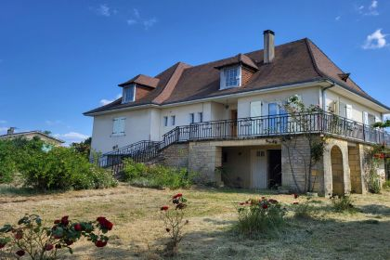

 | 4 Chambres |  | 2 Bathrooms
 | Surface habitable : 185 m² |  | Terrain : 1,235 m²

Descriptif
In a Périgord Noir village with shops, this 1970s Périgourdine house is located in a quiet residential area with all amenities within walking distance. Entrance hall, living room, kitchen, three large bedrooms and bathroom. The U-shaped terrace lets you enjoy the outdoors at any time of day. On the garden level, there's a garage and an independent apartment of around 70m². Good for rental income if desirable. The attic space could be converted for those in need of extra space. In a village with all commerce.
The house is connected to mains drainage and the heat pump heating system is new (installed 2022).
The property needs to be brought up to date, and some work is planned (joinery, bringing electricity up to standard, etc.).

Caractéristiques principales
Type: House / Character property  Année constr.: 1972 | Etat: Needs decorating  Surf. habitable: 185 m²  Terrain: 1,235 m²  Séjour: 35 m²  Terrasse: 45 m²  Hamlet  Exposition: EW | 4 Chambres  2 Salles de bain  7 Pièces  1 Garage  Chauffage: Heating pump

Détails complémentaires
PROPERTY LOCATION:  - Village  GARDEN LEVEL:  - Appartment  GROUND FLOOR:  - 3 Bedrooms  - Kitchen  - Entrance lobby  - Living room  - Bathroom  - Terrace  - WC  1ST FLOOR:  - Attic | ENERGY REPORT:  - Energy performance: 283 KWHep/m²an  - Gas emission: 9 Kgco2/m²an  - Année de référence utilisée pour établir la simulation des dépenses annuelles  - Date de réalisation DPE (jj/mm/aaaa)  - Montant bas supposé et théorique des dépenses énergétiques: 3120 €  - Montant haut supposé et théorique des dépenses énergétiques: 4250 €  HEATING:  - Electric  -  OTHER EQUIPMENT:  - Mains drainage  SERVICES:  - Nearest town :  - Calm  - Nearest shops :  - School  - Gite  - Broadband  - Bungalow  LAND:  - fenced

DPE
Classe énergétique : E | Classe GES : B
Date de réalisation DPE (jj/mm/aaaa)
Année de référence utilisée pour établir la simulation des dépenses annuelles
Montant bas supposé et théorique des dépenses énergétiques: 3120 €
Montant haut supposé et théorique des dépenses énergétiques: 4250 €

Photos

