Phone : +33 (0)5 53 07 06 27  Email : info@pioneerfrance.com  Web : www.PioneerFrance.com  Domaine Le Ruisseau , 24580, Fleurac, Dordogne | 

THE DORDOGNE'S LEADING QUALITY PROPERTY AGENCY

REFERENCE  PF90313 | PRICE (inc.agency comm)  250,000 € | LOCATION  DORDOGNE -  LE BUGUE AREA | TYPE  House / Character property | LAND AREA  938 m2

RIVERSIDE LARGE 5-BED PROPERTY WITH GARDENS & GARAGE, PEACEFUL LOCATION ON OUTSKIRTS OF LE BUGUE. FURTHER 100SQM OF GARDEN-LEVEL ADAPTABLE SPACE. PF90313

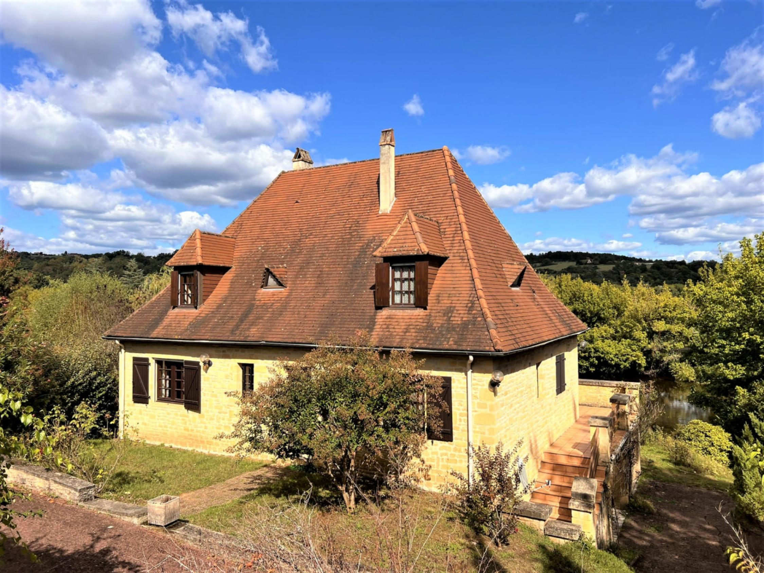

With direct access to the river in Le Bugue, a delightful, lively market town with all amenities. internally update, and expand if needed, this substantial 5-bed property. Offering over 180sqm over 2 floors, plus a garden level floor totalling 100sqm adaptable for further accommodation/ a huge workroom, garages, etc. 2 large terraces with views onto the garden and river. Off-road parking. VERY well priced. PF90313
PROPERTY DESCRIPTION ( Ref : PF90313)
RIVERSIDE LARGE 5-BED PROPERTY WITH GARDENS & GARAGE, PEACEFUL LOCATION ON OUTSKIRTS OF LE BUGUE. FURTHER 100SQM OF GARDEN-LEVEL ADAPTABLE FLOOR-SPACE. PF90313
With direct access to the river in Le Bugue, a delightful, lively market town with all amenities. internally update, and expand if needed, this substantial 5-bed property. Offering over 180sqm over 2 floors, plus a garden level floor totalling 100sqm adaptable for further accommodation/ a huge workroom, garages, etc. 2 large terraces with views onto the garden and river. Off-road parking. VERY well priced. PF90313
THE HOUSE
Habitable Space: approx: 180 sqm
Accessed via gates, a paved drive down the side of house to garage and parking. Walled front garden partially laid to lawn with shrubs and pathway to front door.
The house, with direct access to the river, is on a quiet, residential, road with other properties all on good-sized plots. It has double glazing throughout, electric heating via a heat exchanger and an open fireplace.
Ground Floor
Entrance Hall: 14sqm Tiled floor. Built-in storage and coats cupboard with sliding doors.
Double glass doors to:
Living/Dining Room: 40sqm Tiled floor, raised open fireplace, double glass doors onto terrace with stunning views onto river Vezere and gardens below.
Terrace: 4.5m x 3m Raised terrace with awning. Accessed via Living/Dining room and kitchen. Wraps around side of house with steps down to driveway onto garden.
Kitchen: 14sqm Accessed via Living/Dining room and Entrance Hall. Good range of fitted cabinets with low level breakfast bar. Equipment includes dishwasher, oven, microwave and fridge. Double doors onto the terrace.
Bedroom 3: 16sqm Bright room with built-in wardrobe.
Bathroom: 8.5sqm Large bright room, tiled floor and walls. Bath with shower attachment, shower cubicle, double sink unit.
Guest WC: 2sqm WC, sink.
Staircase to First Floor
Landing: 15sqm
Bedroom 1: 20sqm Exposed beams, views onto river. Door to:
Attic: 8.7sqm.
Bedroom 2: 17sqm Exposed beams, low-level built in cupboards.
Bedroom 4: 15sqm Exposed beams, river views.
Shower Room: 10sqm Raised, tiled, corner shower, tiled floor and walls, double sink unit.
Stairs from Entrance Hall down to
Garden Level
Total area: approx. 100sqm
Includes:
Bedroom 5: 19sqm with door leading to covered paved terrace & garden. Tiled floor with stone walls.
WC: 2sqm
Garage: 42sqm
3 Storage rooms: 8sqm; 5sqm; 5sqm
2 Workrooms 1: 8sqm; 8sqm
Boiler Room 2sqm
Covered Terrace: 7m x 3m, leading onto the garden.
GARDENS AND LAND: Total plot area 938sqm
Gardens on two levels with steps connecting the two which leads directly onto river access.
Planted with roses and mature shrubs.
Driveway into garage and off-street parking.
GENERAL INFORMATION
ALL AMENTIES VERY CLSOE
Excellent residential, riverside location in bustling town of Le Bugue.
Stunning views onto the river with direct access.
Double-Glazing
Open fireplaces
Great opportunity to refurbish internally to taste.
Expand living space by a further 80sqm in the garden floor level.
Bergerac 40 mins drive & Perigueux 30 mins drive
Ideal as either a permanent or holiday home.
REF: PF90313

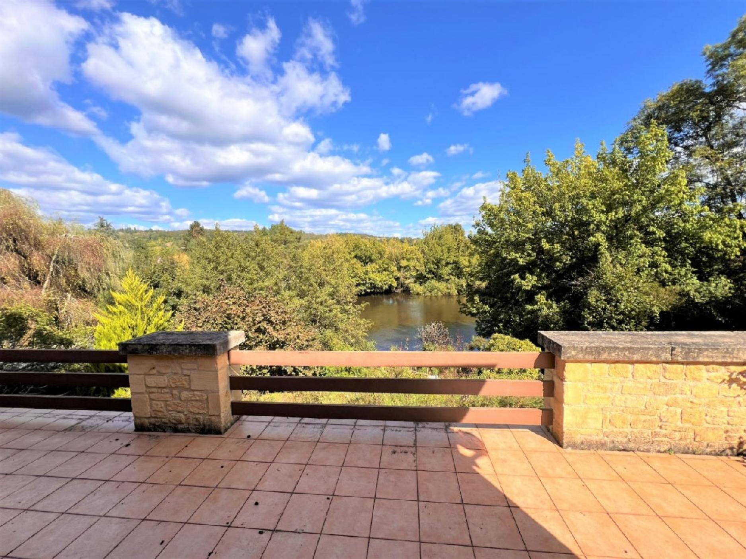 | 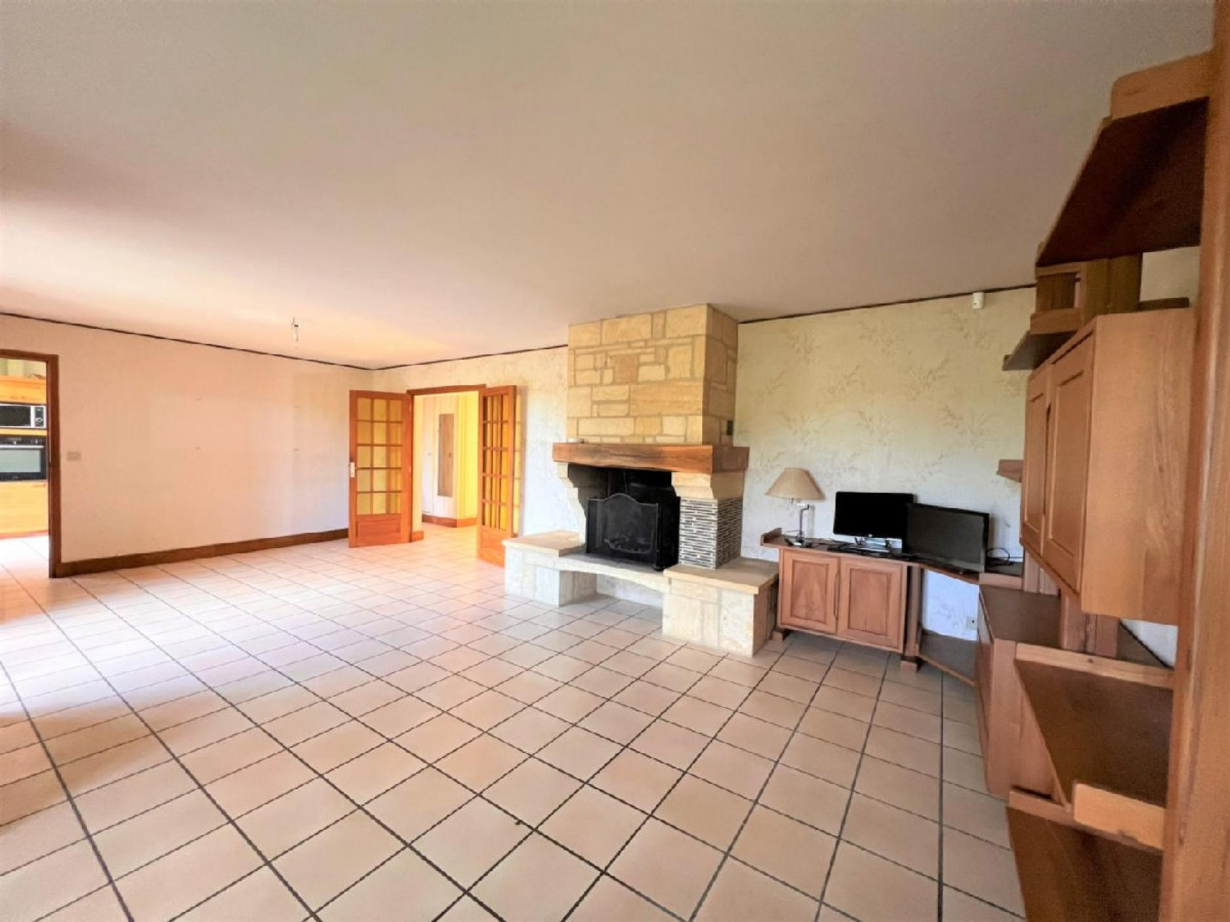
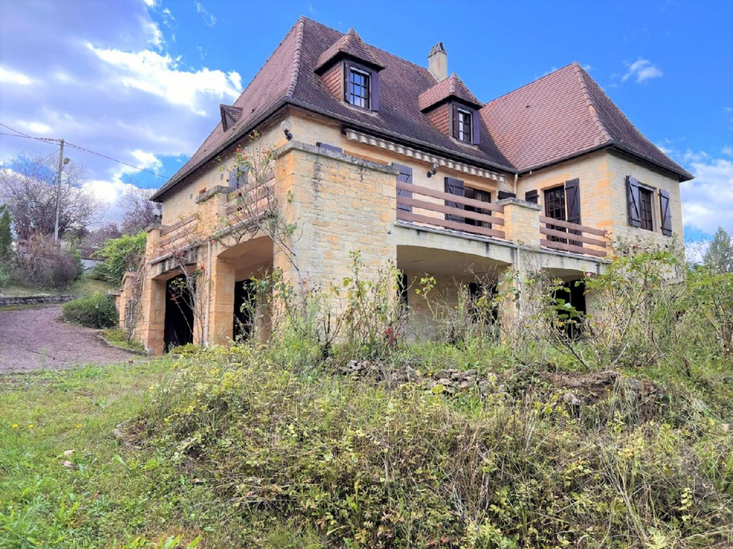 | 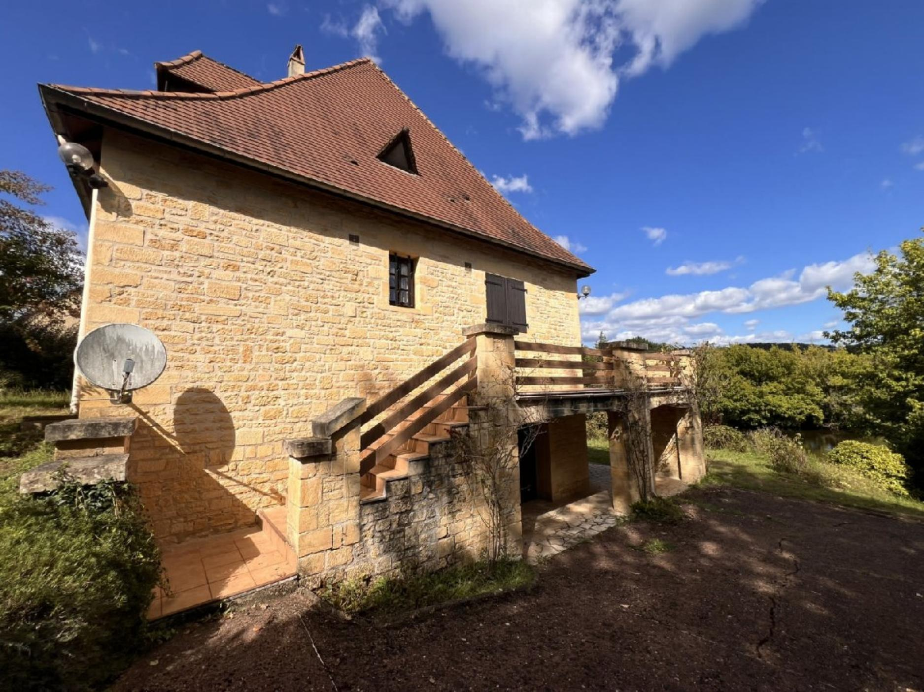
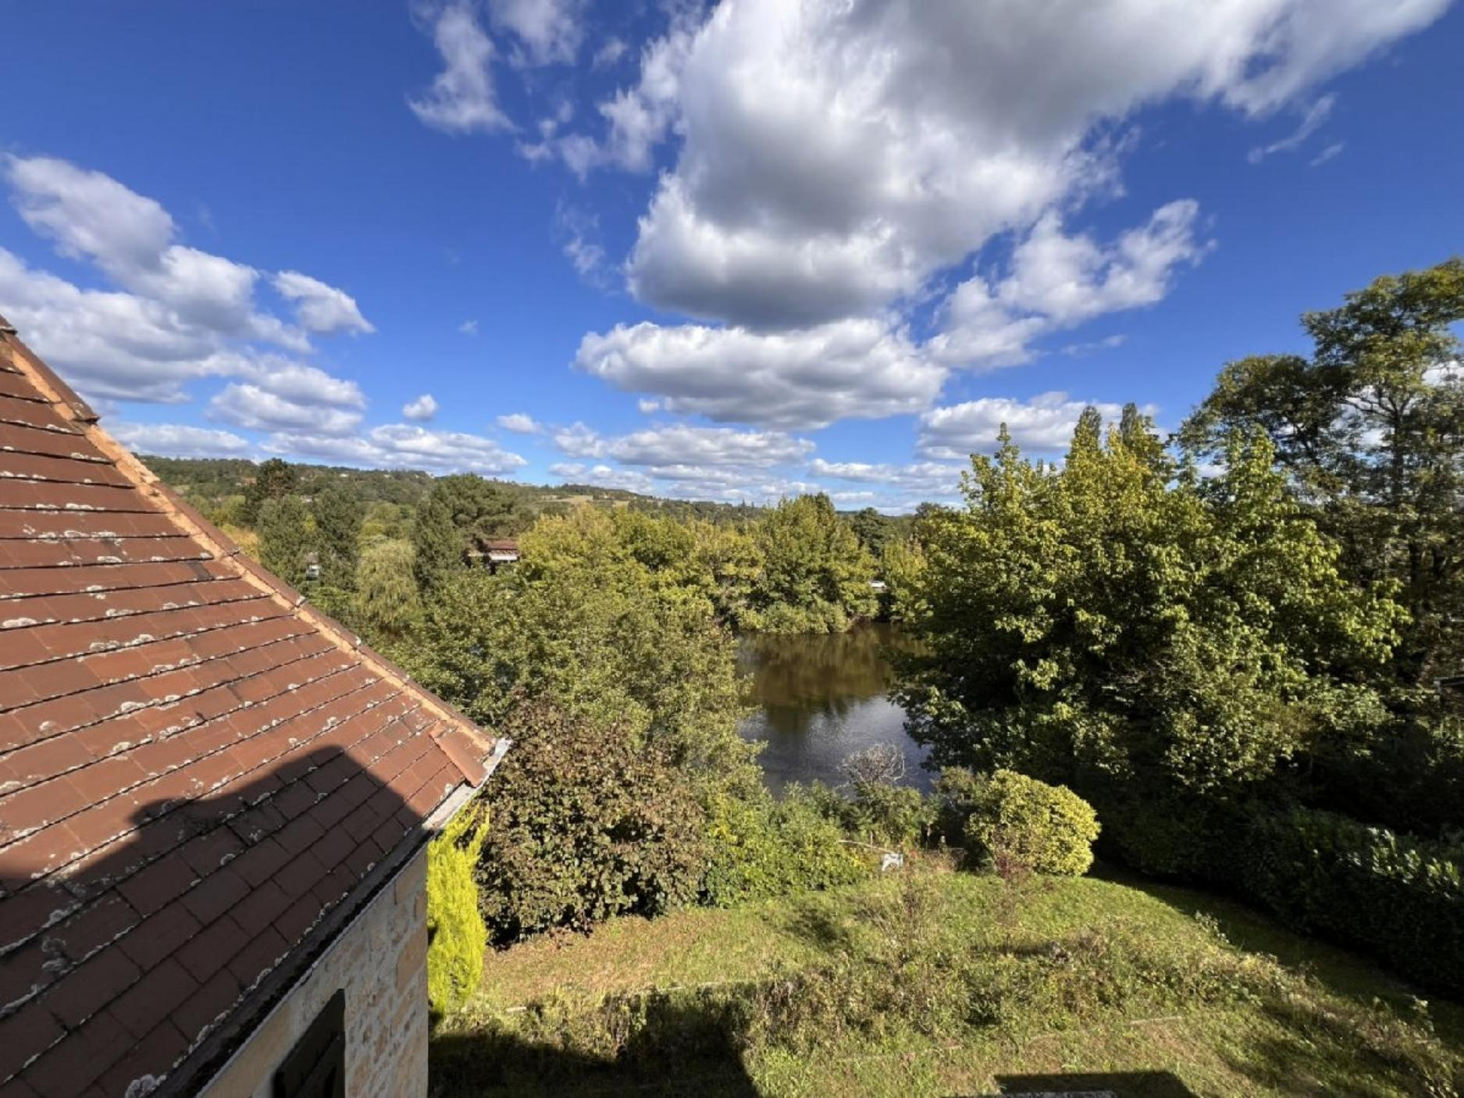 | 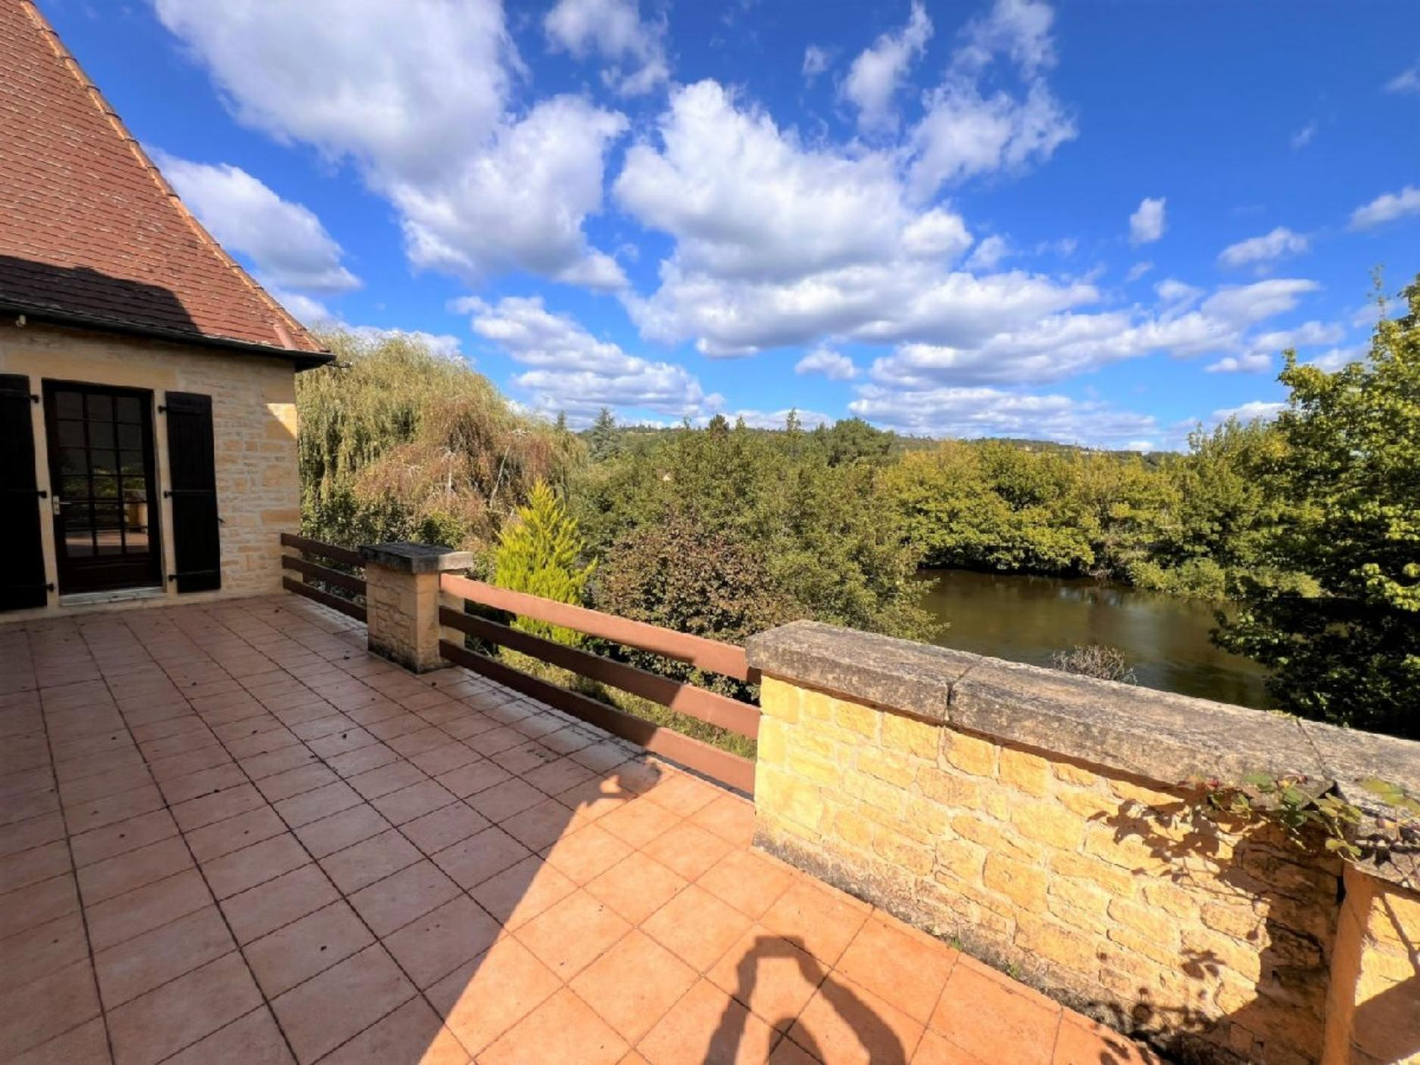
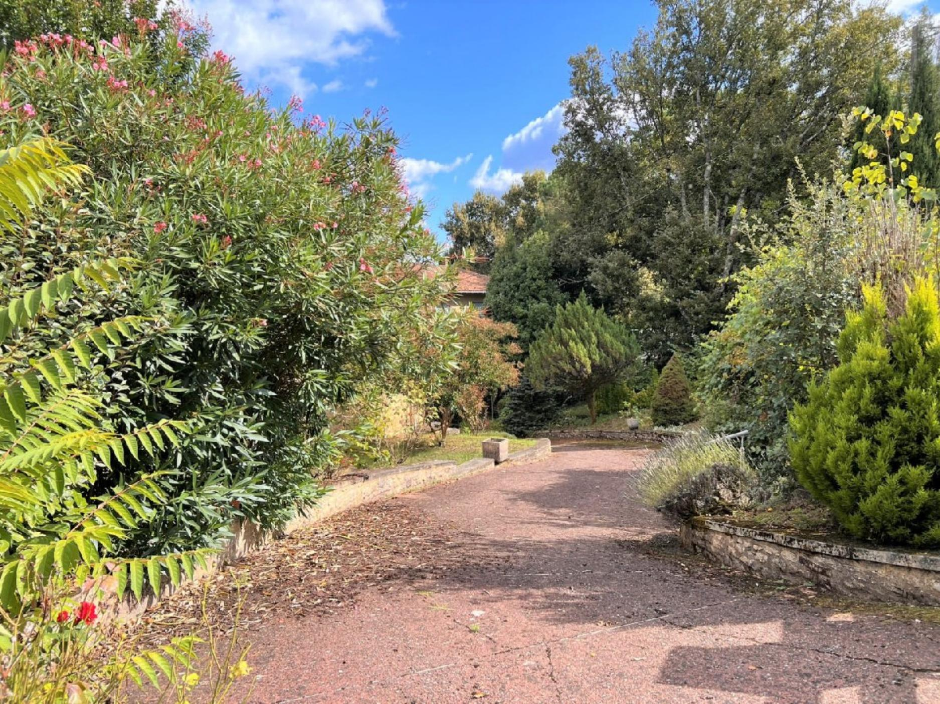 | 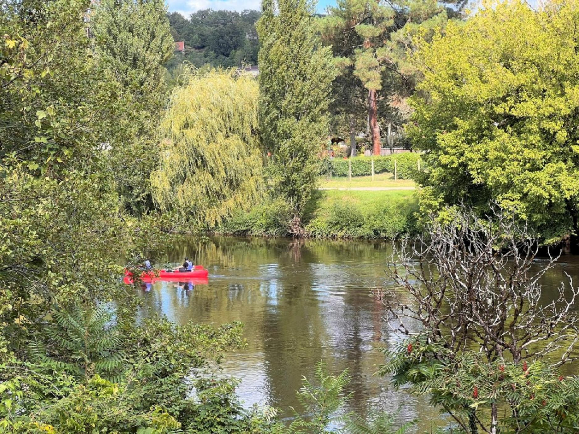
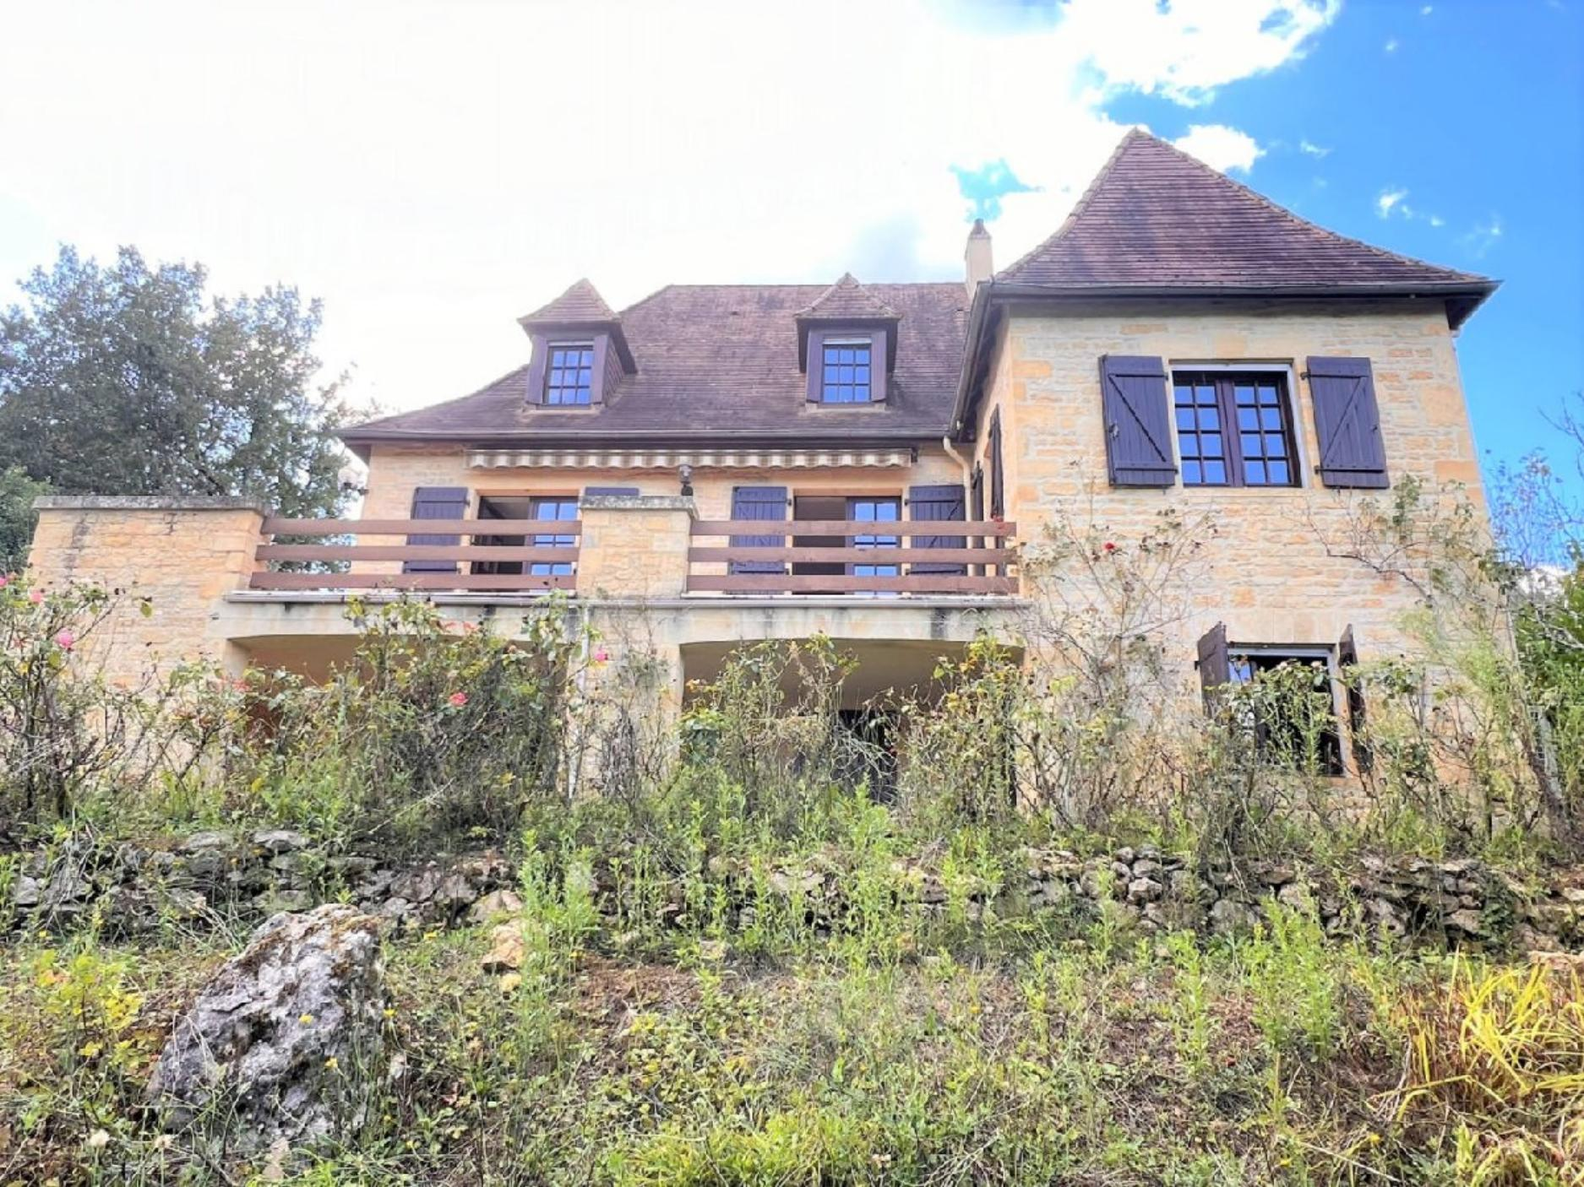 | 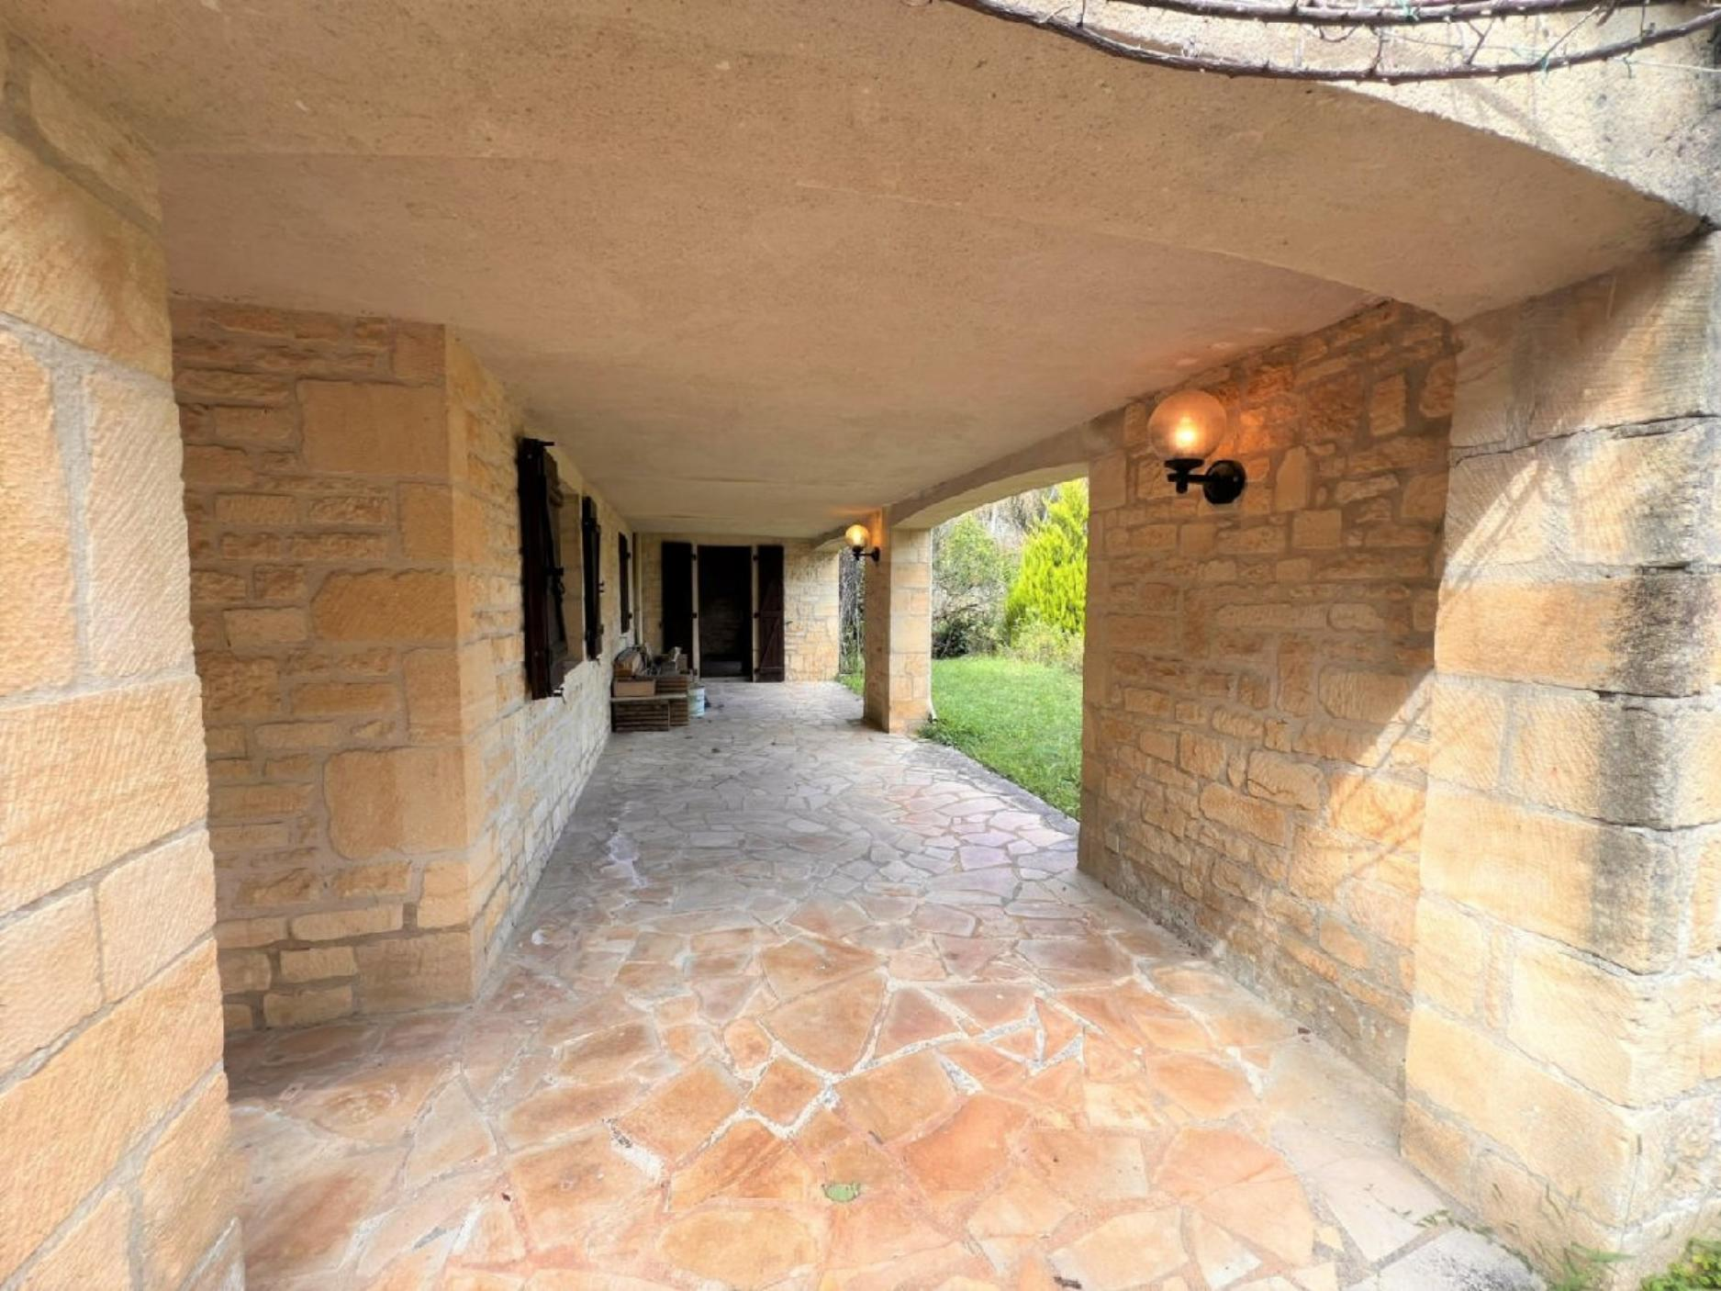
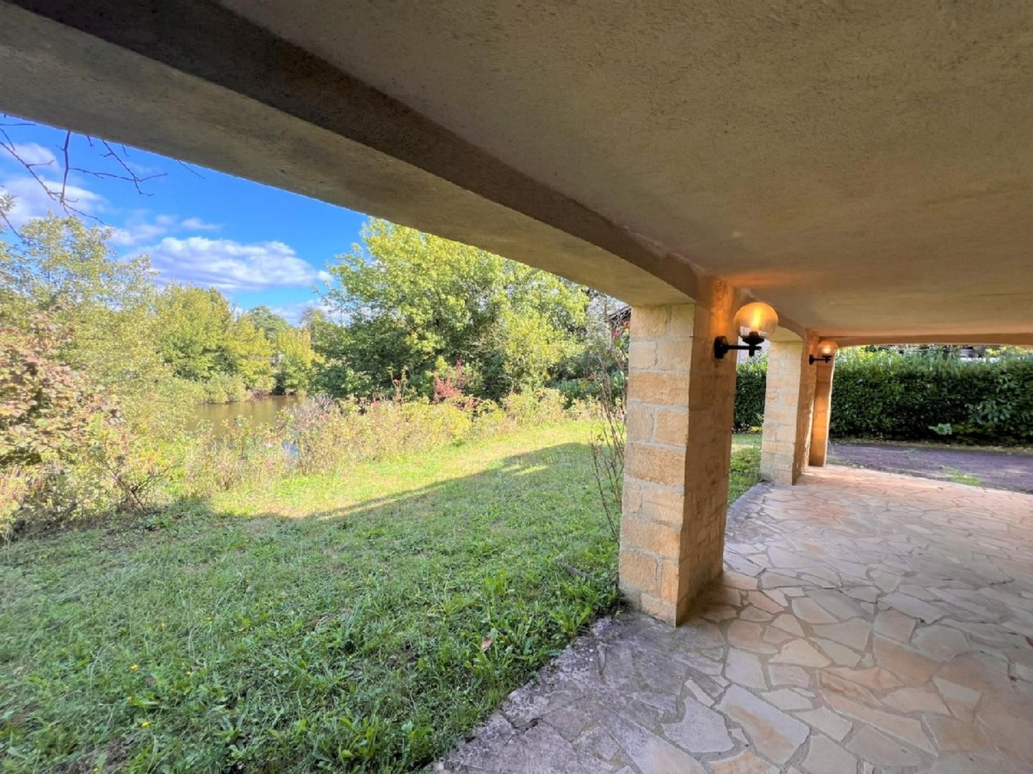 | 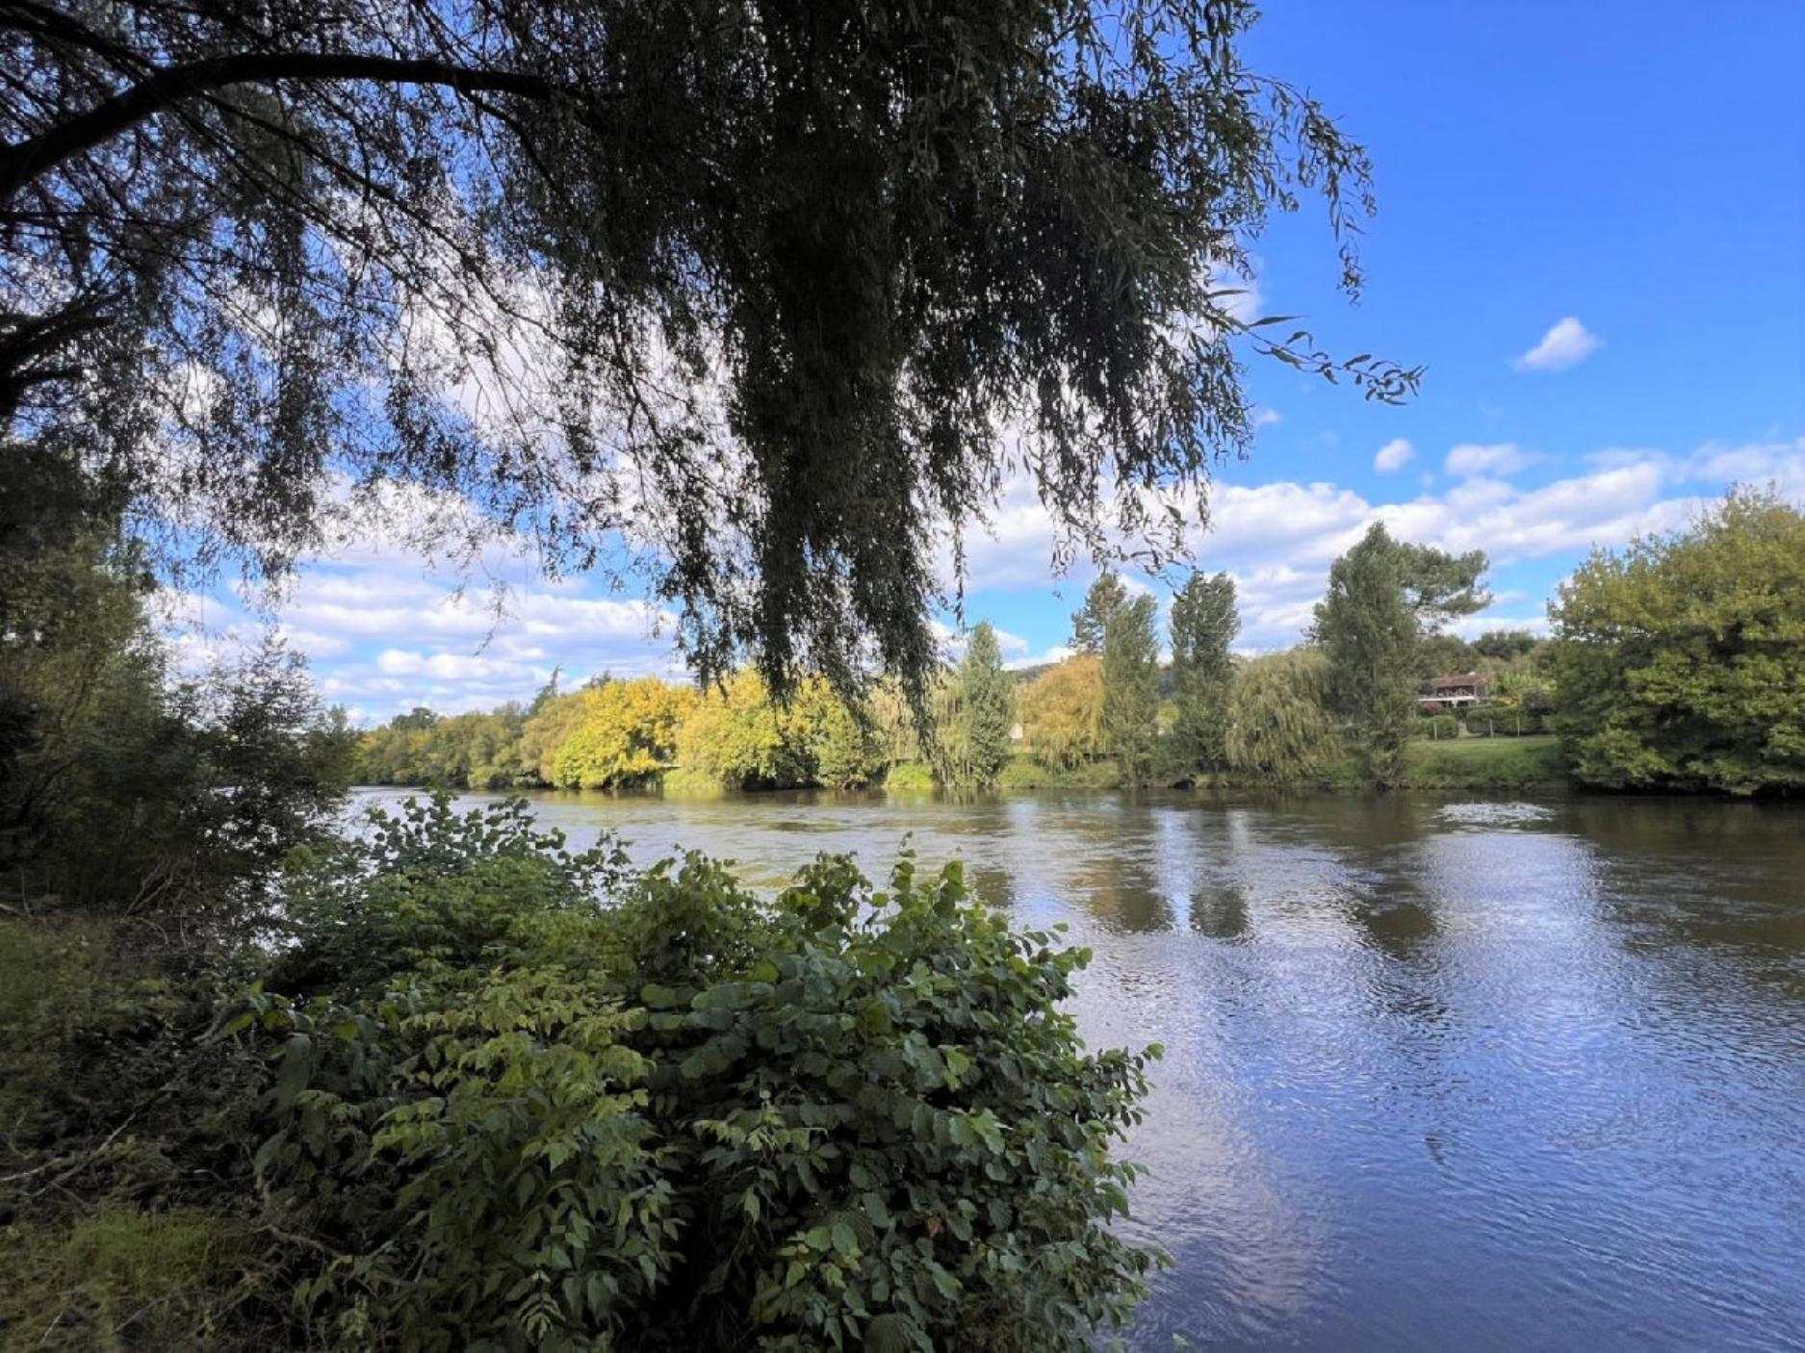
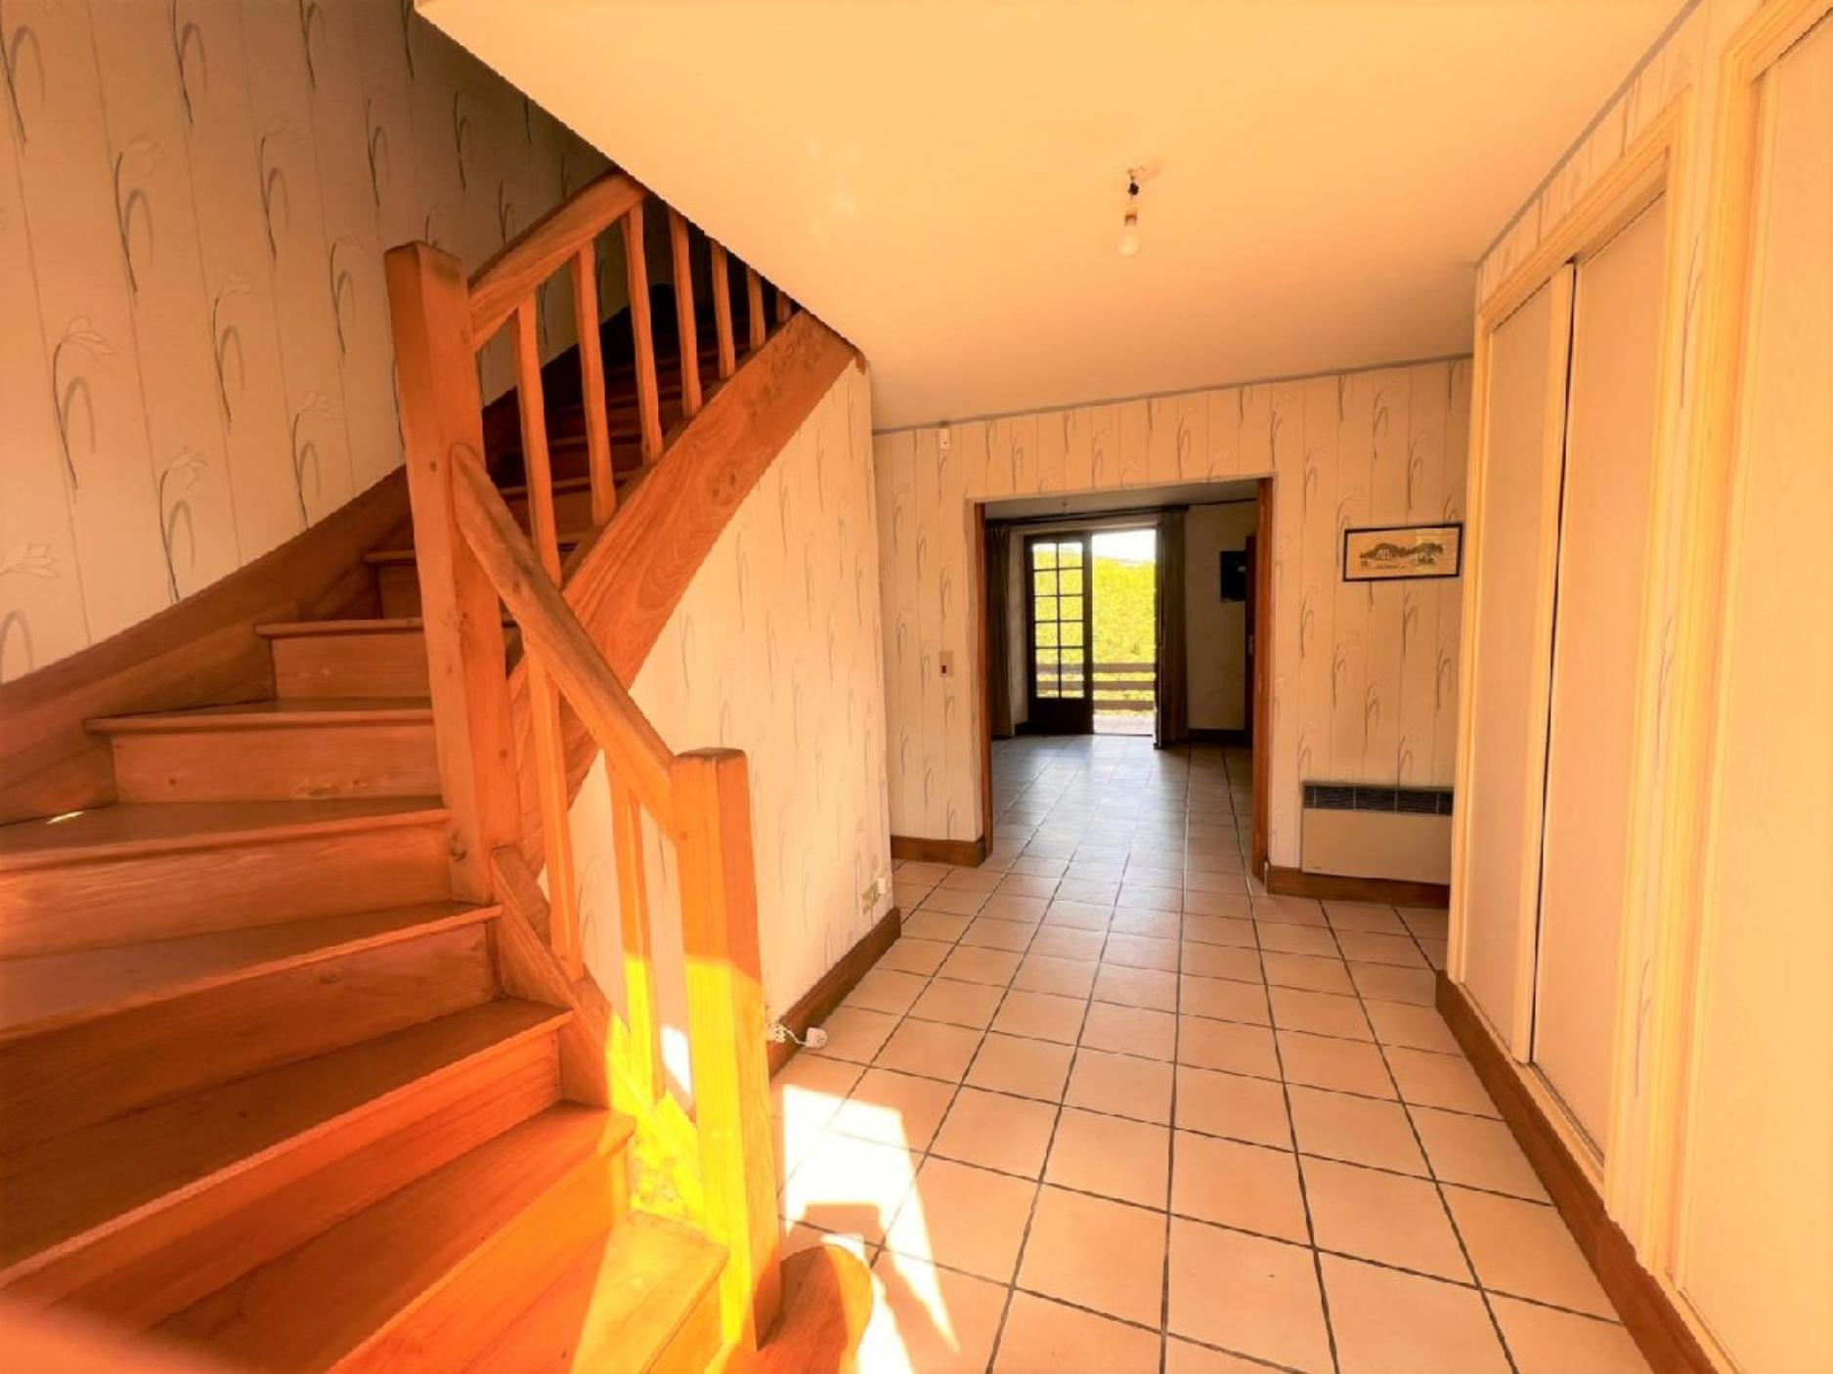 | 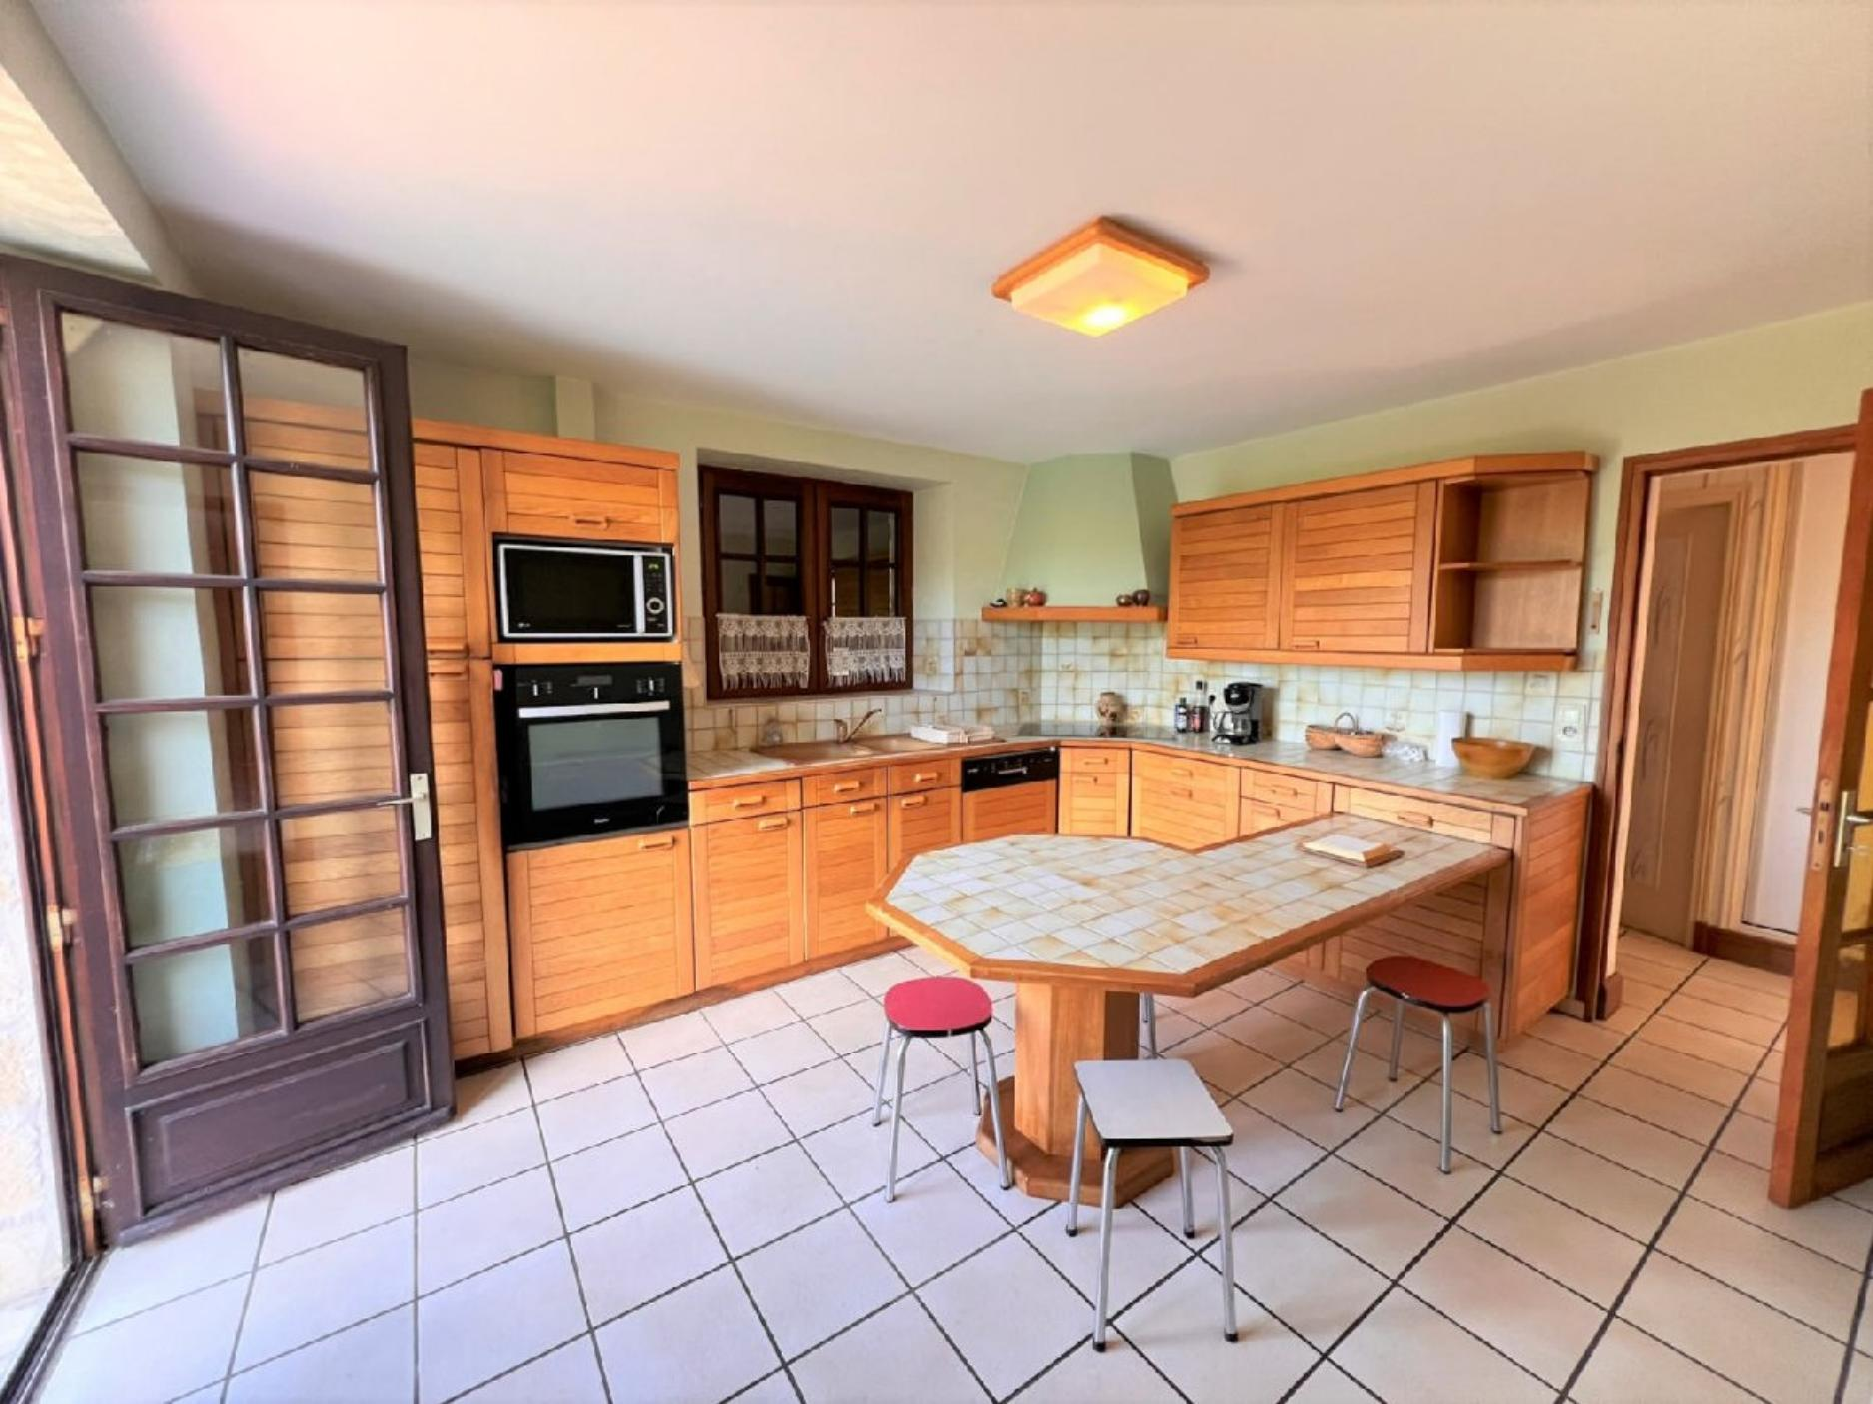
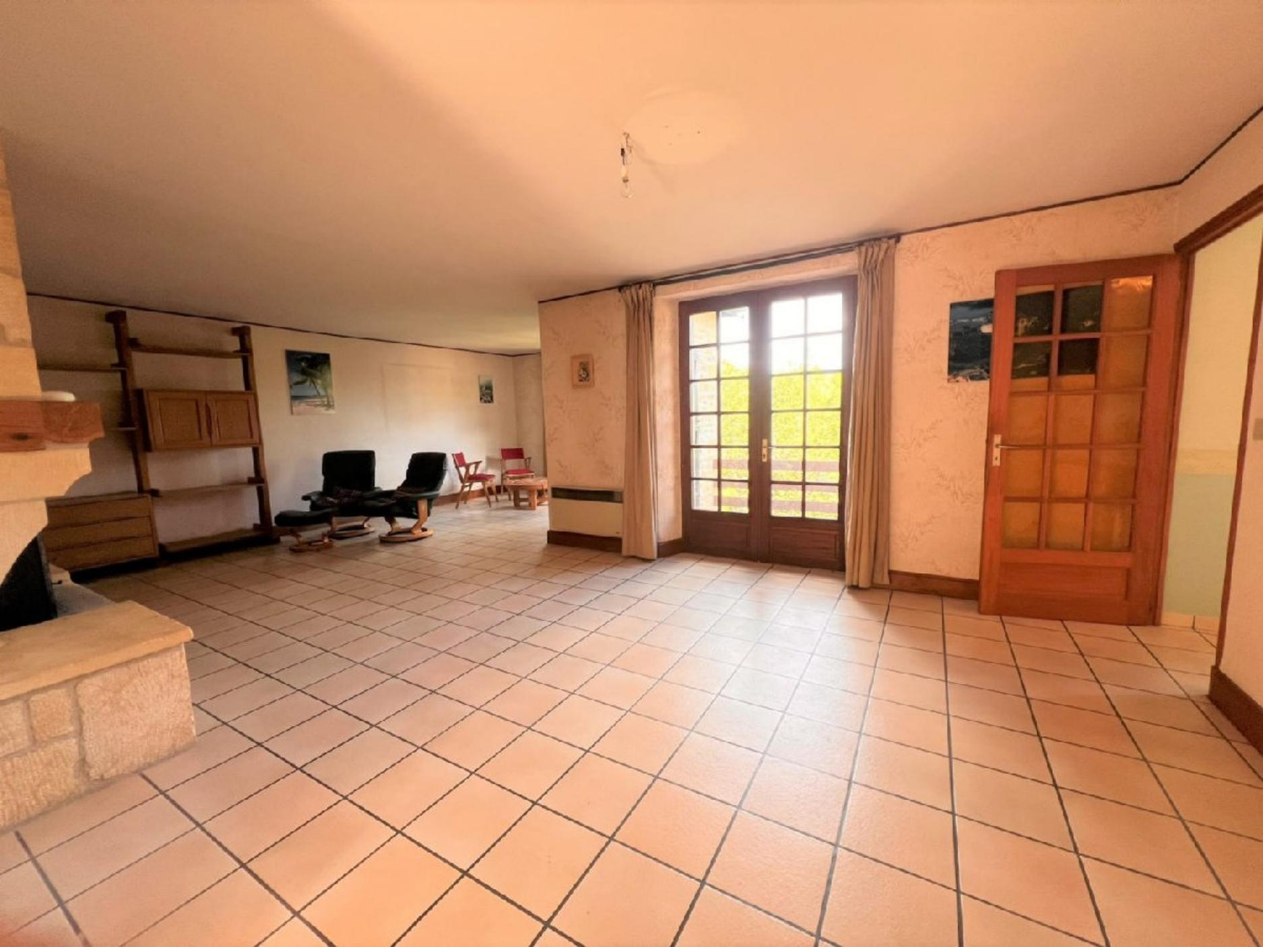 | 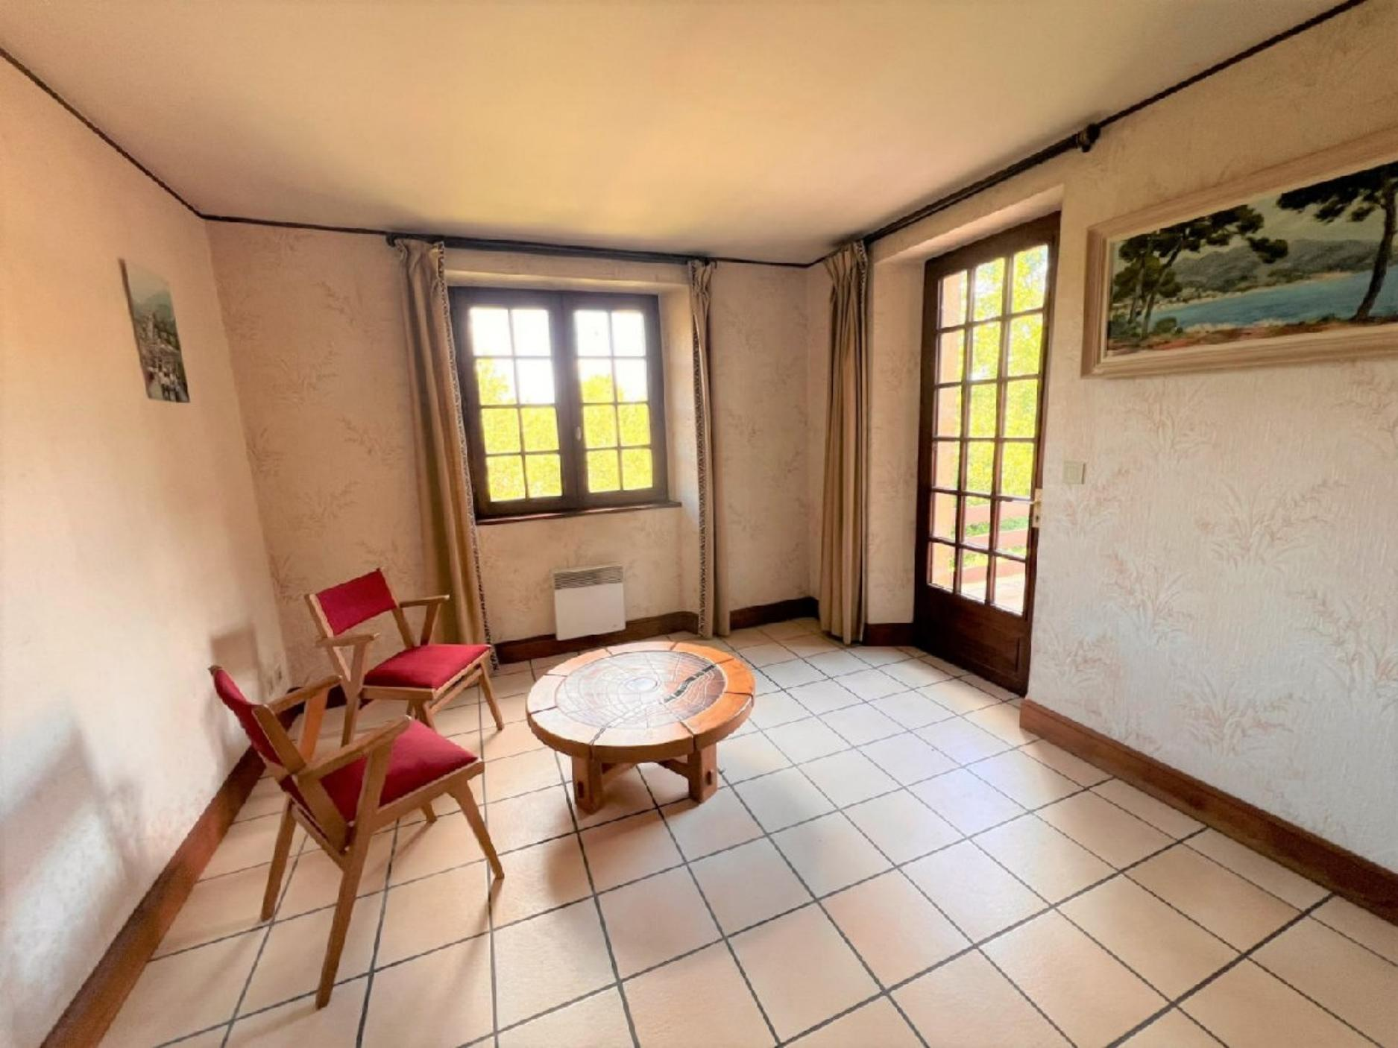
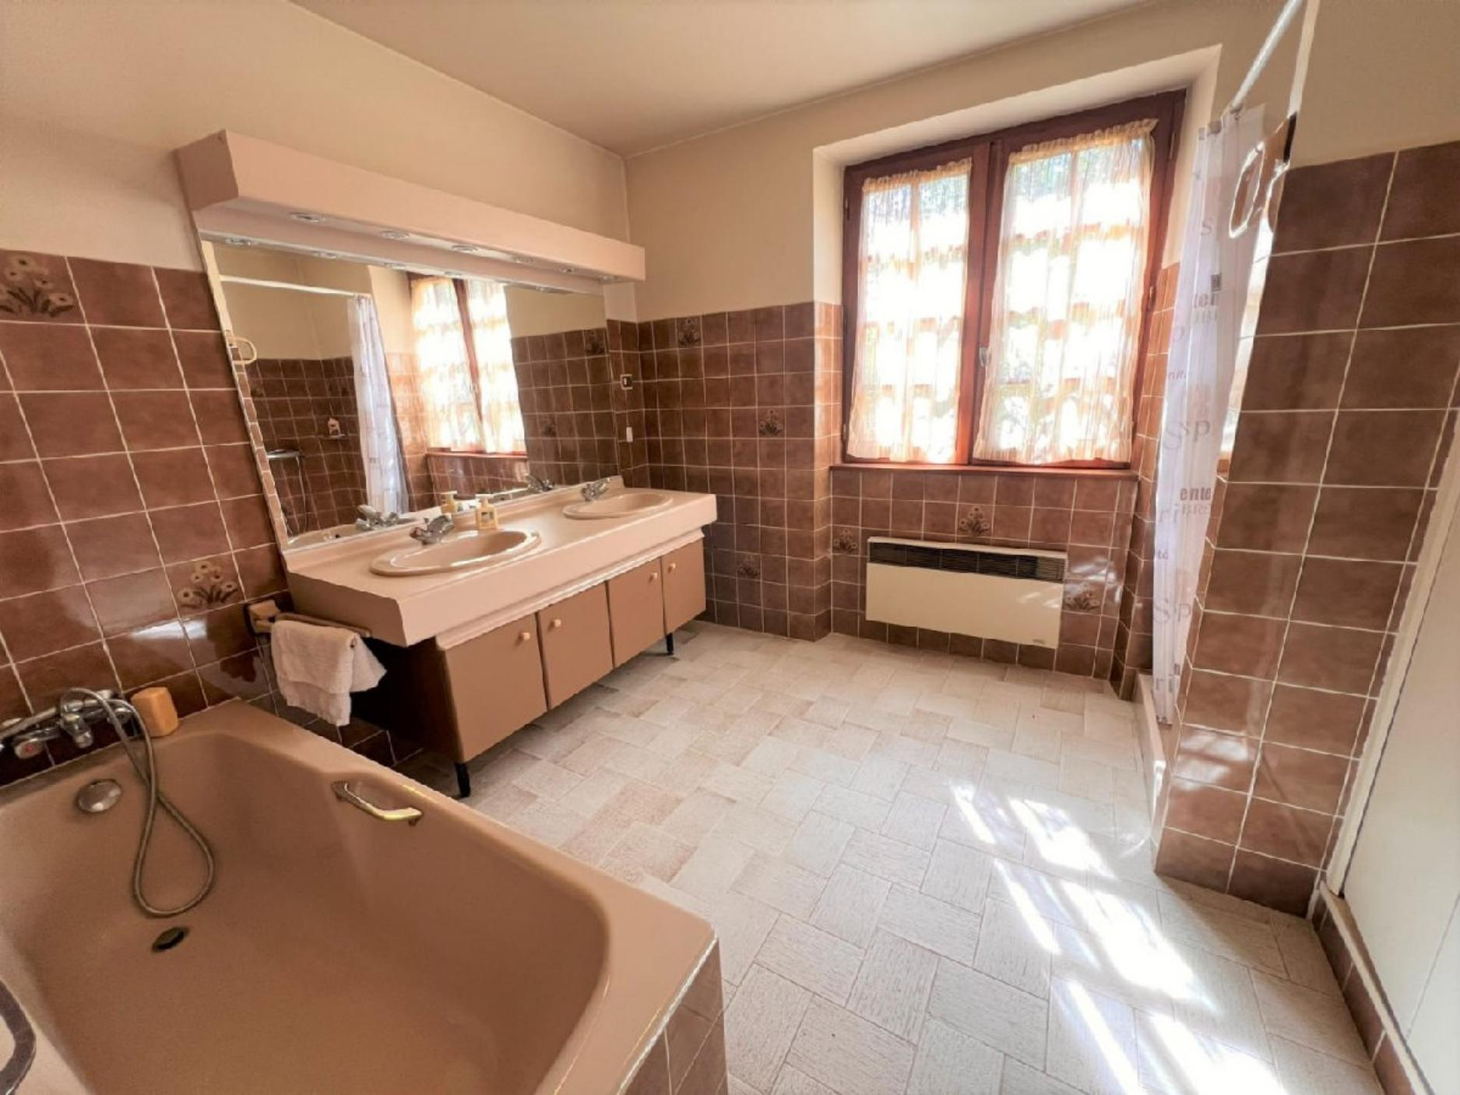 | 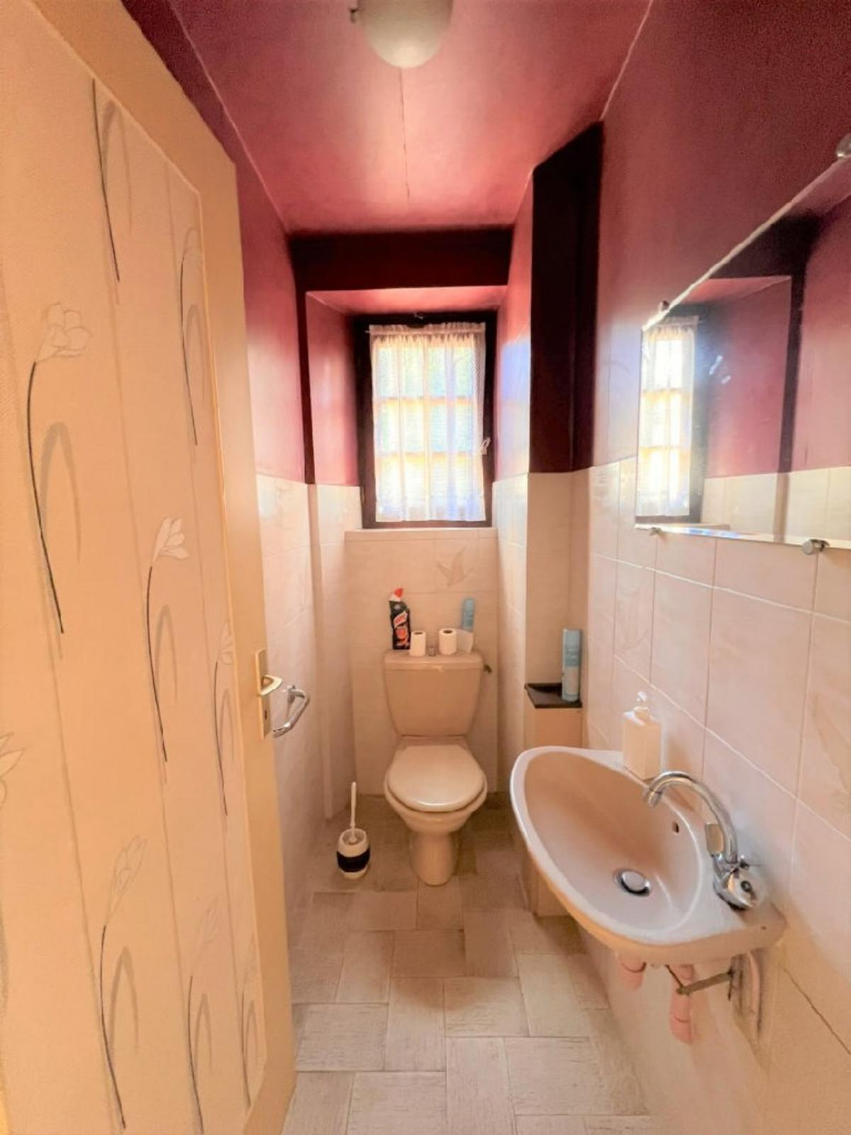
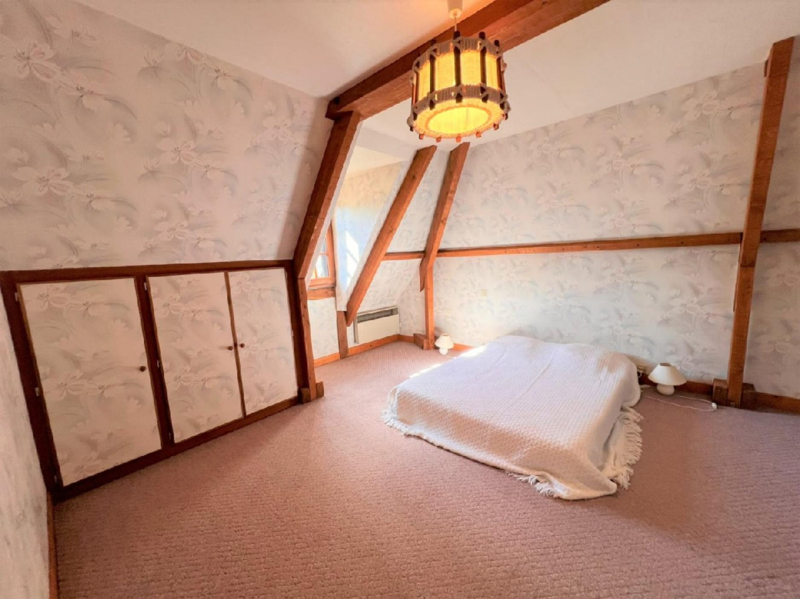 | 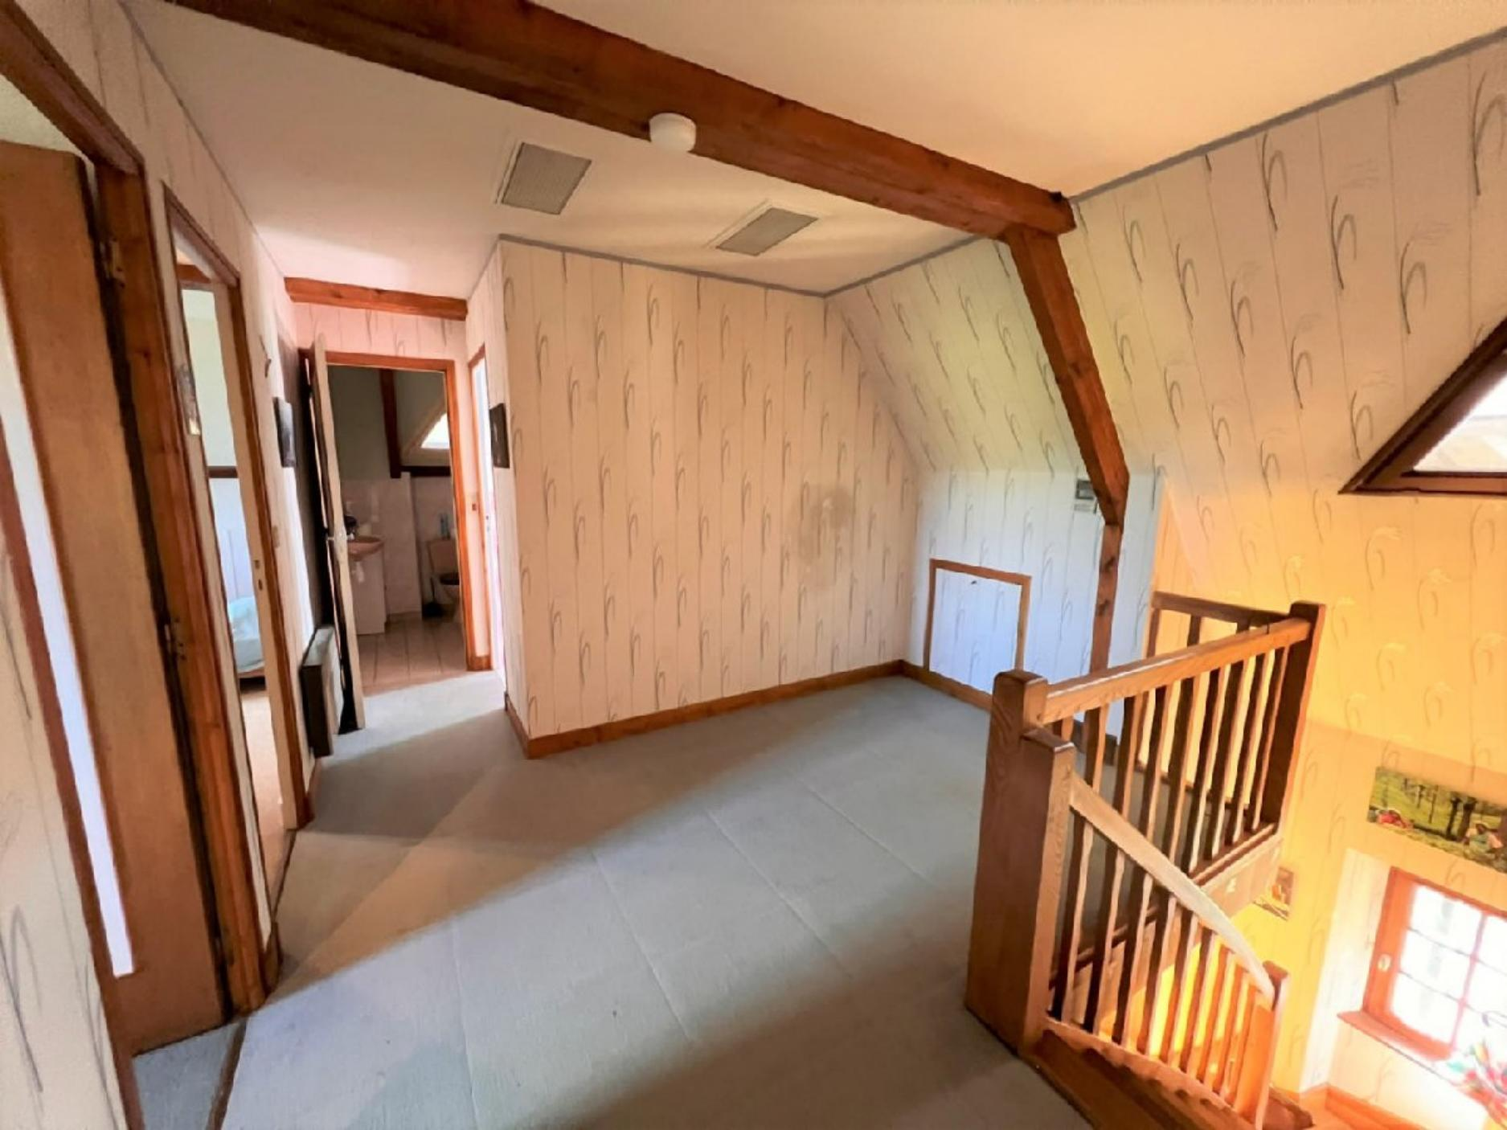
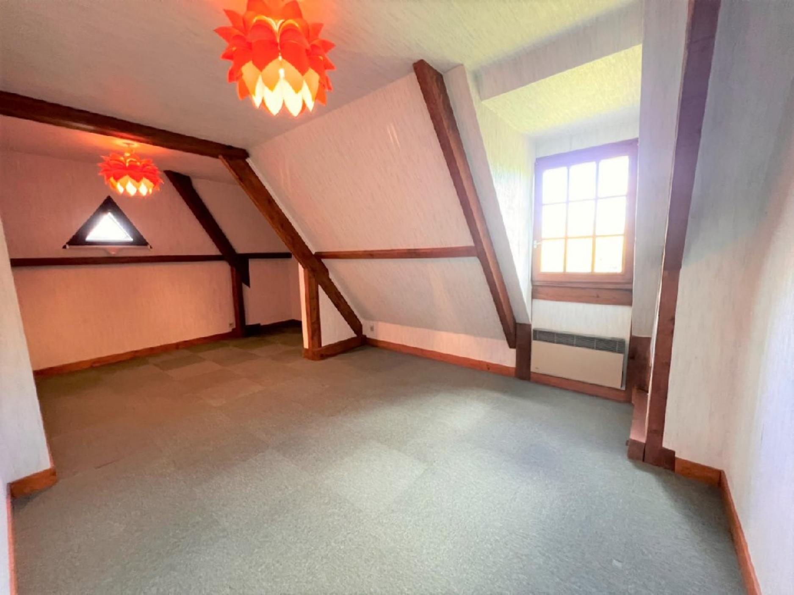 | 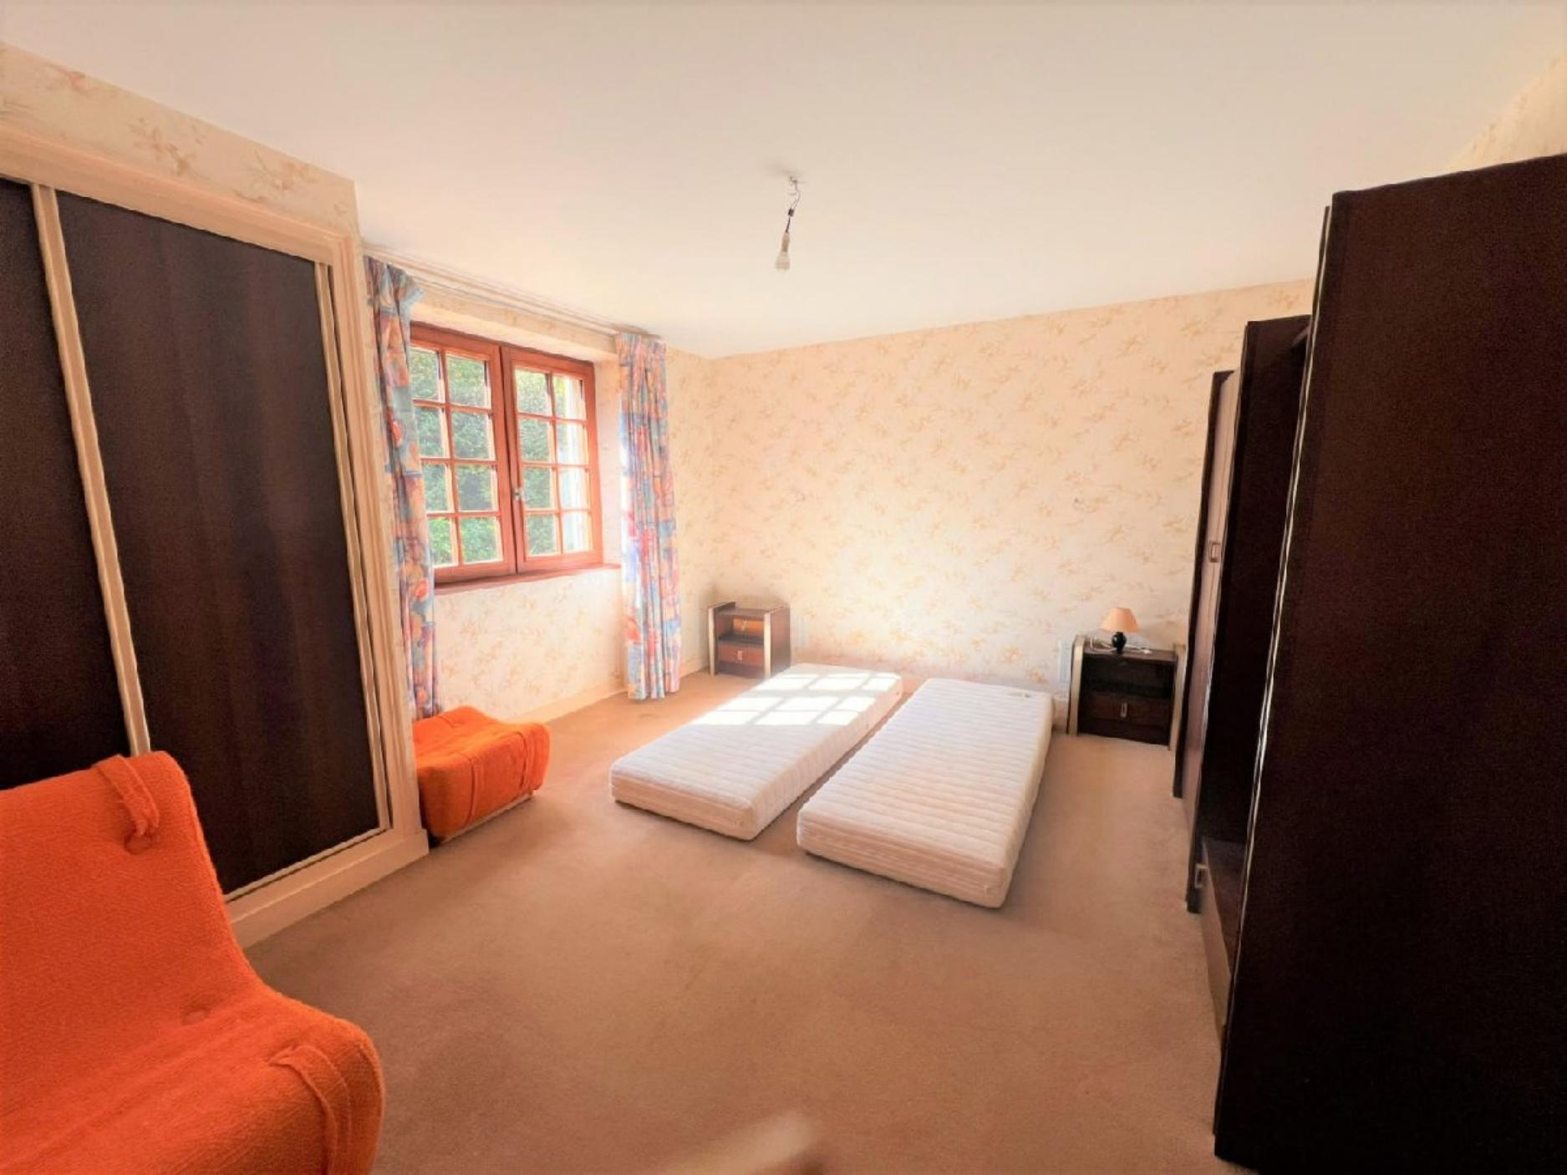
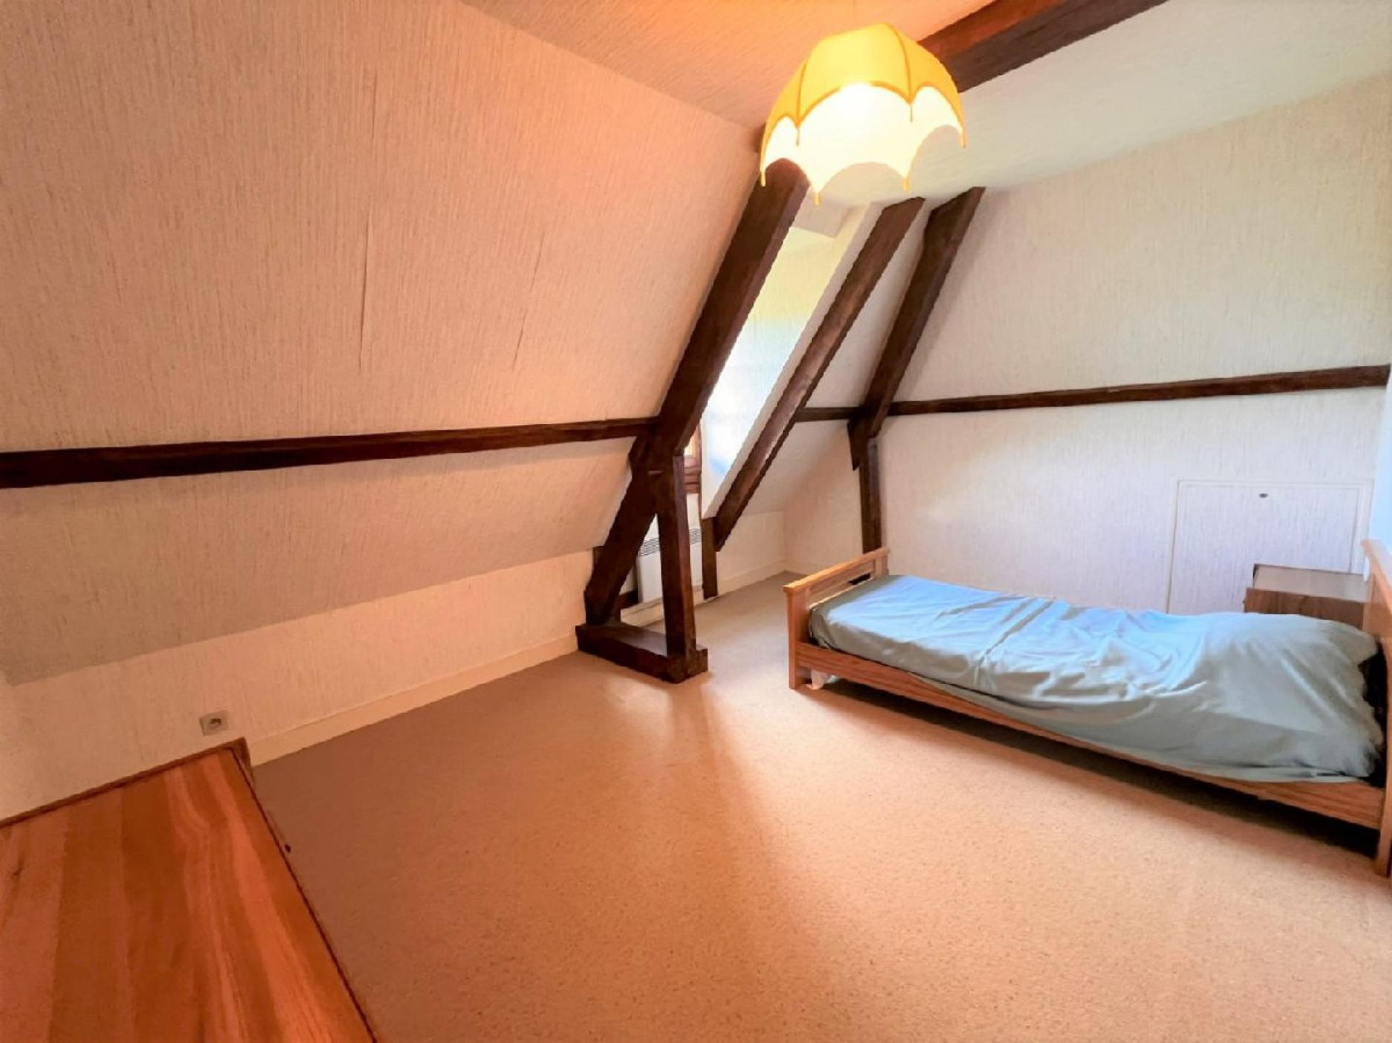 | 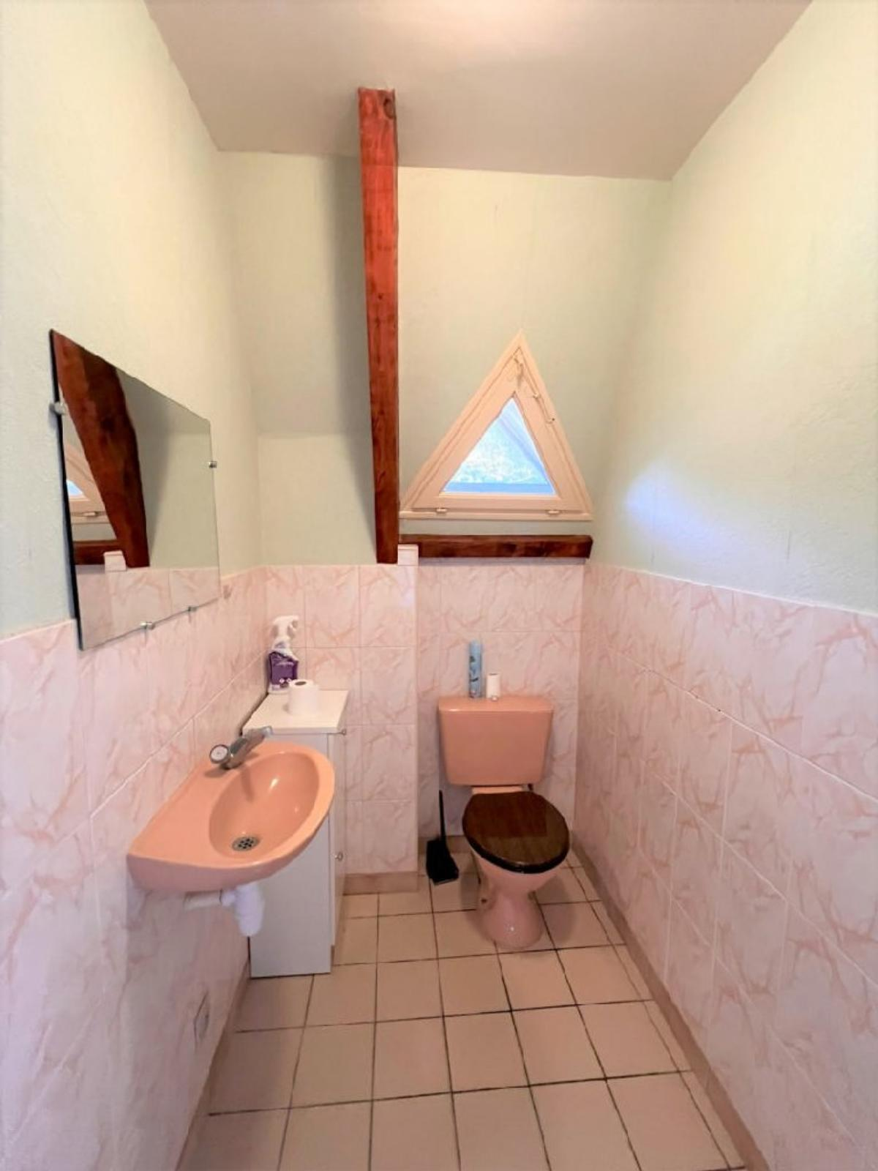
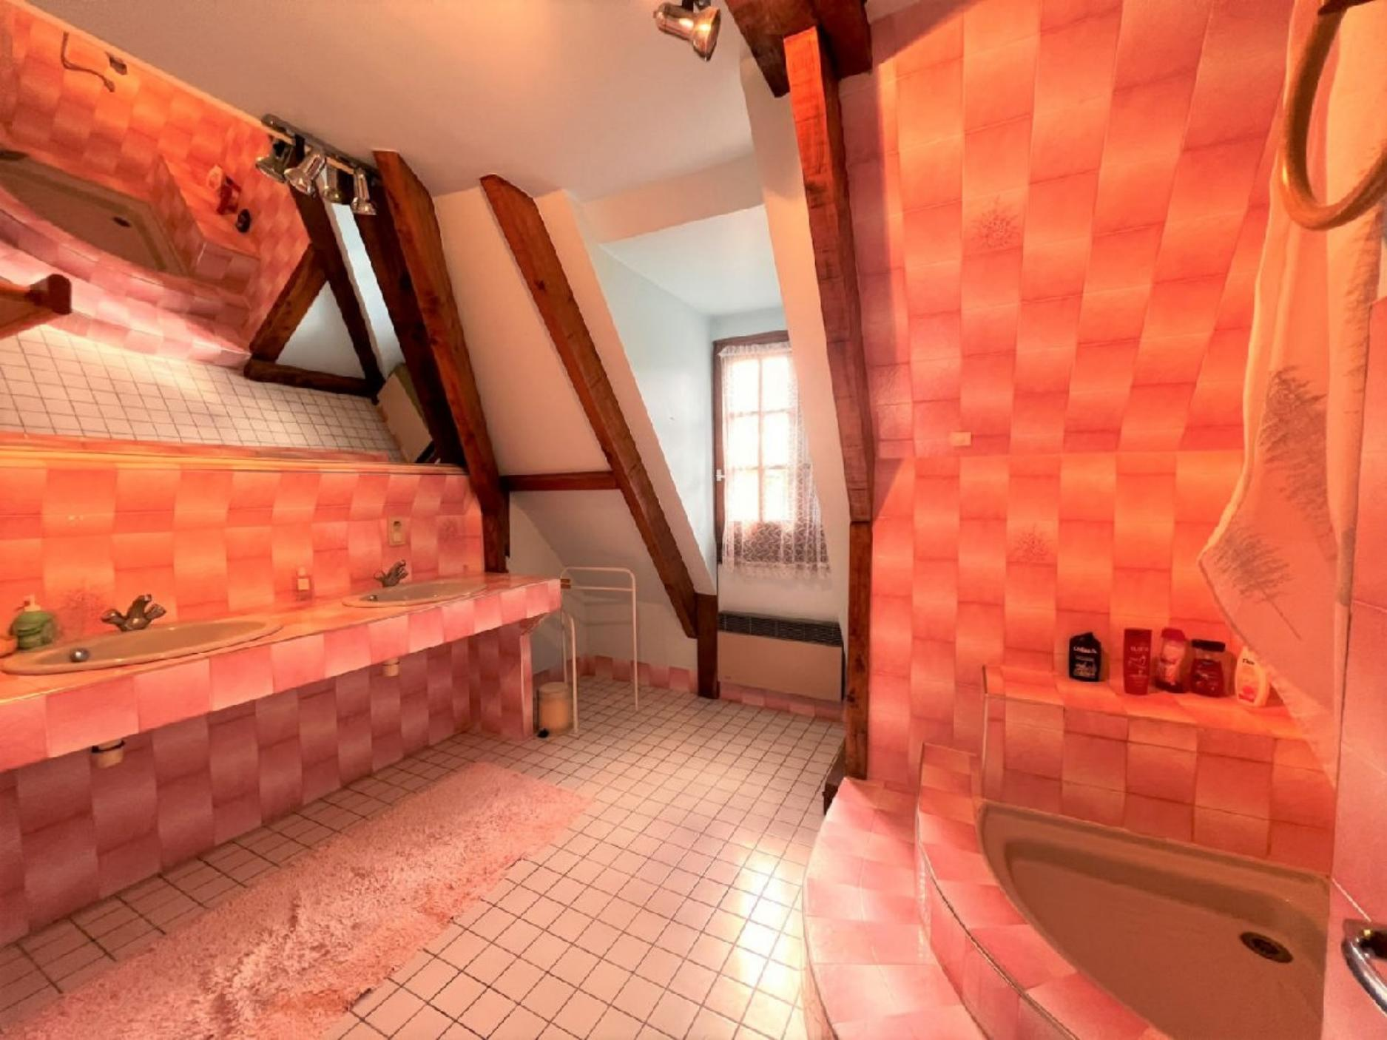 | 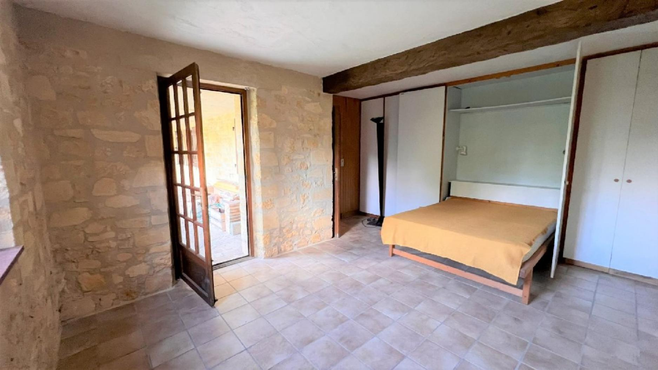
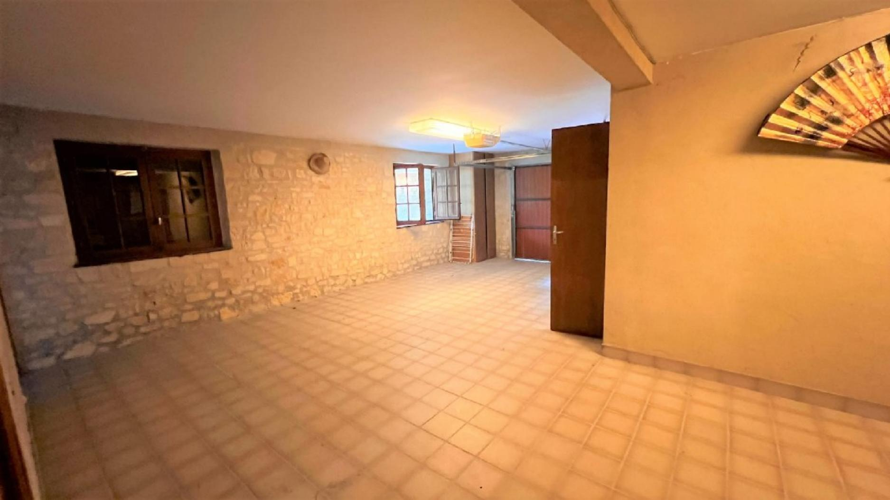 | 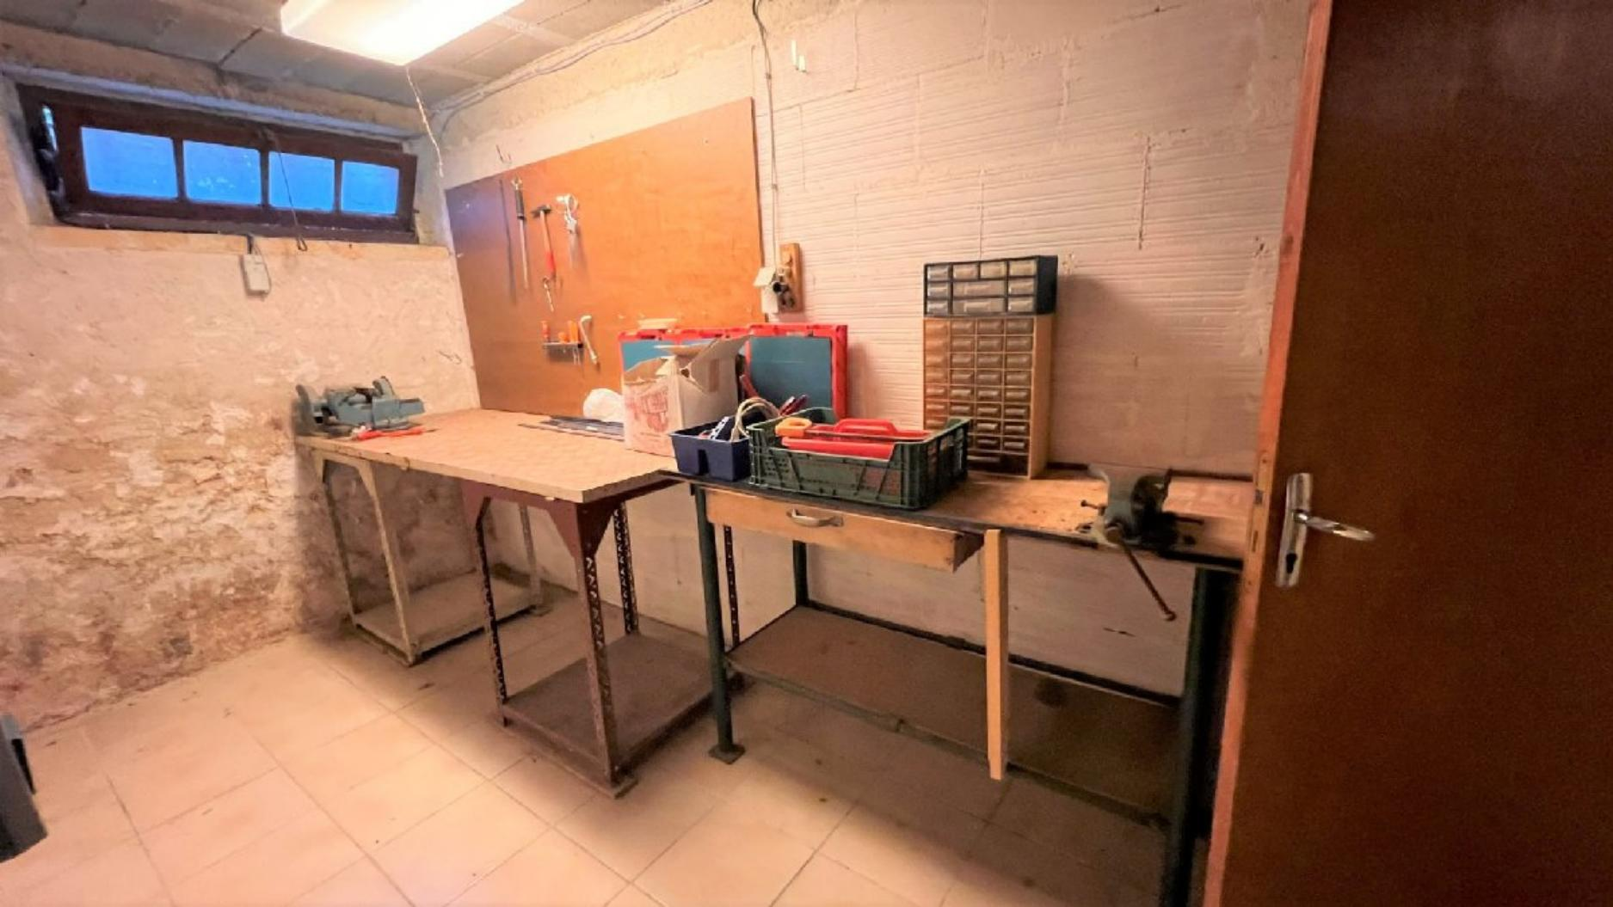
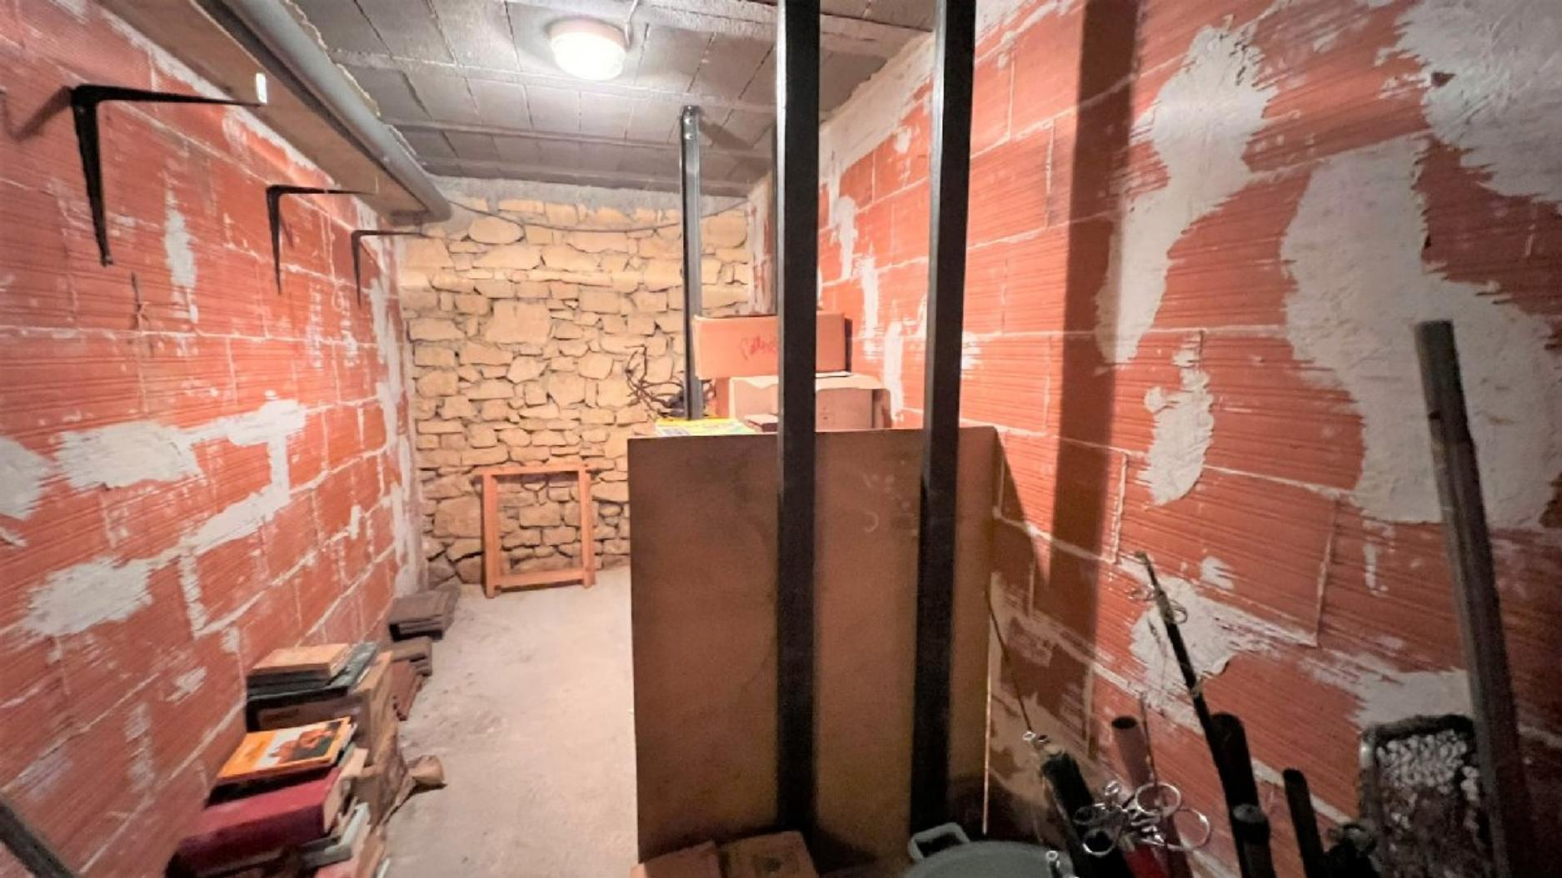 | 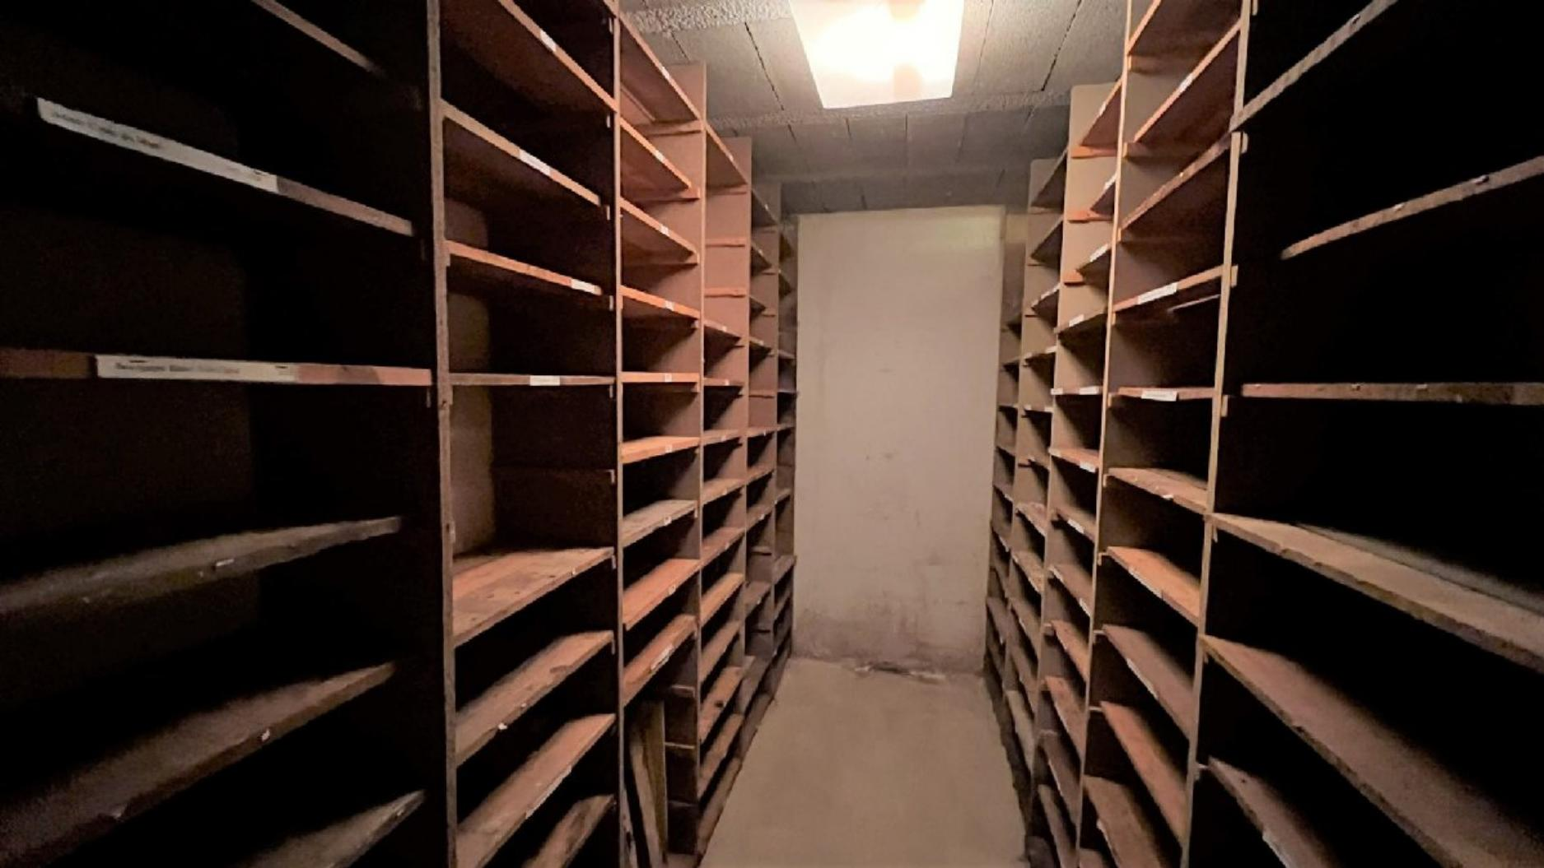
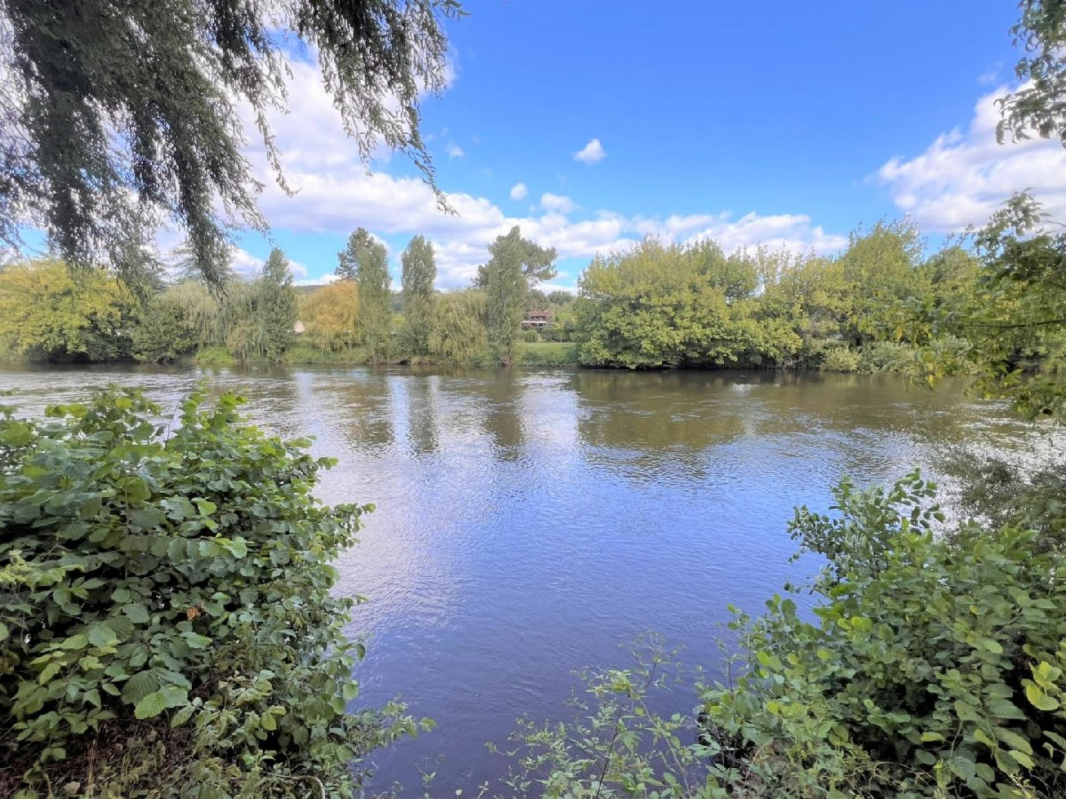 | 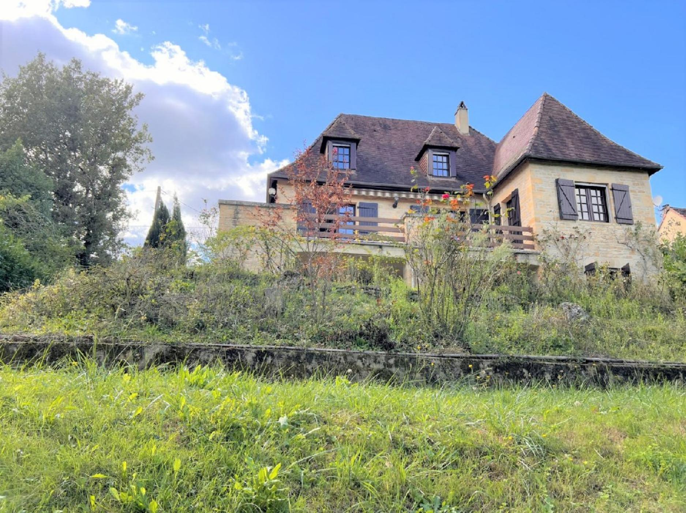

KEY DETAILS ( Ref . : PF90313) :
Total living space : 200 Sqm  Land area : 938 Sqm  Heating : Heating pump + oil  Energy Efficiency : D | Nearest town : LE BUGUE - 1MINUTE  Nearest commerce : 1 MINUTE  Nearest autoroute : A20'/A89  Nearest airport : BERHGERAC - 40MINS

PIONEER FRANCE CAN  ASSIST YOU WITH :  € Foreign Currency Exchange  the best rates : the best service  € Mortgage and Loan Facilities  pre-qualified, top lenders  € Your Total purchase process  a dedicated, fixed fee, total service from  initial offer through to post-completion  Call us or see our website  www.PioneerFrance.com   | PROPERTY LOCATION MAP :

