Phone : +33 (0)5 53 07 06 27  Email : info@pioneerfrance.com  Web : www.PioneerFrance.com  Domaine Le Ruisseau , 24580, Fleurac, Dordogne | 

THE DORDOGNE'S LEADING QUALITY PROPERTY AGENCY

REFERENCE  PF90311 | PRICE (inc.agency comm)  299,950 € | LOCATION  DORDOGNE -  MONTIGNAC AREA | TYPE  House / Character property | LAND AREA  1,753 m2

SUPERBLY RENOVATED 3-BED STONE PROPERTY IN A CHARMING HAMLET NEAR MONTIGNAC. NEW HEATED SWIMMING POOL, GARAGE, CHALET AND STONE OUTBUILDINGS, LARGE GARDENS. PF90311

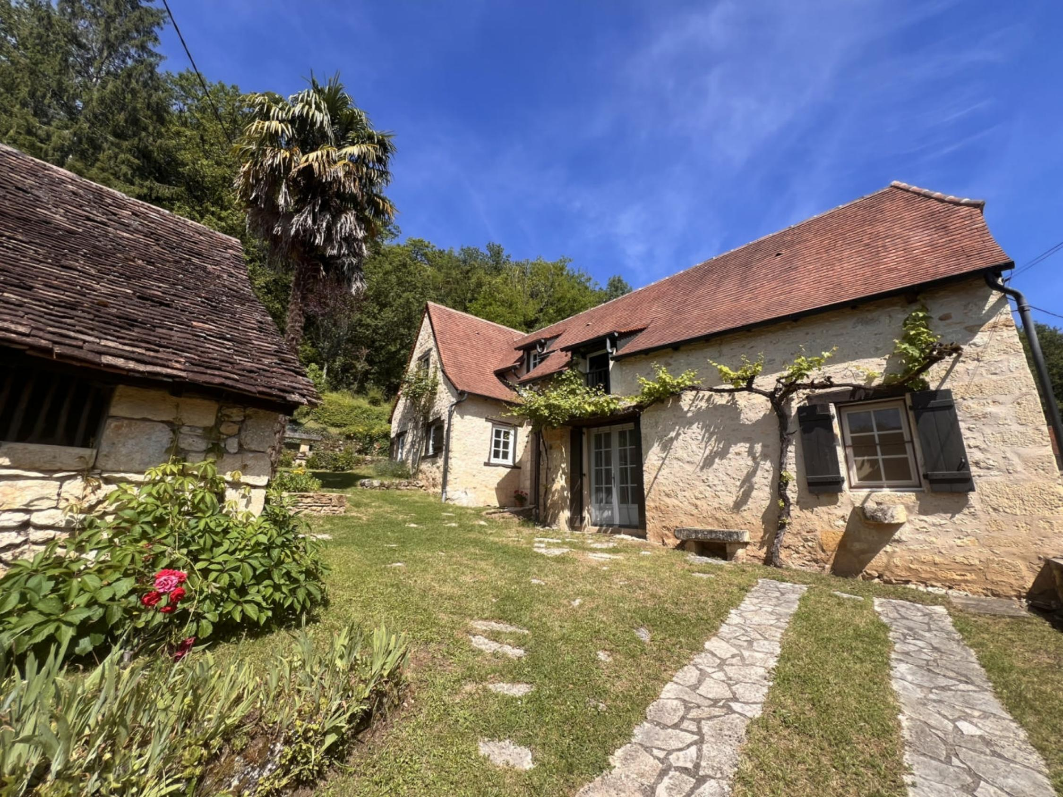
In a peaceful, pretty hamlet only 10 minutes from Montignac, this beautiful stone property has been entirely and thoughtfully renovated. Offering circa 110sqm habitable space, there are 3 double-bedrooms, one en-suite, a 2nd shower room, large kitchen & dining room, and a lovely living room. The property has a newly installed travertine-terraced, heated swimming pool, a self-contained chalet, a 2-storey stone barn and sheep-pens to convert if desired, plus a large garage. Mature well-maintained fenced gardens. PF90311
PROPERTY DESCRIPTION ( Ref : PF90311)
SUPERBLY RENOVATED 3-BED STONE PROPERTY IN A CHARMING HAMLET NEAR MONTIGNAC. NEW HEATED SWIMMING POOL, GARAGE, CHALET AND STONE OUTBUILDINGS, LARGE GARDENS. PF90311

In a peaceful, pretty hamlet yet only 10 minutes from Montignac, this beautiful stone property has been entirely and thoughtfully renovated. Offering circa 110sqm habitable space, there are 3 double-bedrooms, one en-suite, a 2nd shower room, large kitchen & dining room, and a lovely living room. The property has a newly installed travertine-terraced, heated swimming pool, a self-contained chalet, a 2-storey stone barn and sheep-pens to convert if desired, plus a large garage. Mature well-maintained fenced gardens. PF90311
THE MAIN HOUSE
Habitable Space: approx 110sqm
Accessed via a short iris-lined grassy driveway with a stone wall to one side. The house is offered in superb, newly refurbished condition, while retaining many period features. It has electric heating and 2 wood-burning stoves. All windows are new and double-glazed. The roof has been refurbished and the guttering and down-pipes are all new. There are 2 electric water heaters, one for the bathrooms and one for the kitchen. All interior doors, including most cupboard doors are solid oak and have been hand-made.
Ground Floor
Entrance Hall: 3sqm
Two steps down to:
Kitchen/Dining Room 30sqm Terracotta tiled floor, exposed beams
Dining Room: (16sqm) Double doors opening onto garden. Traditional circular Godin wood burner, understairs utility storage cupboard, additional low-level cupboards.
Kitchen: (14sqm) Range of attractive lower & upper-level cabinets, stainless steel sink with drainer, hob, oven, extractor fan, washing machine, dishwasher, fridge-freezer. Traditional stone sink set into wall.
From Entrance Hall, 2 steps up to:
Living Room: 21sqm Terracotta tiled floors & exposed beams, double aspect, large chimney breast with wood burning stove, recessed bookshelves.
From Entrance Hall:
Shower Room: 3sqm Shower unit, sink with drawers below, WC, mirrored cabinet, heated towel rail, large cupboard housing water heater.
From the living room, stairs up to:
First Floor:
Master Bedroom: 17.0sqm Double aspect with views over garden. Parquet floor & exposed beams. Hanging storage area into eaves.
Steps down to:
En-suite Bathroom: 5sqm Bath with shower attachment and glass shower screen, sink unit with drawers below, WC, extractor fan.
From the dining Room, stairs to First Floor:
Landing: 6sqm with recessed cupboards with hanging and shelving storage.
Bedroom 2: 14sqm Bright room with parquet floor & exposed beams. Attractive (& useful) wooden shelf along length of room. Fitted cupboard with shelving & hanging space.Roof-top views of hamlet.
Bedroom 3: 10sqm Parquet floor, exposed beams, windows overlooking garden.
GARDENS & OUTBUILDINGS
Garage/Barn: 24sqm Spacious.
Stone Barn: 22sqm ground floor area with a second floor. New roof recently fitted. Could potentially be converted to a 2-storey property (from ground level to apex of roof is approximately 5.8m) subject to permissions.
2 Traditional stone sheep pens: 6.7sqm & 9.2sqm. Exposed stone walls. These could potentially be opened to create a part-covered parking area, amongst other things.
Wooden Chalet/Cabin: 12sqm Located slightly above the house in the garden, in excellent condition, with new roof, windows, shutters, linoleum floor, electricity.
Swimming Pool: 4mx2.5m Very pretty, newly installed (2024), heated (heat pump) swimming pool with travertine terrace, bathing/paddling ledge and corner steps. Salt electrolysis filtration system. Electric retractable thermic cover. Railing around terrace.
Gardens and Land (total land surface area 1753sqm) Mainly laid to lawn in front of the house with flower borders. To the side and above the house the garden is terraced with old and attractive stone walls & artifacts remaining. Planted with flowering shrubs and trees. Further up is a large grassy area. New fencing to the rear & side.
GENERAL INFORMATION
- Area of outstanding natural beauty, 10 mins to Montignac (and Lascaux!).
- Elevated, peaceful location with far-reaching views.
- Bakery 5 mins.
- Off-street parking for 3 cars.
- Fibre Internet installed.
- Fenced garden.
- Great opportunity to purchase a newly refurbished traditional property, but with potential to renovate outbuildings.
- Excellent Gite income potential
REF: PF90311

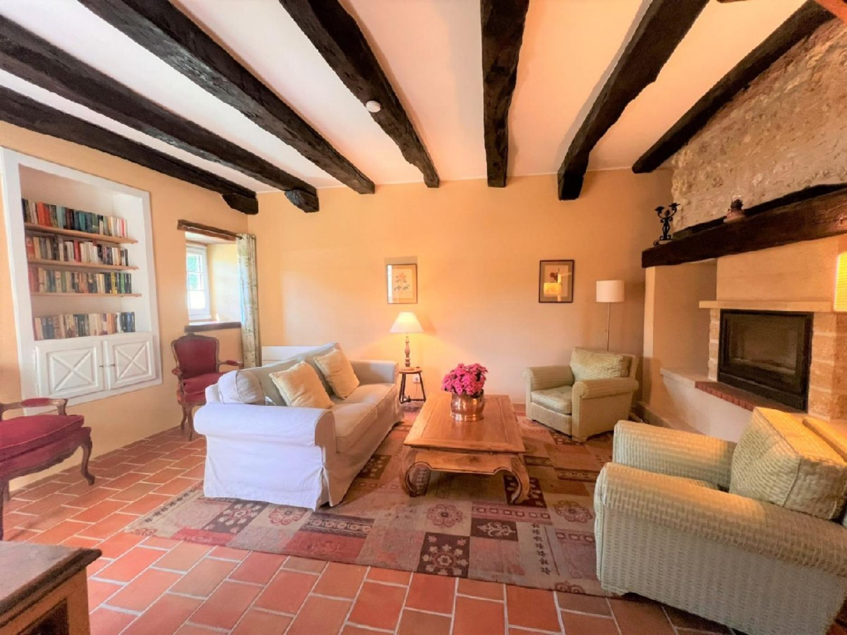 | 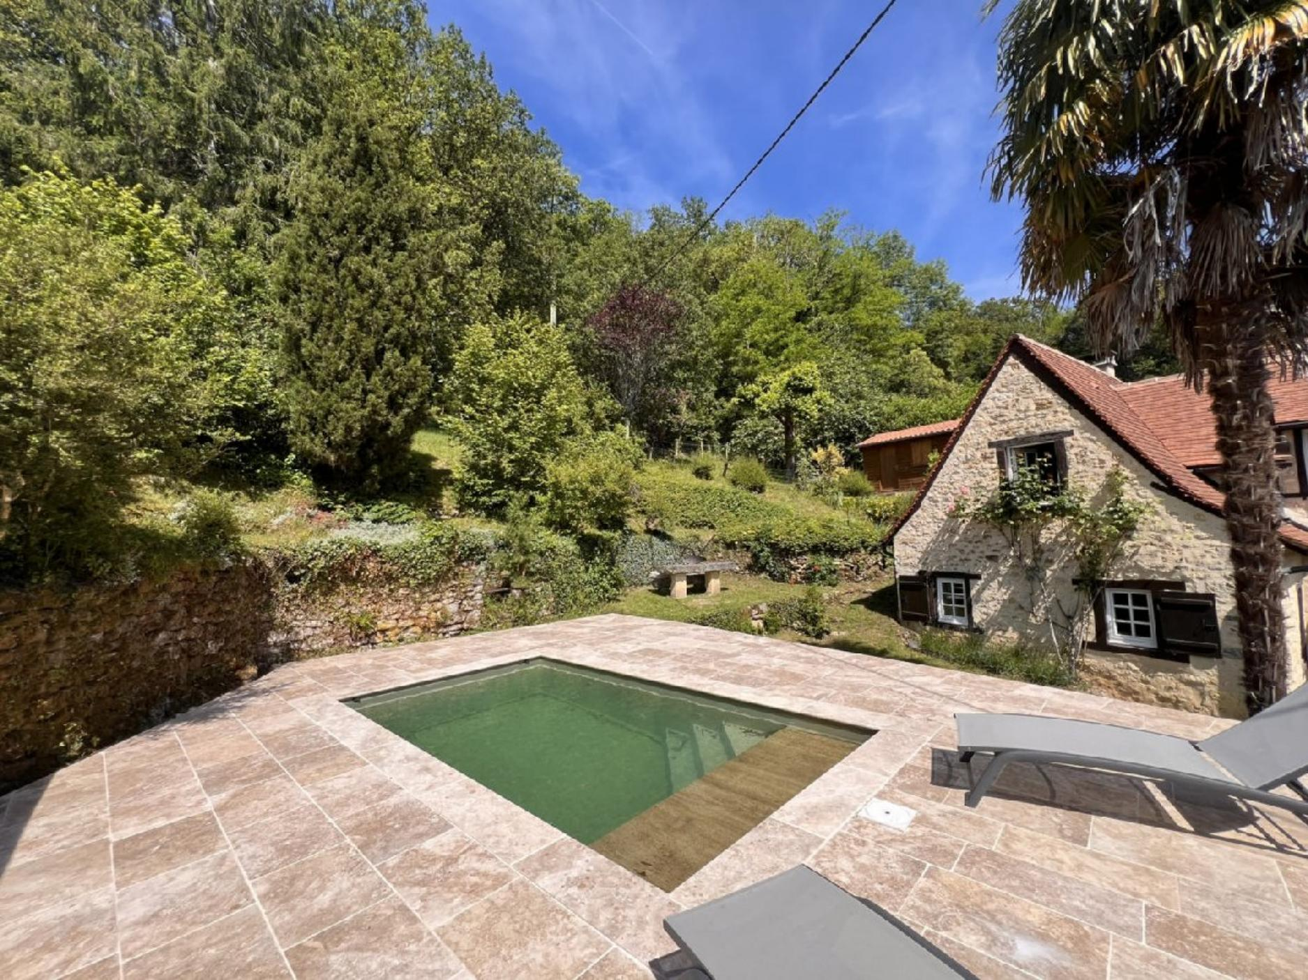
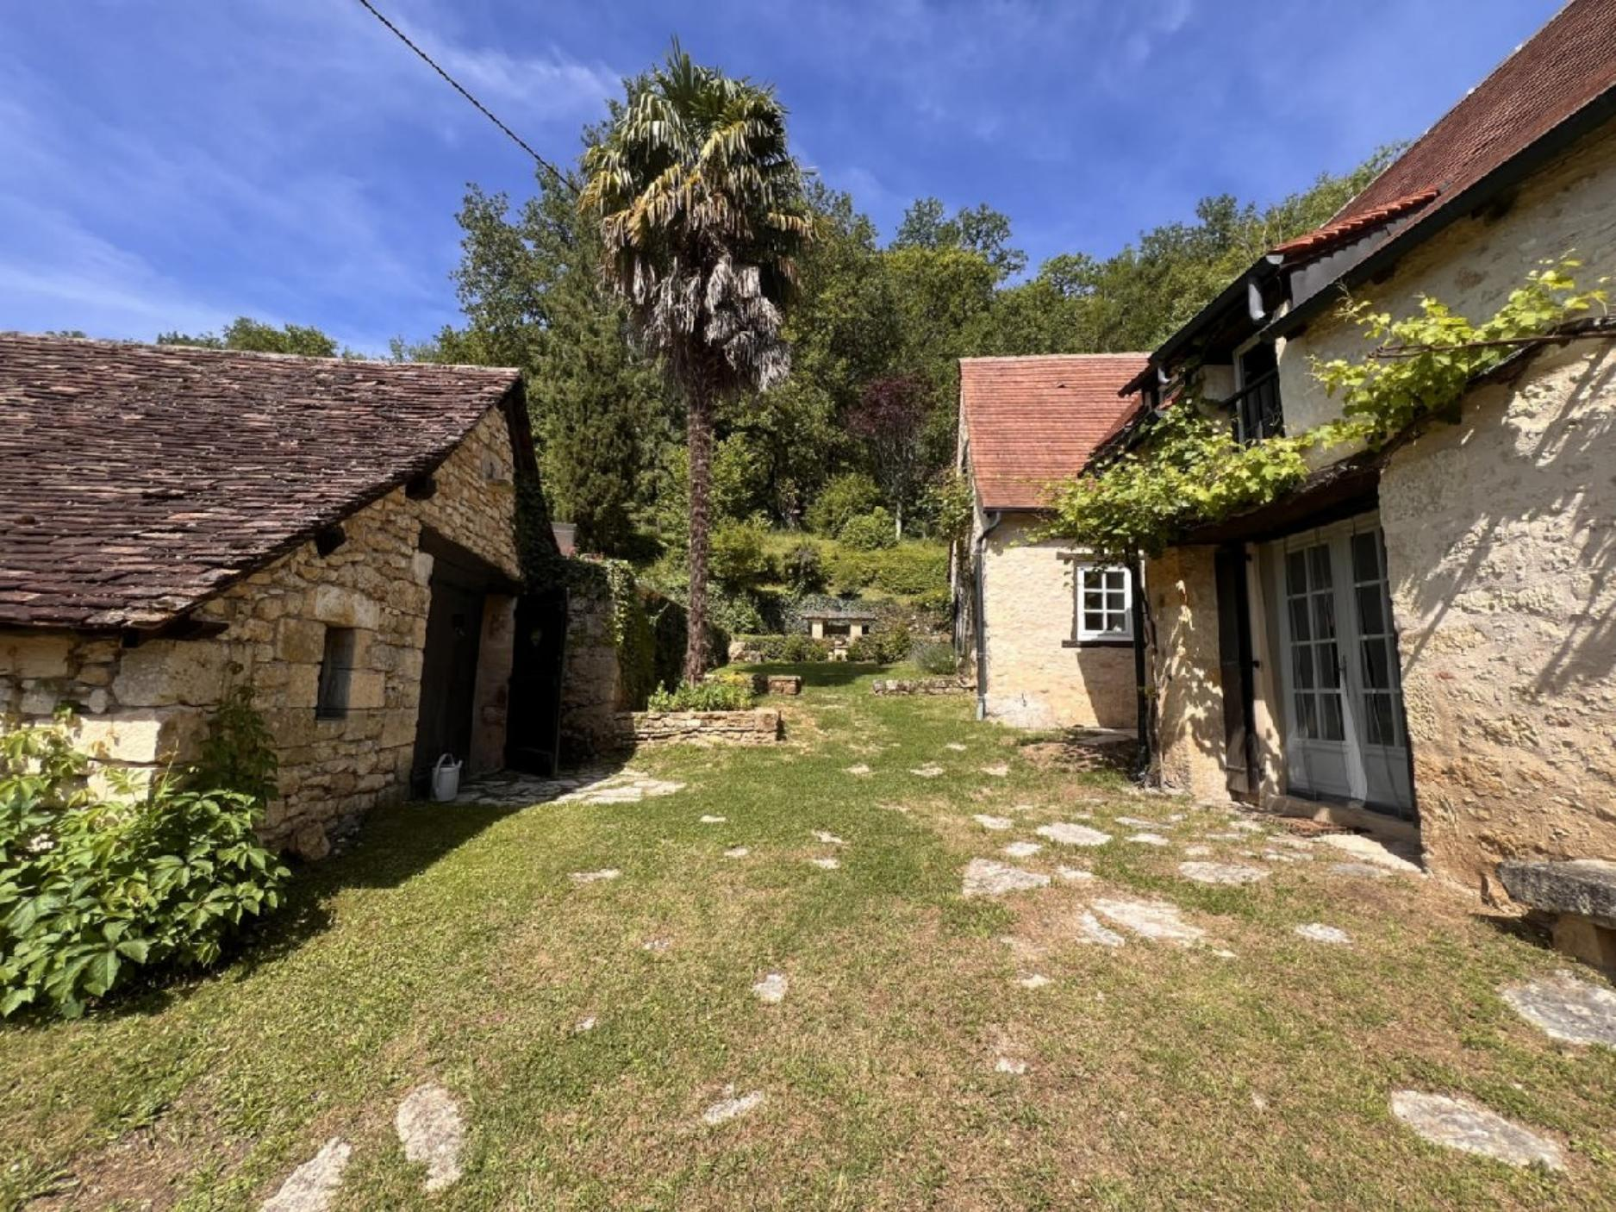 | 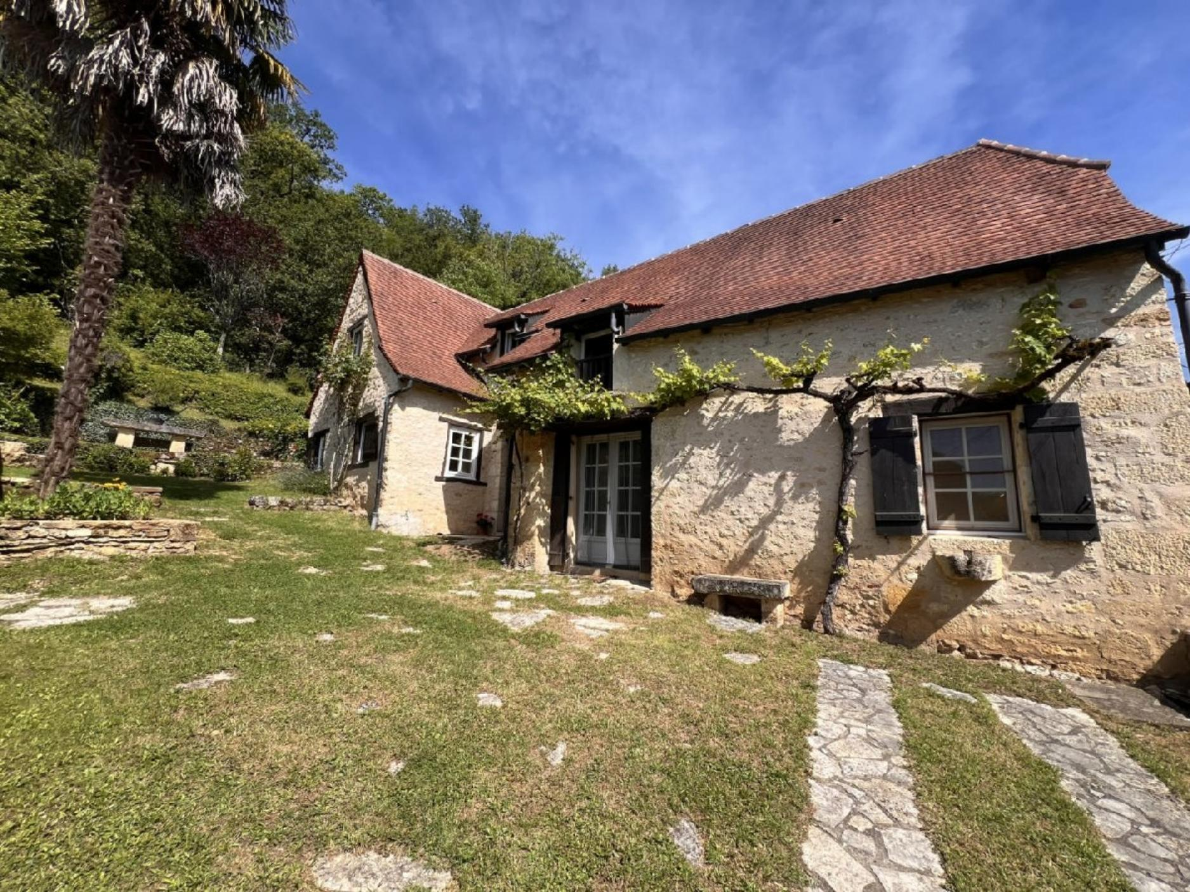
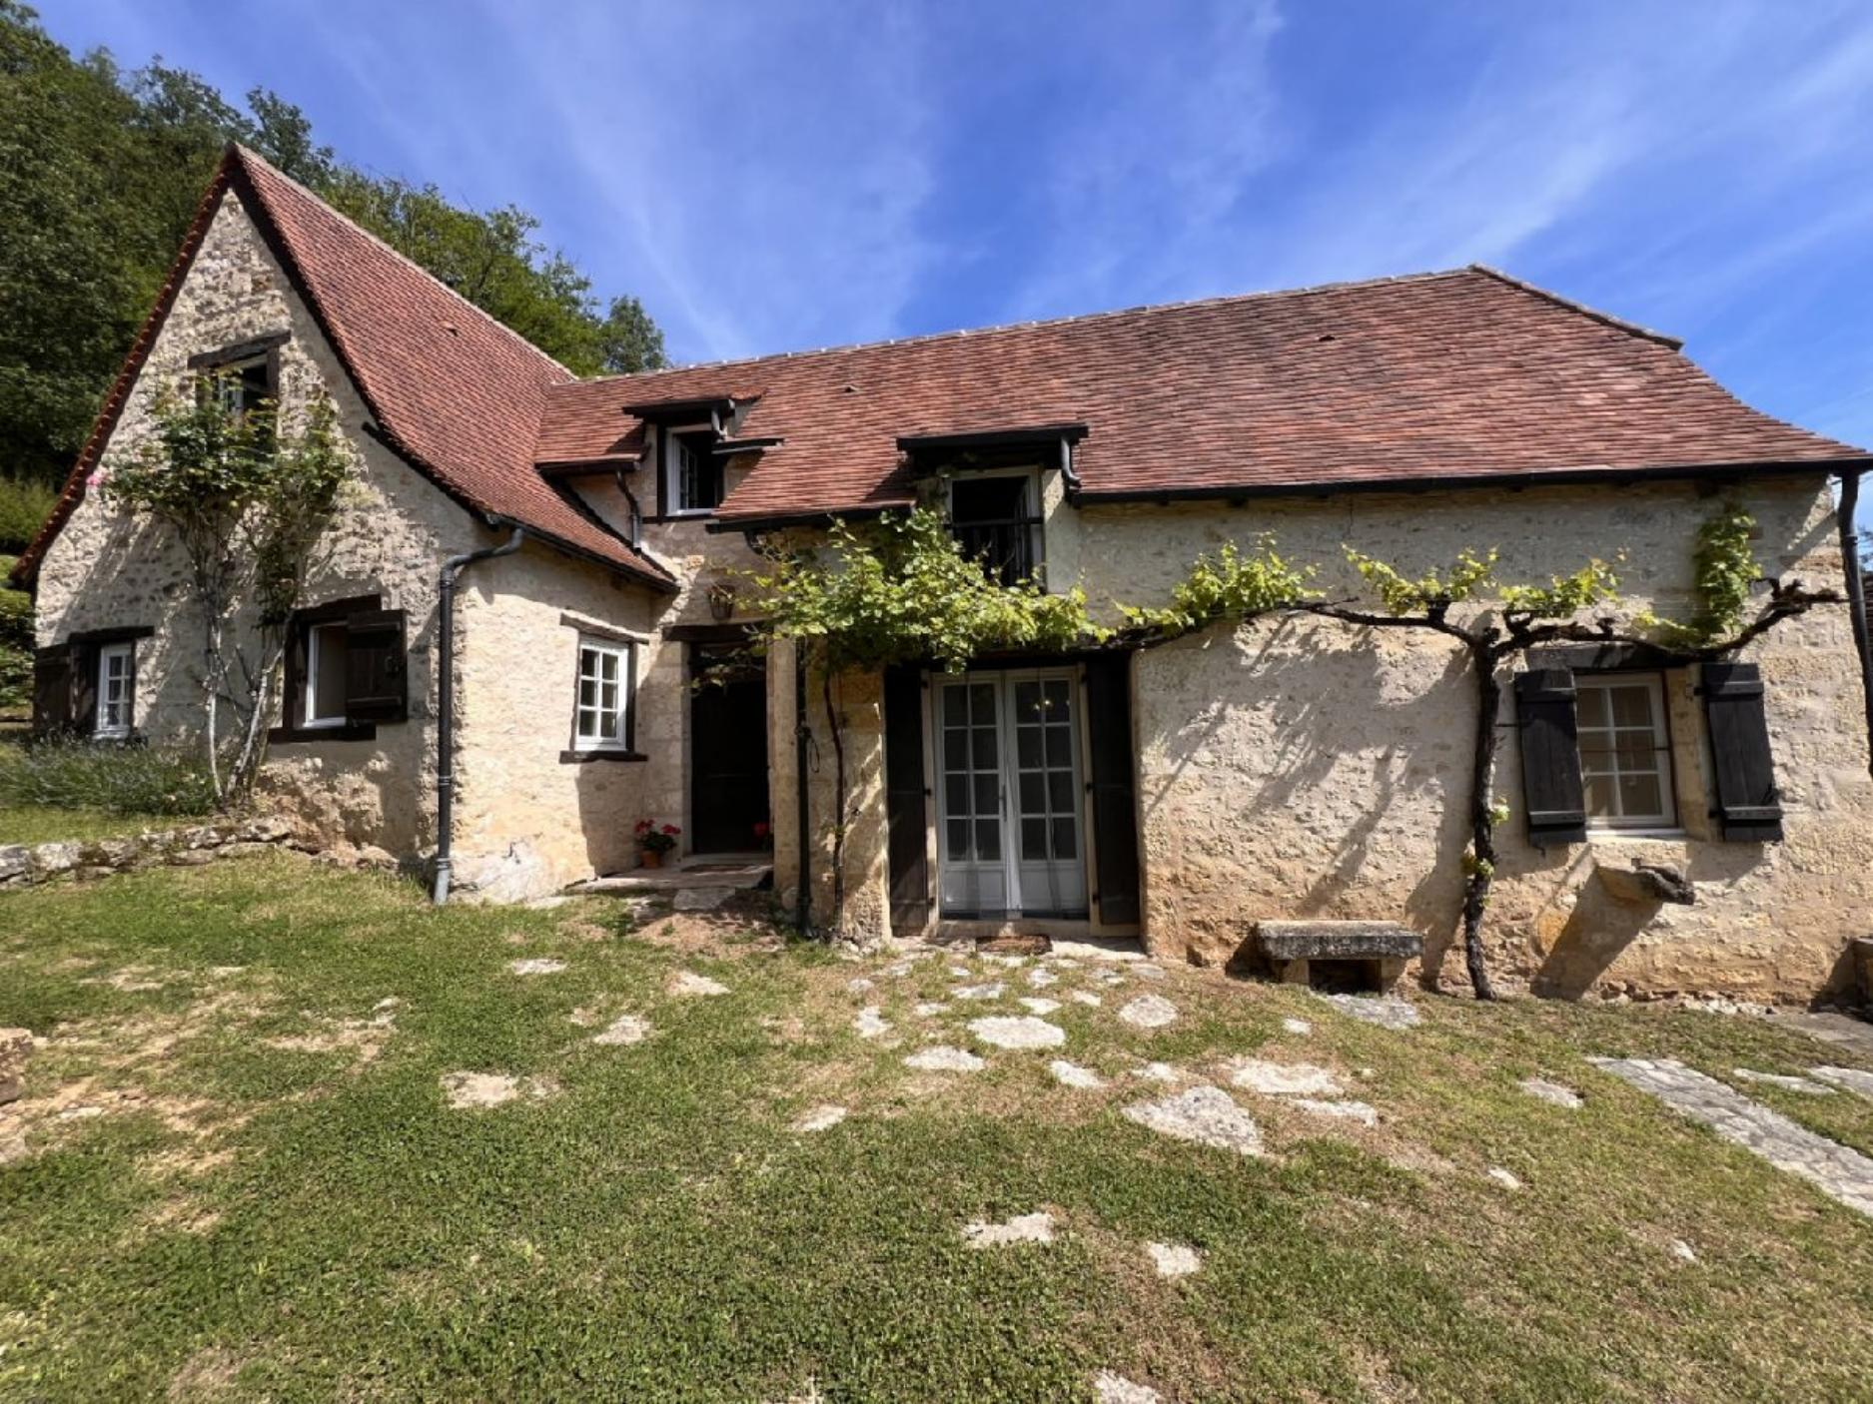 | 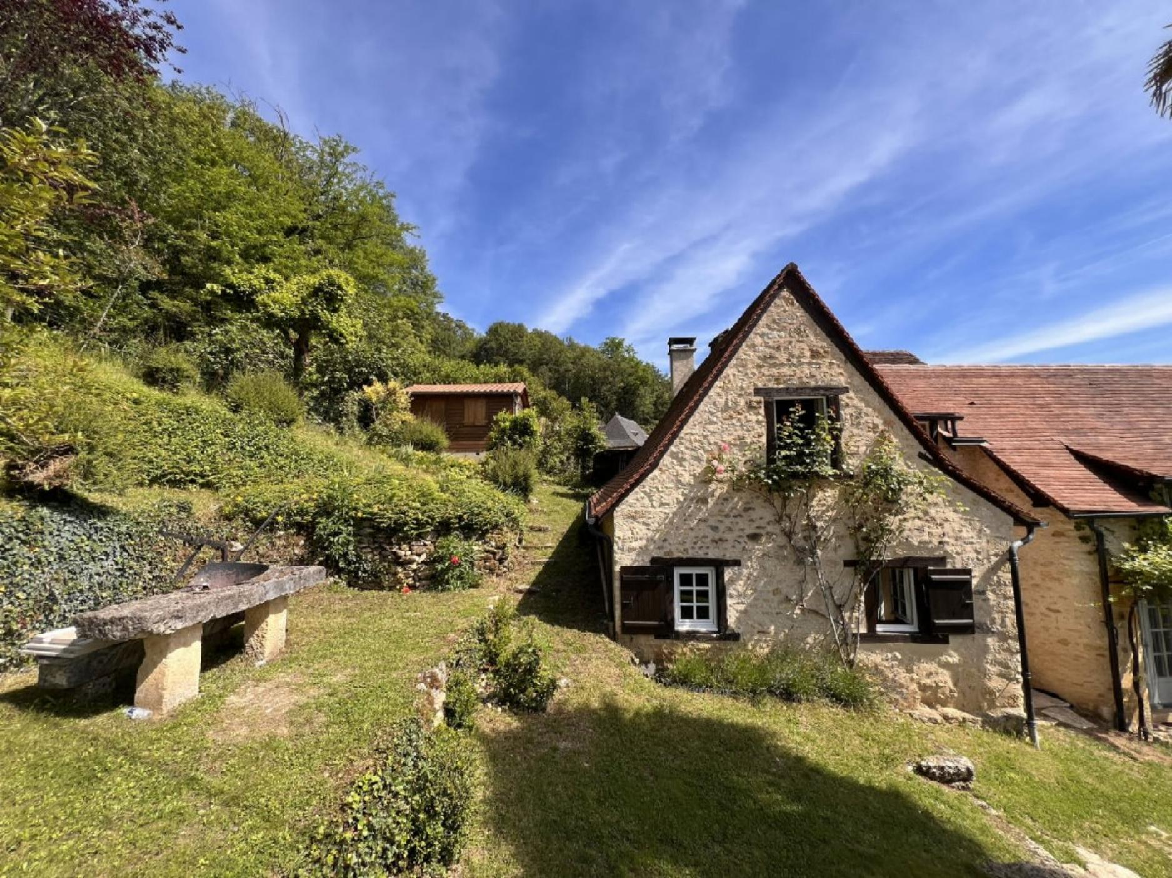
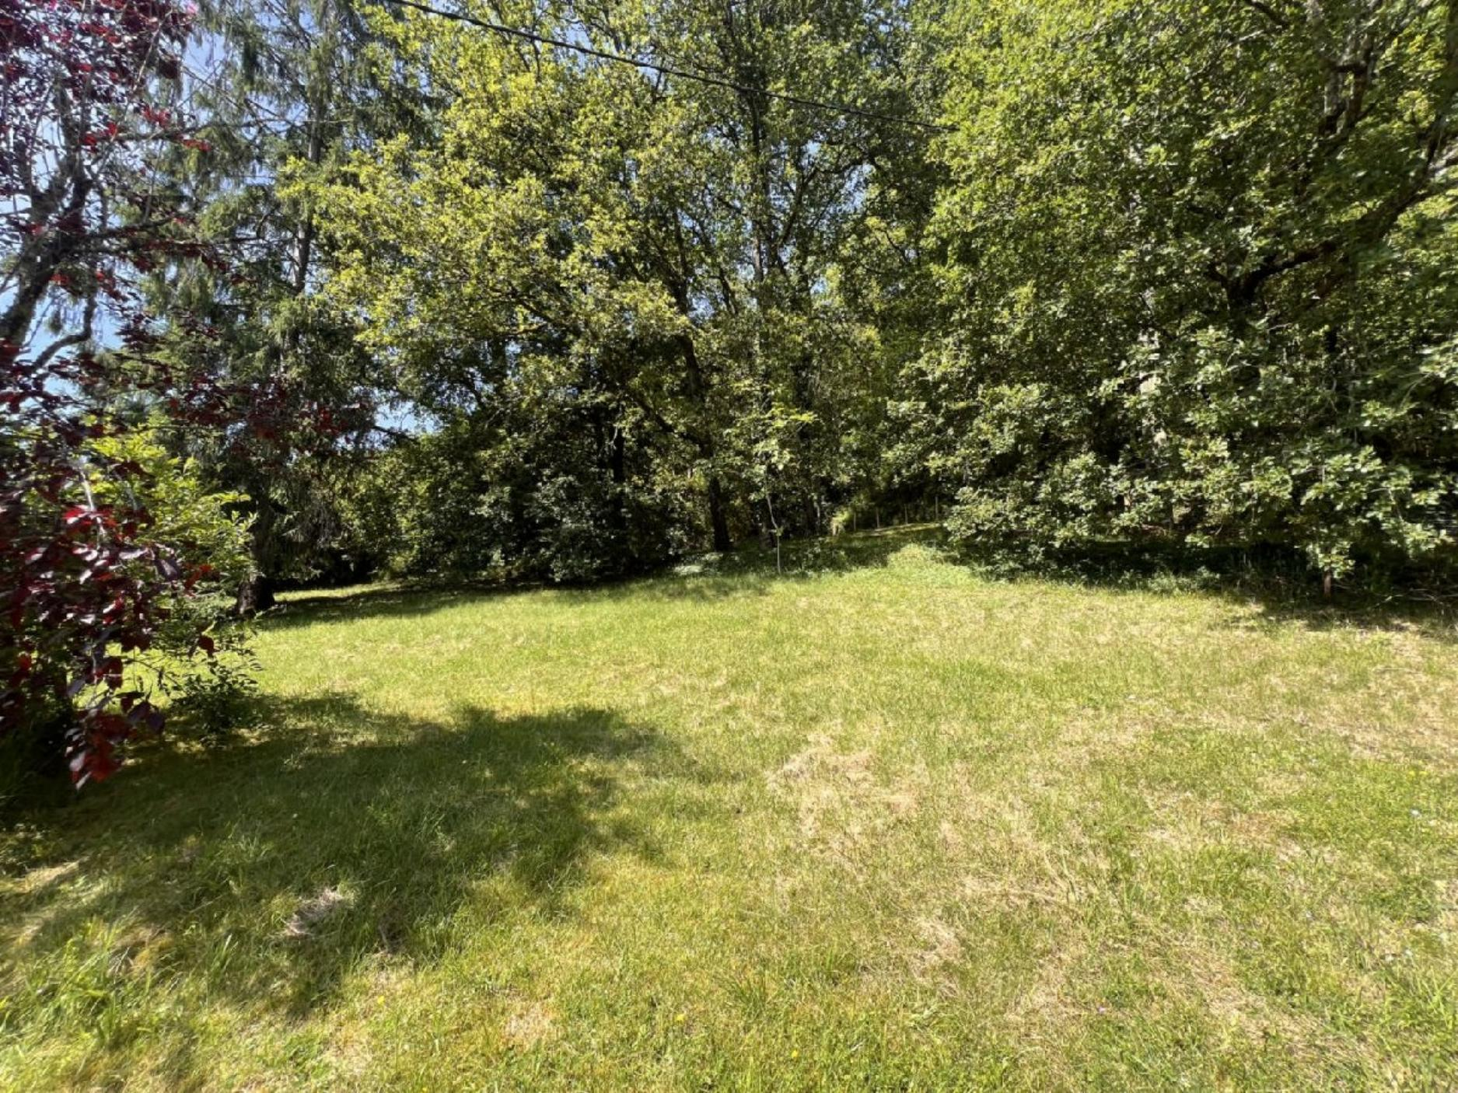 | 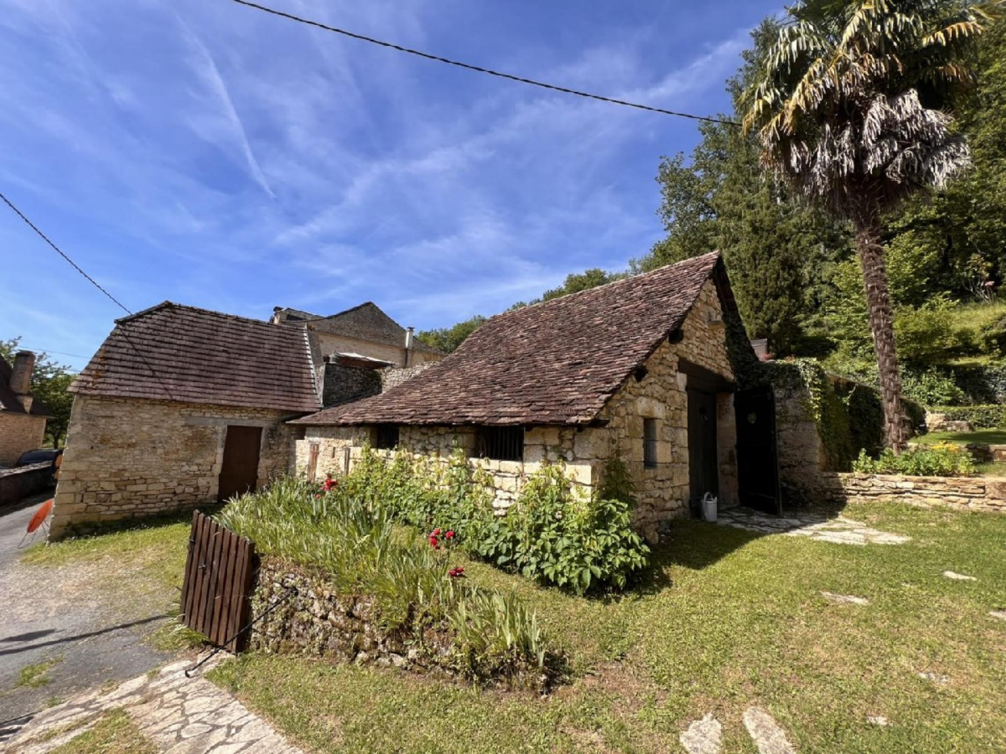
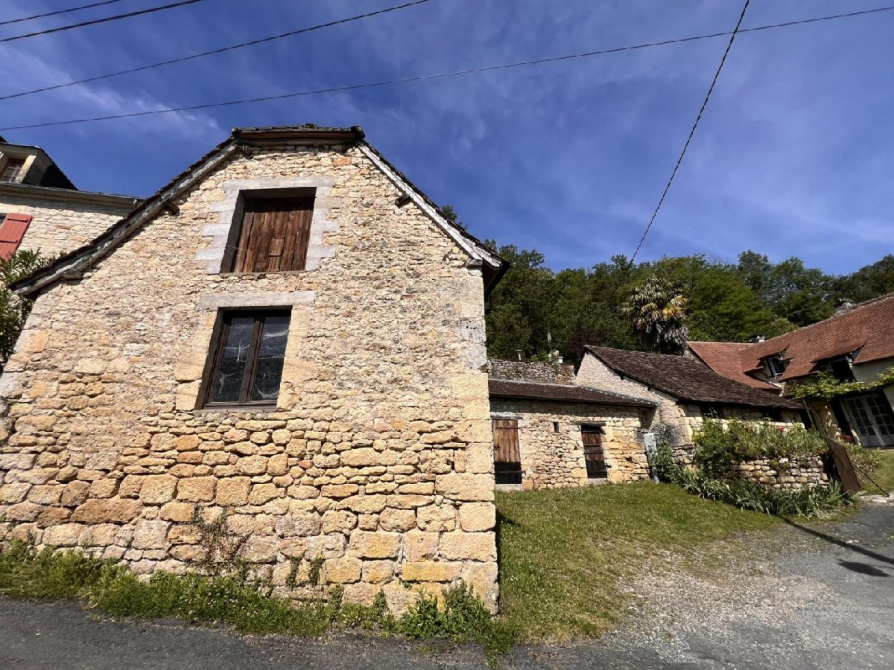 | 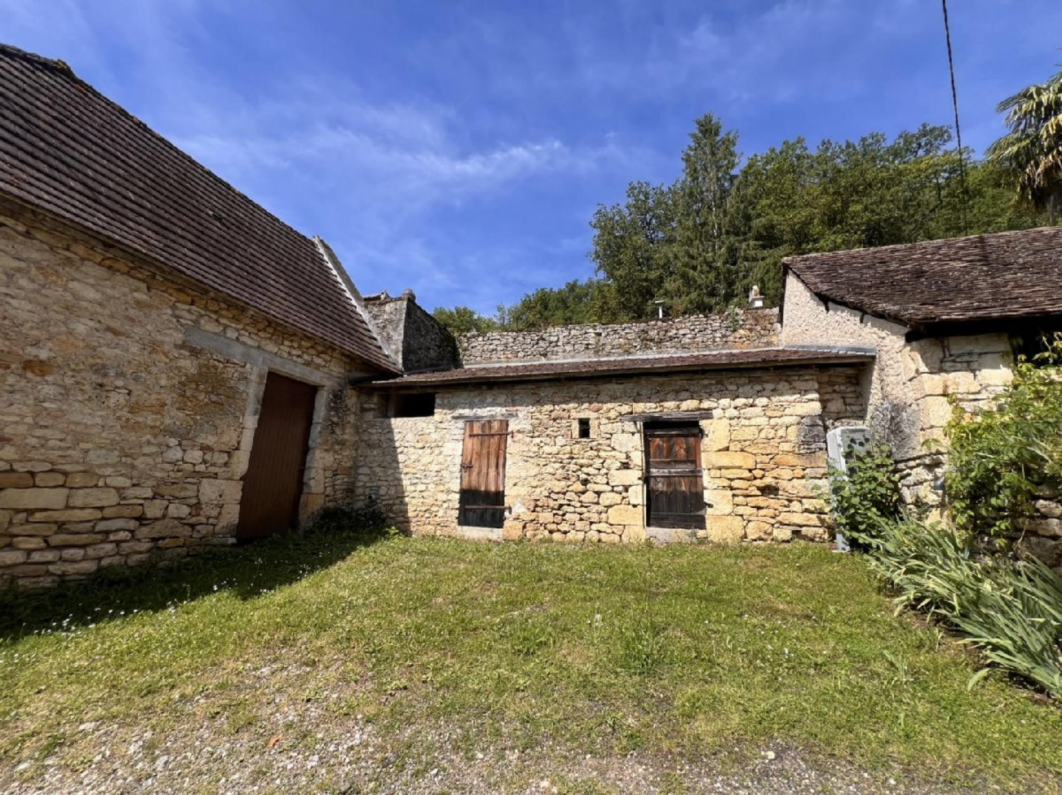
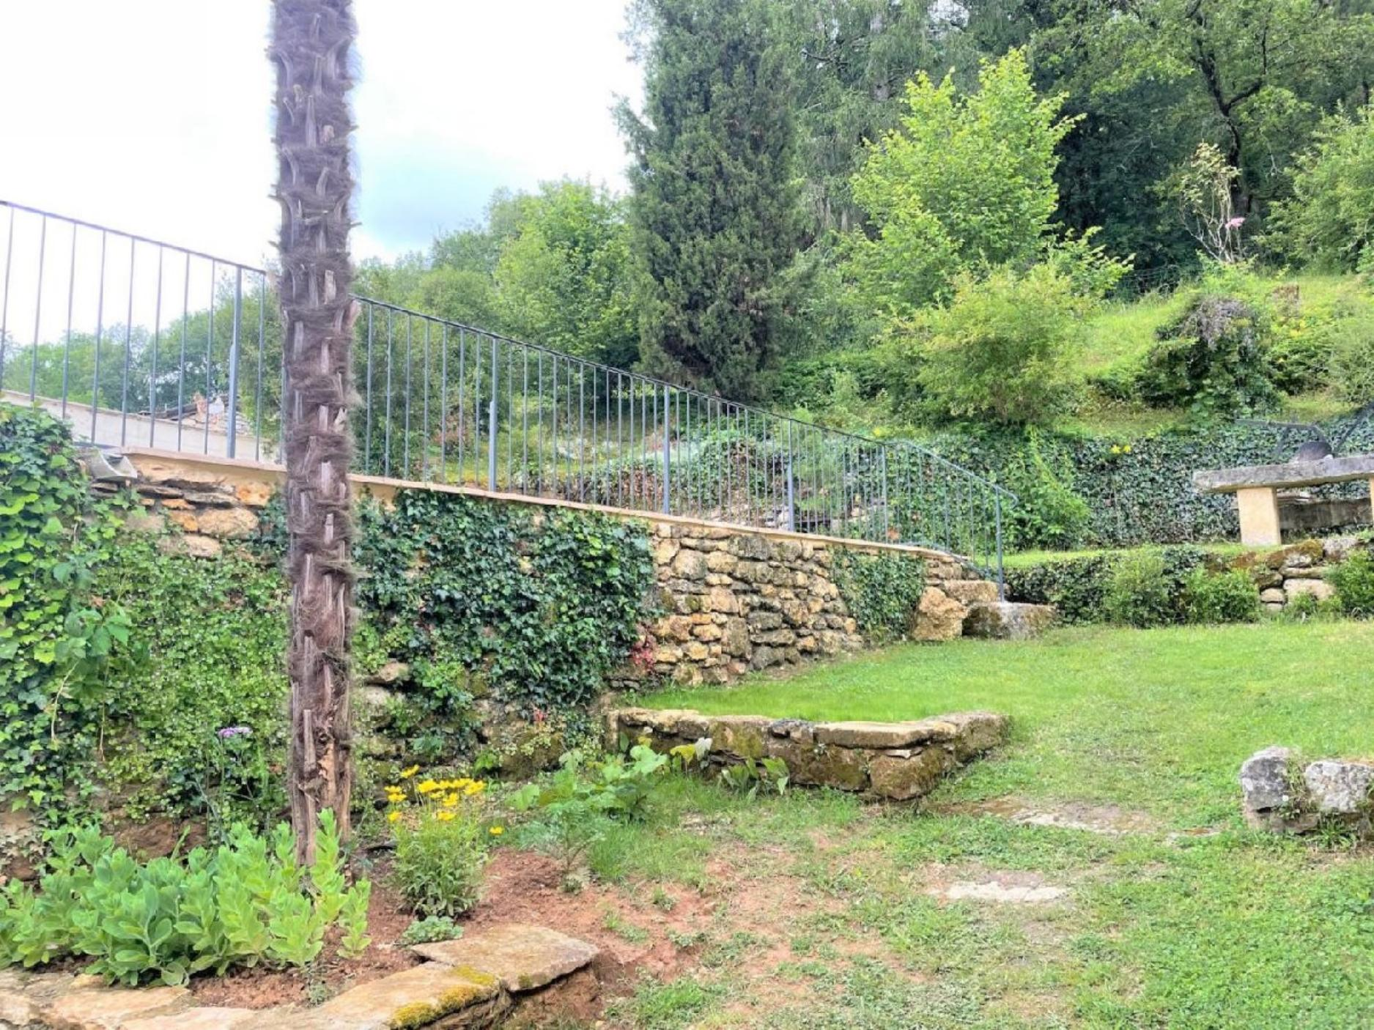 | 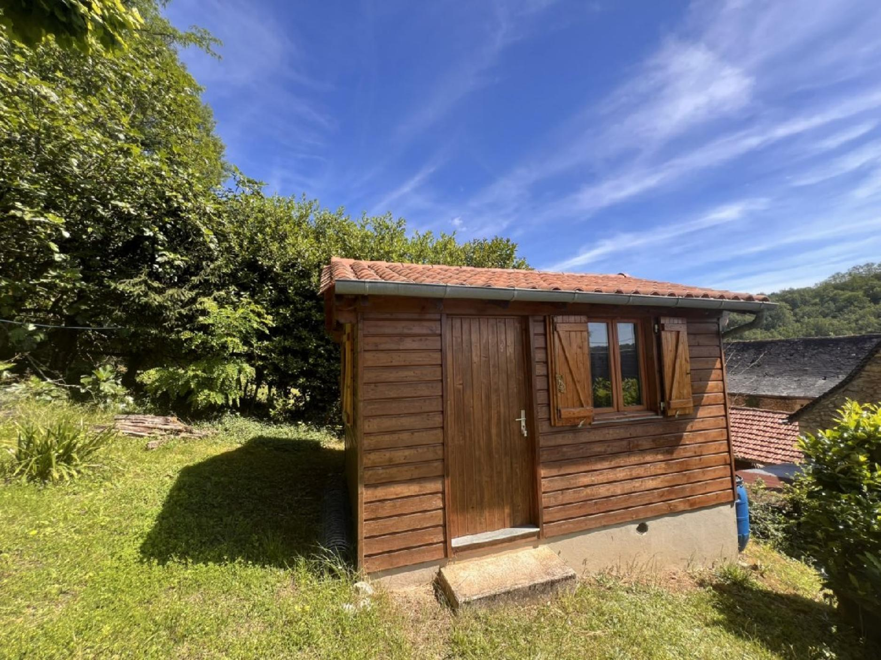
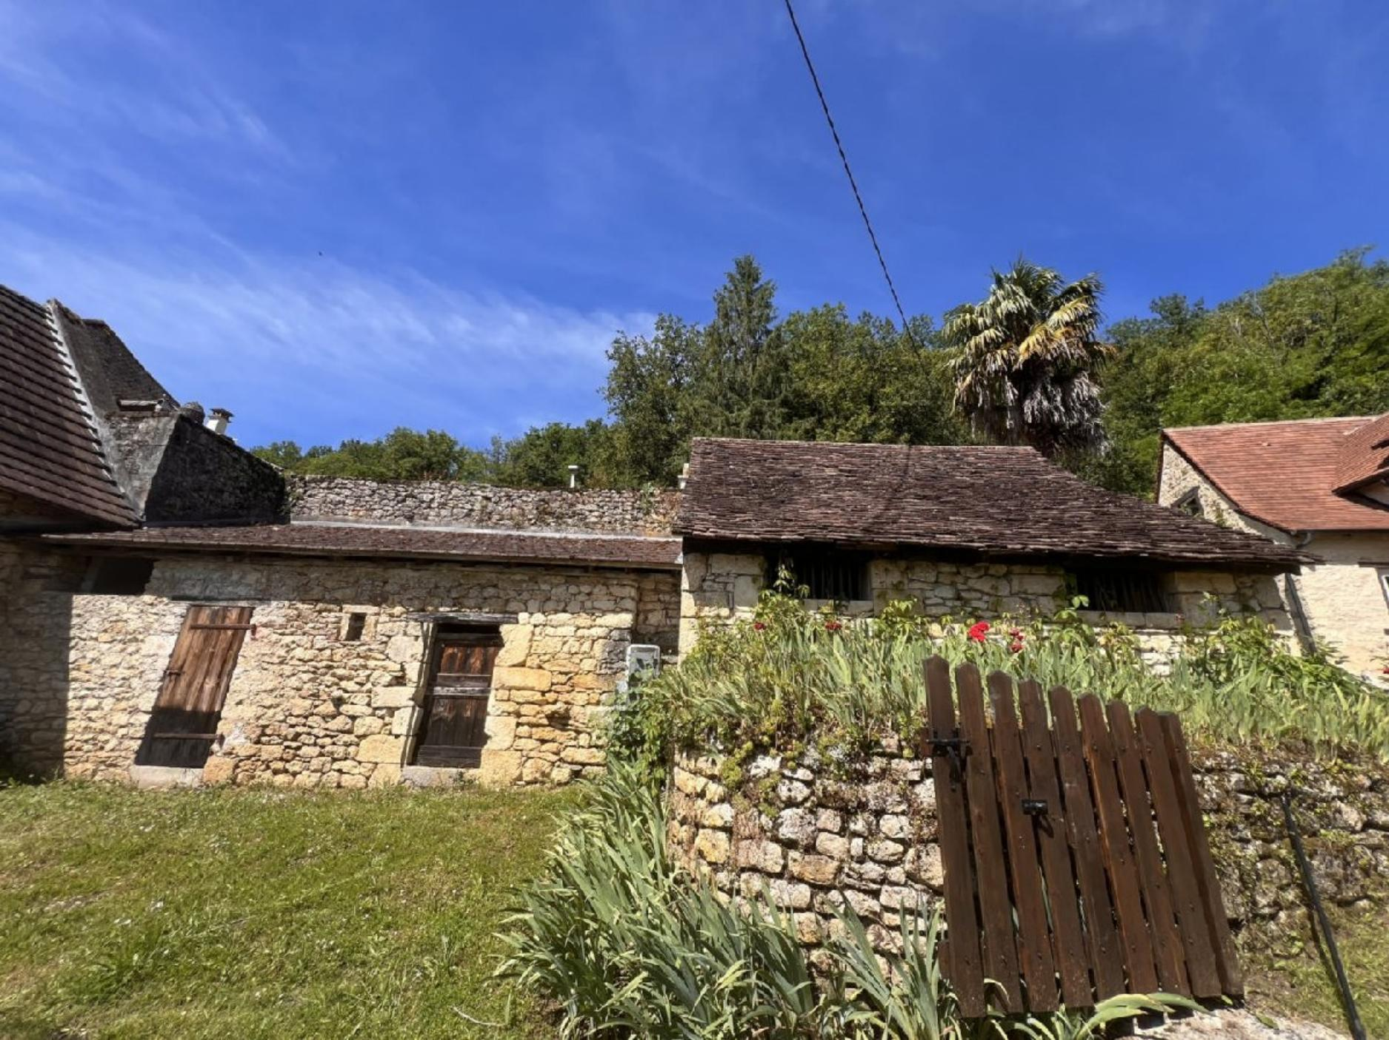 | 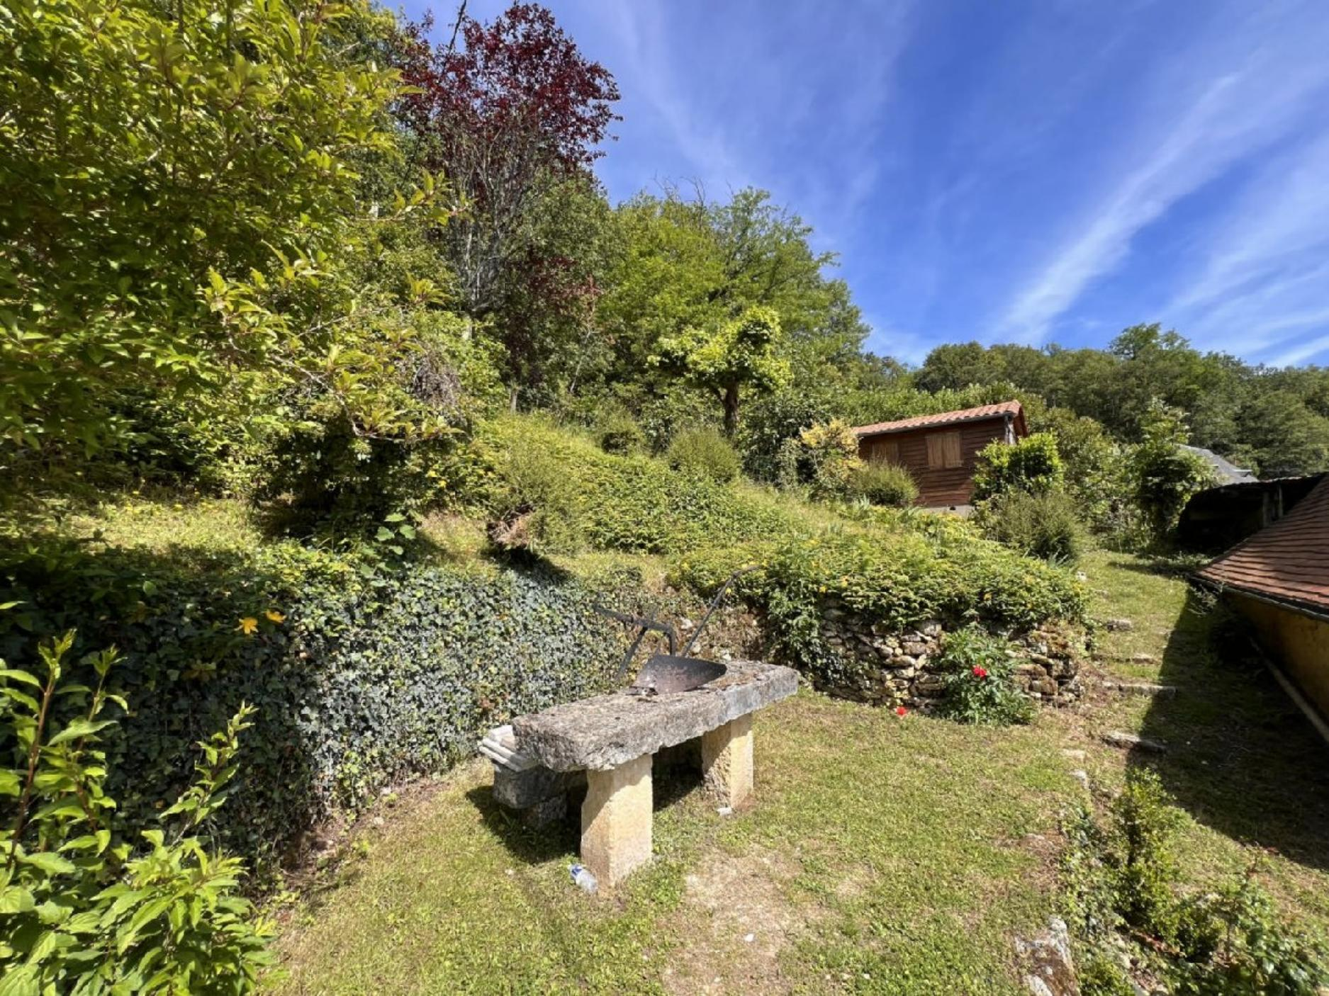
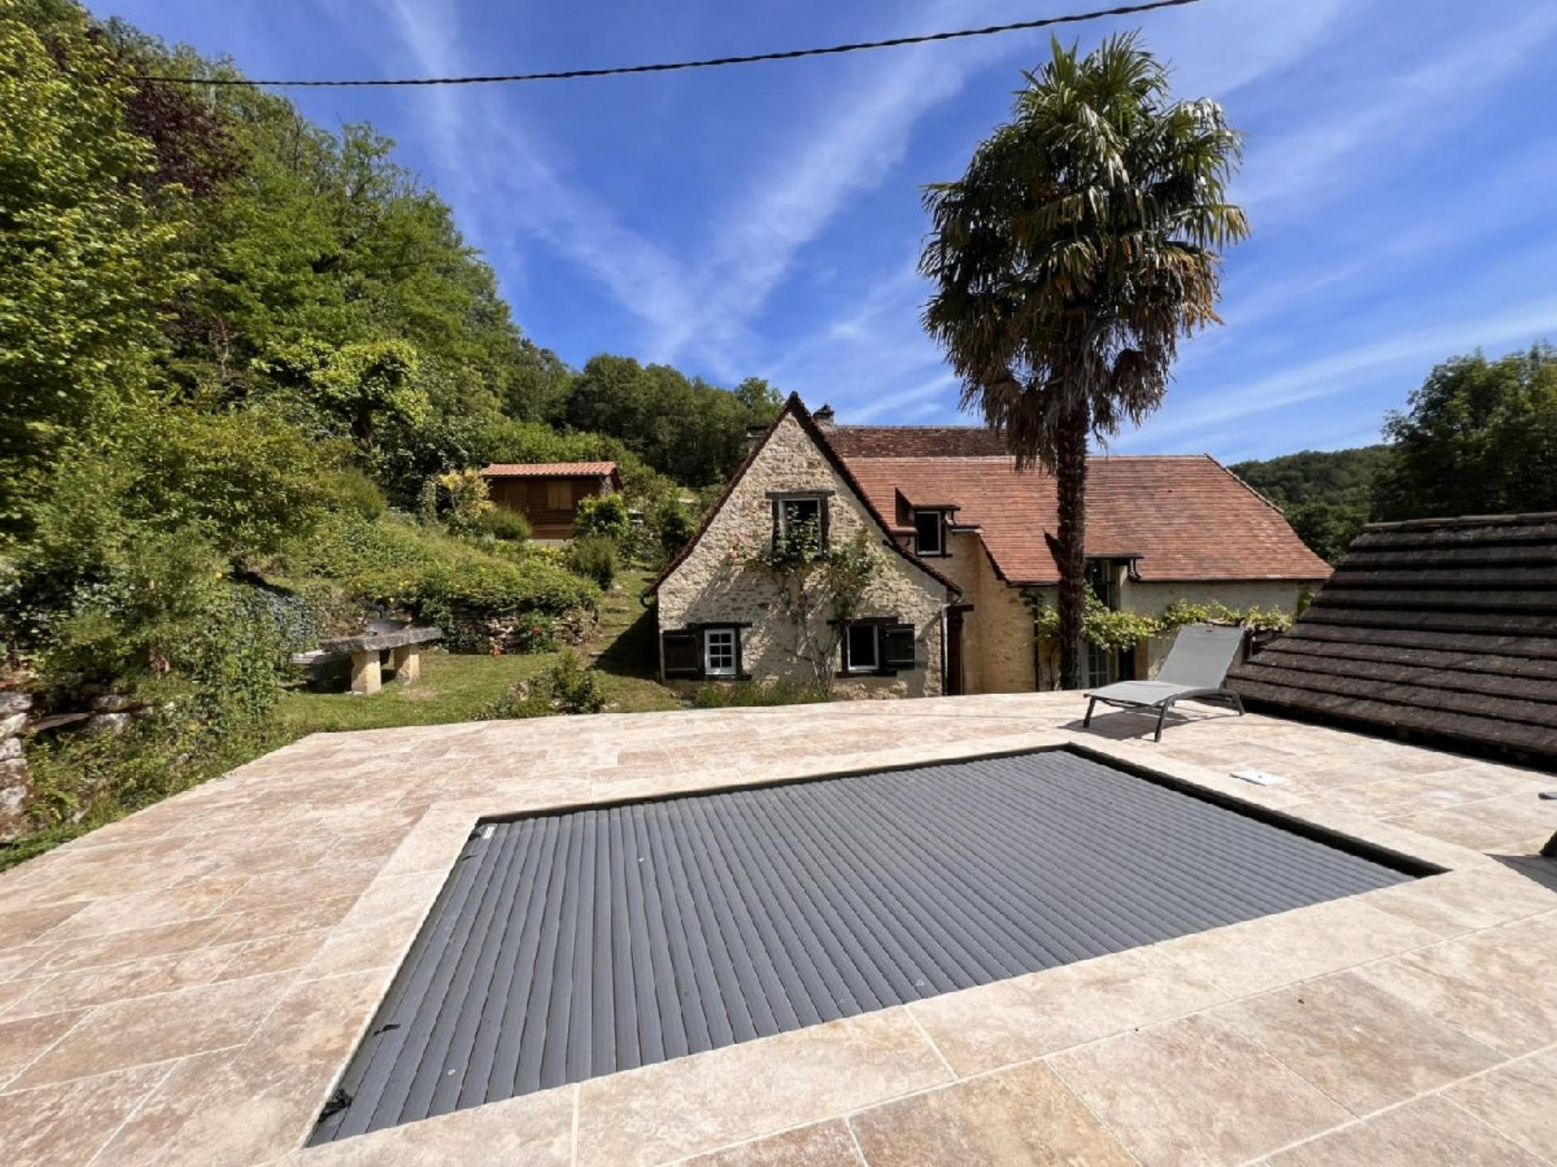 | 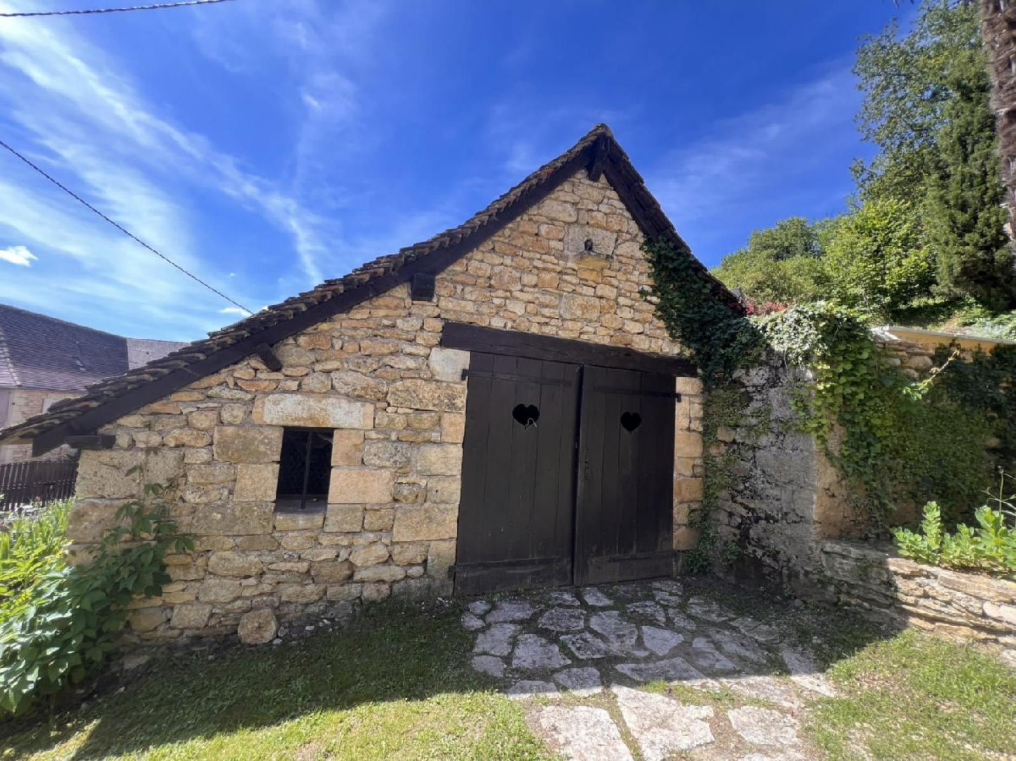
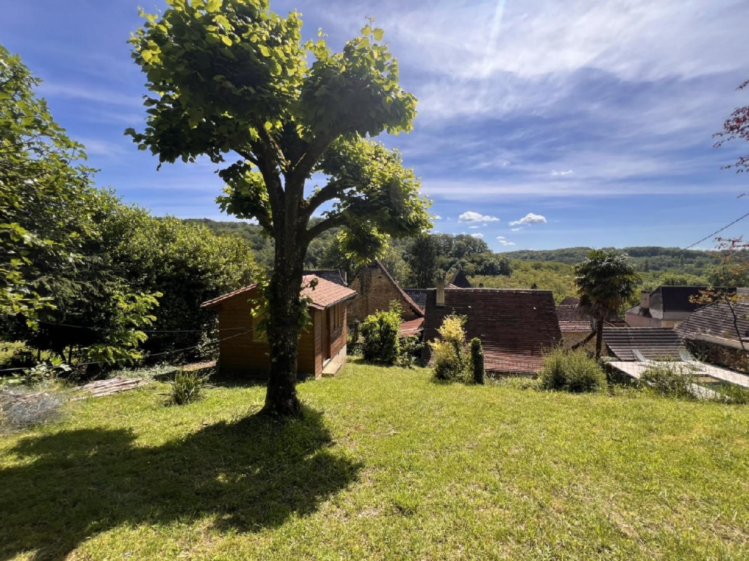 | 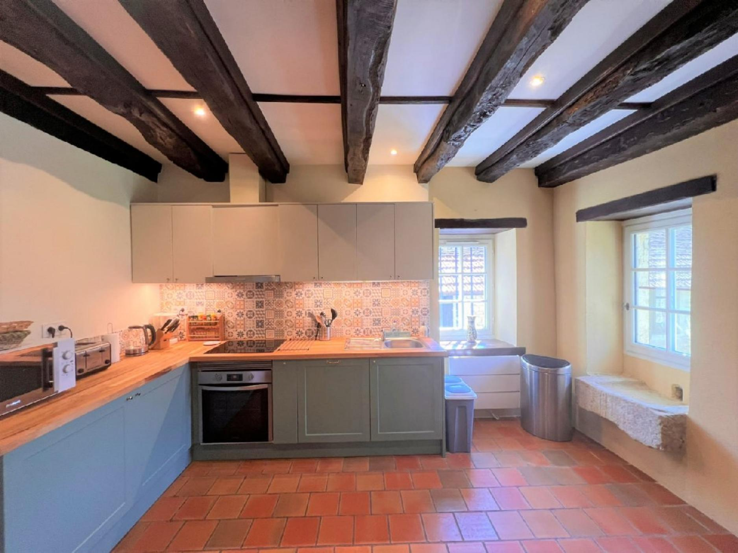
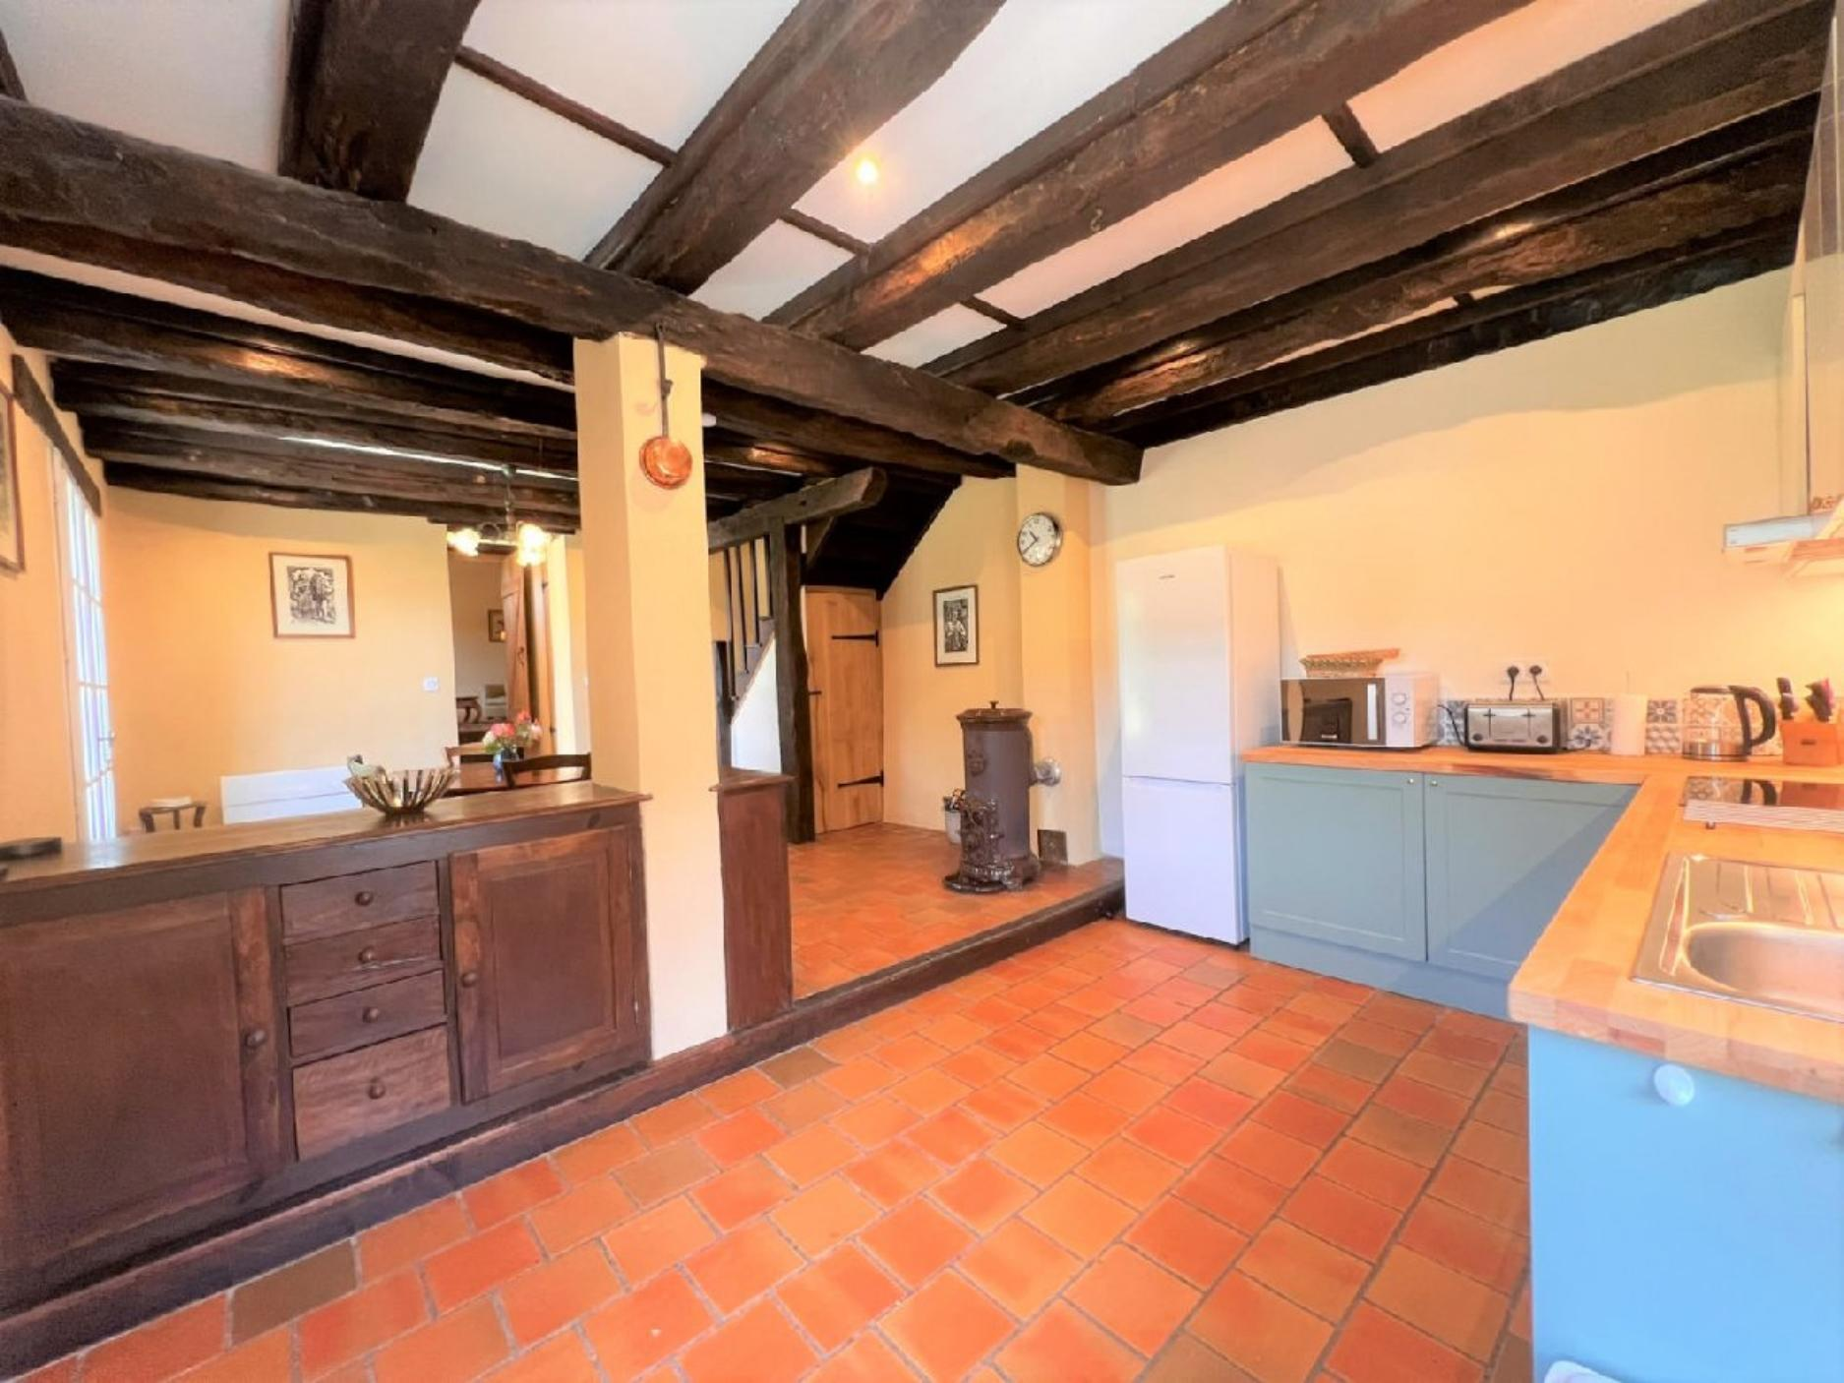 | 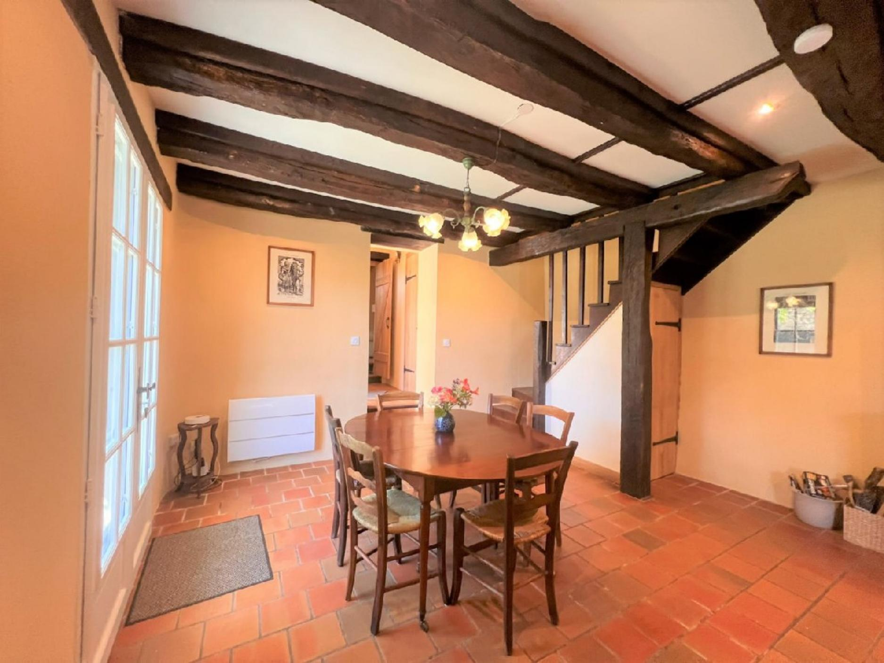
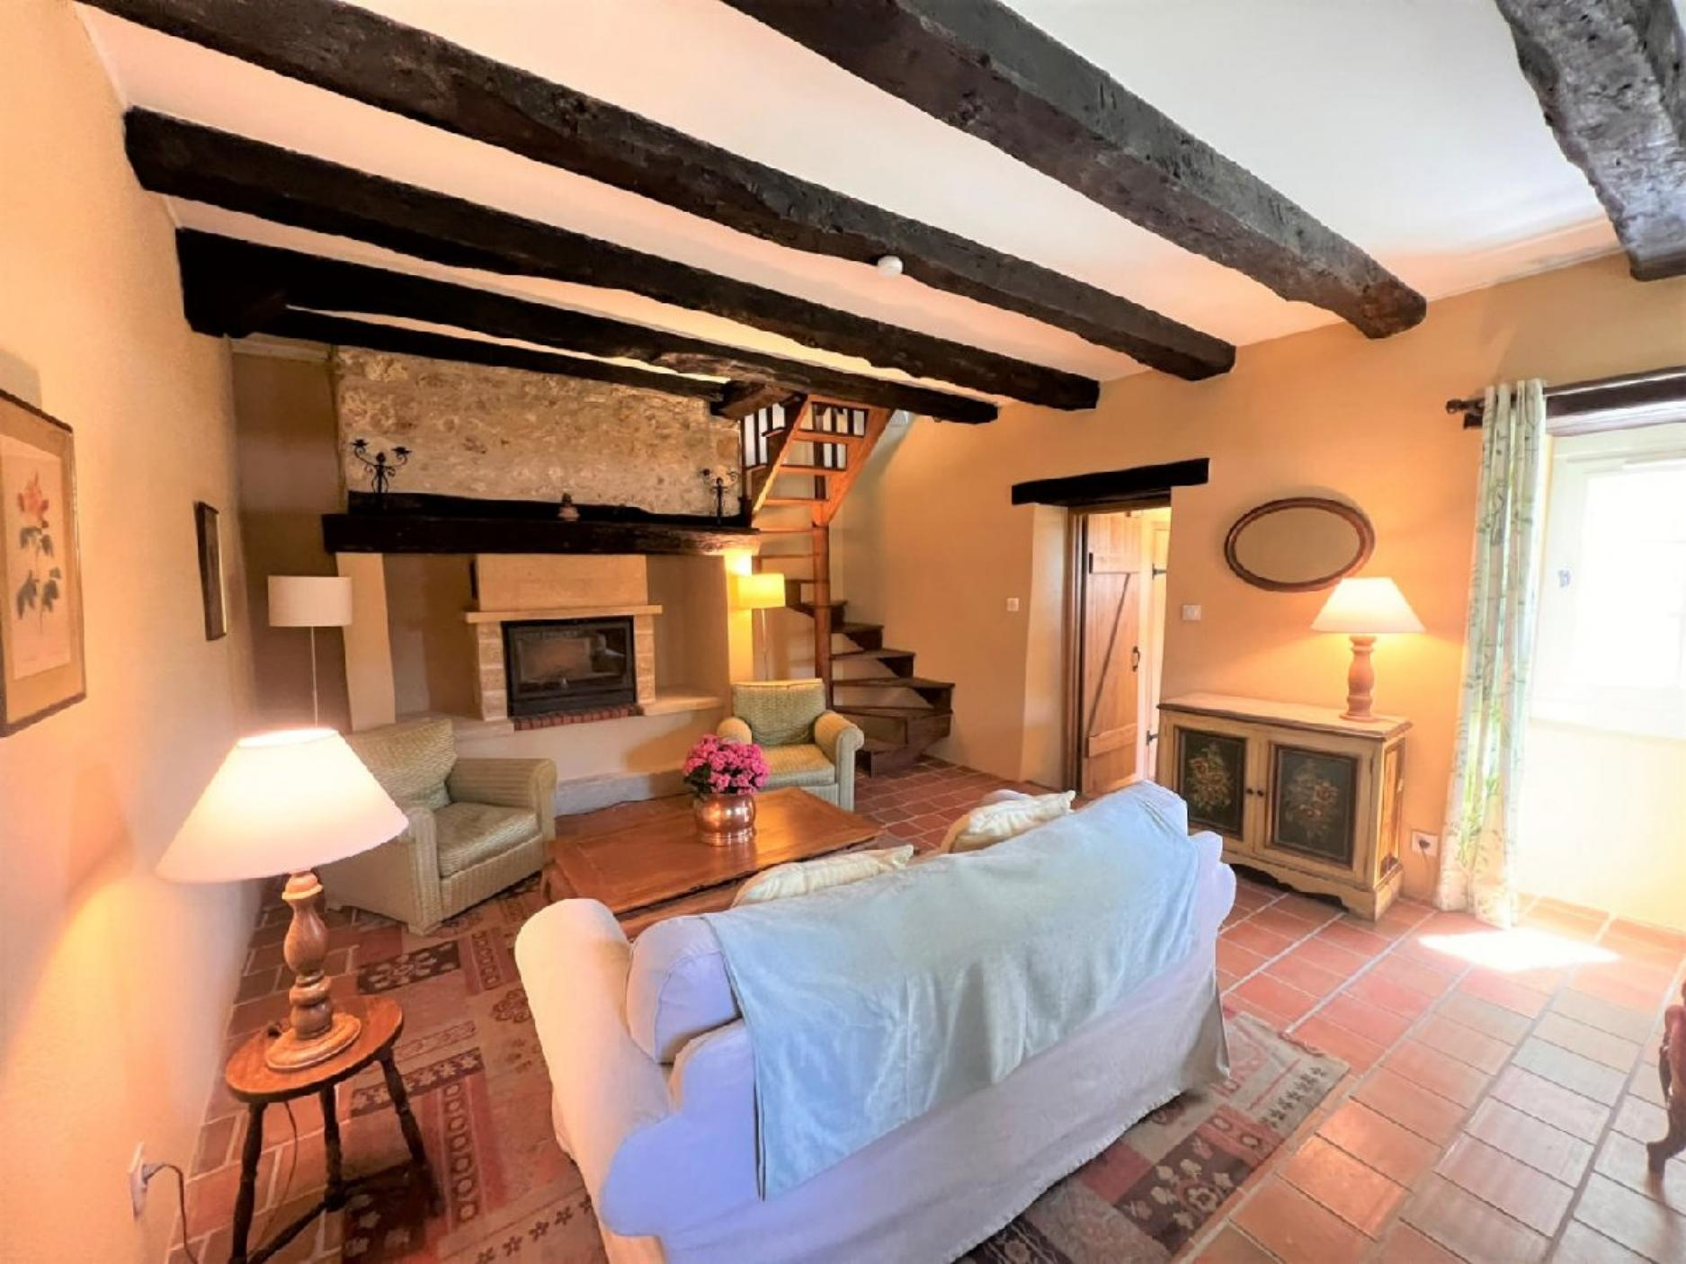 | 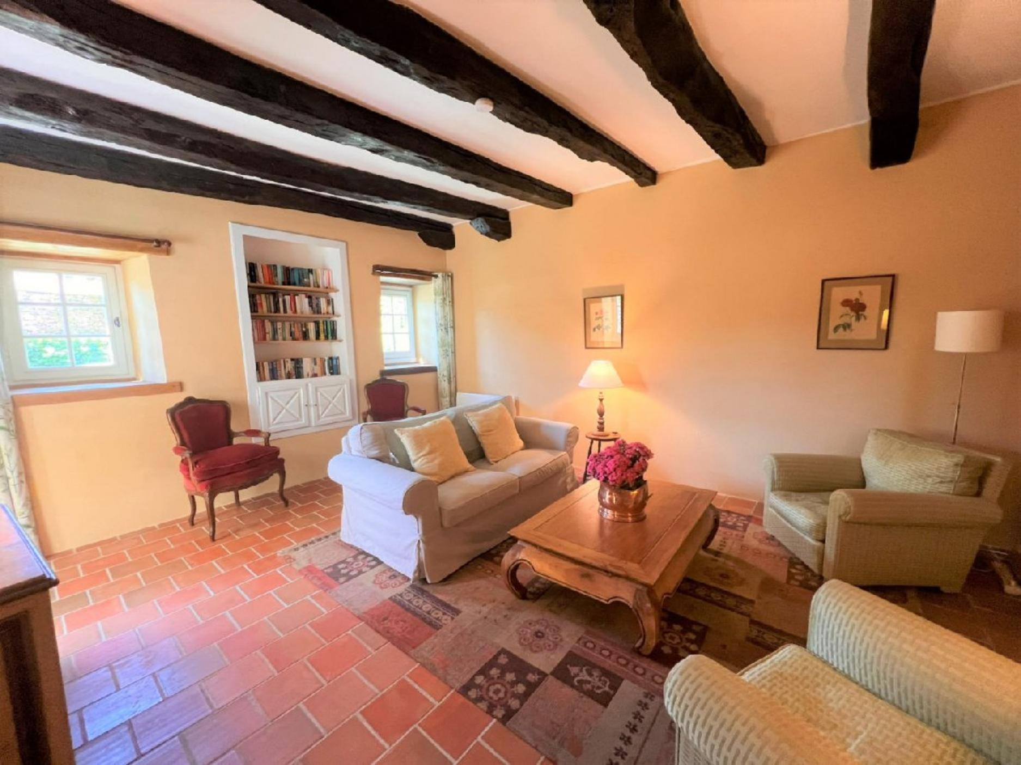
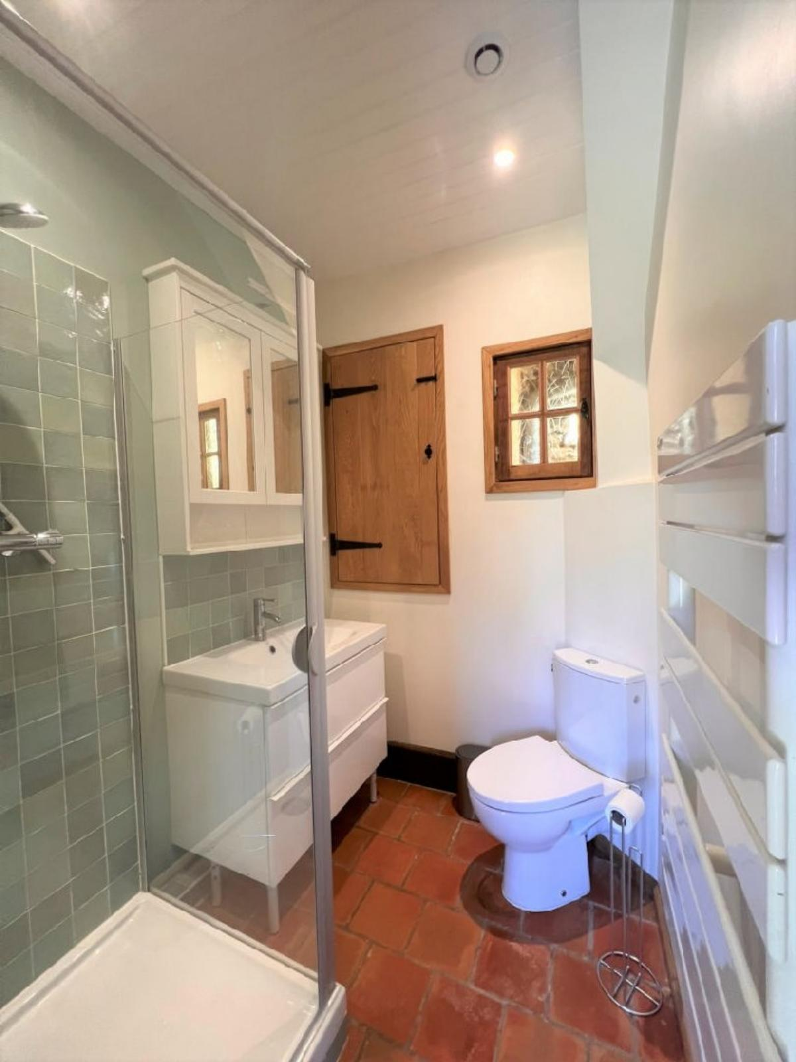 | 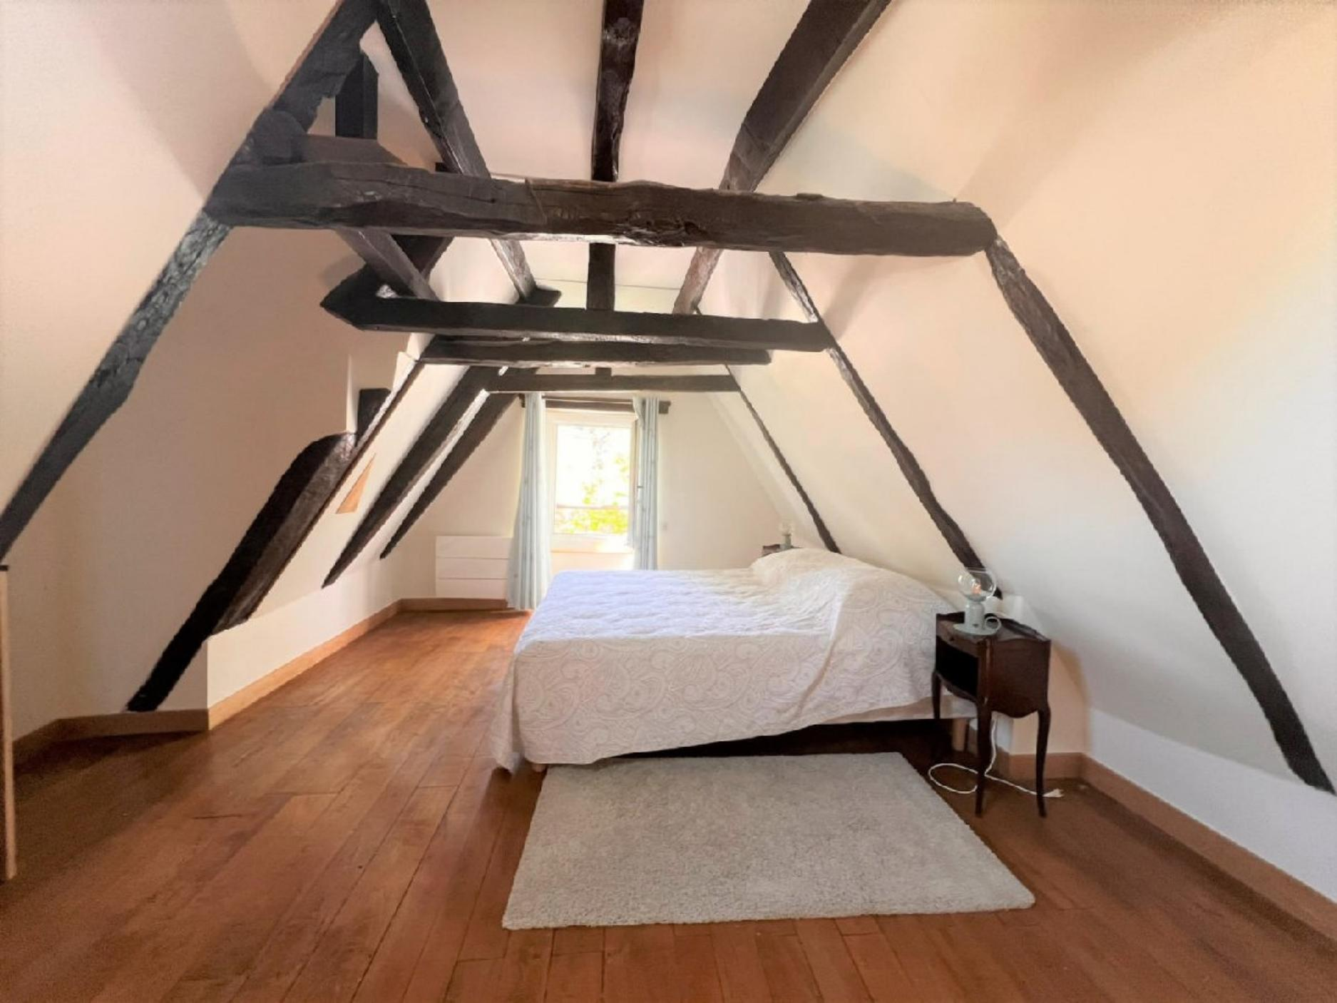
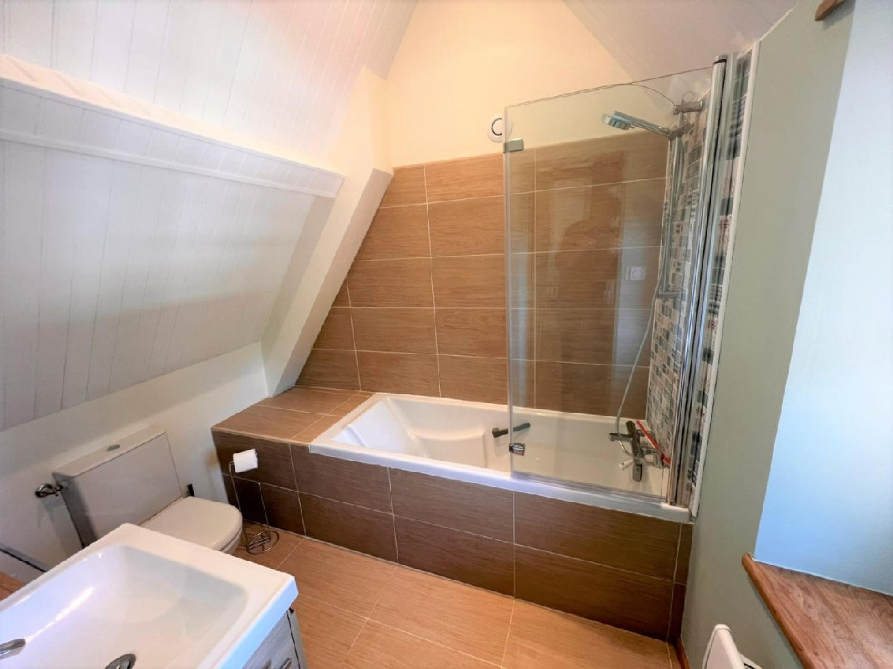 | 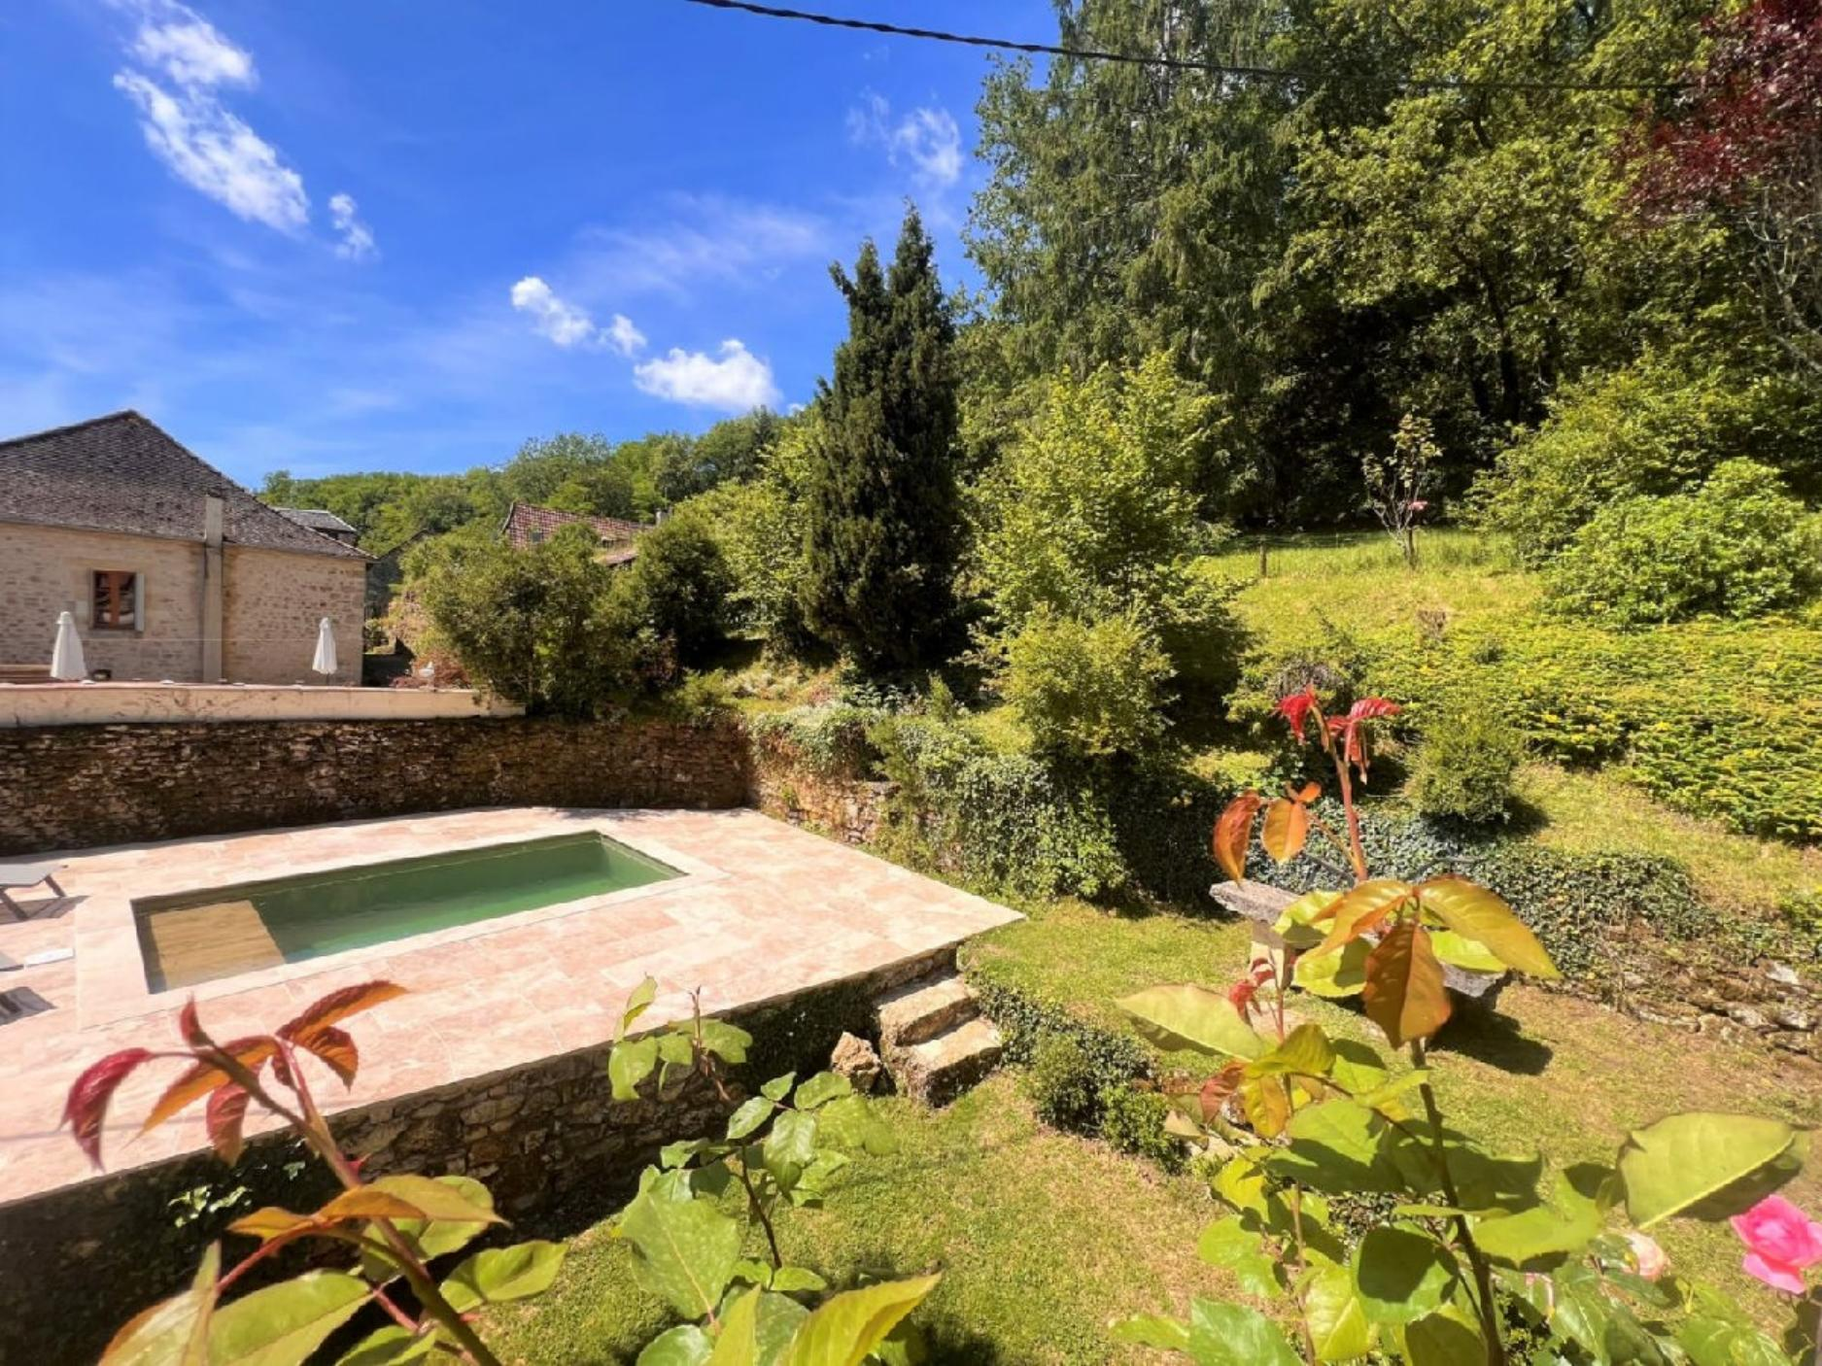
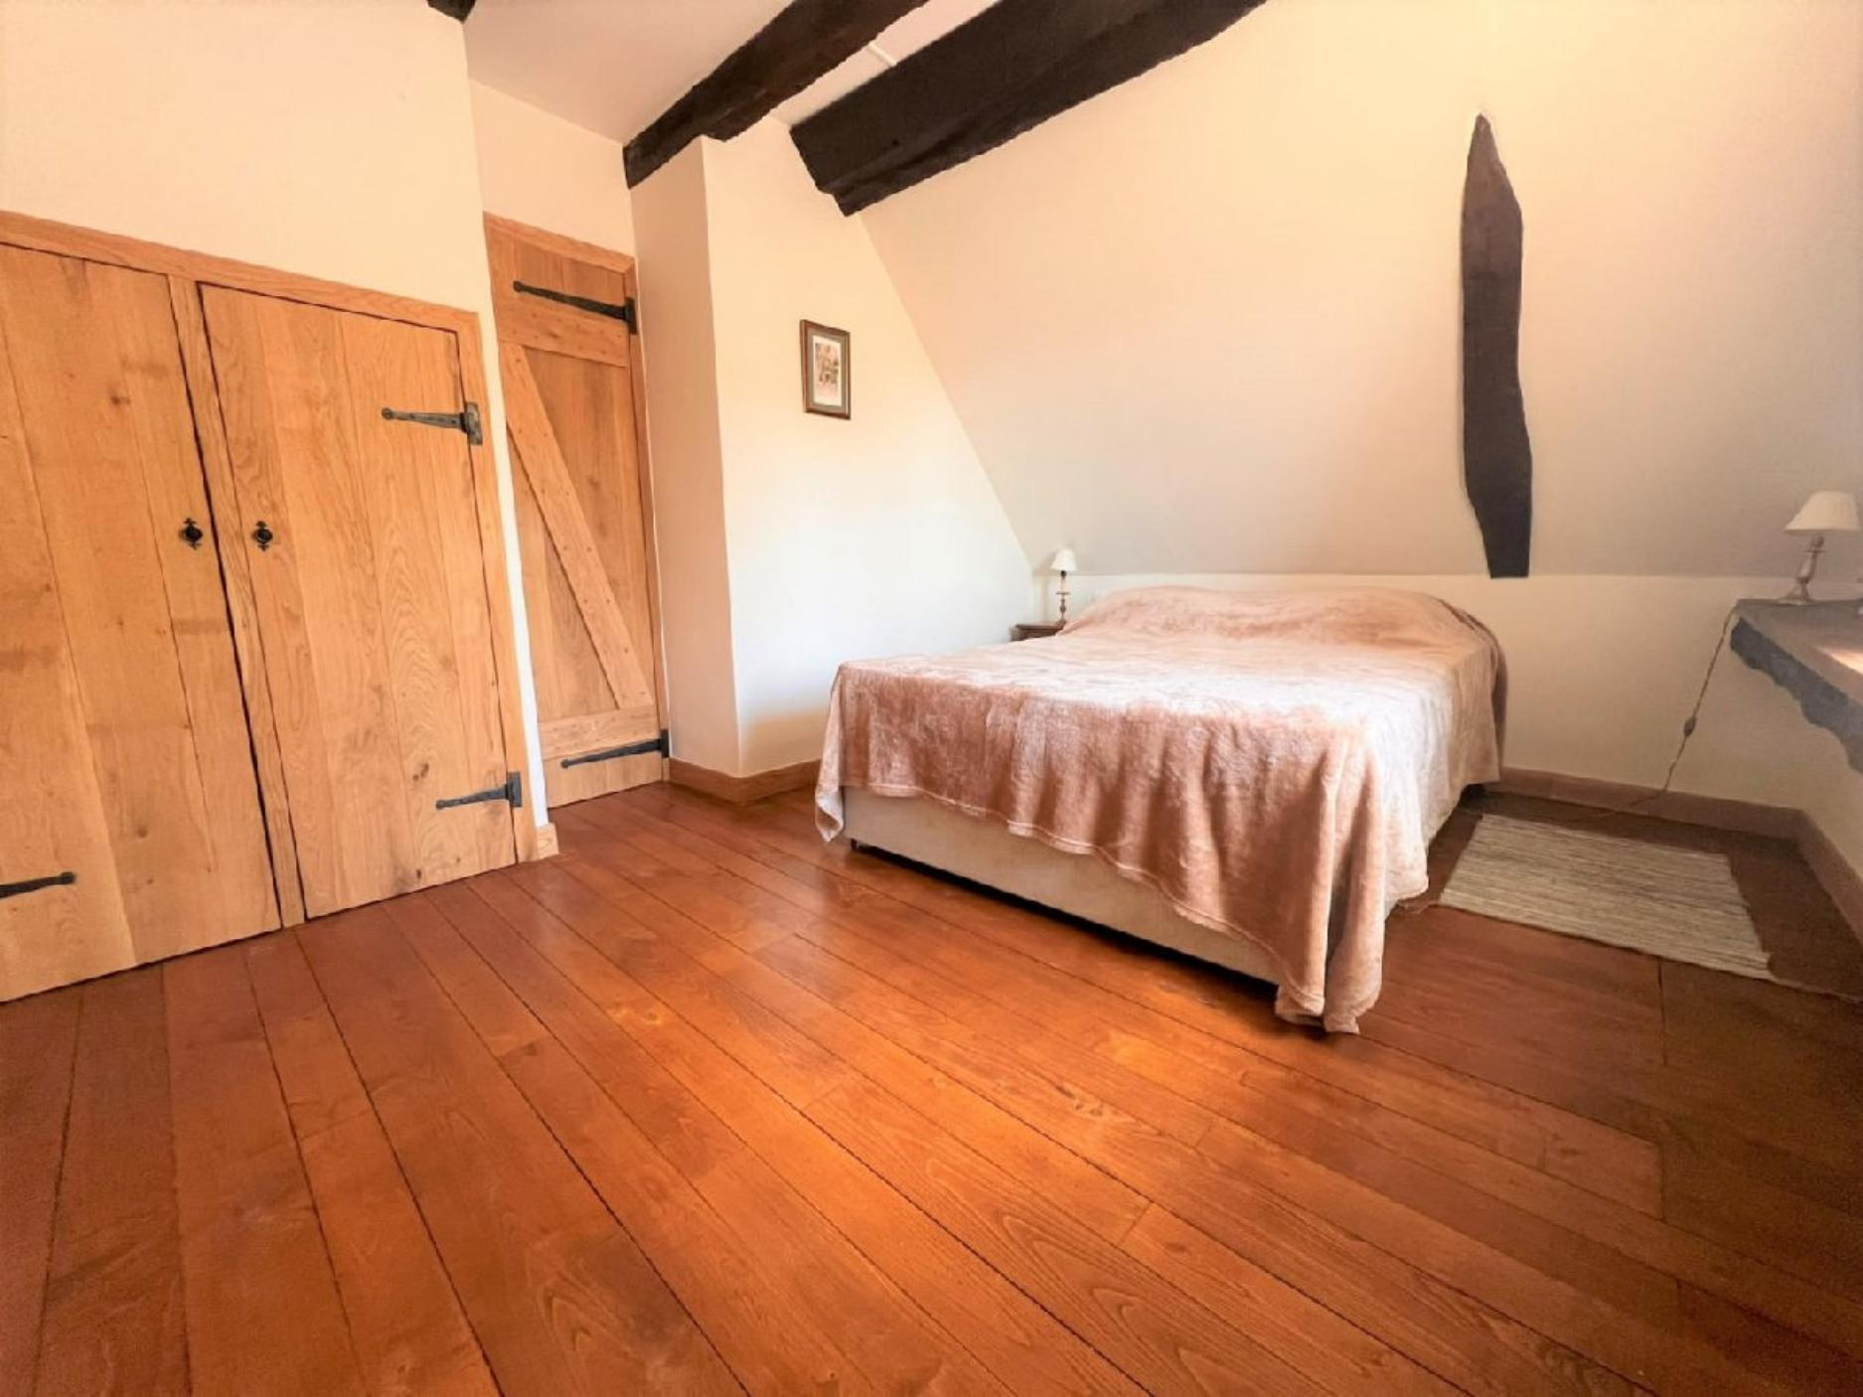 | 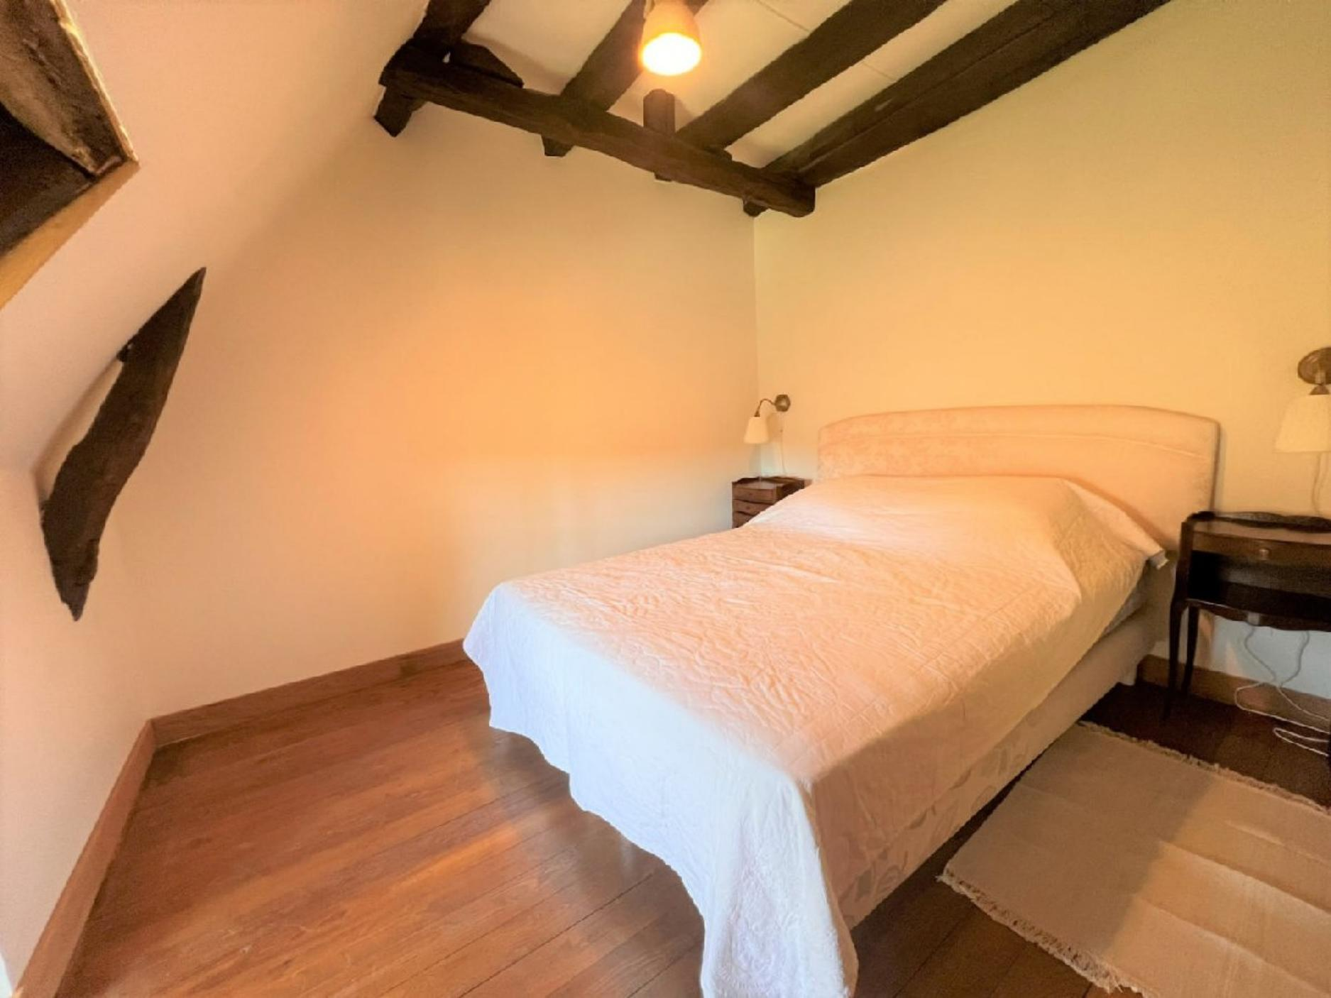
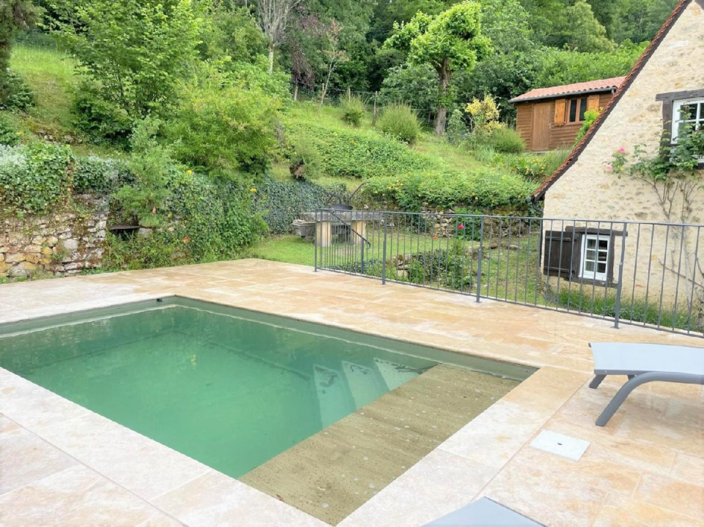 | 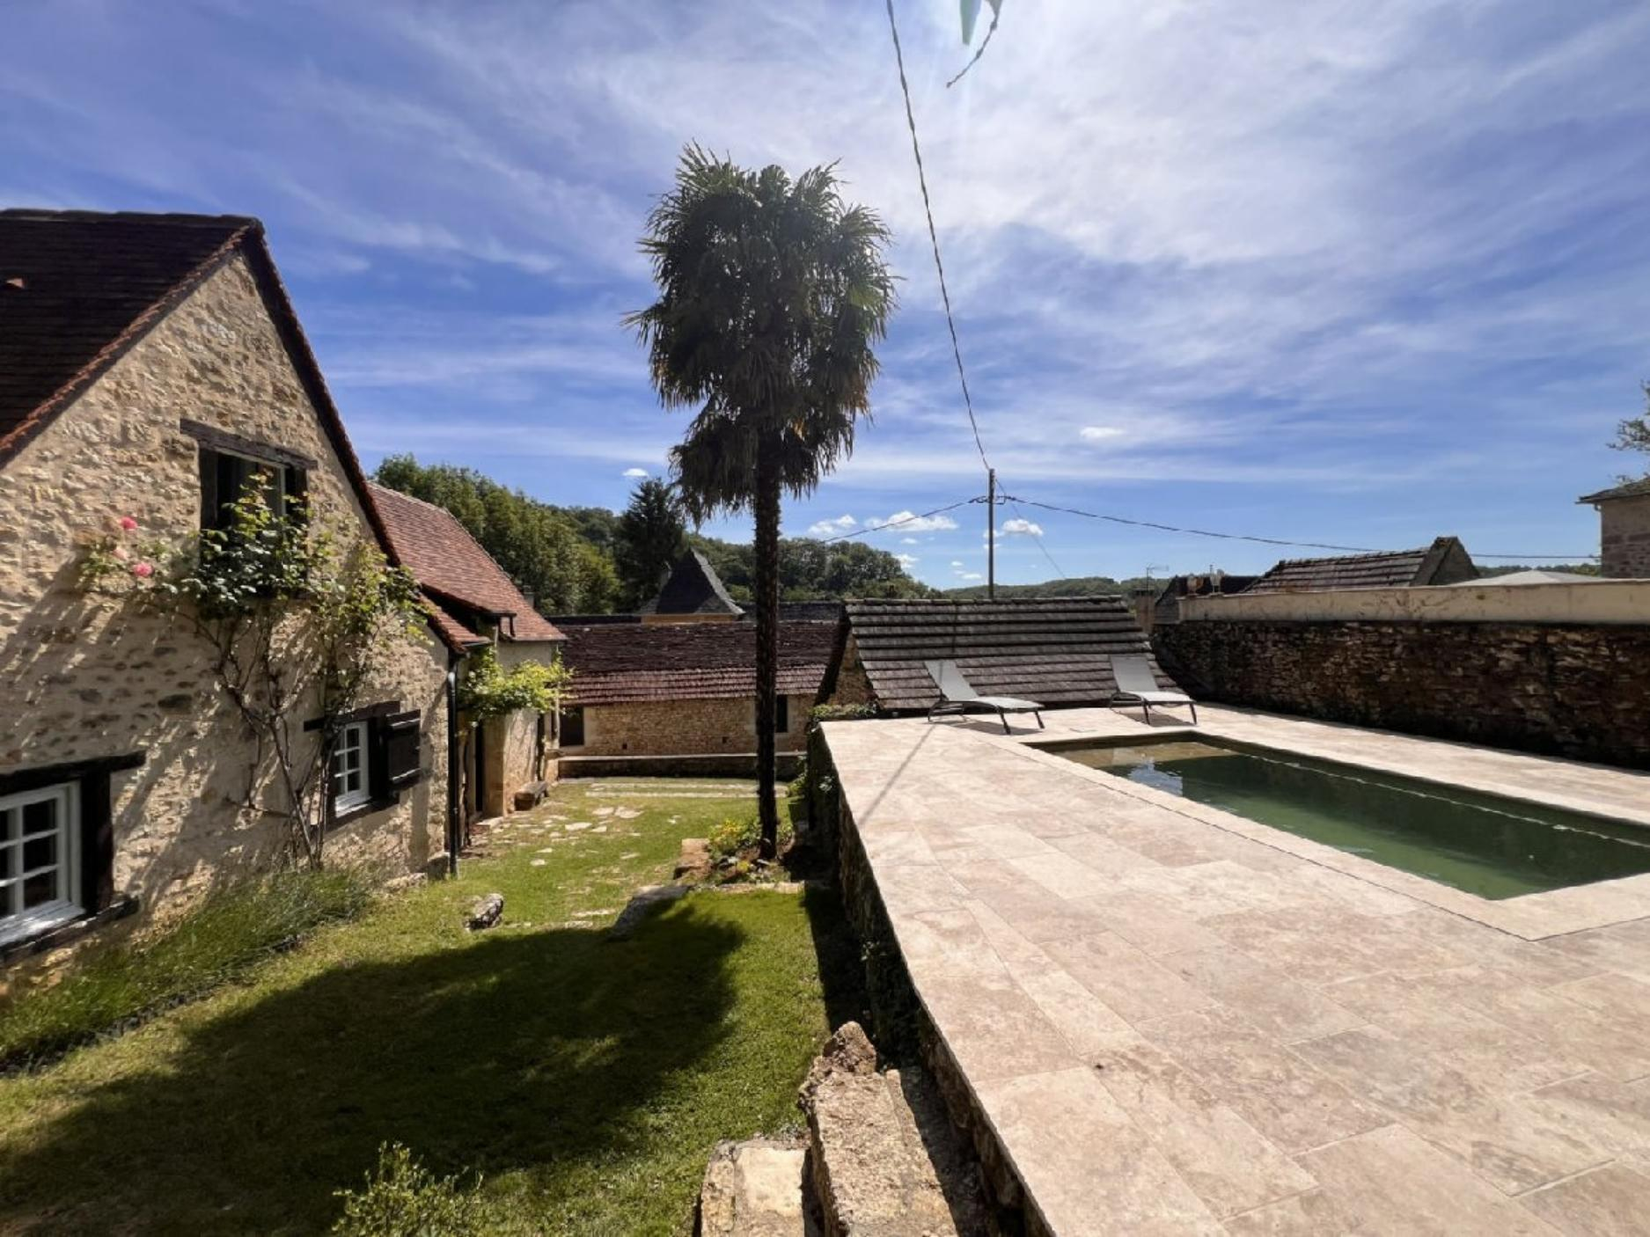
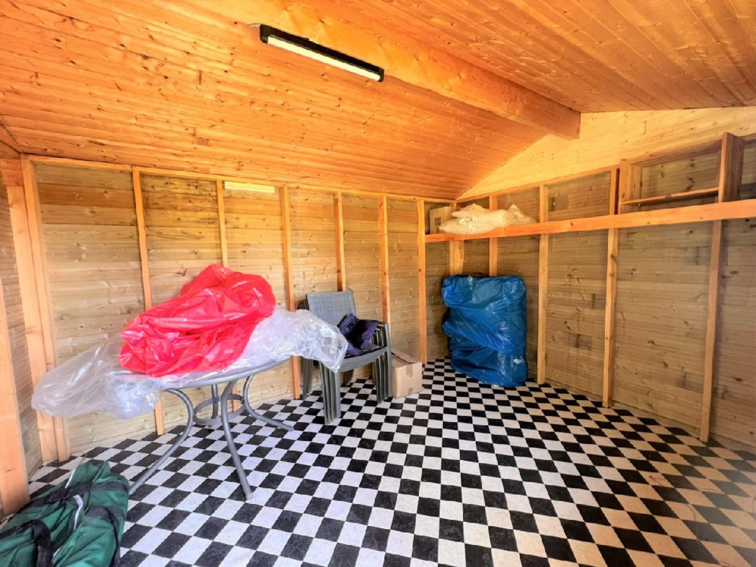 | 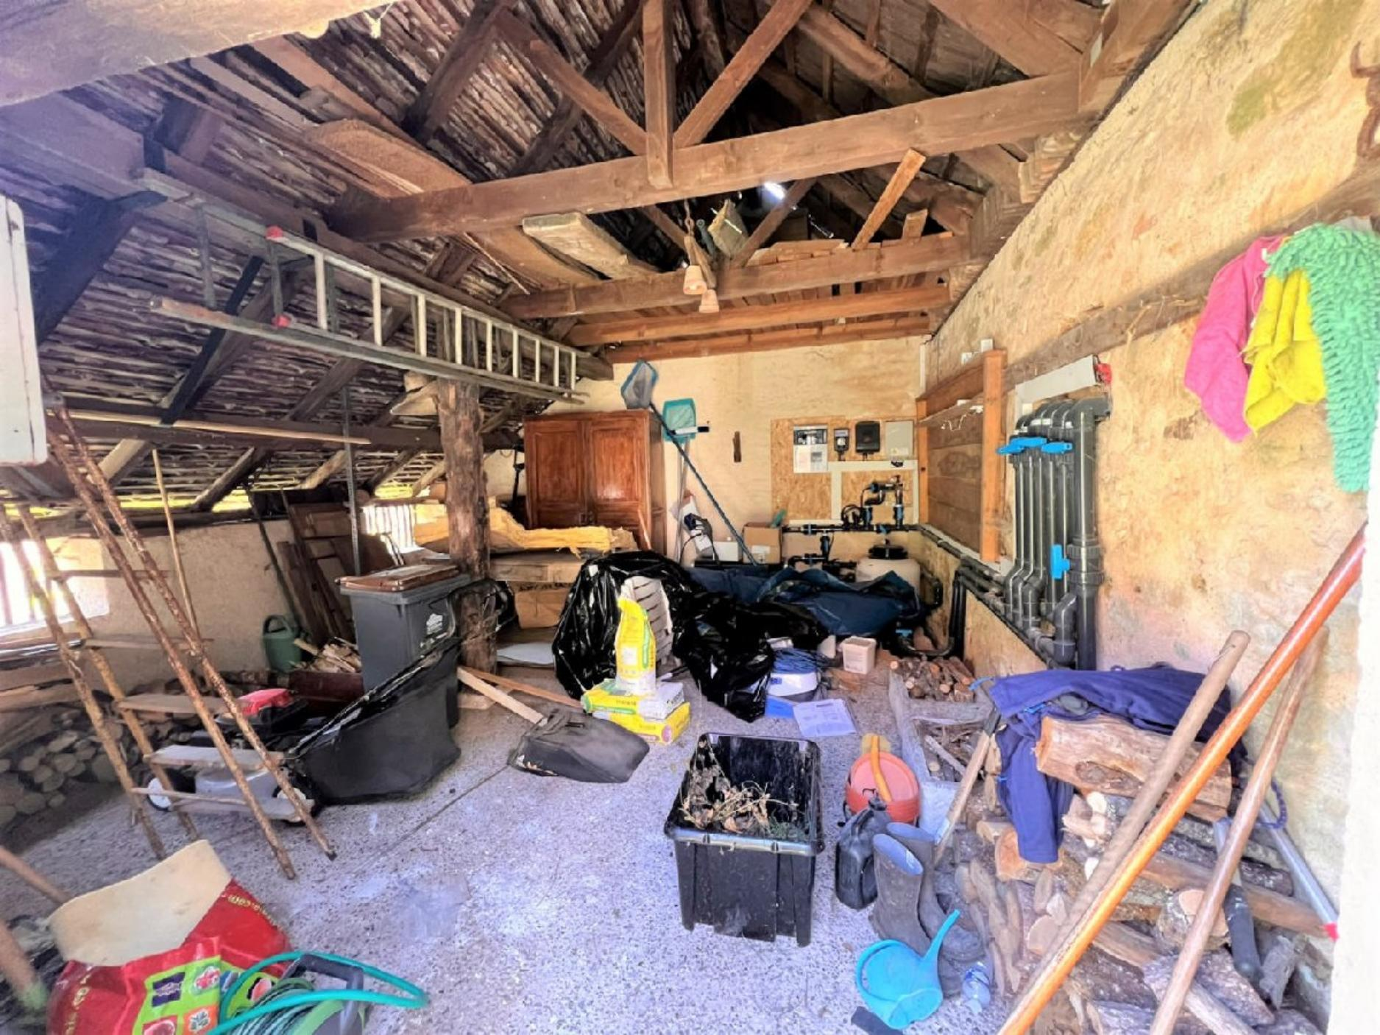
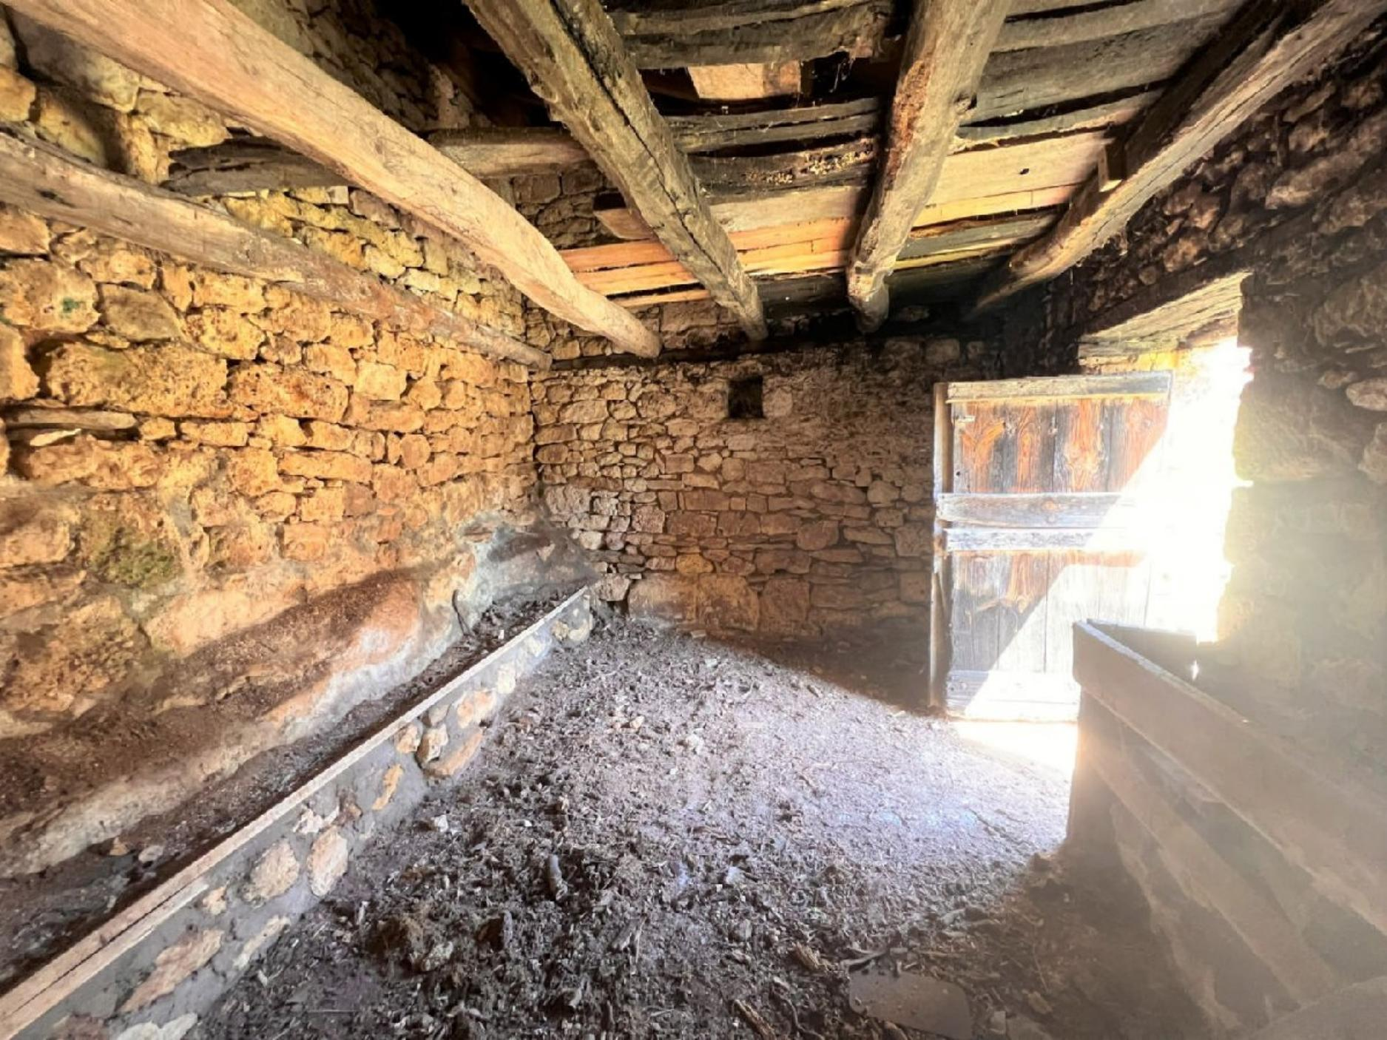 | 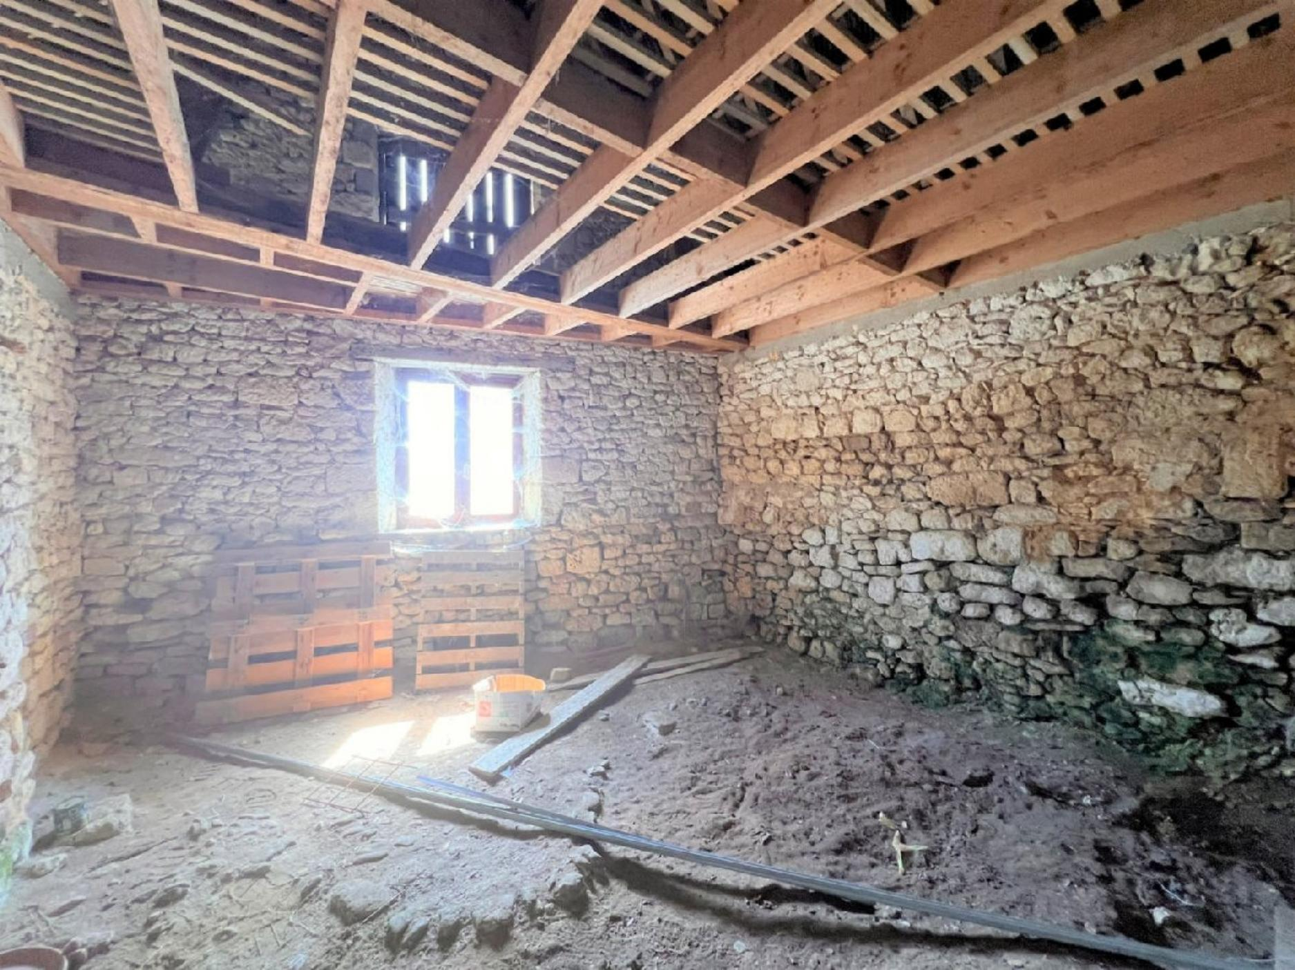

KEY DETAILS ( Ref . : PF90311) :
Total living space : 110 Sqm  Land area : 1,753 Sqm  Heating : Electricity & Wood  Energy Efficiency : | Nearest town : MONTIGNAC  Nearest commerce : 5 MINS  Nearest autoroute : A89/A20  Nearest airport : BERGERAC & BRIVE

PIONEER FRANCE CAN  ASSIST YOU WITH :  € Foreign Currency Exchange  the best rates : the best service  € Mortgage and Loan Facilities  pre-qualified, top lenders  € Your Total purchase process  a dedicated, fixed fee, total service from  initial offer through to post-completion  Call us or see our website  www.PioneerFrance.com   | PROPERTY LOCATION MAP :

