Phone : +33 (0)5 53 07 06 27  Email : info@pioneerfrance.com  Web : www.PioneerFrance.com  Domaine Le Ruisseau , 24580, Fleurac, Dordogne | 

THE DORDOGNE'S LEADING QUALITY PROPERTY AGENCY

REFERENCE  DEP0862 | PRICE (inc.agency comm)  860,000 € | LOCATION  DORDOGNE - LES EYZIES AREA | TYPE  House / Character property | SURF. TERRAIN  258,374m2

EXCEPTIONAL 26 HECTARE, 17thC DORDOGNE ESTATE WITH MAIN HOUSE, 3 GITES, GUARDIAN’S HOUSE, SWIMMING POOL, LAKE AND STONE BARNS

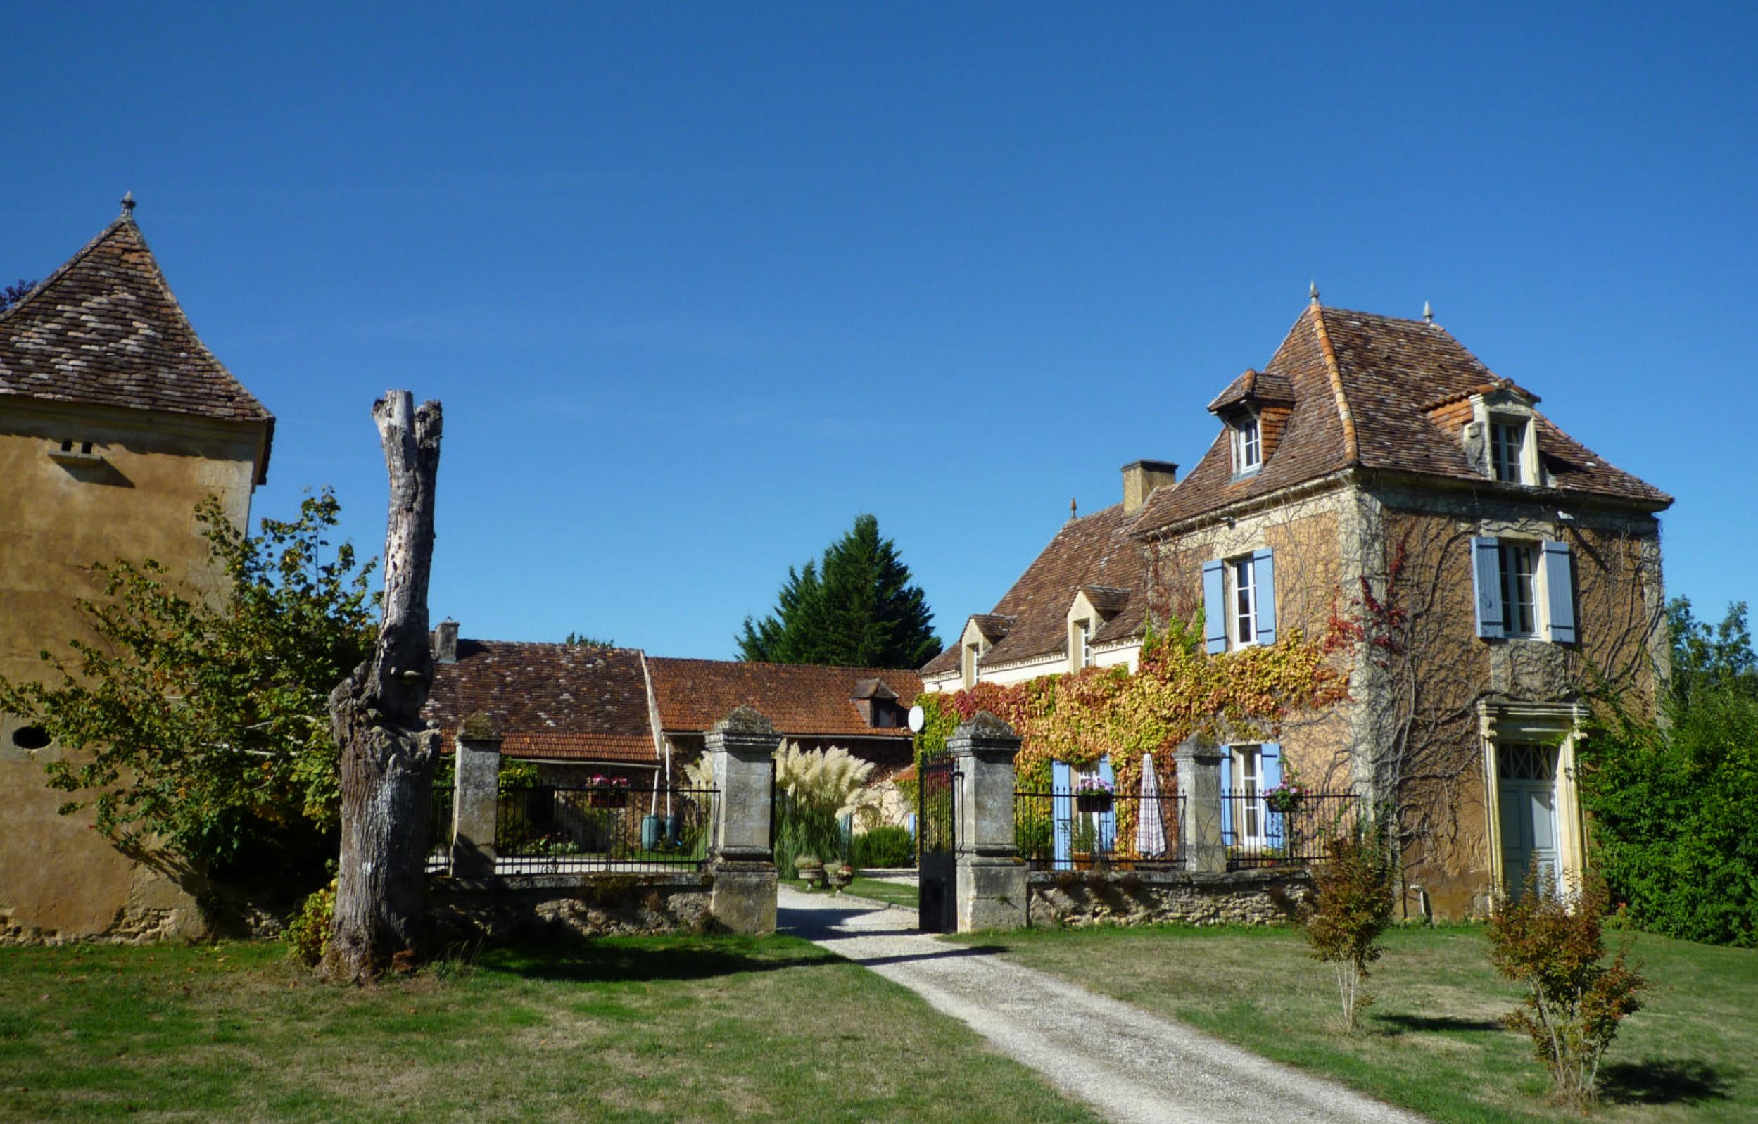
Set high with far-reaching views, the property sits in the middle of its 26 hectares (65 acres) of idyllic land with gardens, meadows, woods, lake and swimming pool. Three independent gites with their own driveway entrance have produced many years of excellent income. In all, over 500sqm of living space. There is also large guardian’s house, garage and stone barns suitable for further expansion if required. The property benefits from total peace and tranquillity yet is only 15mins to two thriving riverside market towns with all commerce.
PROPERTY DESCRIPTION ( Ref : DEP0862)
MAIN HOUSE
250sqm of living space, arranged over three floors, with full central heating and surrounded by external terraces, the main house and independent gites form a wonderful stone-walled and gated courtyard
Ground floor
Main entrance from the courtyard to:
- 29sqm entrance hall / sitting with monumental stone fireplace and doors to the conservatory
- 20sqm fully fitted kitchen / breakfast room with door to the courtyard and vegetable garden
- 26sqm superbly proportioned dining room with carved stone fireplace
- 10sqm utility room
- 26sqm double aspect living room
- 31sqm wood timbered conservatory with doors to the rear terraces
First Floor
Hand-made stone stairs lead to:
- 15sqm landing area /study
- 20sqm master double bedroom with…
- 6sqm Ensuite bathroom and WC.
- 15sqm double bedroom
- 10sqm bedroom
- 10sqm Shower room and WC
- 5sqm shower room
Second Floor
Stairs lead to:
- 27sqm bedroom with exposed oak-beam work in the vaulted ceiling
GUEST HOUSE / GITE 1
3 bedrooms, with independent access from its own terrace:-
Ground floor
- 22sqm living room and kitchen
- 6sqm shower room and WC
- 9sqm sitting room
- 13sqm Double bedroom
First Floor
Stairs lead to:-
- 14sqm double bedroom
- 11sqm double bedroom
GUEST HOUSE / GITE 2
2 bedrooms, with independent access from its own terrace:-
Ground floor
- 33sqm living room and kitchen
First Floor
Stairs lead to:-
- 17sqm double bedroom
- 17sqm double bedroom
- 4sqm shower room and WC
GUEST HOUSE / GITE 3
1 bedroom, with independent access from its own terrace:-
Ground floor
- 30sqm living room and kitchen
First Floor
Stairs lead to:-
- 14sqm double bedroom
- 6sqm shower room
GUARDIANS HOUSE
Set in its own land away from the main house, a two storey house
Ground floor
- 42sqm Garage and workshop
- 15sqm Boiler room
First Floor
External stairs to Guardians house entrance:-
- 18sqm living room
- 9sqm dining room
- 8 sqm fully fitted kitchen
- 12sqm double bedroom
- 5sqm Bathroom / WC
- 14sqm double bedroom
LAND, EXTERNAL BUILDINGS AND SWIMMING POOL
Approached via a private driveway through the property’s woods, the land opens up to reveal superb views and the various houses and buildings set in 26 hectares / 65 acres of land.
- Fully fenced and stone-terraced 10x5 metre Heated Swimming Pool – recently installed
- Landscaped gardens, fountains, orchards and play areas
- Huge 8000sqm Lake
- 2 Stone Barns adaptable to a variety of uses
- Further stone outbuildings
- Vegetable garden
GENERAL INFORMATION
- Energy rating: D
- Centrally heated
- Broadband
- Only 15mins from the lovely riverside market town of Le Bugue and Les Eyzies with all amenities
- 55minutes to Bergerac Airport
- Good income generation if required. The current owners have all marketing, etc. in place and new owners can take this and any bookings over if required.

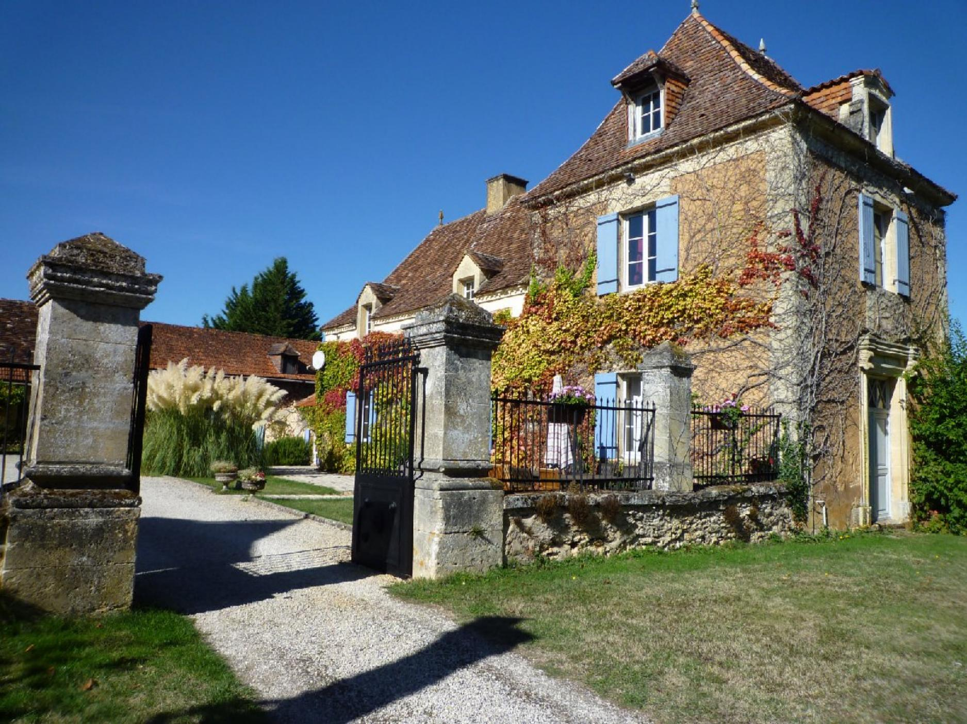 | 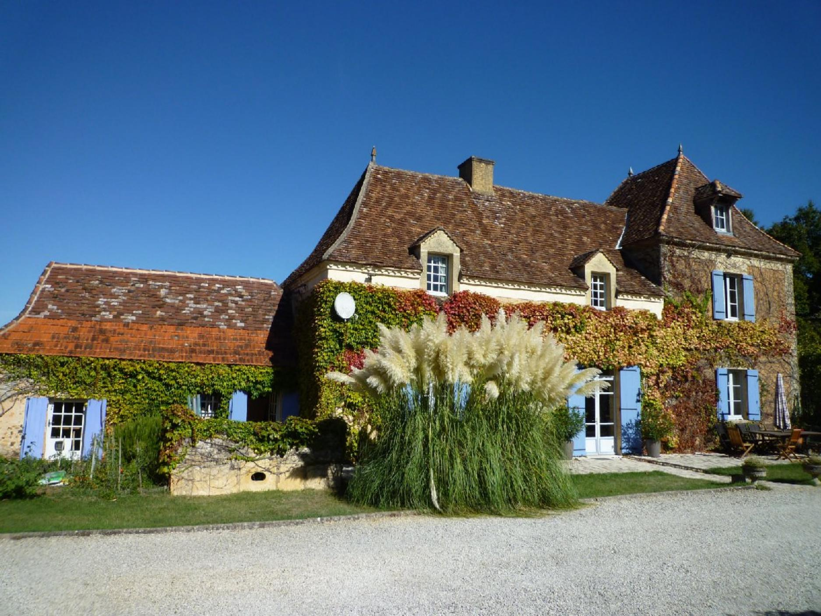
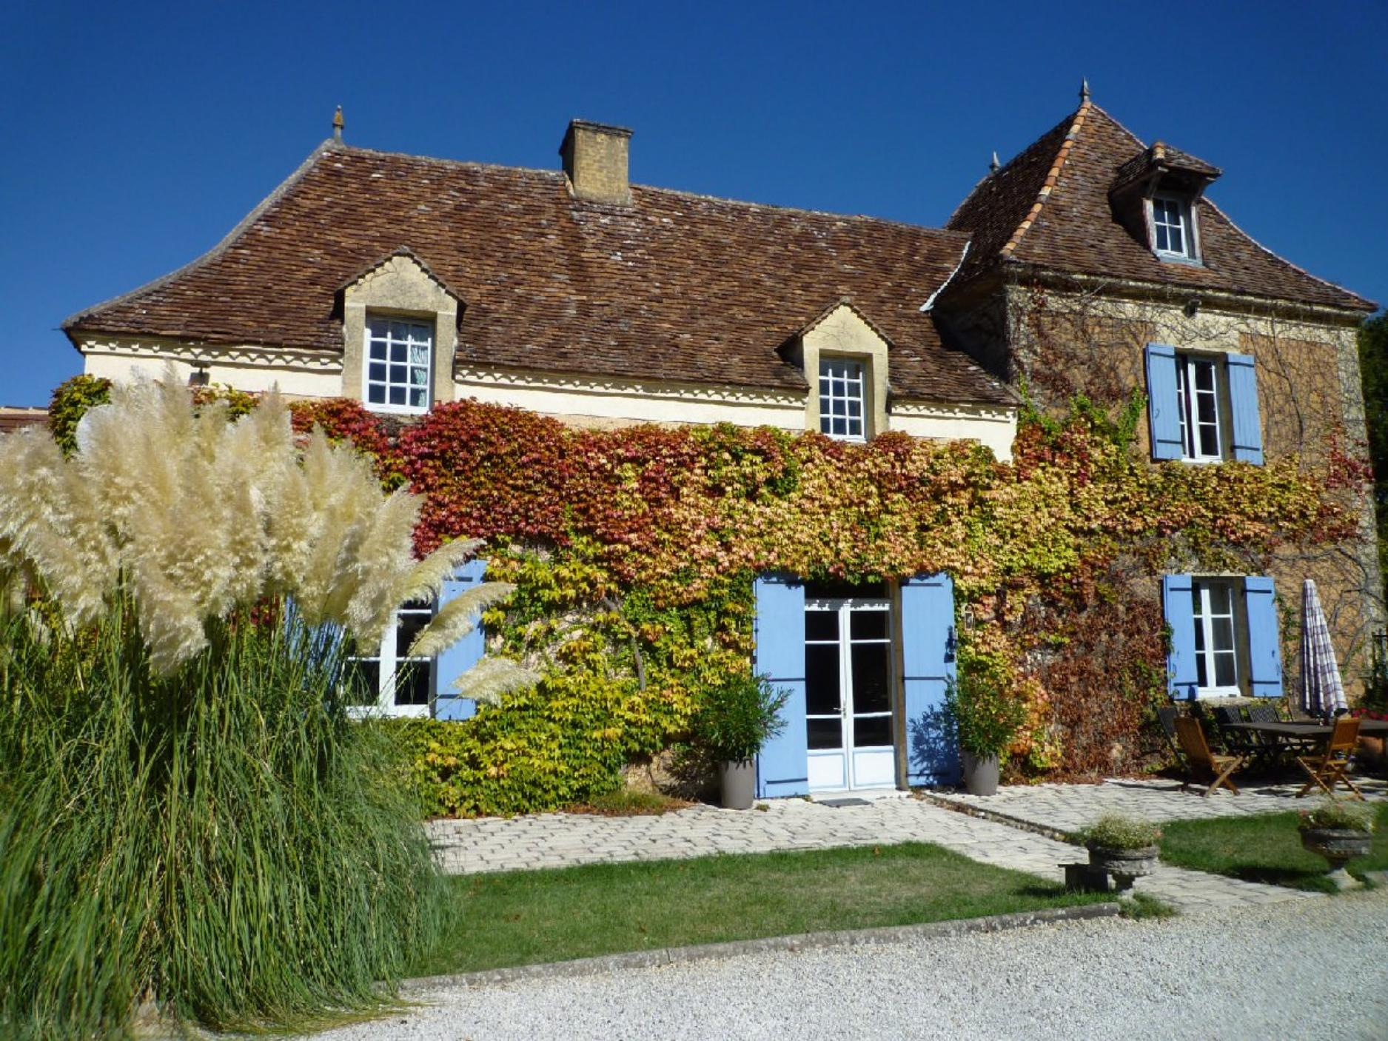 | 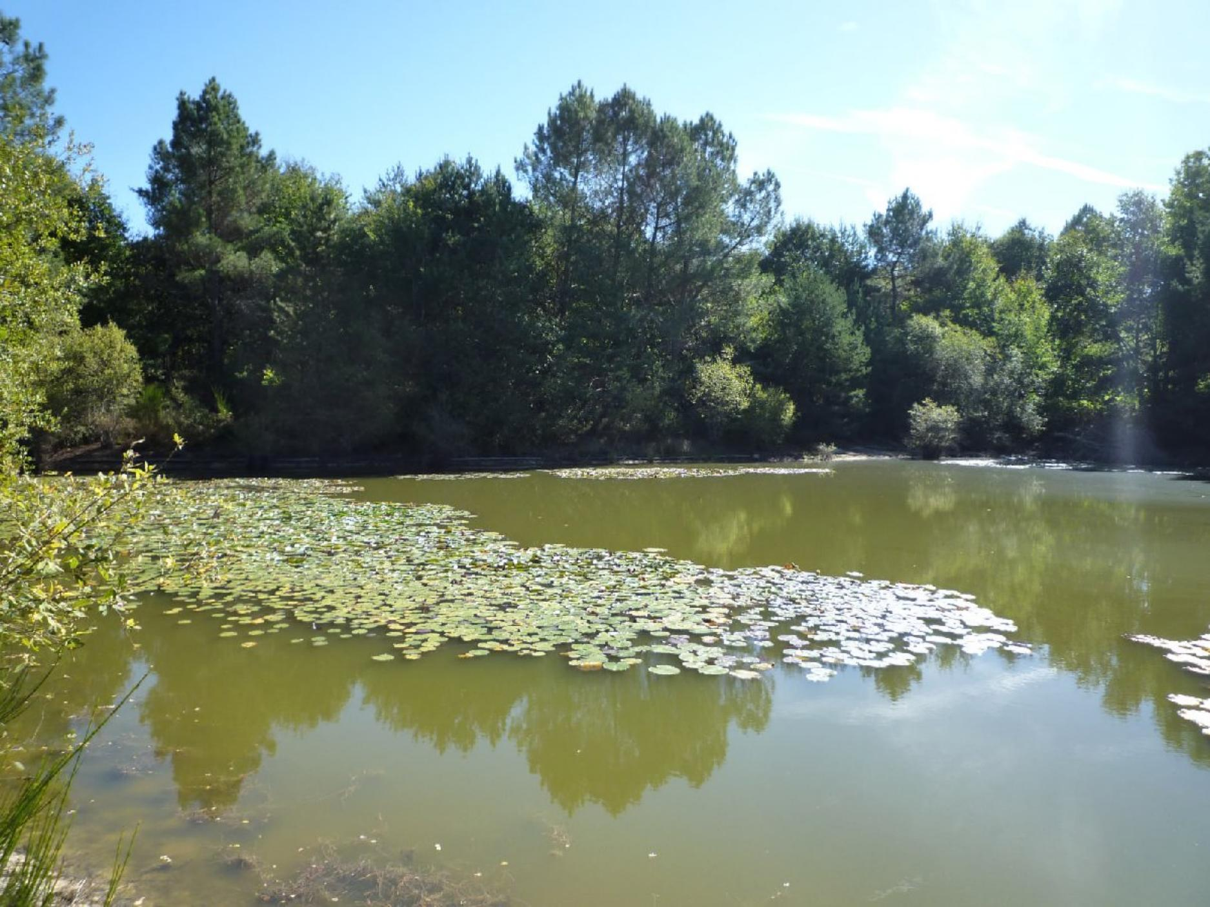
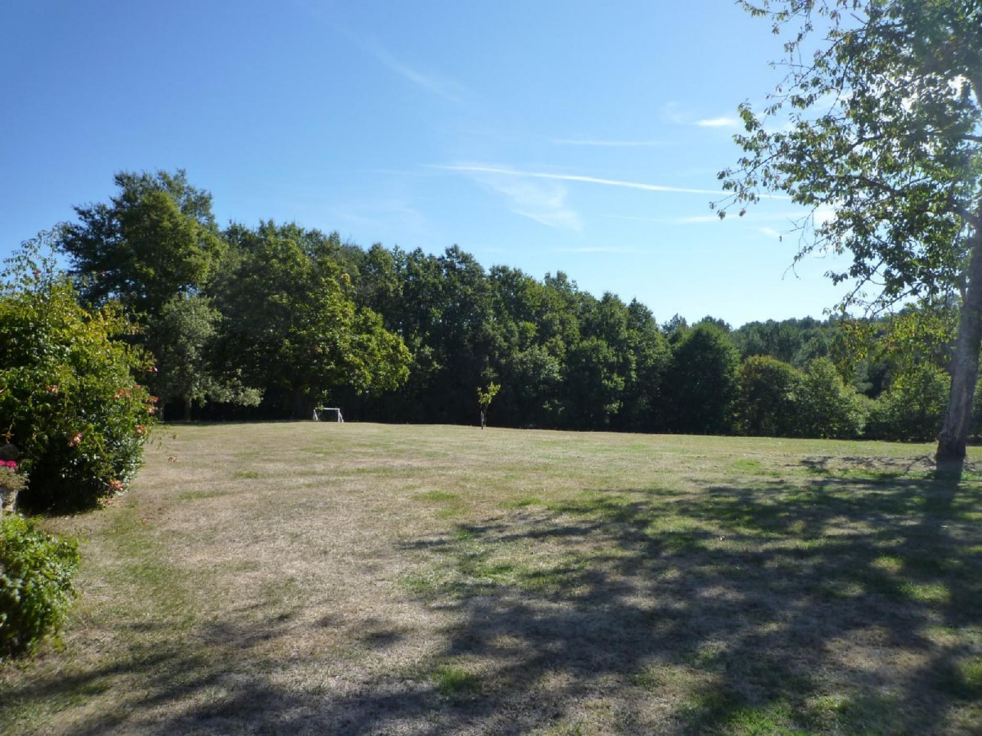 | 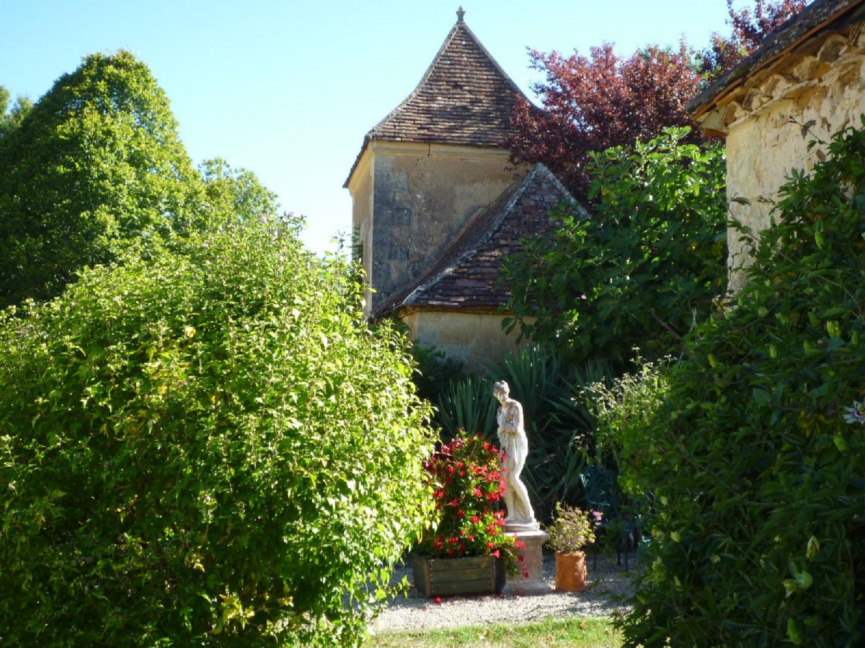
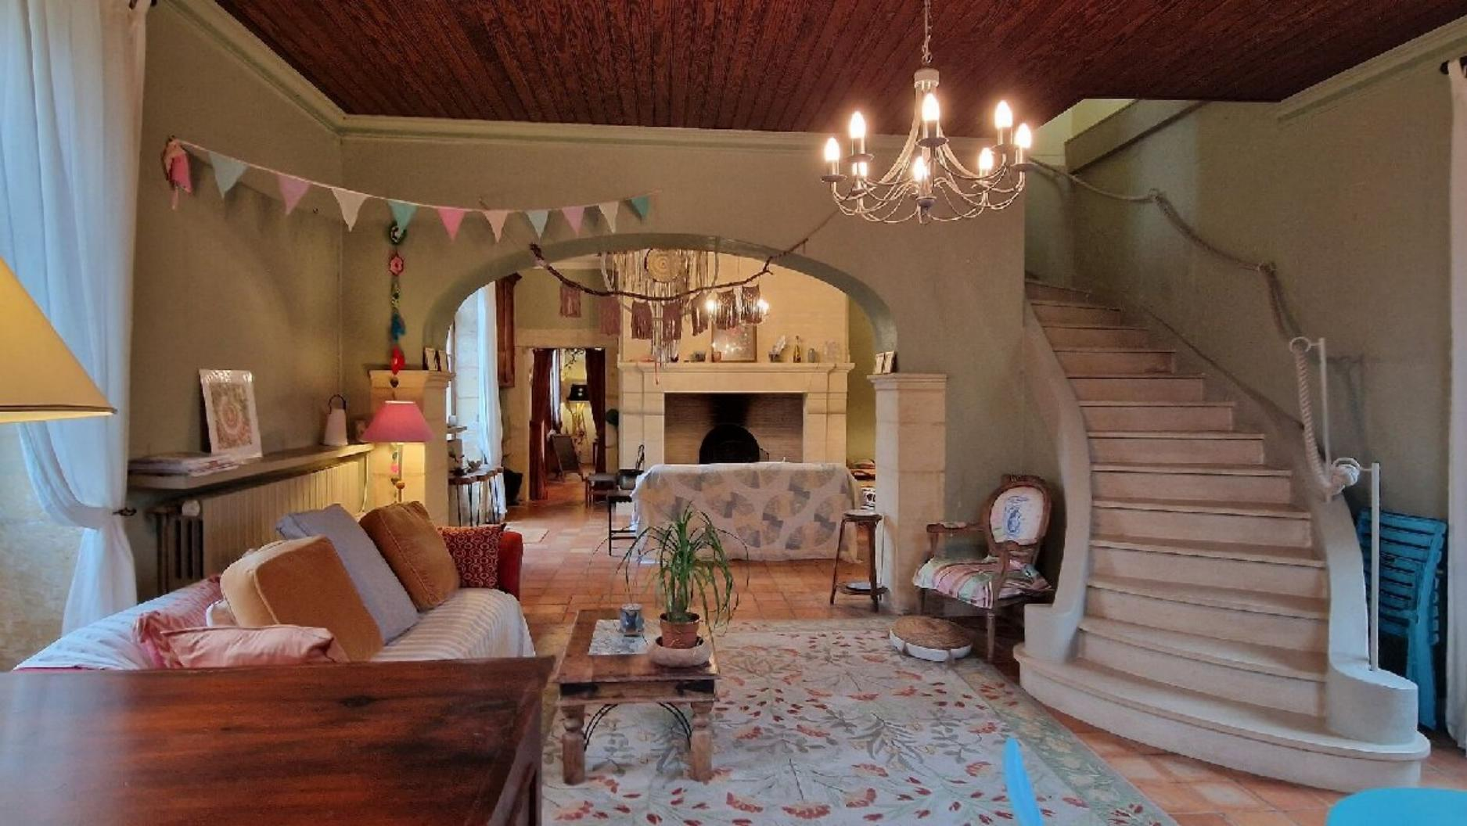 | 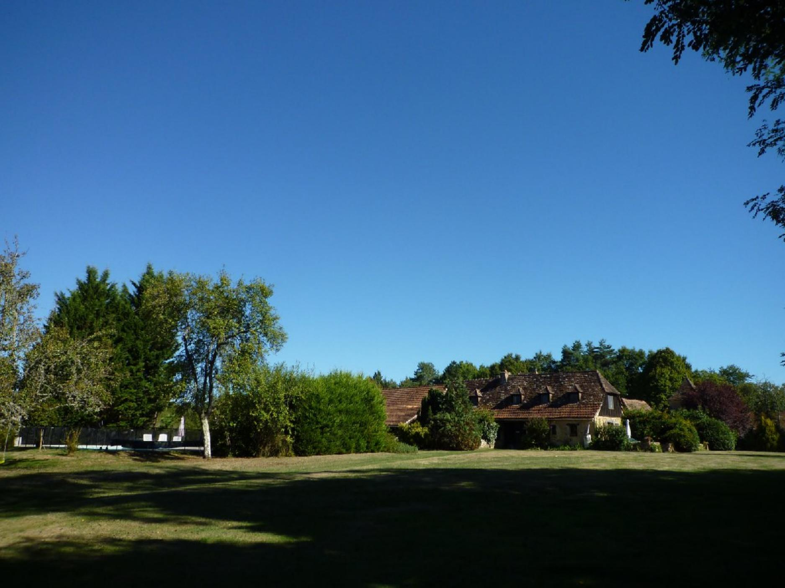
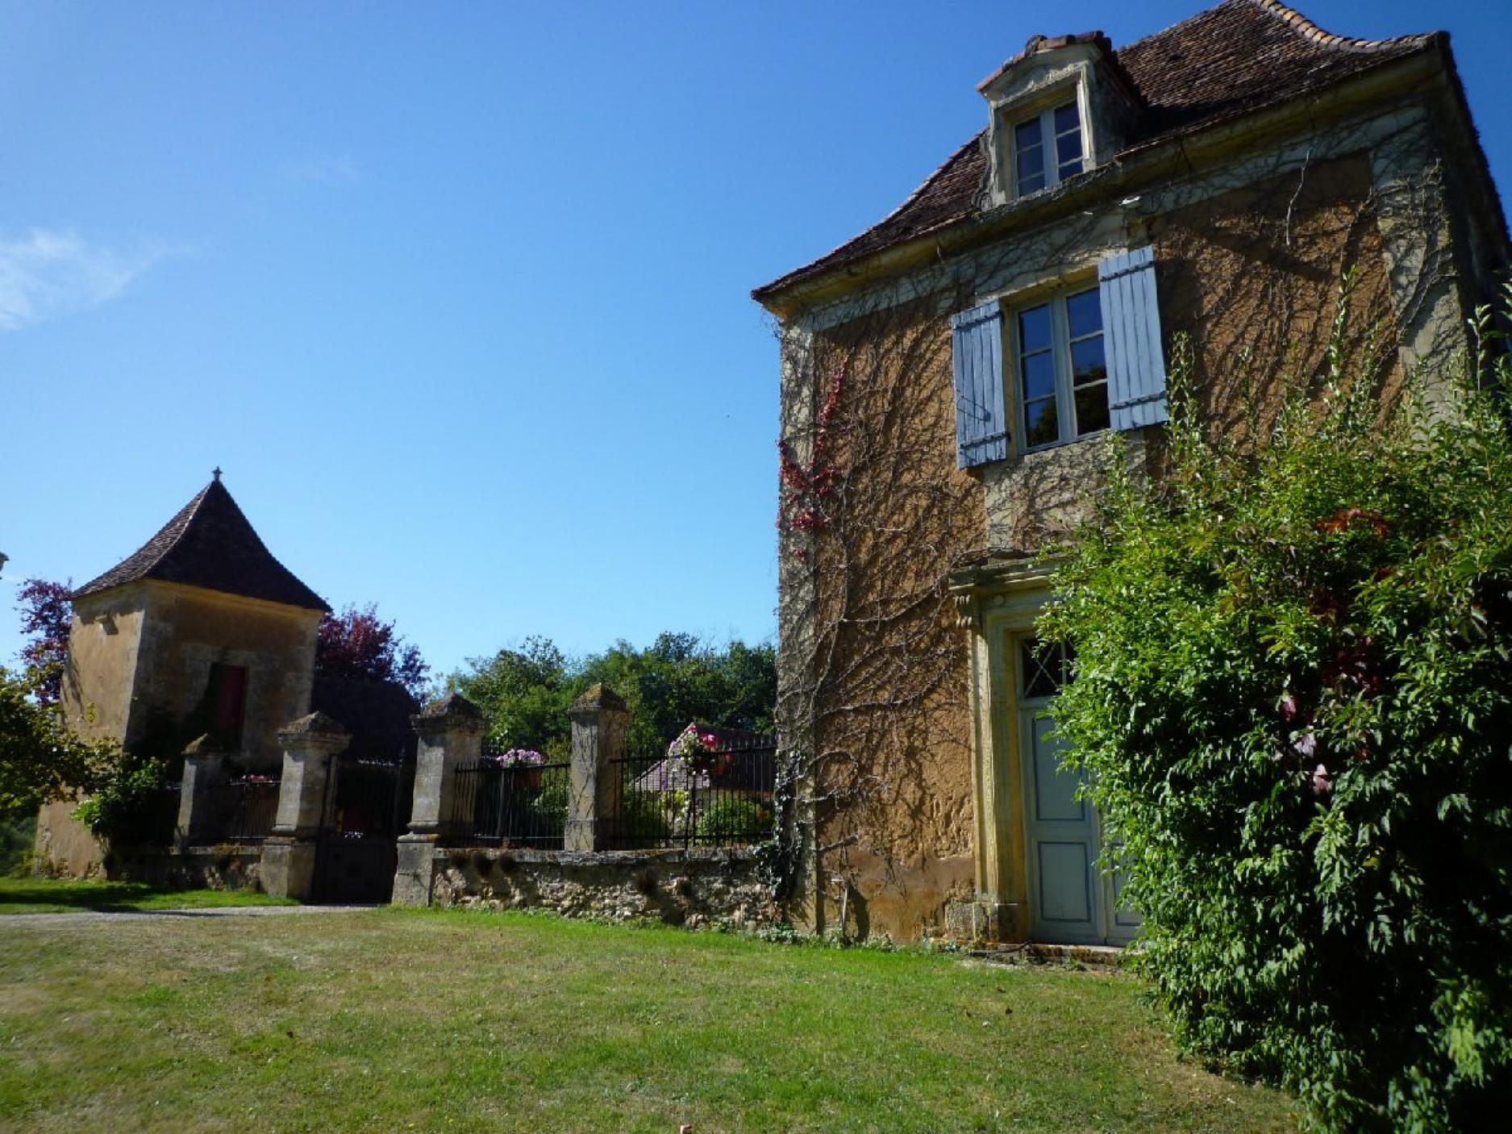 | 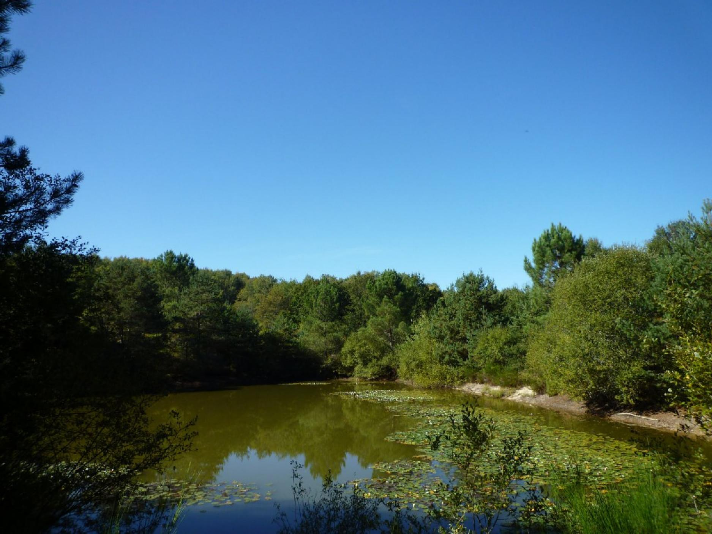
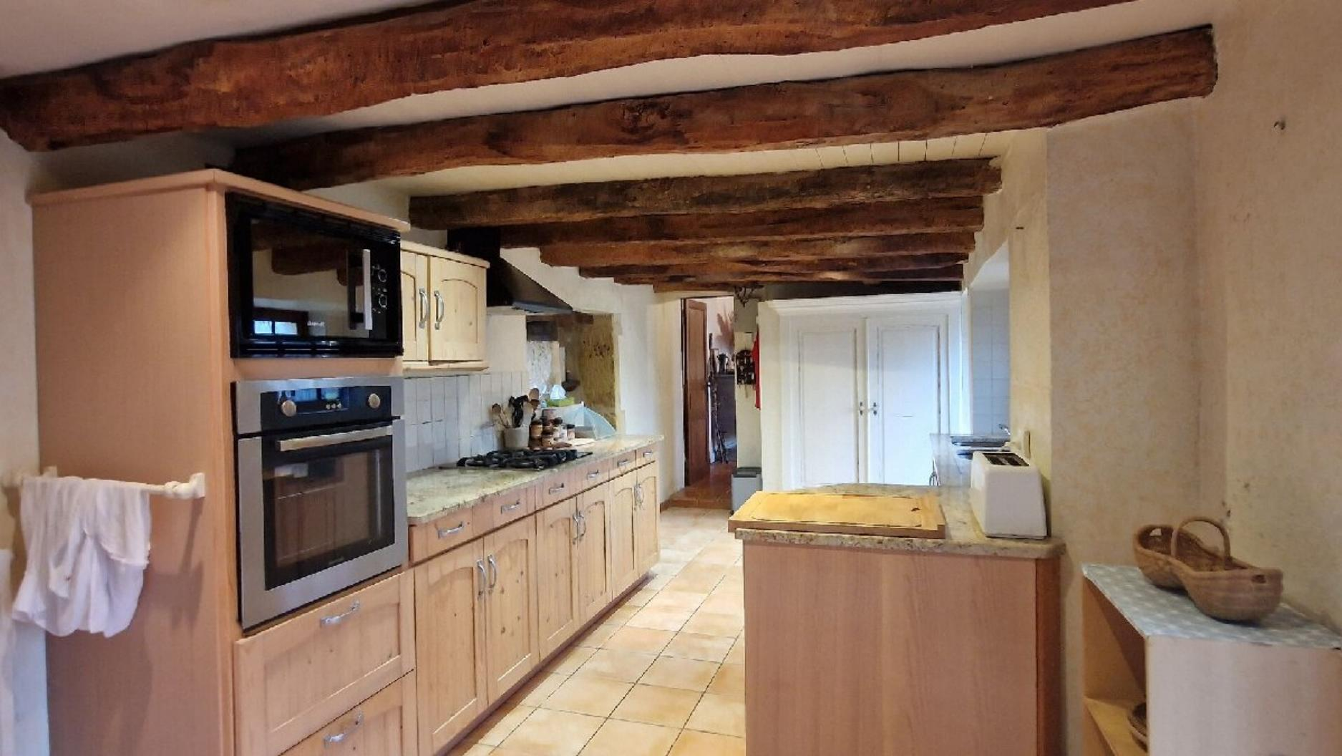 | 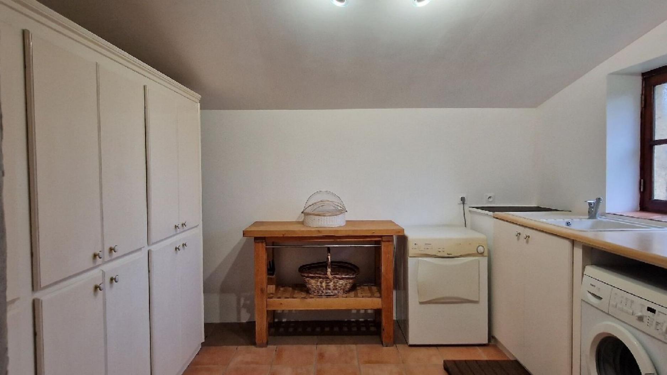
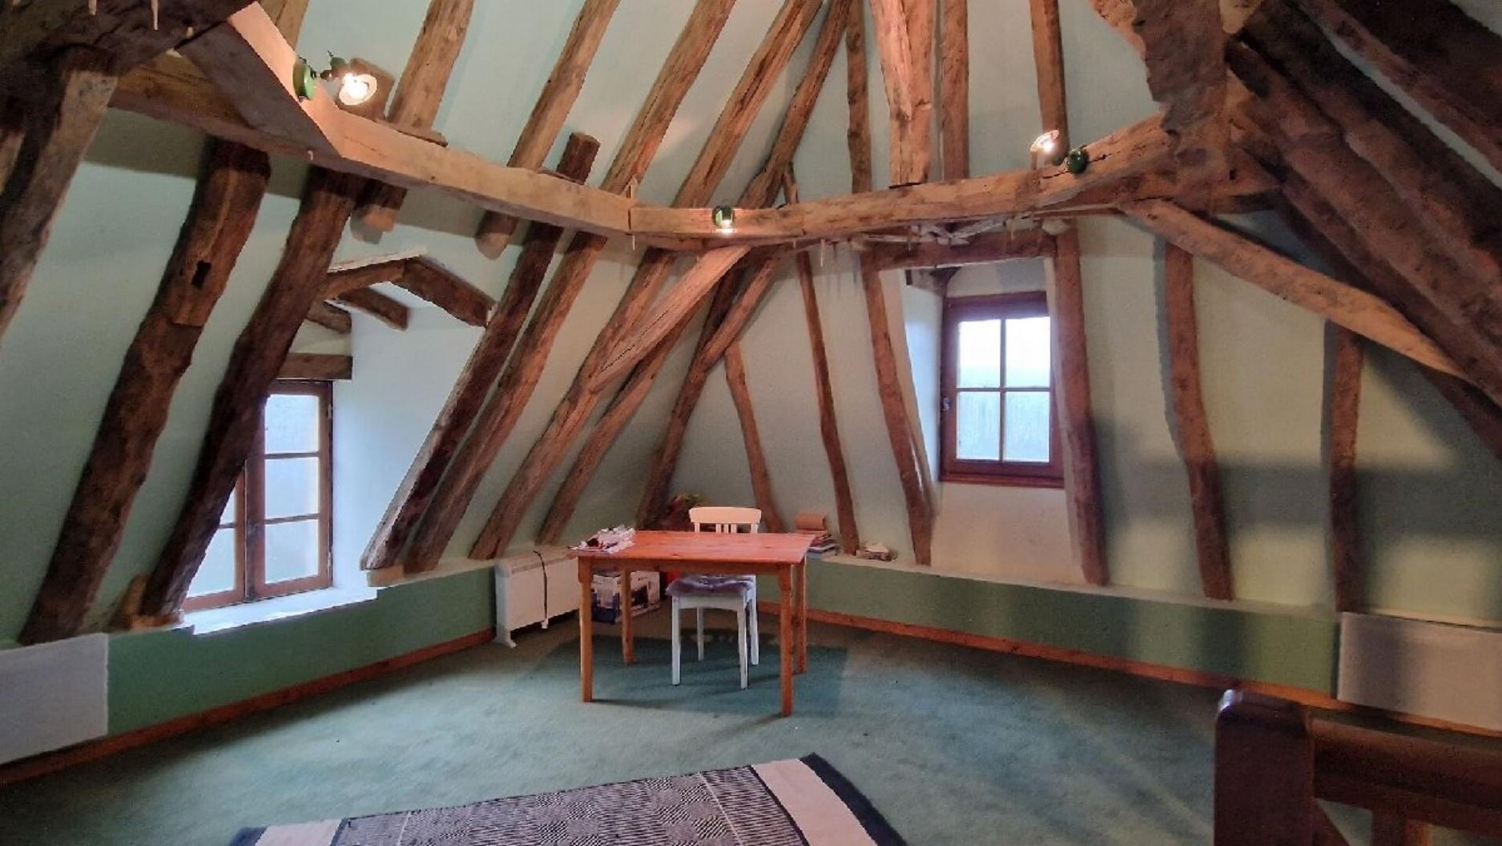 | 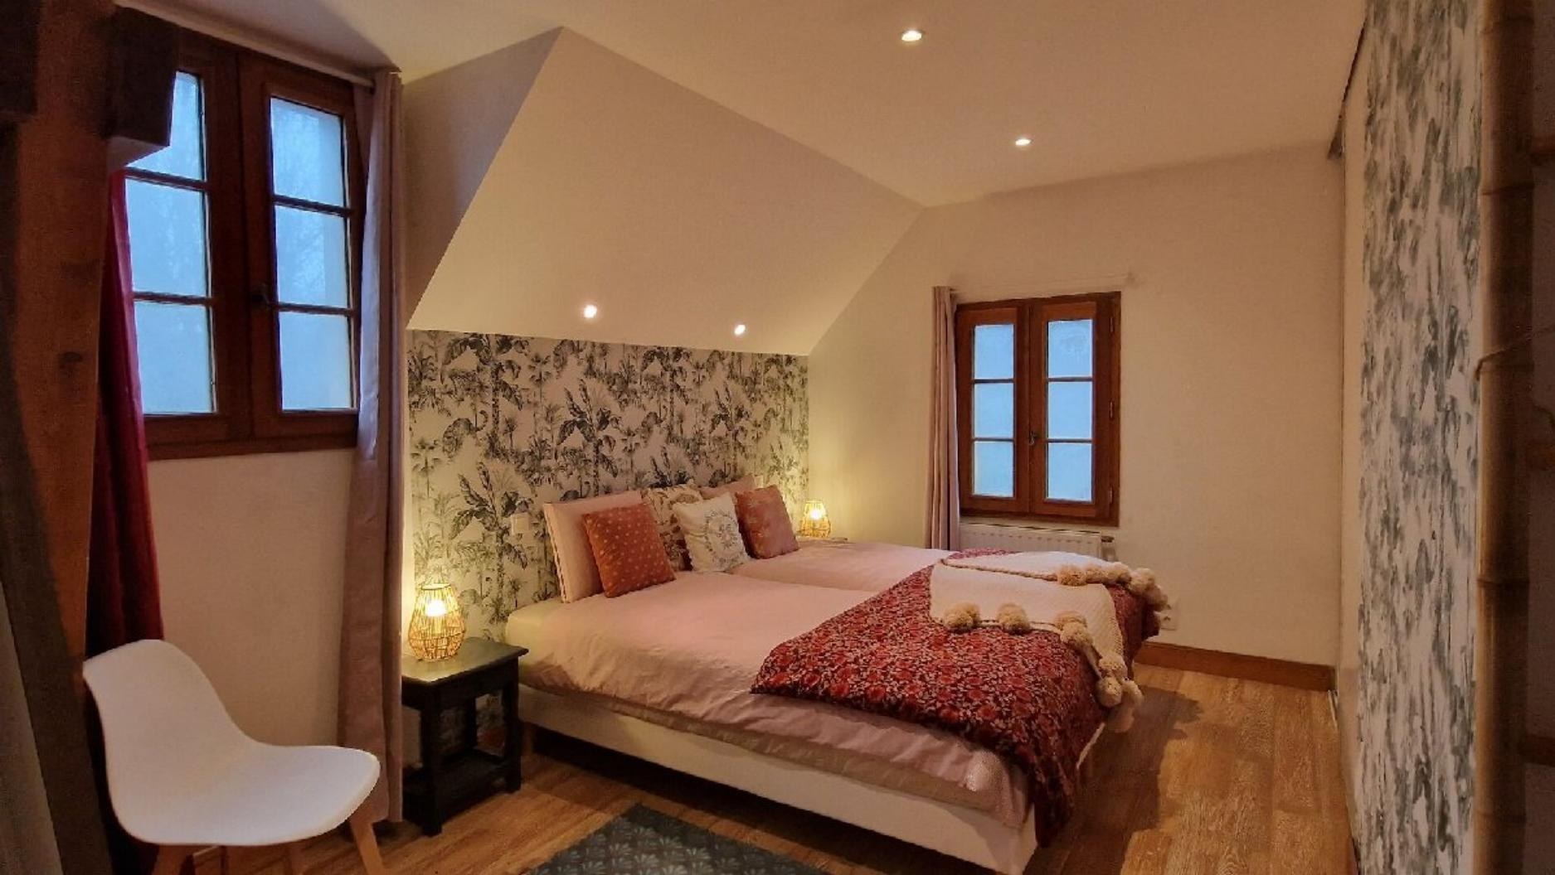
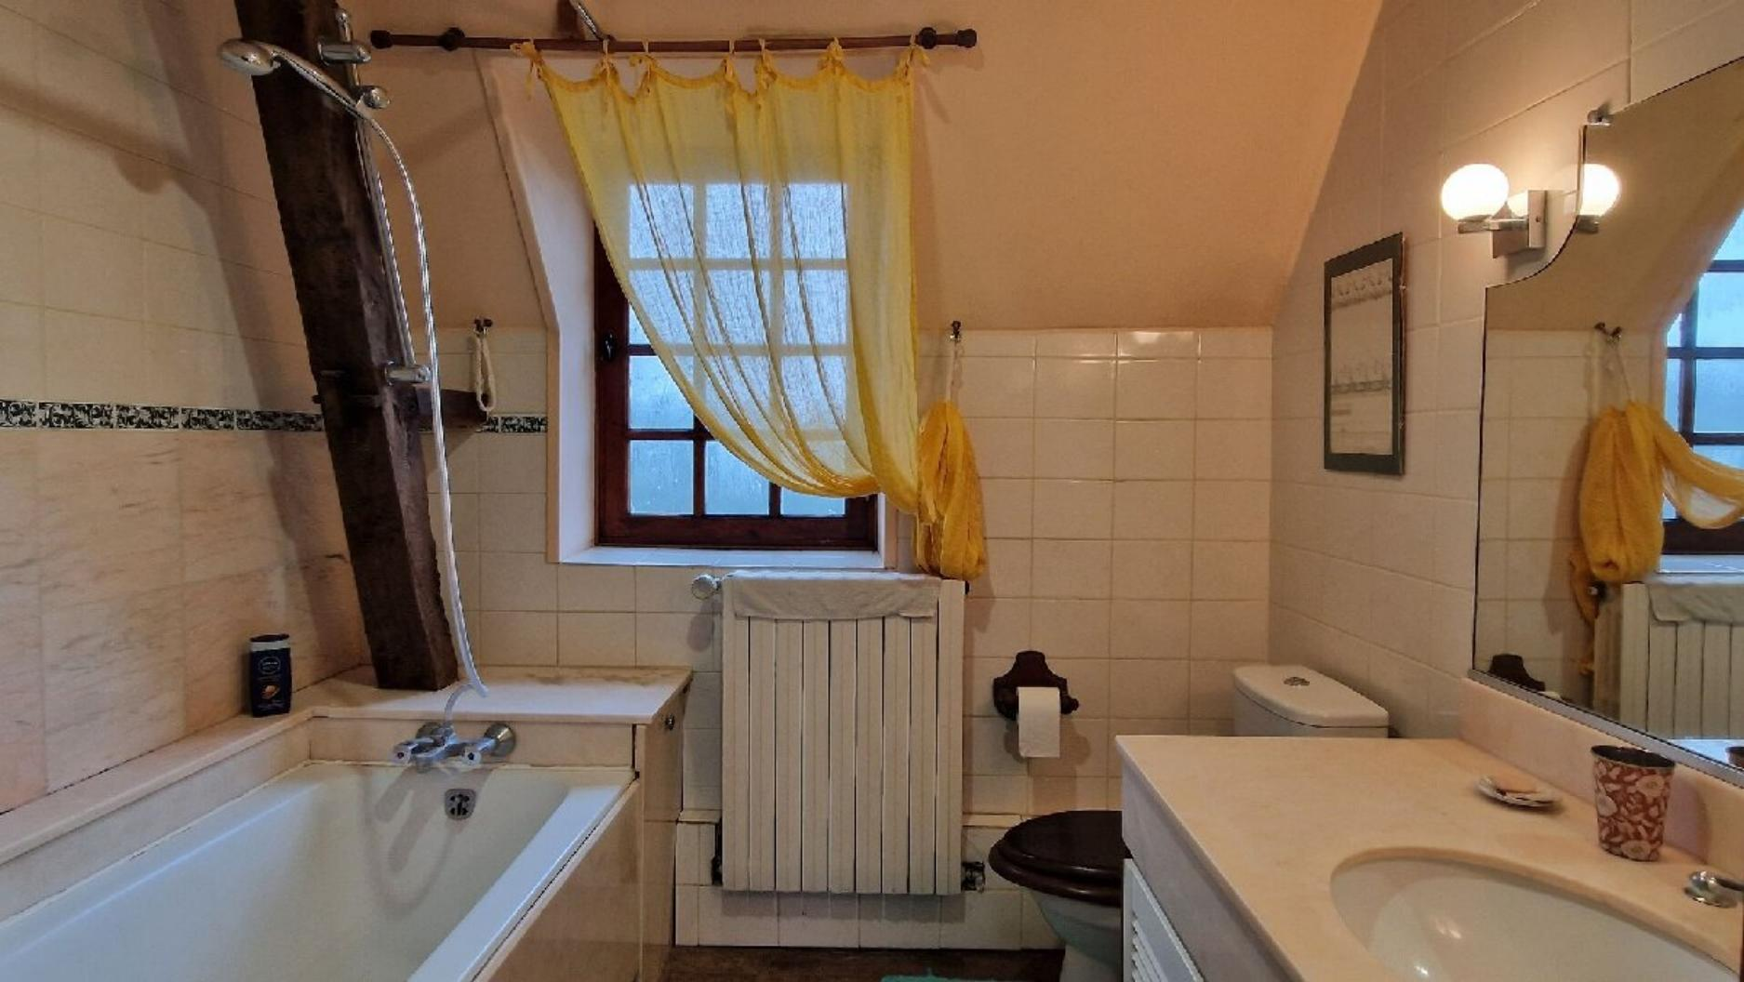 | 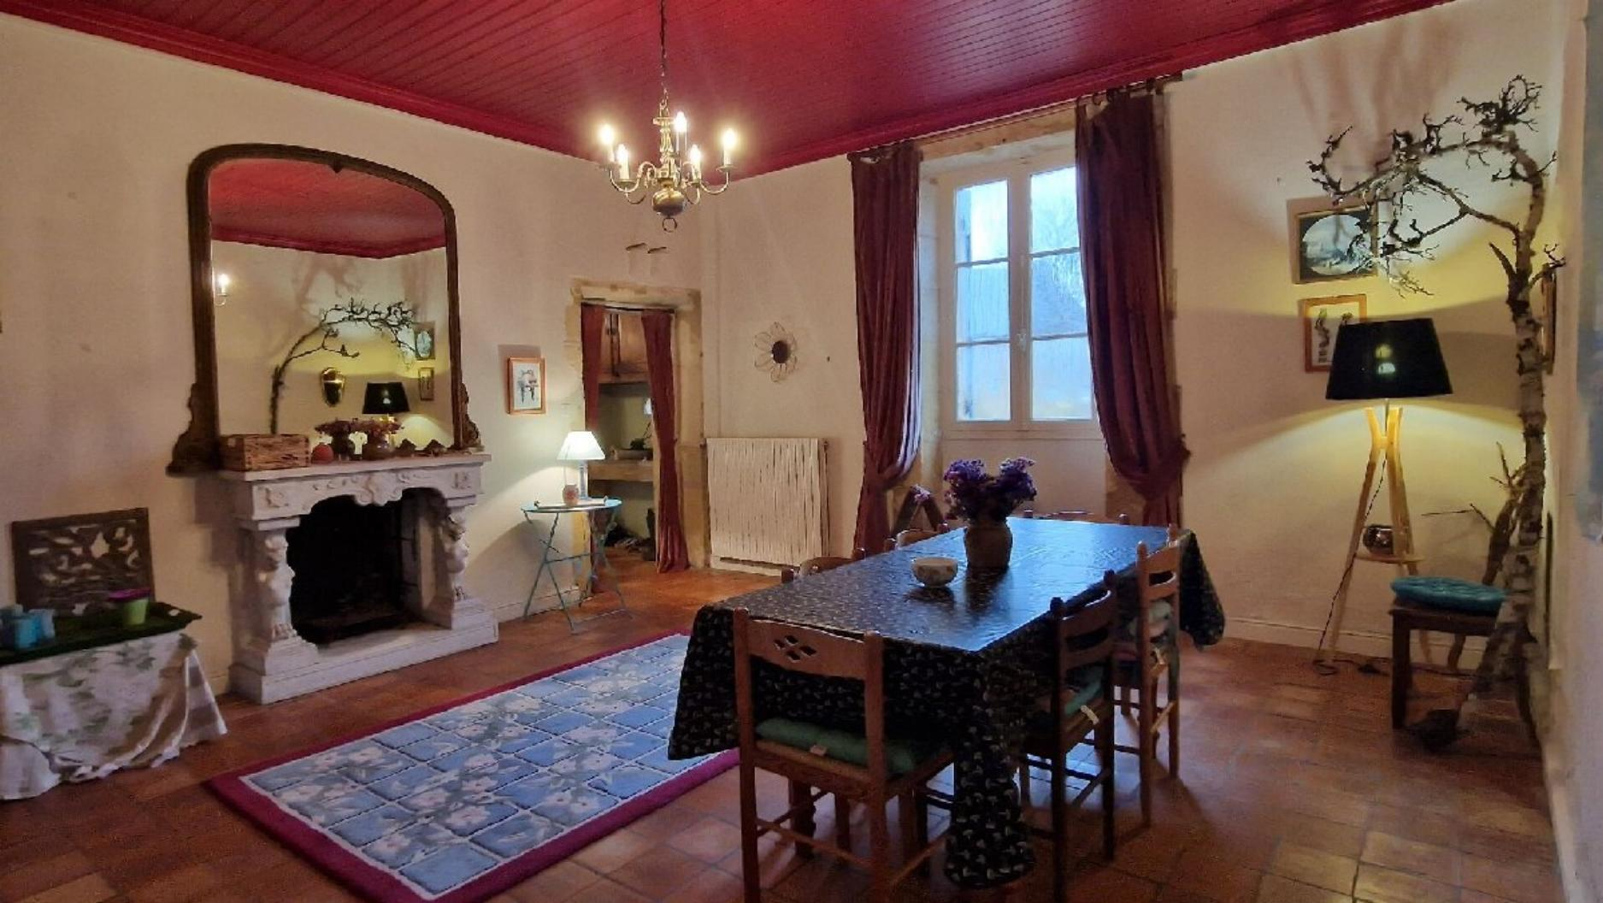
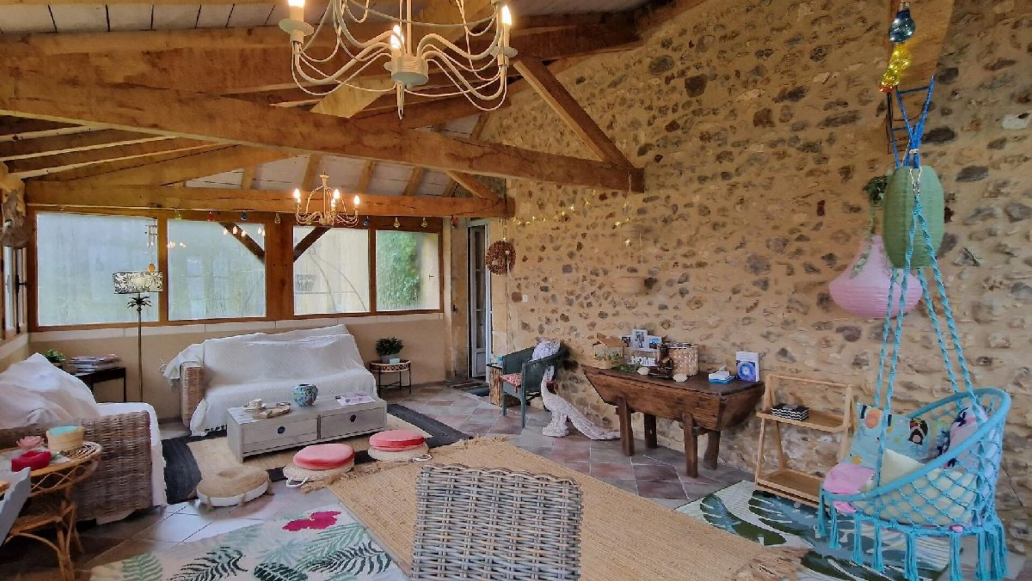 | 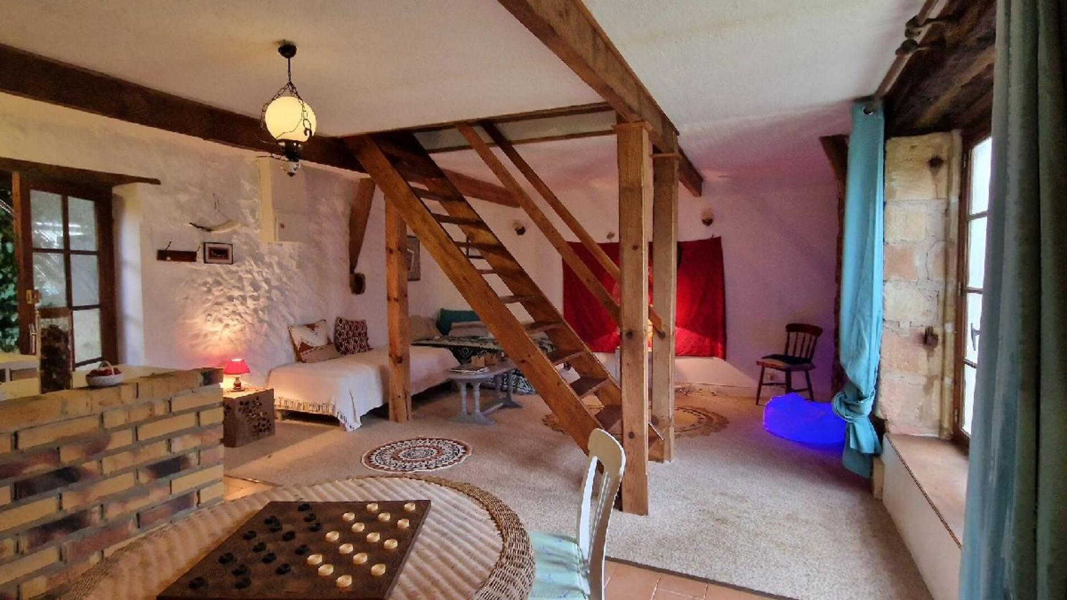
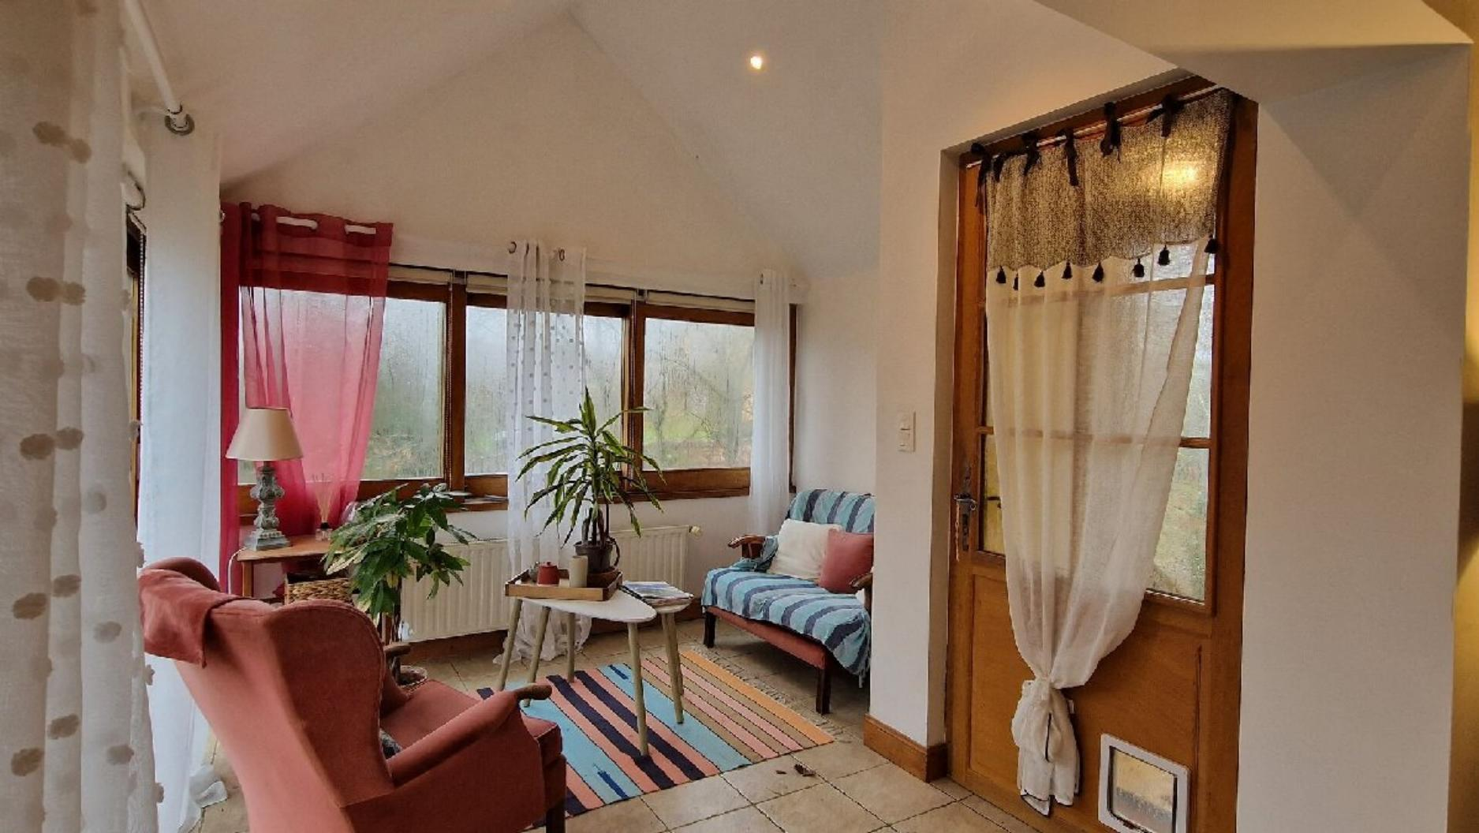 | 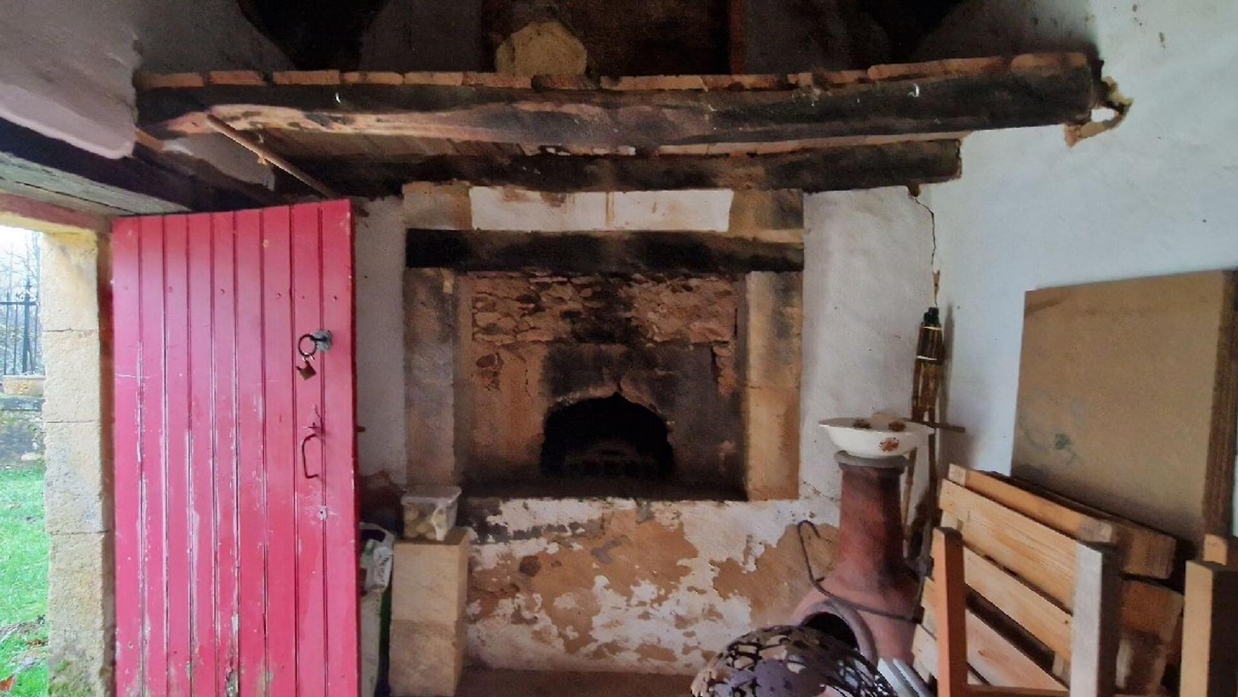
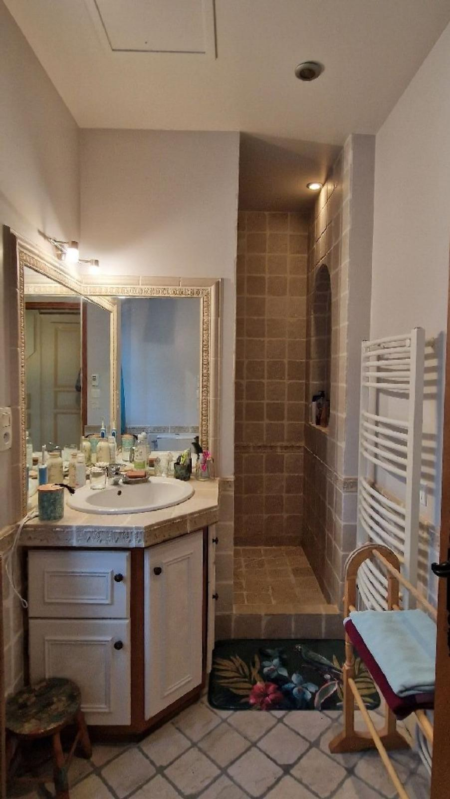 | 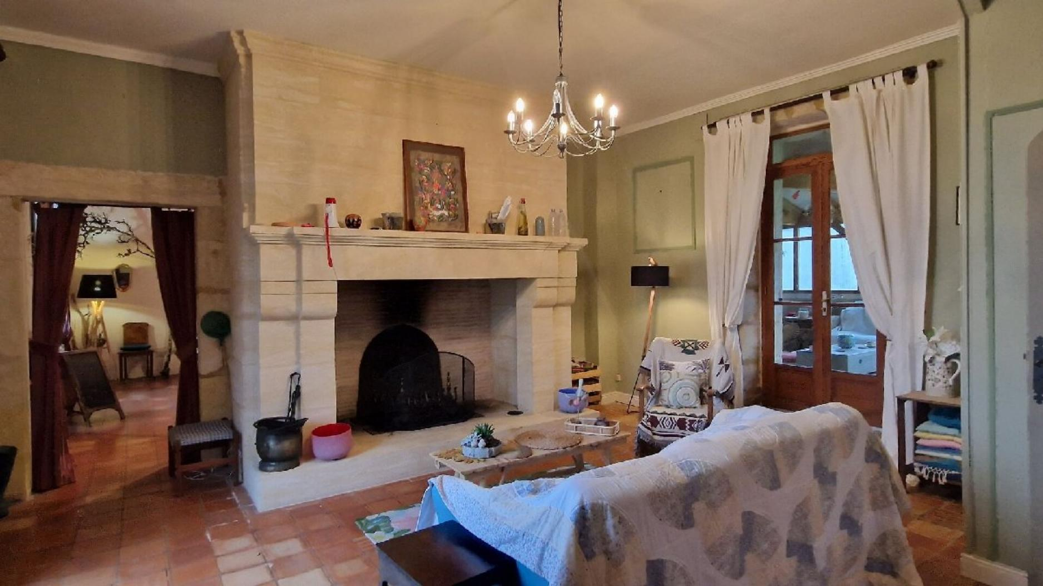
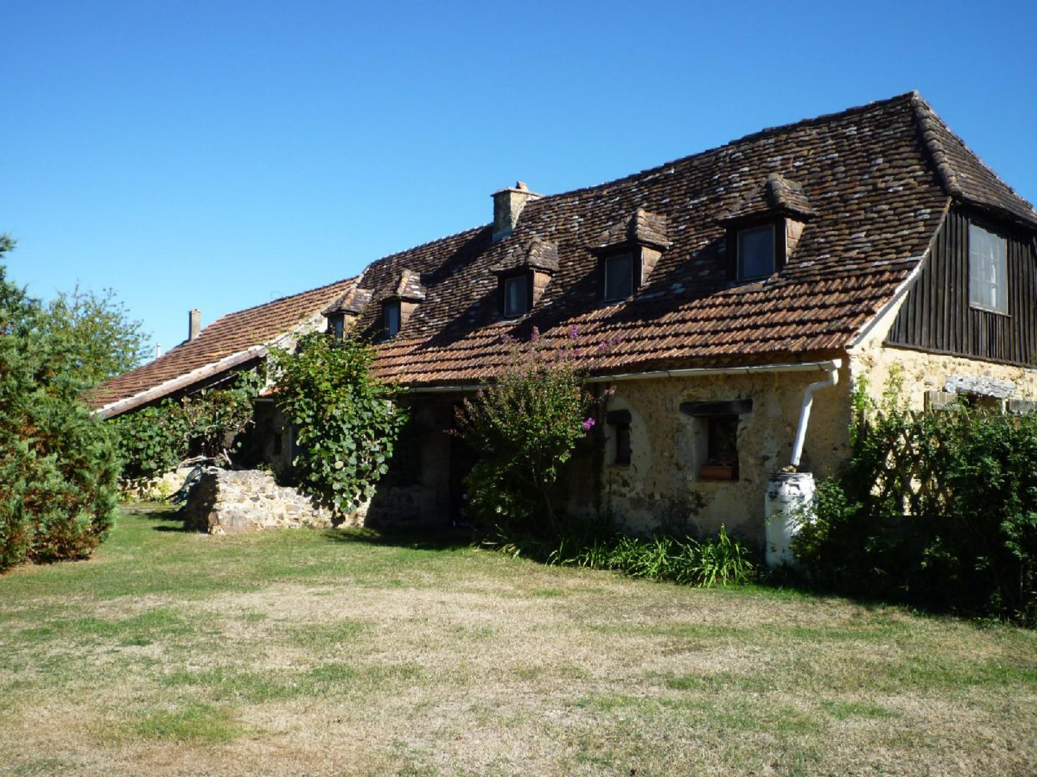 | 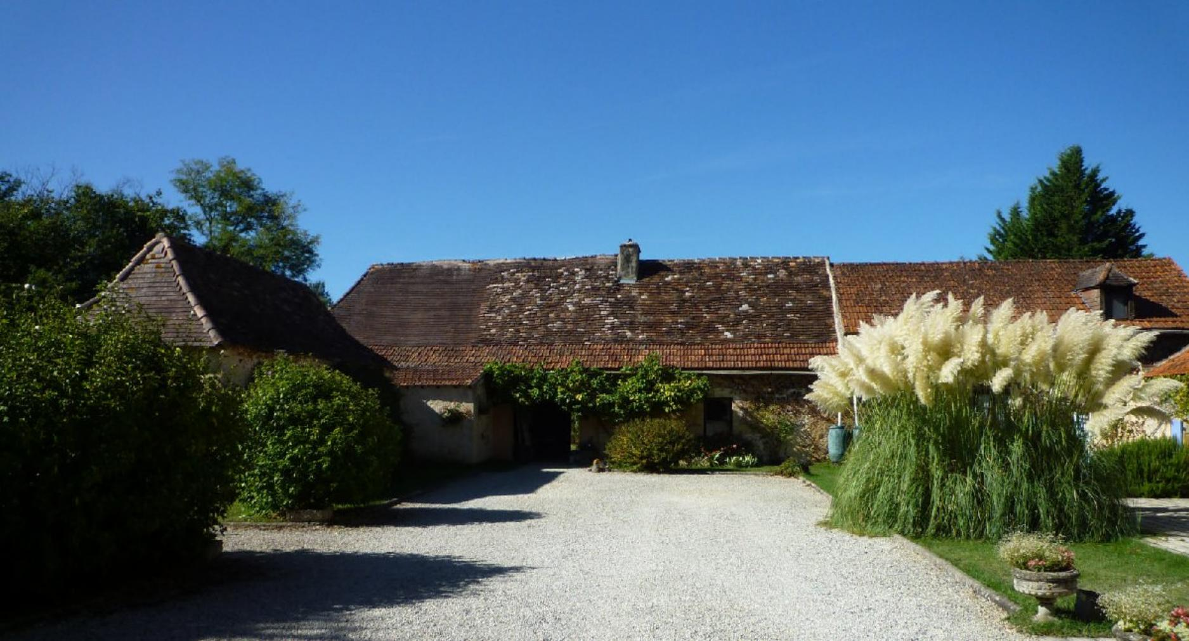
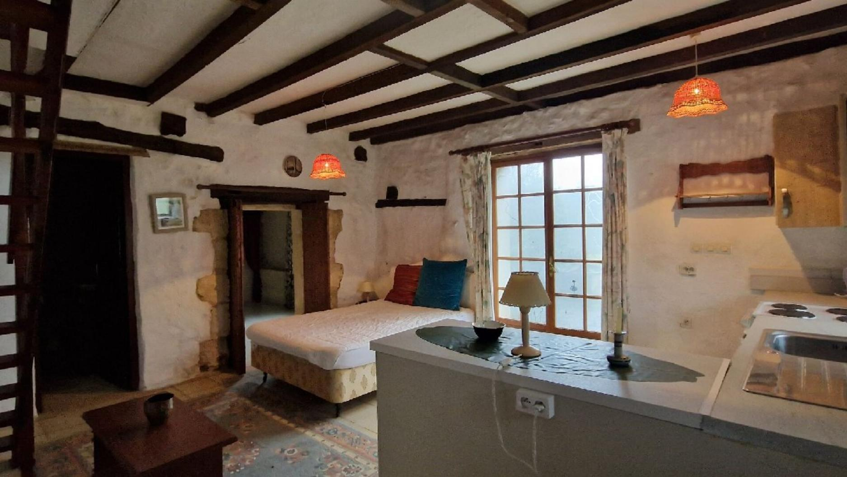 | 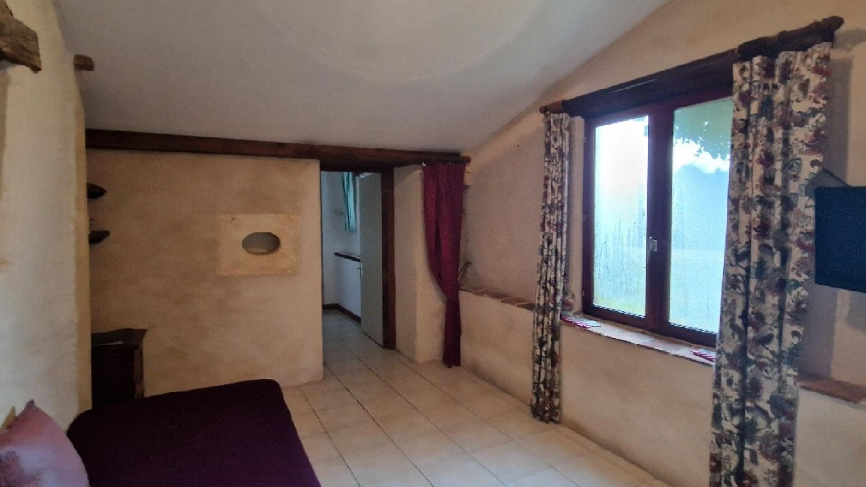
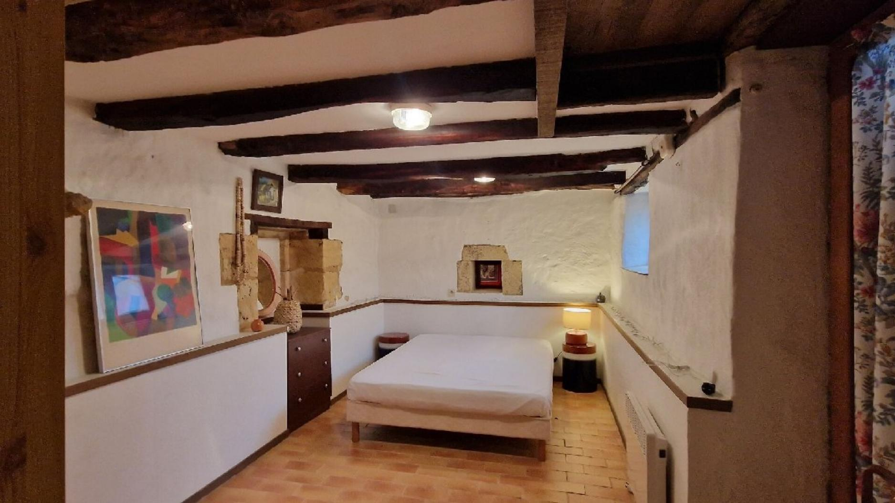 | 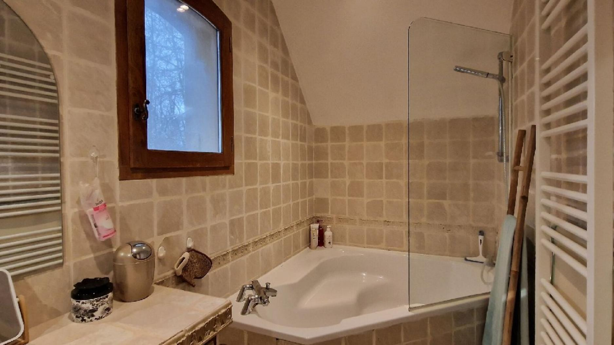
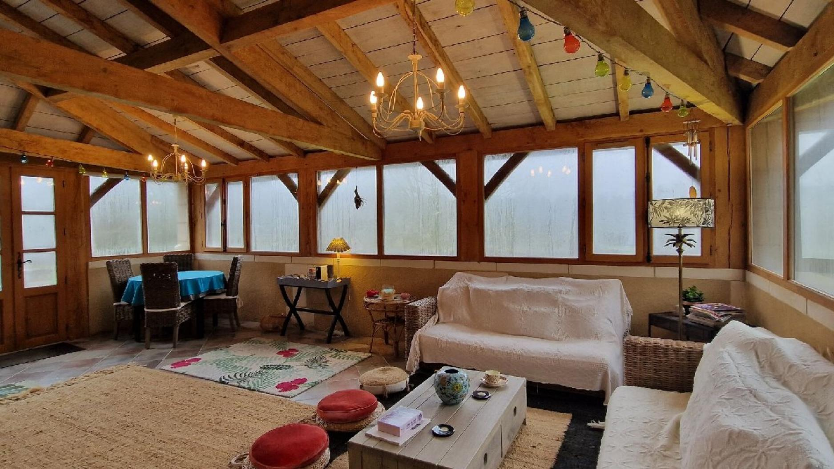 | 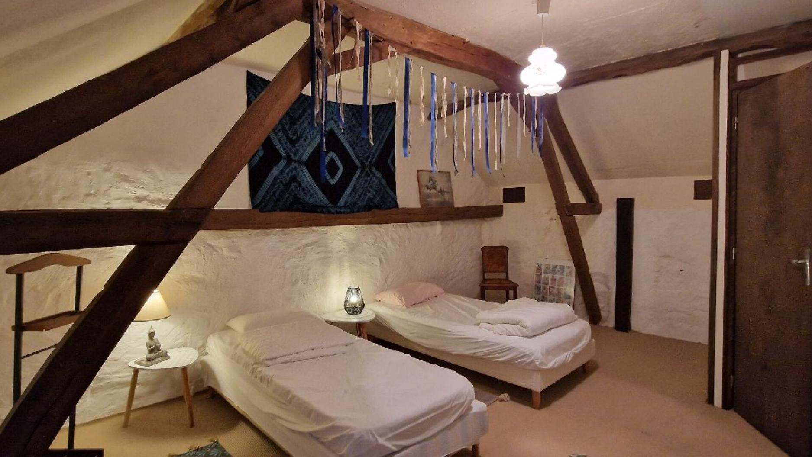
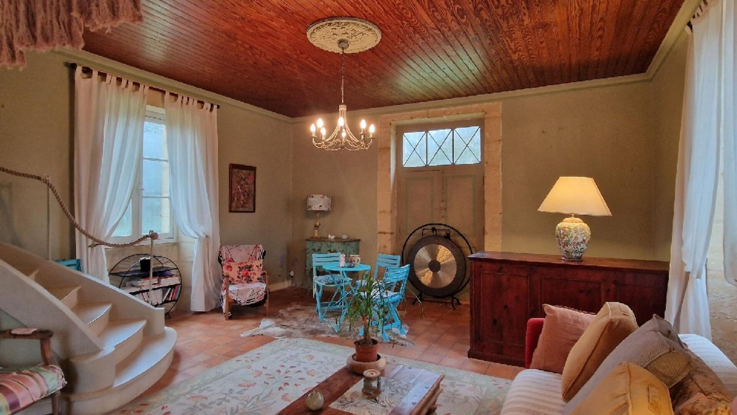 | 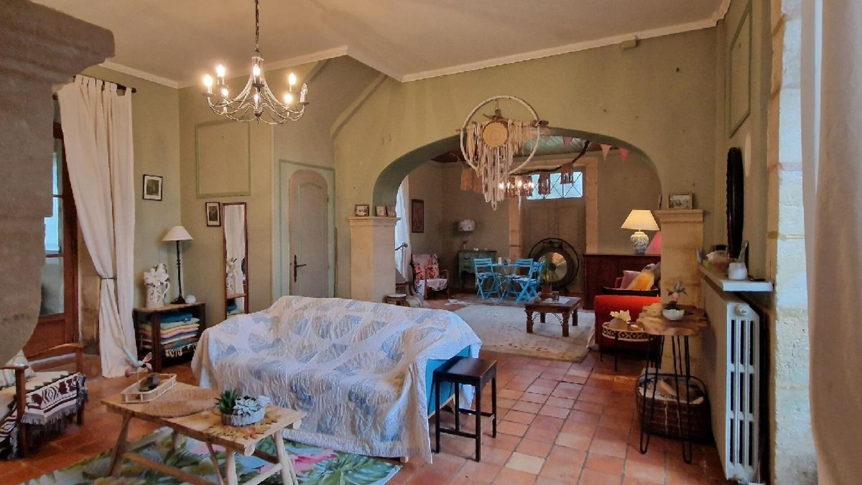
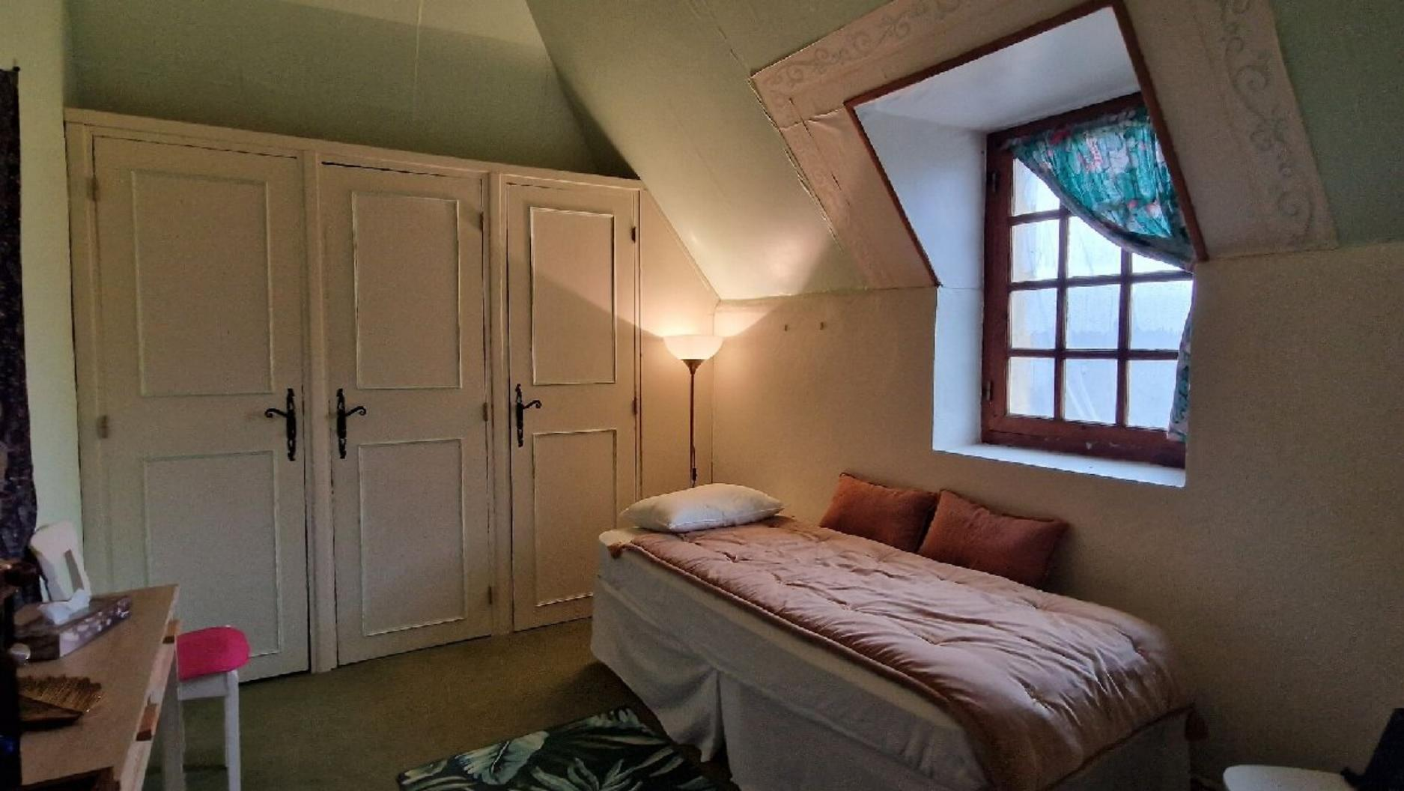 | 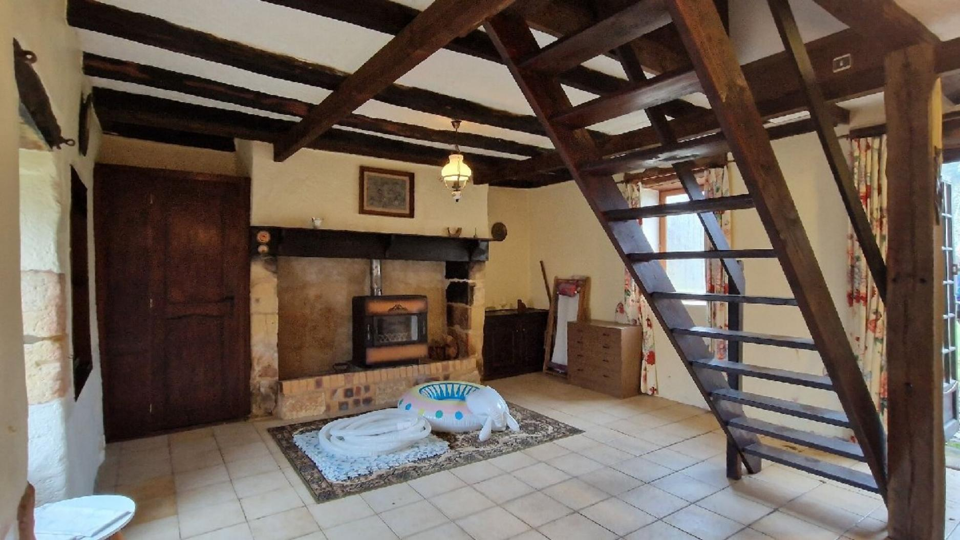
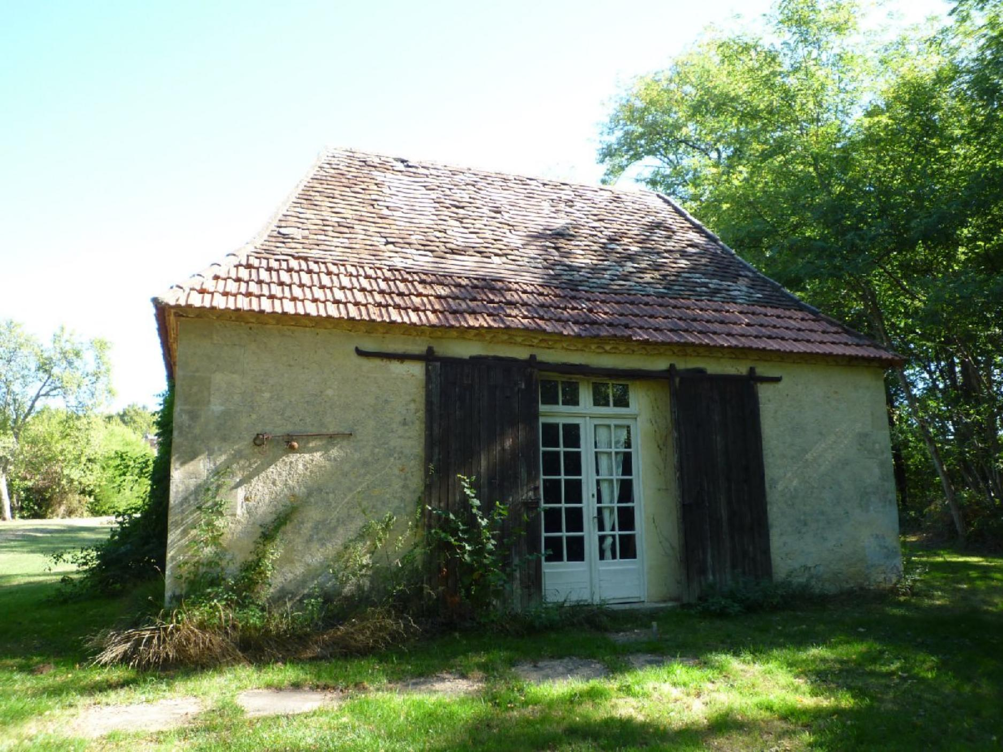 | 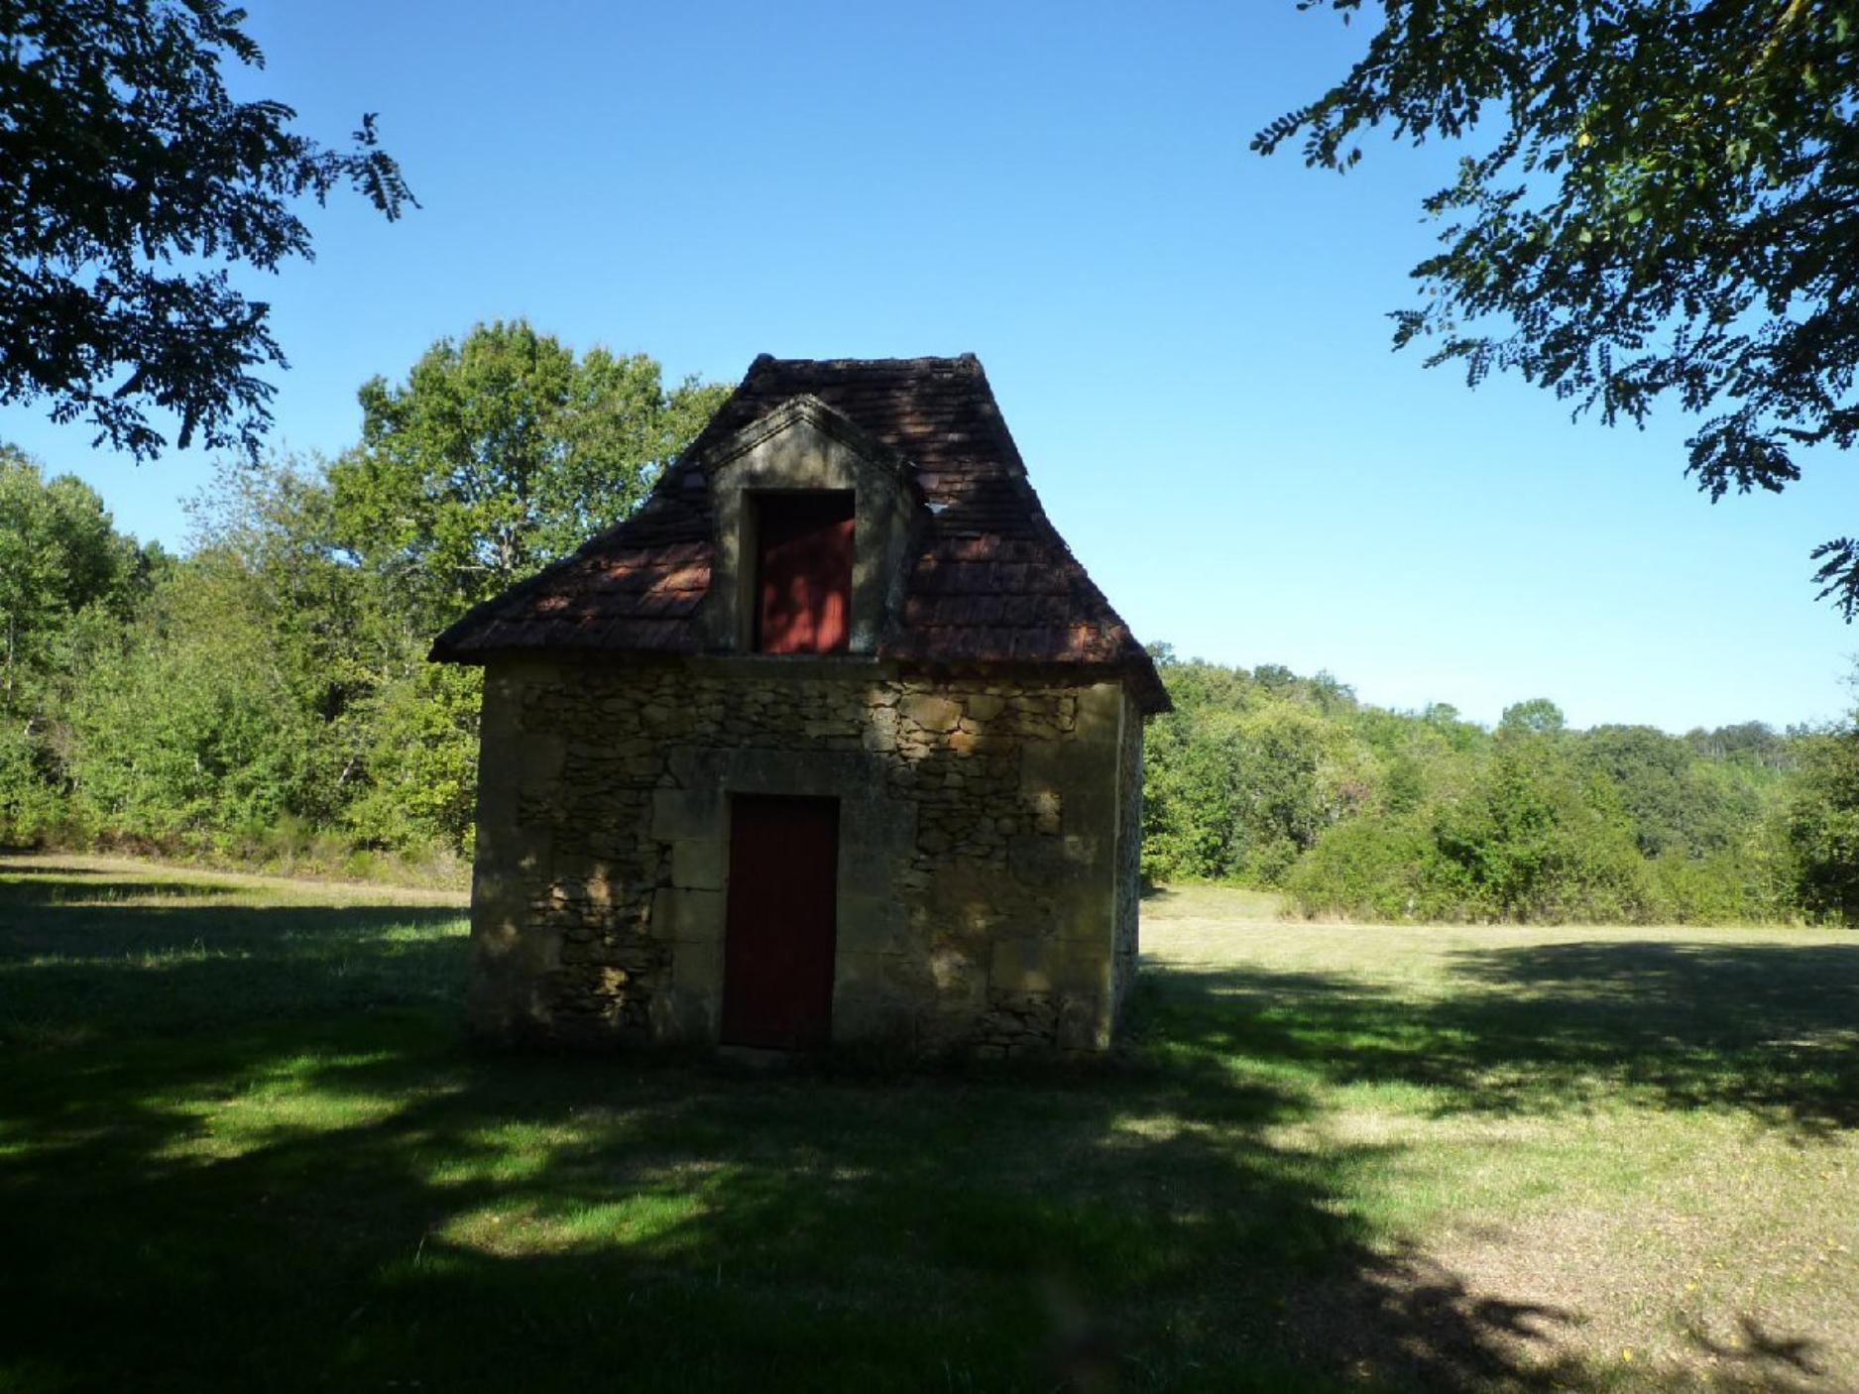
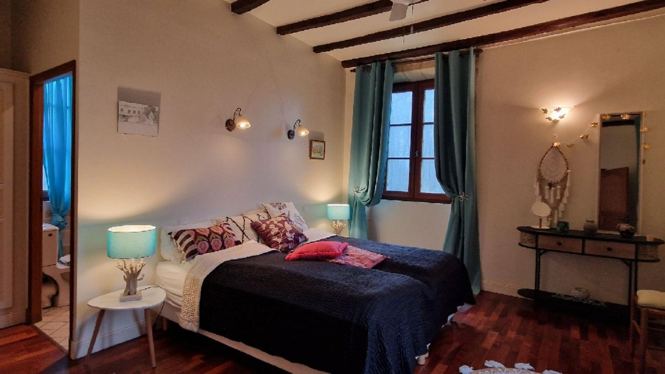 | 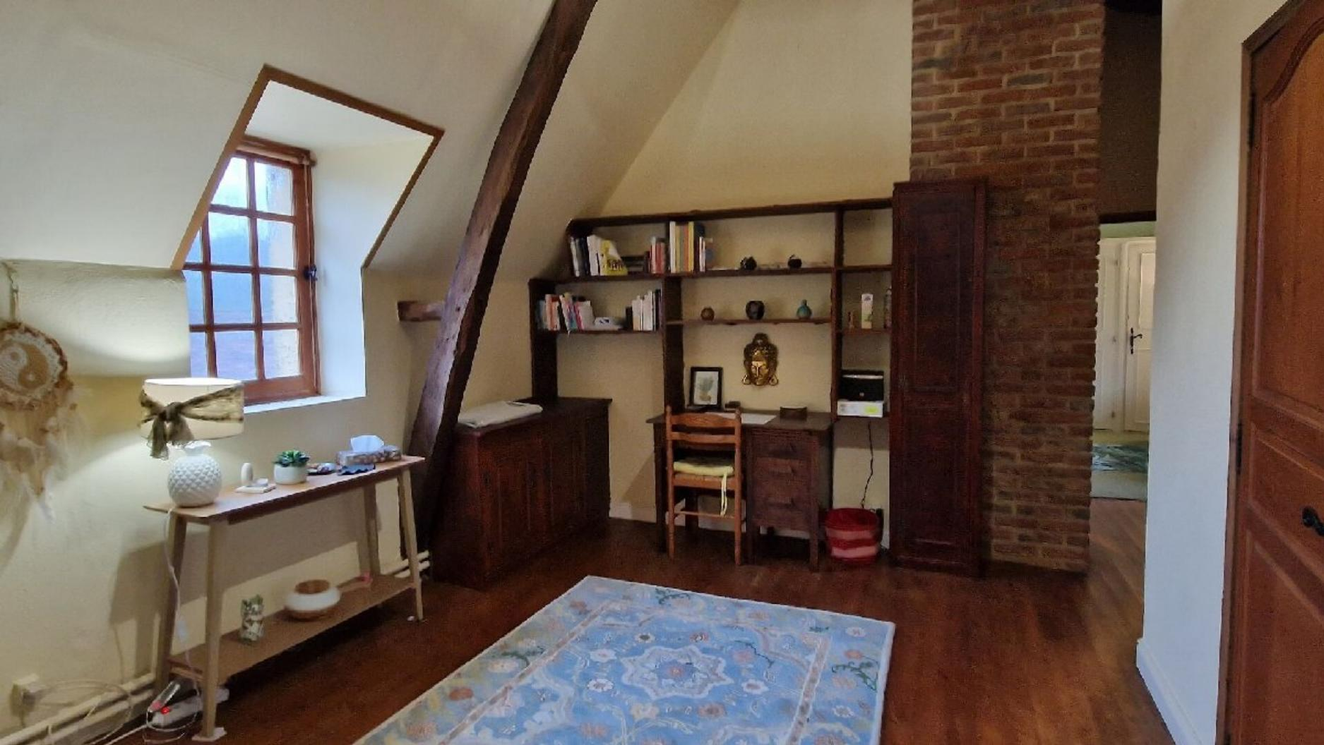
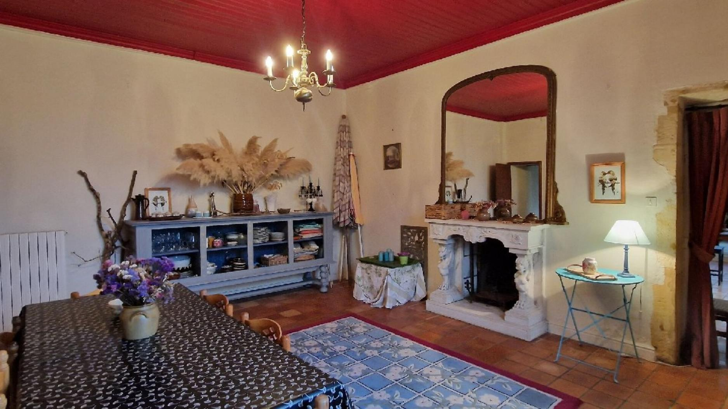 | 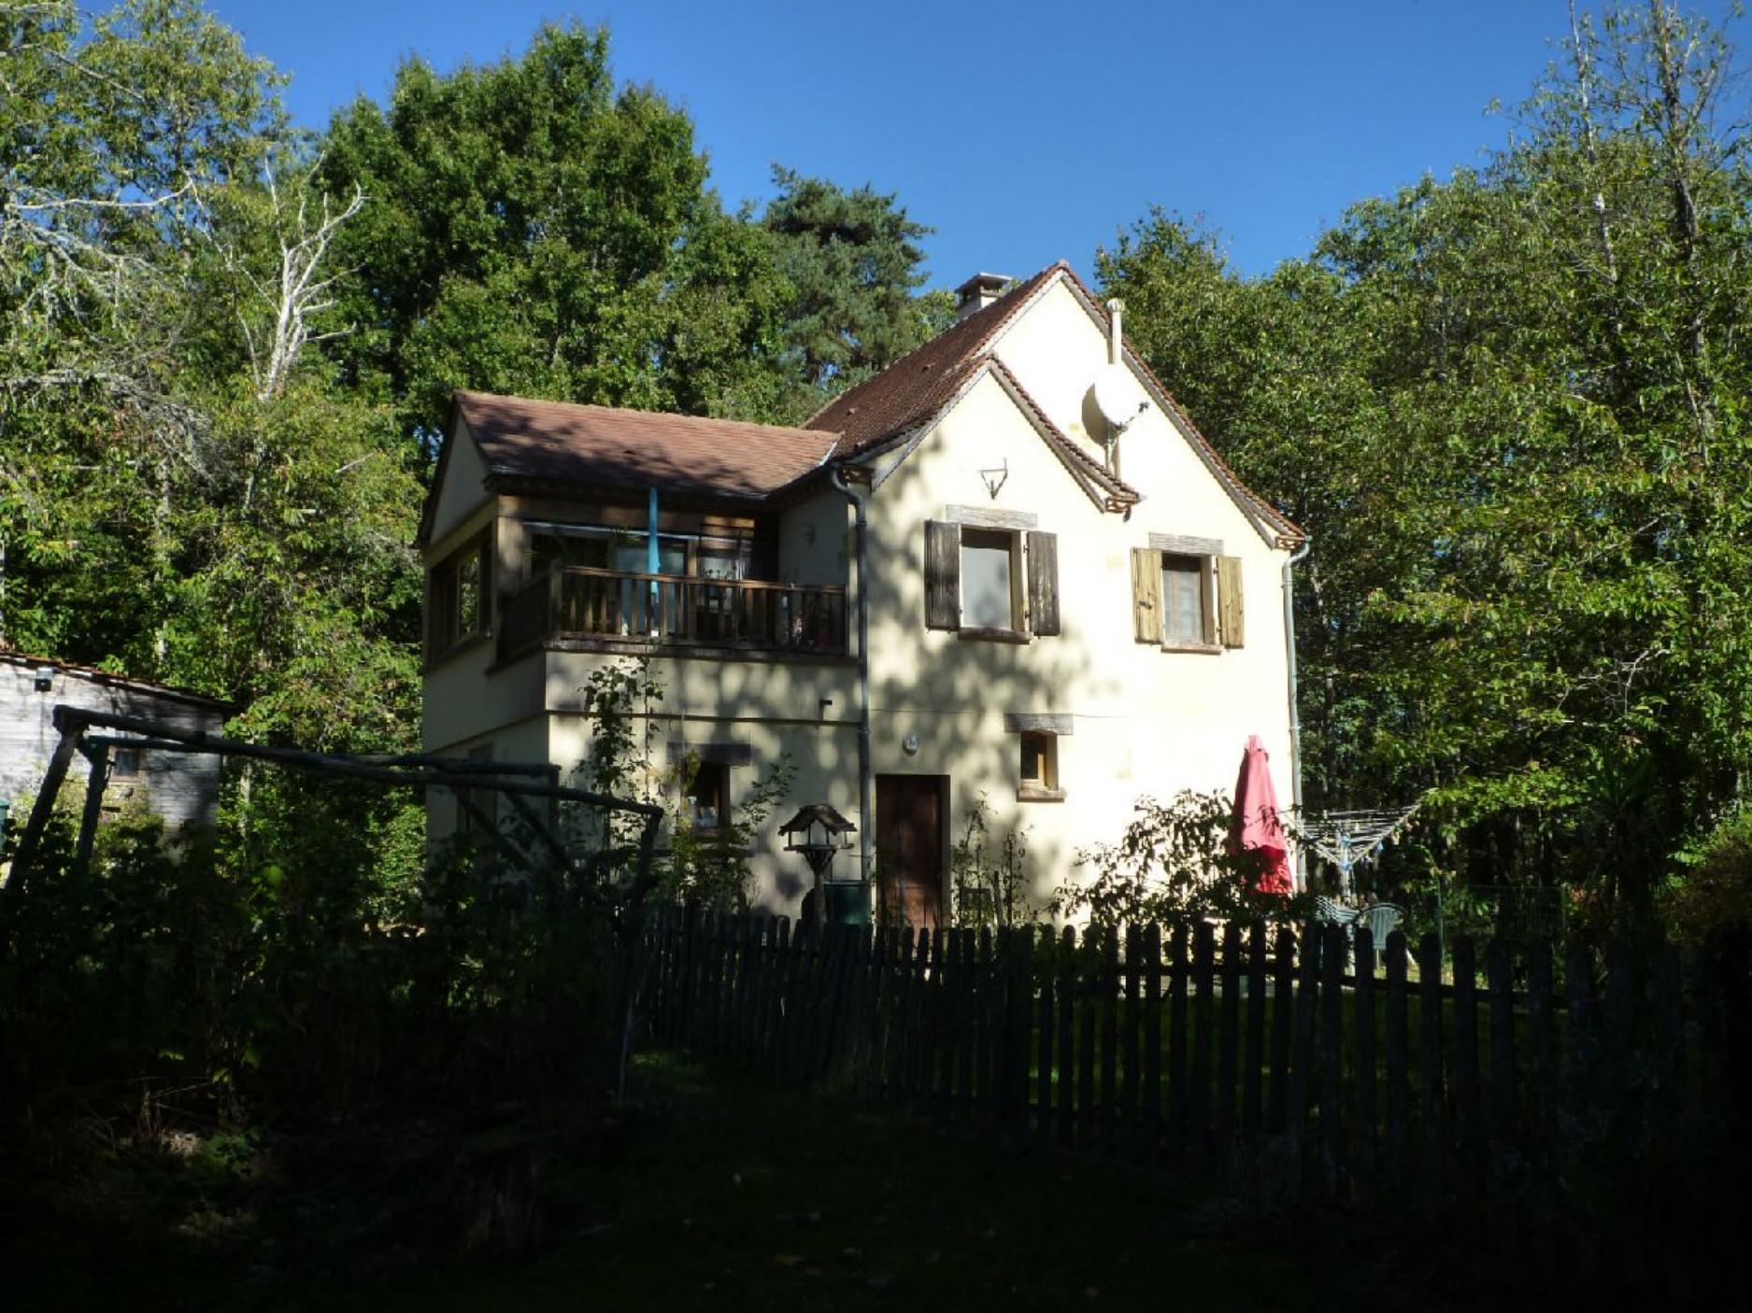
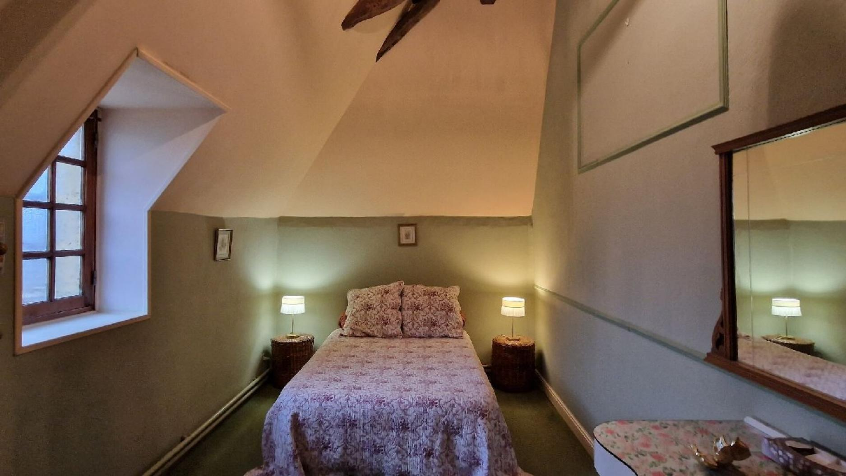 | 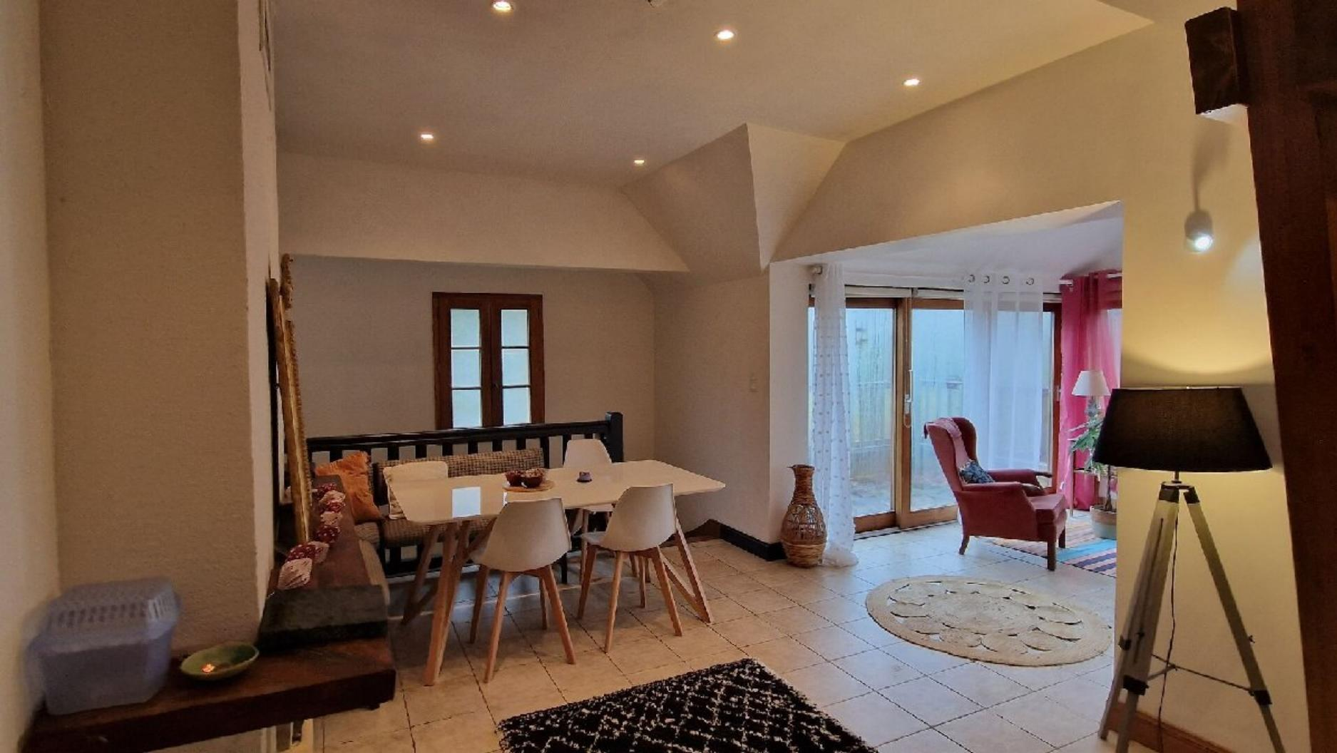
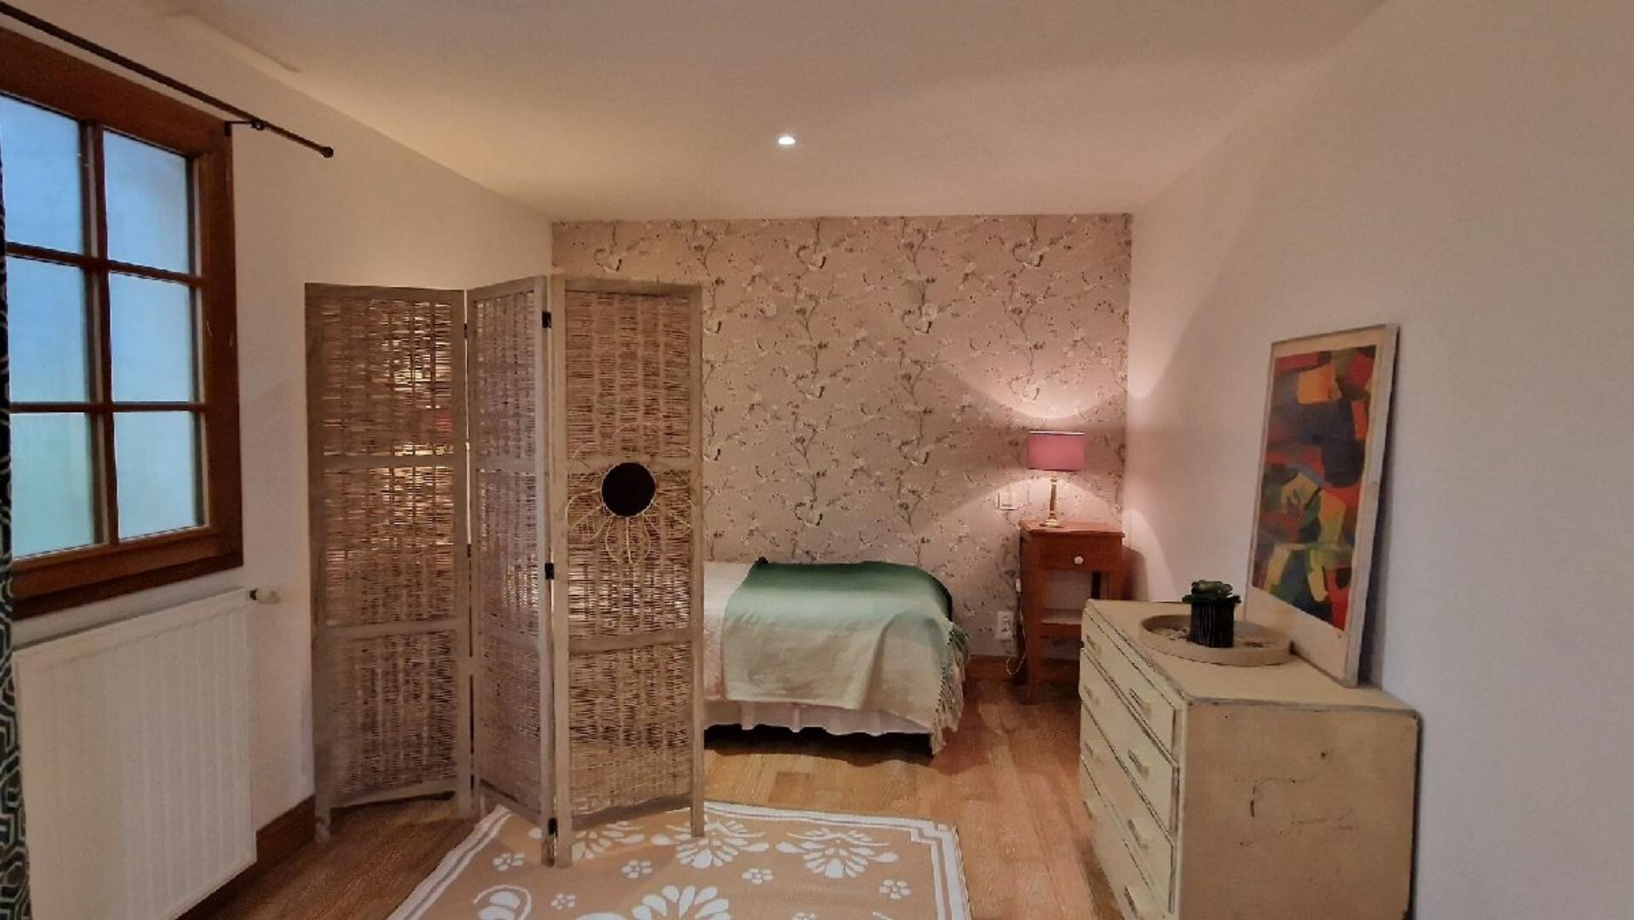 | 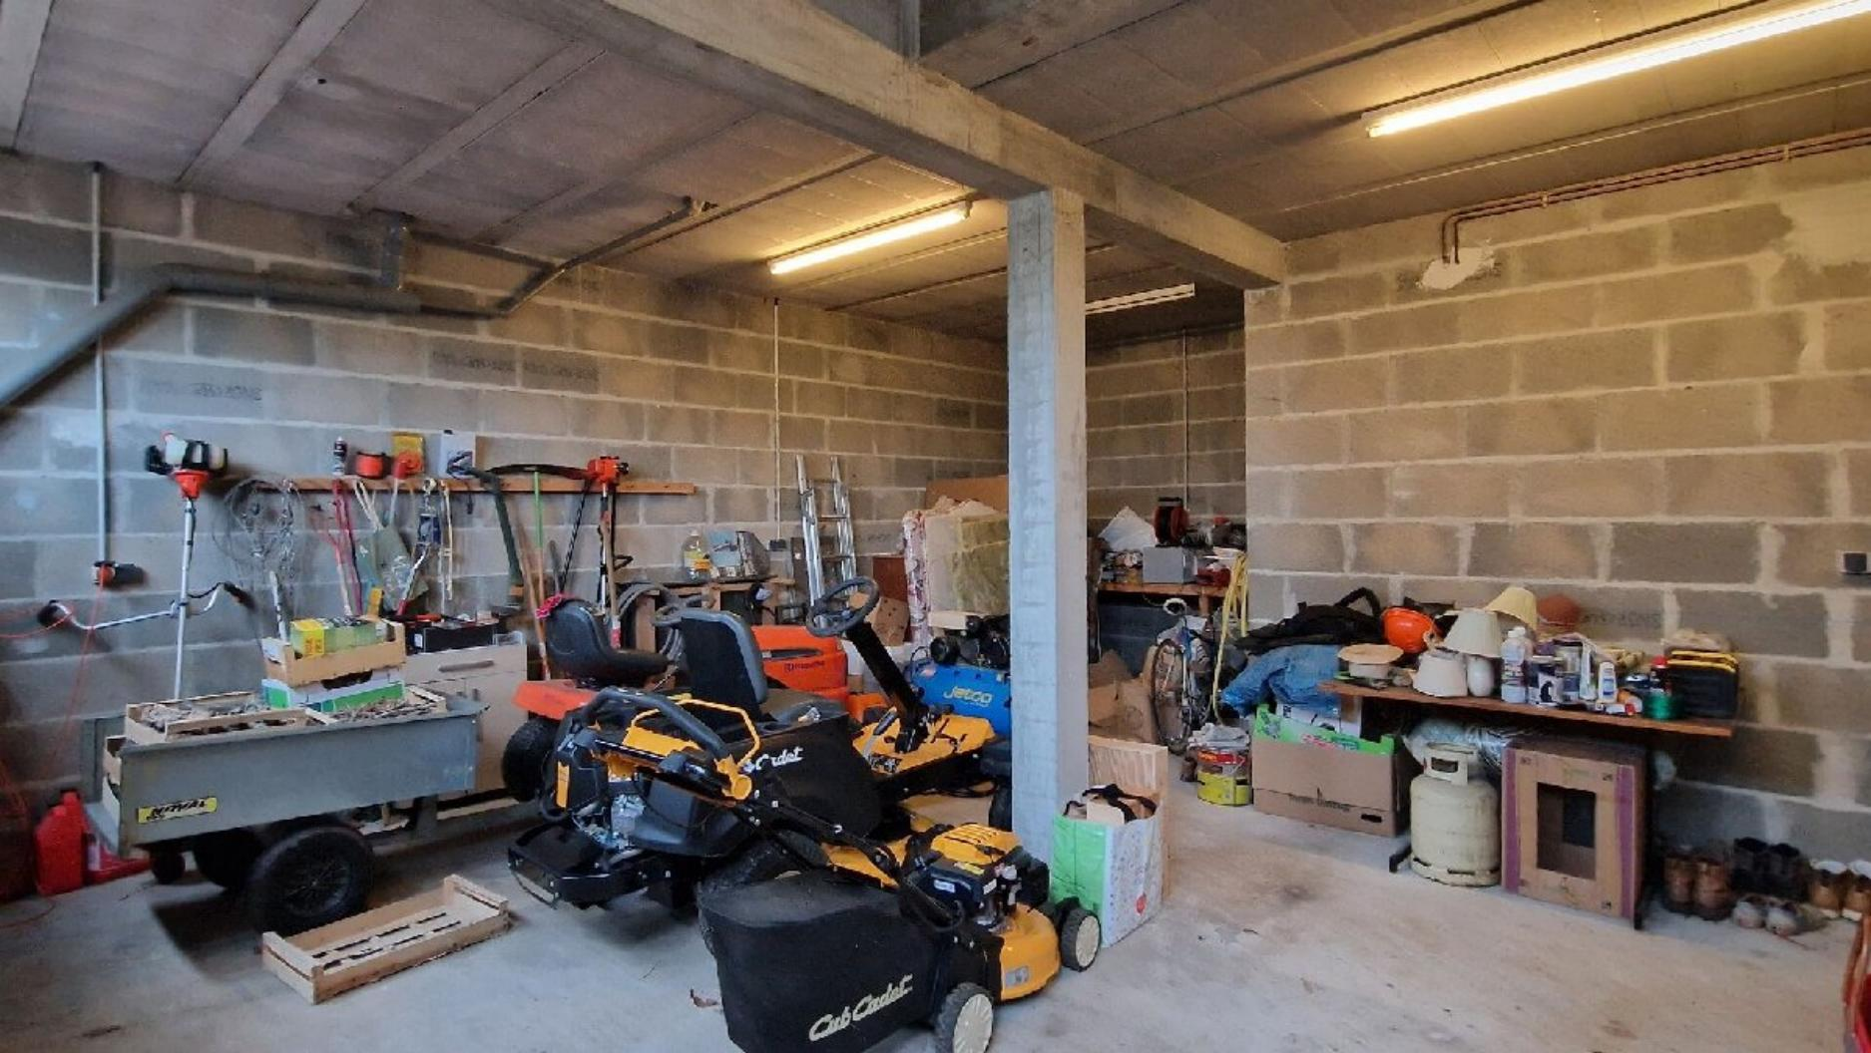

KEY DETAILS ( Ref . : DEP0862) :
Total living space : 500 Sqm  Land area : 258,374 Sqm  Heating : Oil  Energy Efficiency : E | Nearest town : 15mins - LE BUGUE / LES EYZIES  Nearest commerce : 15mins  Nearest autoroute : 15mins - A89/A20  Nearest airport : 50mins - BERGERAC

PIONEER FRANCE CAN  ASSIST YOU WITH :  € Foreign Currency Exchange  the best rates : the best service  € Mortgage and Loan Facilities  pre-qualified, top lenders  € Your Total purchase process  a dedicated, fixed fee, total service from  initial offer through to post-completion  Call us or see our website  www.PioneerFrance.com   | PROPERTY LOCATION MAP :

