Bon de Géolocalisation n° 25076
On the 14 February 2024
Mr RICHARD HORSNELL -- Tel : +447538658422 - richard.horsnell@redstartnw.com

Acknowledge having received from the above-mentioned agency the references, addresses, terms, and conditions of sale of the property or properties below.
Consequently, they expressly undertake not to communicate to anyone this information which is given to them on a personal and confidential basis, and to refrain from any direct contact and/or agreement, or through an intermediary or other property agency, with the seller which would result in the agency suffering any loss of commission in the event of the eventual purchase of one of these properties.
In the event of a breach of the above commitments, they will be liable to pay damages to compensate for the harm and/or loss caused to this agency.
This agreement is valid for a period of thirty-six months from this day.

Description of the geolocalised properties :

Nature : Properties | Property Ref : DEP0735
Description : CHARACTERFUL STONE DORDOGNE FARMHOUSE WITH LARGE 4-BED MAIN HOUSE, A LARGE GITE AND ADDITIONAL ACCOMMODATION TO FINISH INTERNALLY. MANY OUTBUILDGNS. 15 HECTARES OF LAND, STREAM, PONDS & WOODS. DEP0735 | Price : 795,000 €  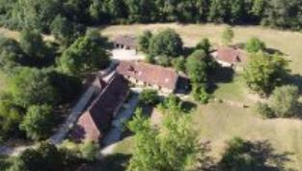

Prepare at Fleurac, Dordogne , on the 14 February 2024
Two copies, one of which is given to enquirers/visitors, and one retained by the Agency.

Signature of the agent preceded by the words, 'read and agreed' | Enquirer's / Visitor's signatures, preceded by the hand-written words: ' read and agreed '
For Pioneer France : Harris RAPHAEL | Mr RICHARD HORSNELL

