THE DORDOGNE'S LEADING PROPERTY AGENCY +33 (0)5 53 07 06 27 info@PioneerFrance.com www.PioneerFrance.com  PF90307 399,500 € inc agency comm 6 % payable by buyer 0.06 ACRES STE ALVERE AREA  SUPERB, ELEGANT 5 BED 5 BATH HOUSE WITH BARNS IN A GEORGOUS DORDOGNE VILLAGE WITH ALL AMENTIES. CURRENTLY OPERATING AS A SUCCESSFUL CHAMBRE D’HÔTES/B&B. PF90307  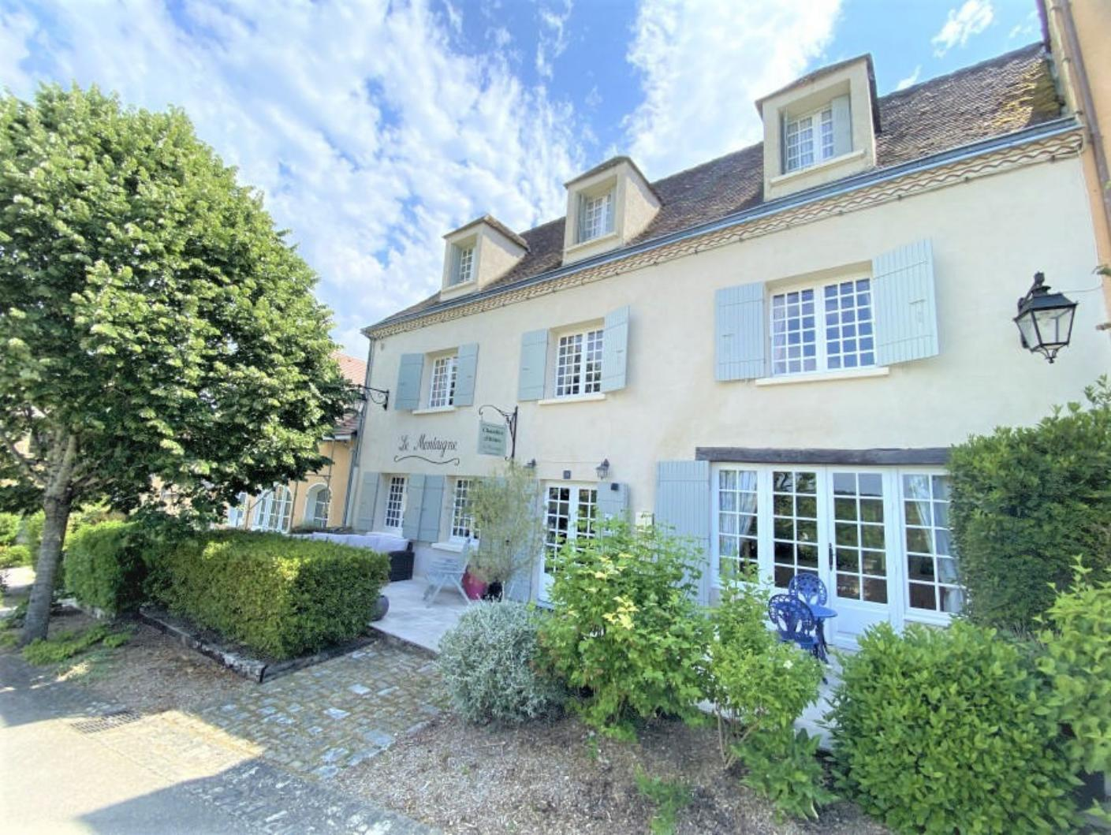 | 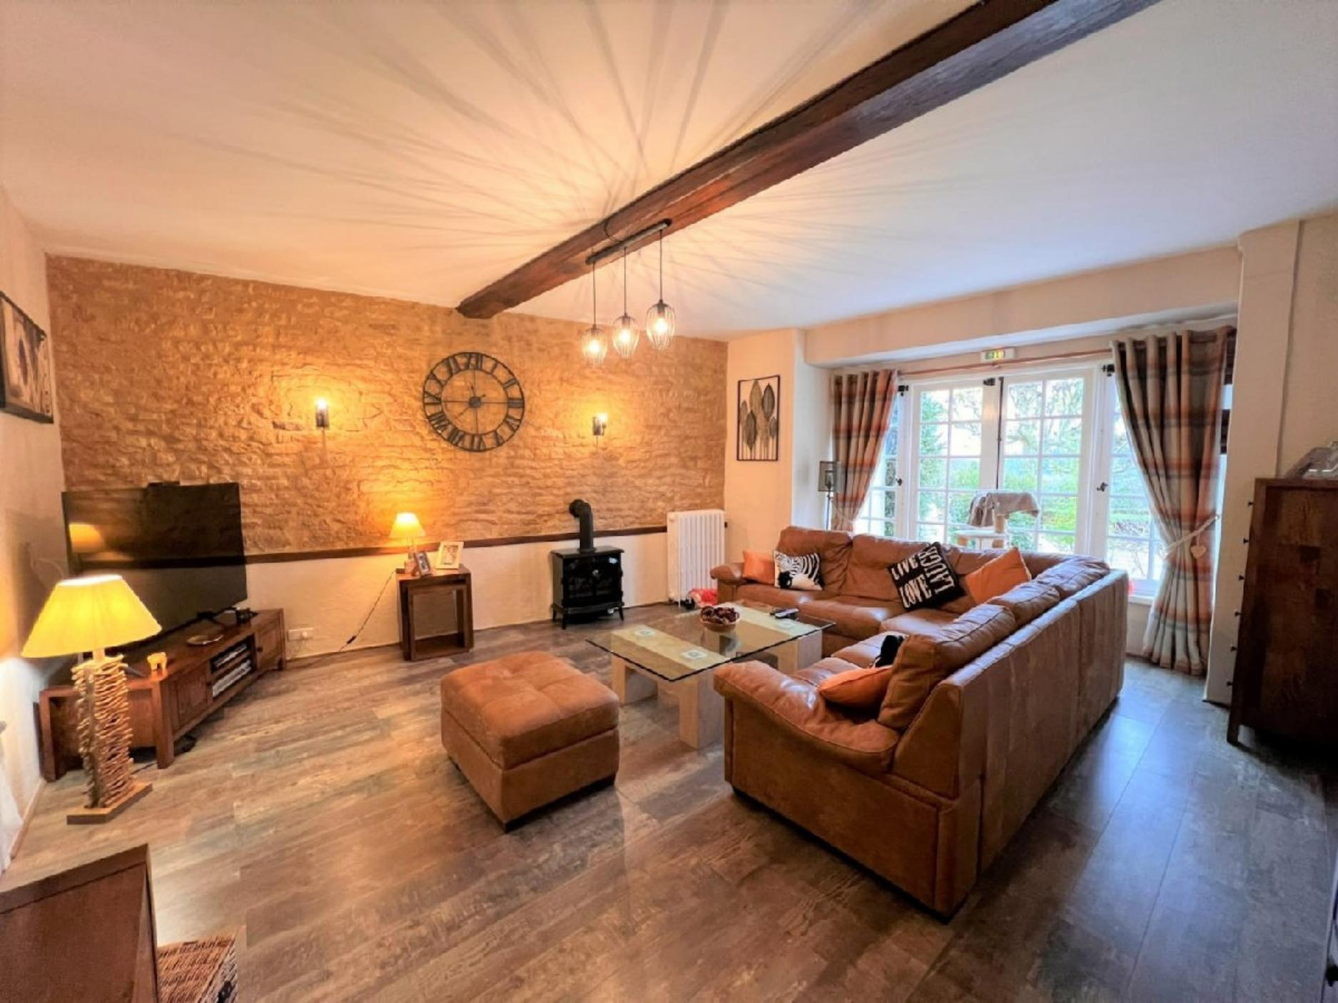  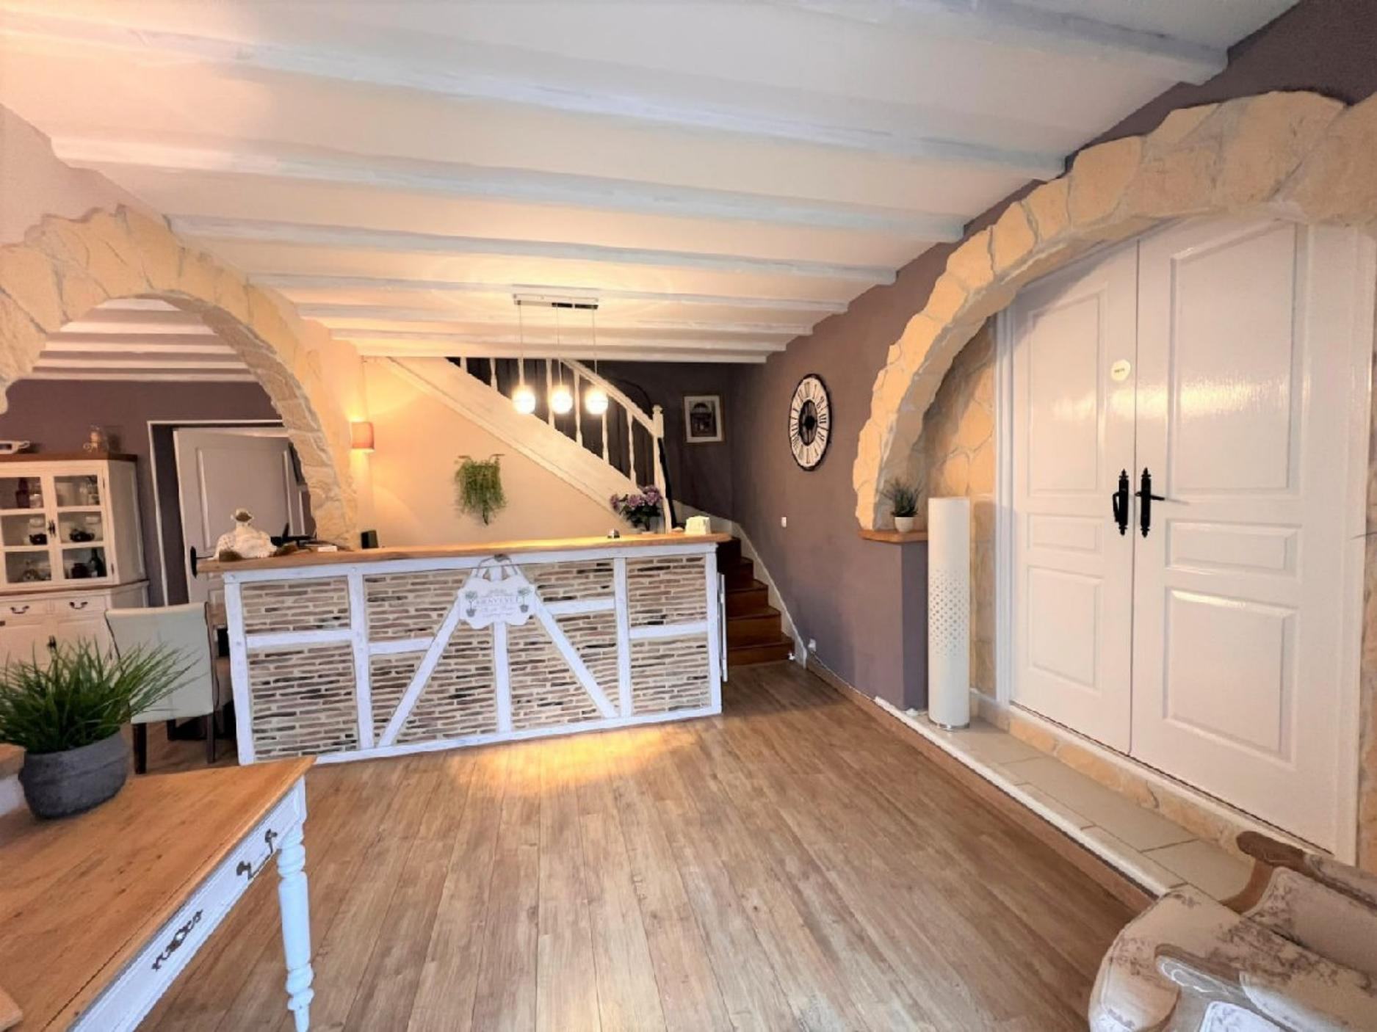  190 KWHep/m² an 46 Kg CO2/m² an

