THE DORDOGNE'S LEADING PROPERTY AGENCY +33 (0)5 53 07 06 27 info@PioneerFrance.com www.PioneerFrance.com  PF90301 450,000 € inc agency comm 6 % payable by buyer 2.47 ACRES PERIGUEUX AREA  RENOVATED 5/6 BED STONE HOUSE, HUGE INDEPENDENT BARN, SEPARATE VERY LARGE WORKSHOP WITH APARTMENT, 1 HA (ALMOST 2.5 ACRES) OF LAND. PF90301  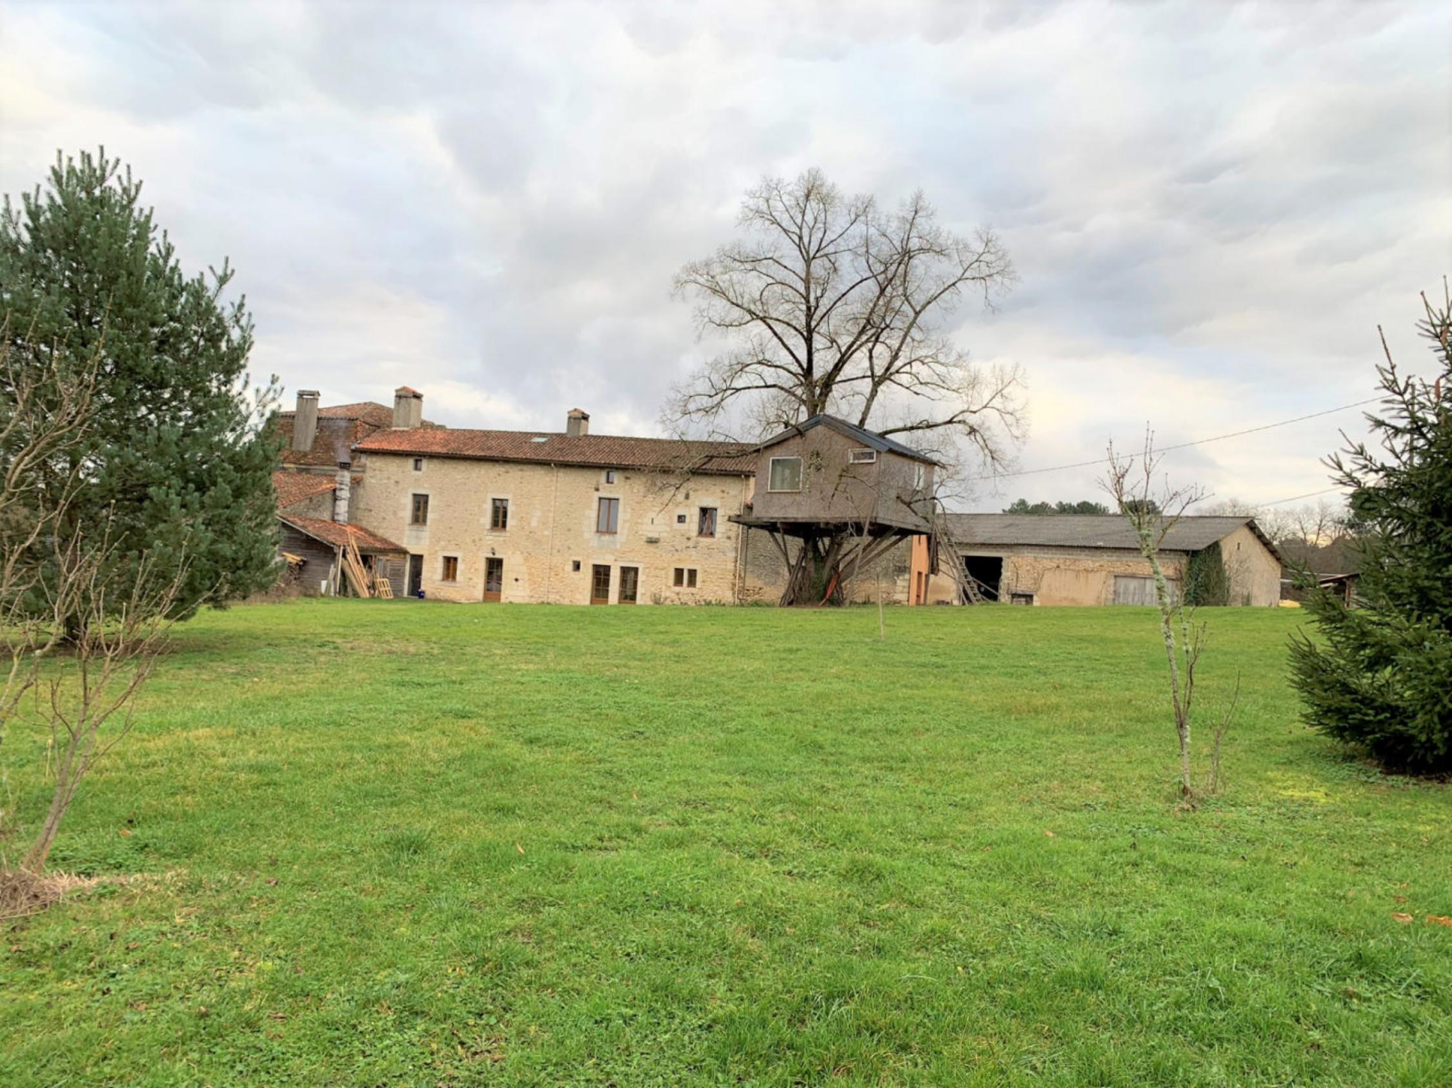 | 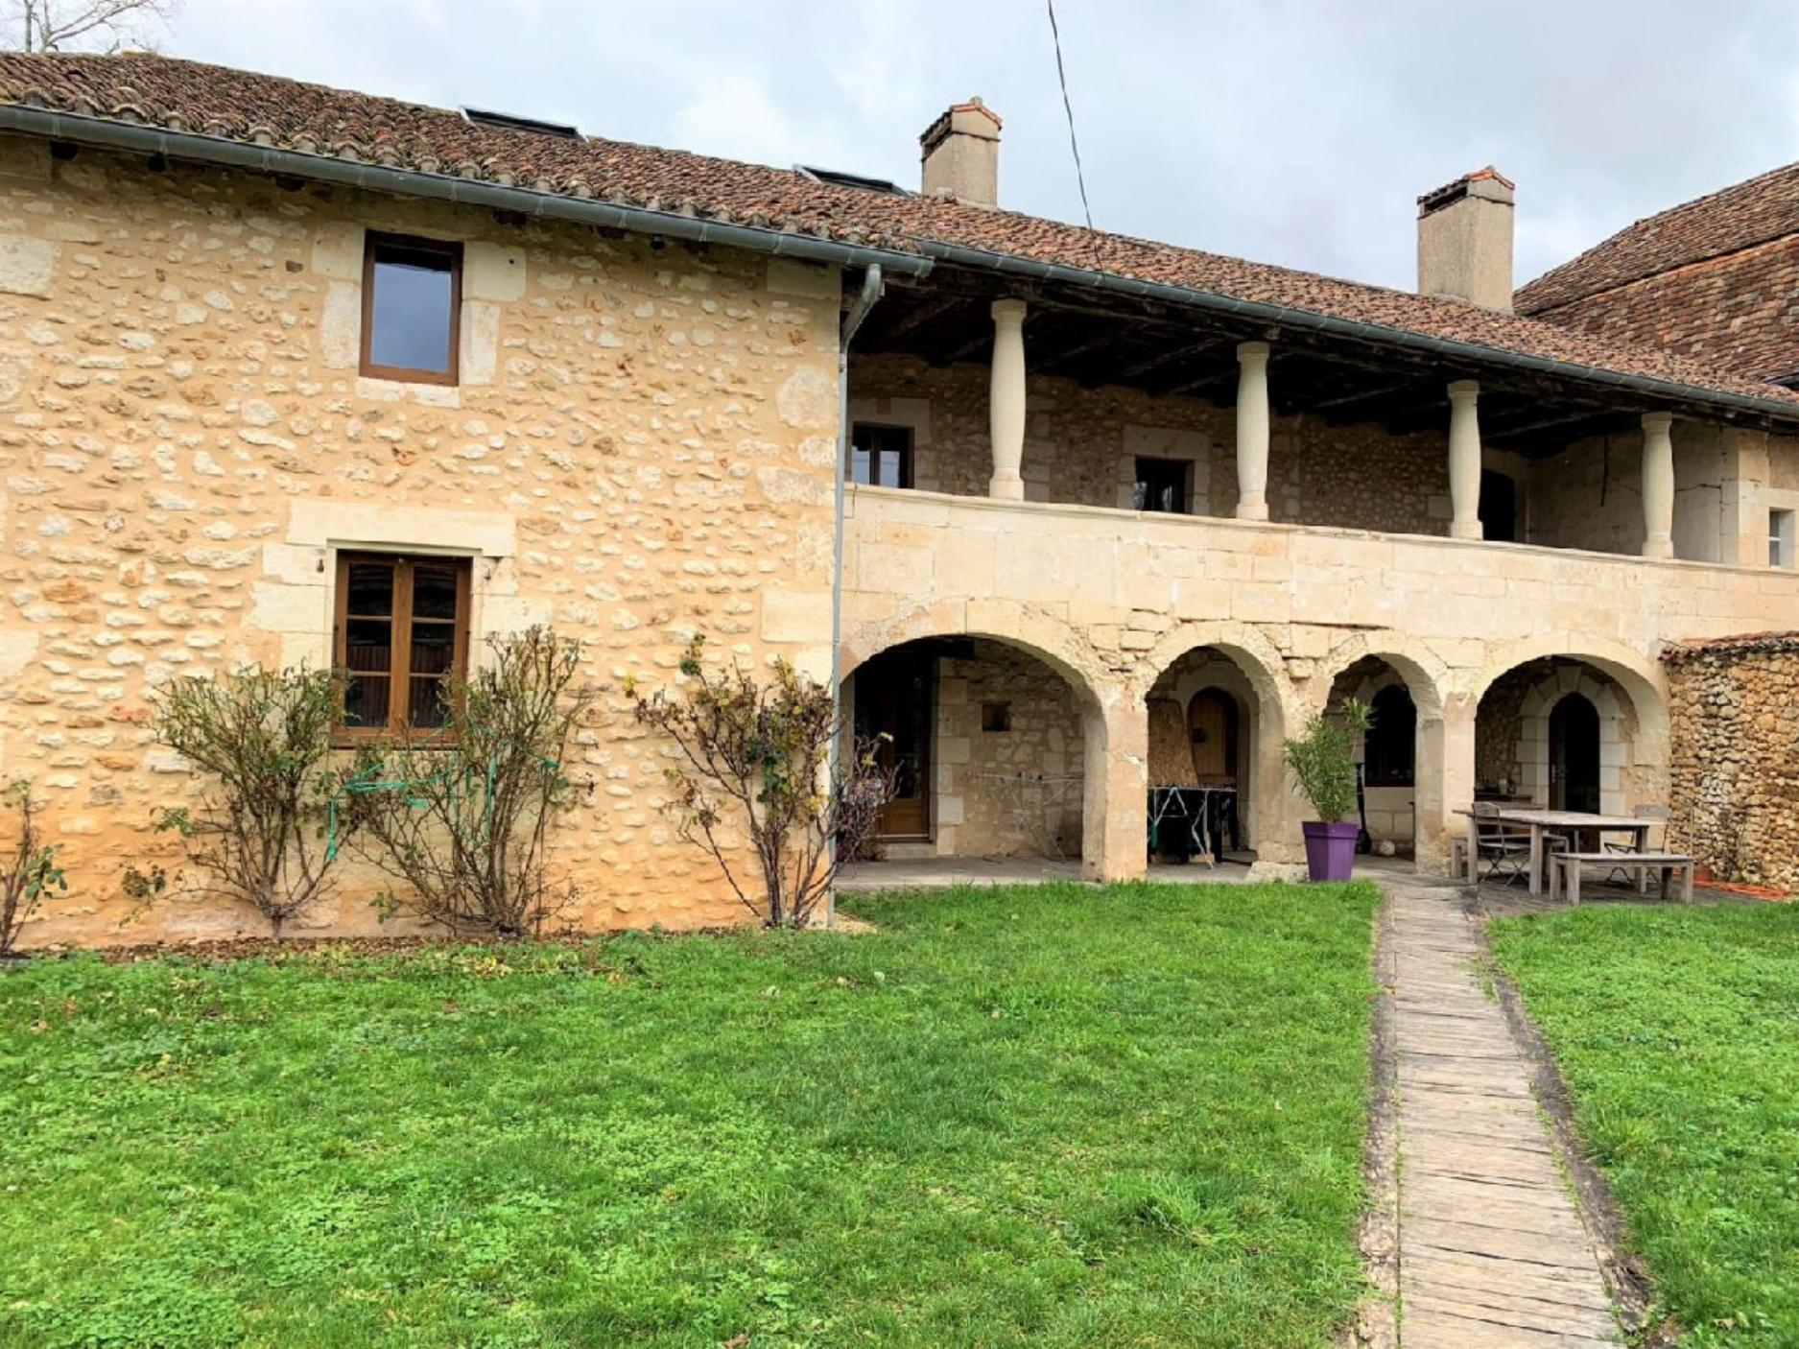  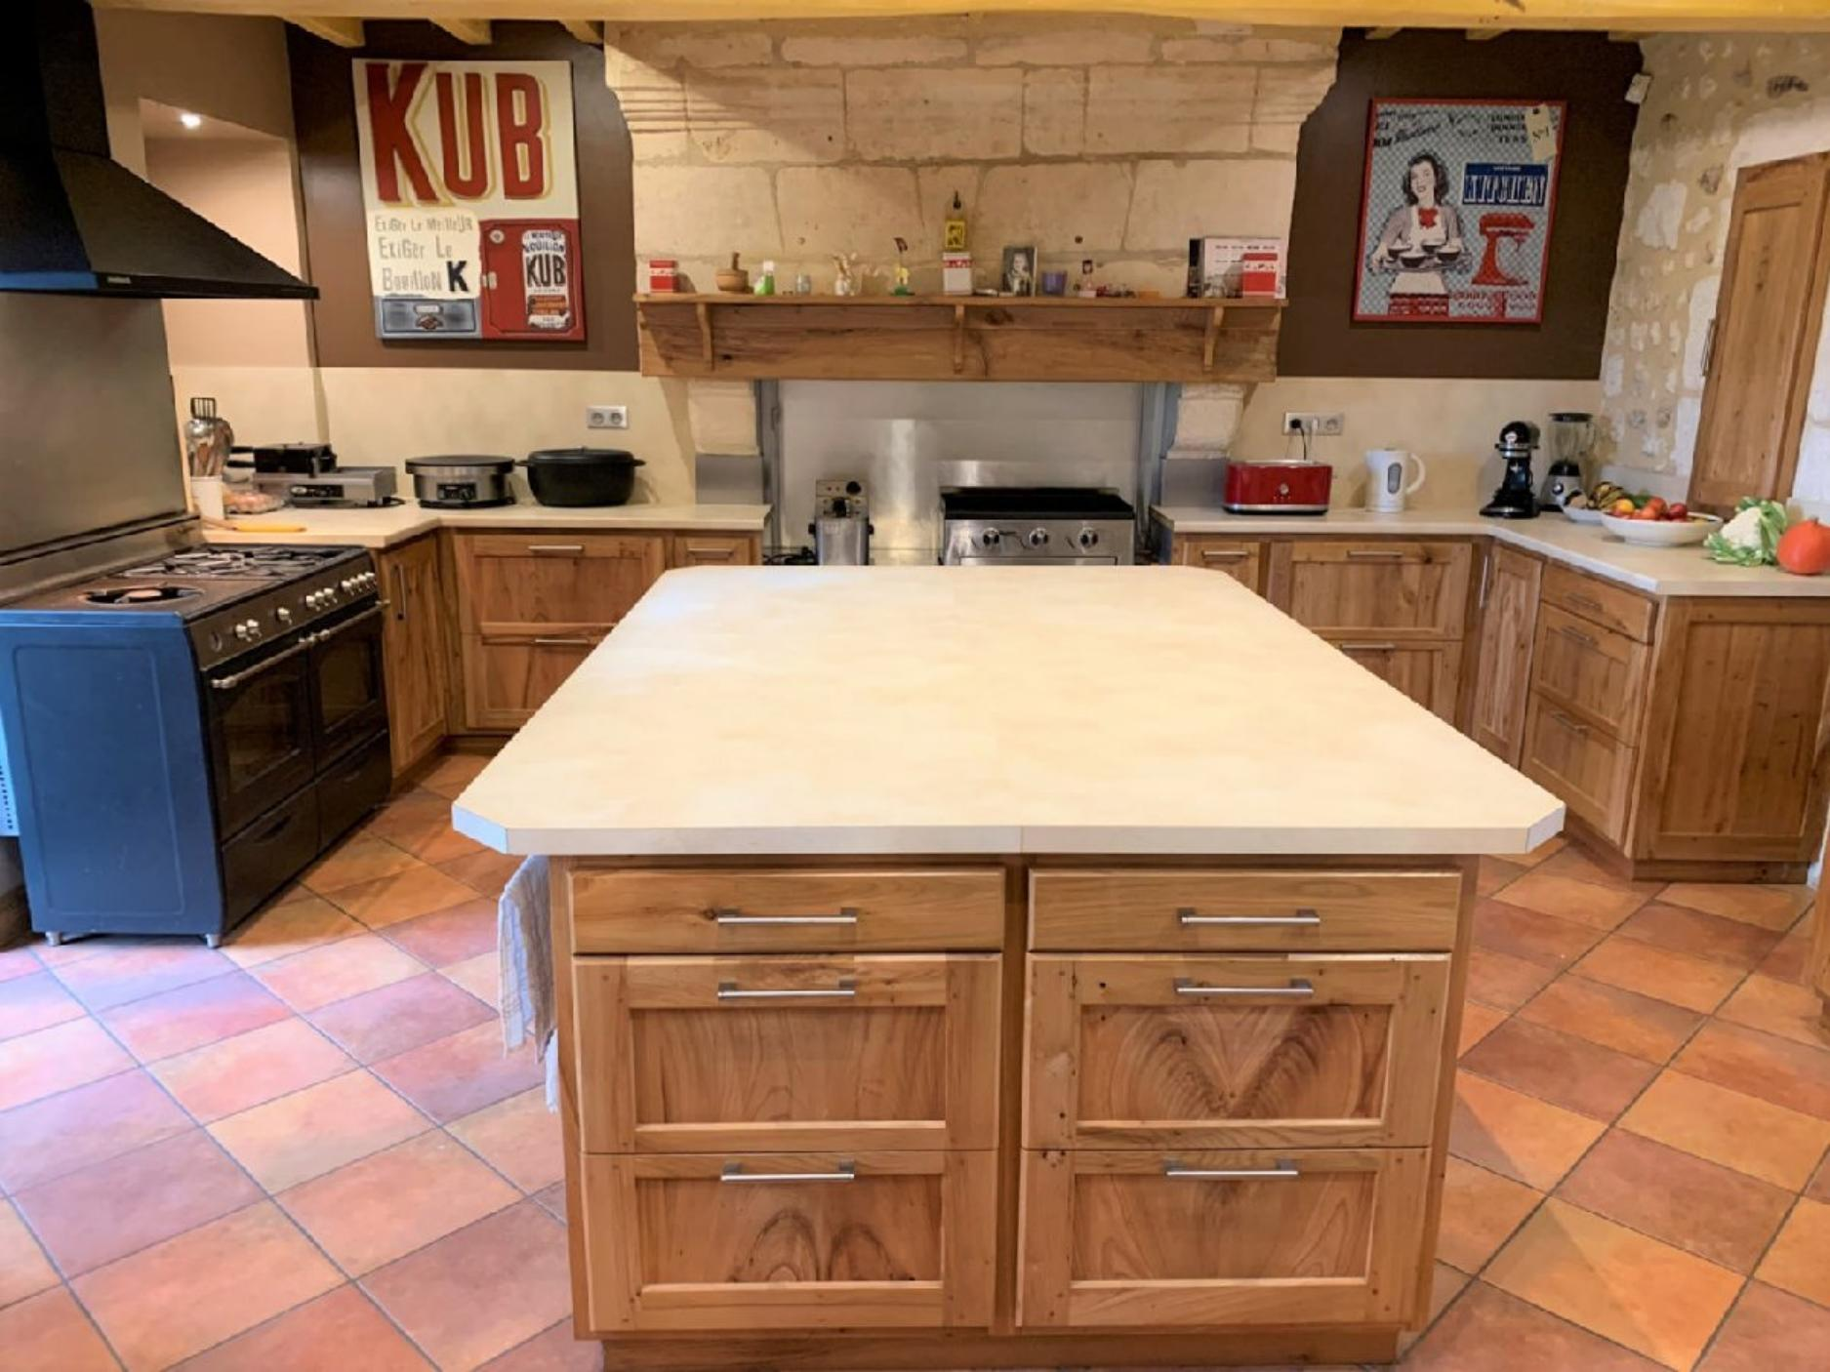  222 KWHep/m² an 30 Kg CO2/m² an

