Phone : +33 (0)5 53 07 06 27  Email : info@pioneerfrance.com  Web : www.PioneerFrance.com  Domaine Le Ruisseau , 24580, Fleurac, Dordogne | 

THE DORDOGNE'S LEADING QUALITY PROPERTY AGENCY

REFERENCE  PF90301 | PRICE (inc.agency comm)  450,000 € | LOCATION  DORDOGNE -  PERIGUEUX AREA | TYPE  House / Character property | LAND AREA  10,000 m2

RENOVATED 5/6 BED STONE HOUSE, HUGE INDEPENDENT BARN, SEPARATE VERY LARGE WORKSHOP WITH APARTMENT, 1 HA (ALMOST 2.5 ACRES) OF LAND. PF90301

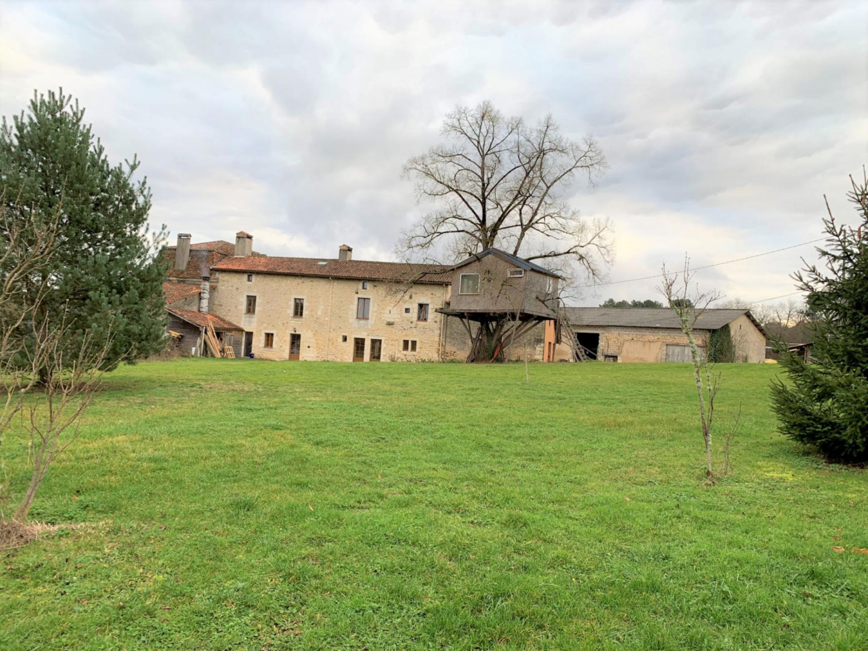

A large, creatively renovated stone property featuring large bright rooms with high ceilings, combining the contemporary with the traditional. A huge 300sqm barn and enormous 200sqm workshop with attached 60sqm apartment. Equidistant between Perigueux and Bergerac, the property has 1ha (almost 2.5 acres) of land with more land nearby (fields, woods, etc.) also available by separate negotiation. PF90301
PROPERTY DESCRIPTION ( Ref : PF90301)
RENOVATED 5/6 BED STONE HOUSE, HUGE INDEPENDENT BARN, SEPARATE WORKSHOP WITH APARTMENT, 1 HA (ALMOST 2.5ACRES) LAND. PF90301
A large, creatively renovated stone property featuring large bright rooms with high ceilings, combining the contemporary with the traditional. A huge 300sqm barn and enormous 200sqm workshop with attached 60sqm apartment. Equidistant between Perigueux and Bergerac, the property has 1ha (almost 2.5 acres) of land with more land nearby (fields, woods, etc.) also available by separate negotiation. PF90301
THE MAIN HOUSE
In honey-coloured stone, the house is accessed via a driveway leading to a small garden, into to an ancient, cloistered terrace with carved stone pillars and a key-stone above the doorway dating to before the French revolution! The house is fully double-glazed and the bi-fold doors are of strengthened anti-theft glass. The ground floor has underfloor heating, and the house has a wood (log) central heating system. The house has been insulated to a rarely found in a domestic setting. In the hallways, on the landings, staircase and in the bathrooms, the lights are automatic.
Ground Floor
Heavy oak door opening onto:
Entrance Hall: 15sqm Exposed beams, exposed stone walls, door leading onto rear garden.
Kitchen: 33sqm Bright, fully fitted and well-equipped kitchen with large central island. Tiled floor, exposed beams and retained period features, including recessed cupboards into the stone walls. Door onto garden.
Back kitchen/Utility room: 7sqm Shelved and plumbed for white goods. Door onto covered terrace.
Guest WC: Under stairs. WC and original stone sink.
Dining room: 52sqm Exceptional, baronial style room, currently used as a dining room with magnificent, stone fireplace and sunken surround. Perigordine flag-stone floor, recessed areas into original stone walls, doors onto garden on both sides of room.
Wide wooden steps, automatically lit, leading from this room to:
Home Cinema/Family Room/Piece a vivre: 102sqm: Oldest part of the property has been totally renovated in a contemporary vein now offering a fully insulated space with home cinema (can be removed if required), fitted bar kitchen with bar tables, solid wood parquet floor, 2 large, extra strengthened bi-fold doors. Wooden stairs up to:
Mezzanine: 20sqm Parquet floor, currently used as billiards room.
Study: 18sqm Large fitted cupboard, door leading onto covered terrace.
Wooden staircase from entrance hall up to
First Floor
Door to hot water boiler off staircase
L-Shaped landing 7.5sqm and 7.5sqm
Bedroom 1: 22.5sqm Bright room with over 3m high ceiling. Double door opening onto covered terrace (35sqm). 2 x fitted dressing cupboards. Stone fireplace, parquet floor, exposed beams. Door leading onto proposed shower-room, yet to be finishing but will have WC, sink, shower.
Bedroom 2: 21sqm Parquet floor, exposed beams, stone fireplace.
Bedroom 3: 18sqm Door opening onto covered terrace (as above). Fitted wardrobe with shelving, stone walls, parquet floor and exposed beams.
Large, deep cupboard at end of landing.
Separate WC
Bathroom: 15.8sqm Scandinavian style bathroom beautifully finished throughout in teak with steps up to sunken bath (with shower attachment), separate walk-in shower, 2 x sink units with storage below, heated towel rail plus additional electric radiator, some original stone features.
Wooden staircase with ‘butterfly’ landing to
Second floor
To left of staircase:
Landing: 6.5sqm
Bedroom 4: 14sqm Velux windows with 2 additional windows, parquet floor, exposed beams, light wood panelled walls, fitted shelving and storage.
Bedroom 5: 10.5sqm Velux window, parquet floor, exposed beams, light wood panelled walls, fitted shelving and storage.
To right of staircase:
Proposed Bedroom 6: Approx 19sqm Not finished at time of writing, but fully insulated and will have en-suite shower room and separate WC.
GARDENS AND OUTBUILDINGS:
Barn: Approx 300sqm 2 x huge barn doors and corrugated iron roof. Adaptable space with enormous potential.
Atelier: 200sqm Very bright space with all utilities.
Apartment: 60sqm Attached to atelier with living room, bedroom and bathroom.
Garden: Approx 1 hectare (almost 2.5 acres) Currently laid to lawn with some mature trees and shrubs.
General Information
Wood powered central heating system
Under-floor heating on ground floor
Open fireplaces.
Fully double glazed throughout.
Extra wall insulation throughout
Home cinema
Integrated vacuum system
Ample parking
Elevated, peaceful countryside location yet, close to commerce and activities in Villamblard (4km) and St Astier (12km).
10mins drive from A89, 20mins drive to Perigueux and to Bergerac
Potential to purchase additional land
Potential for commercial use
REF: PF90301

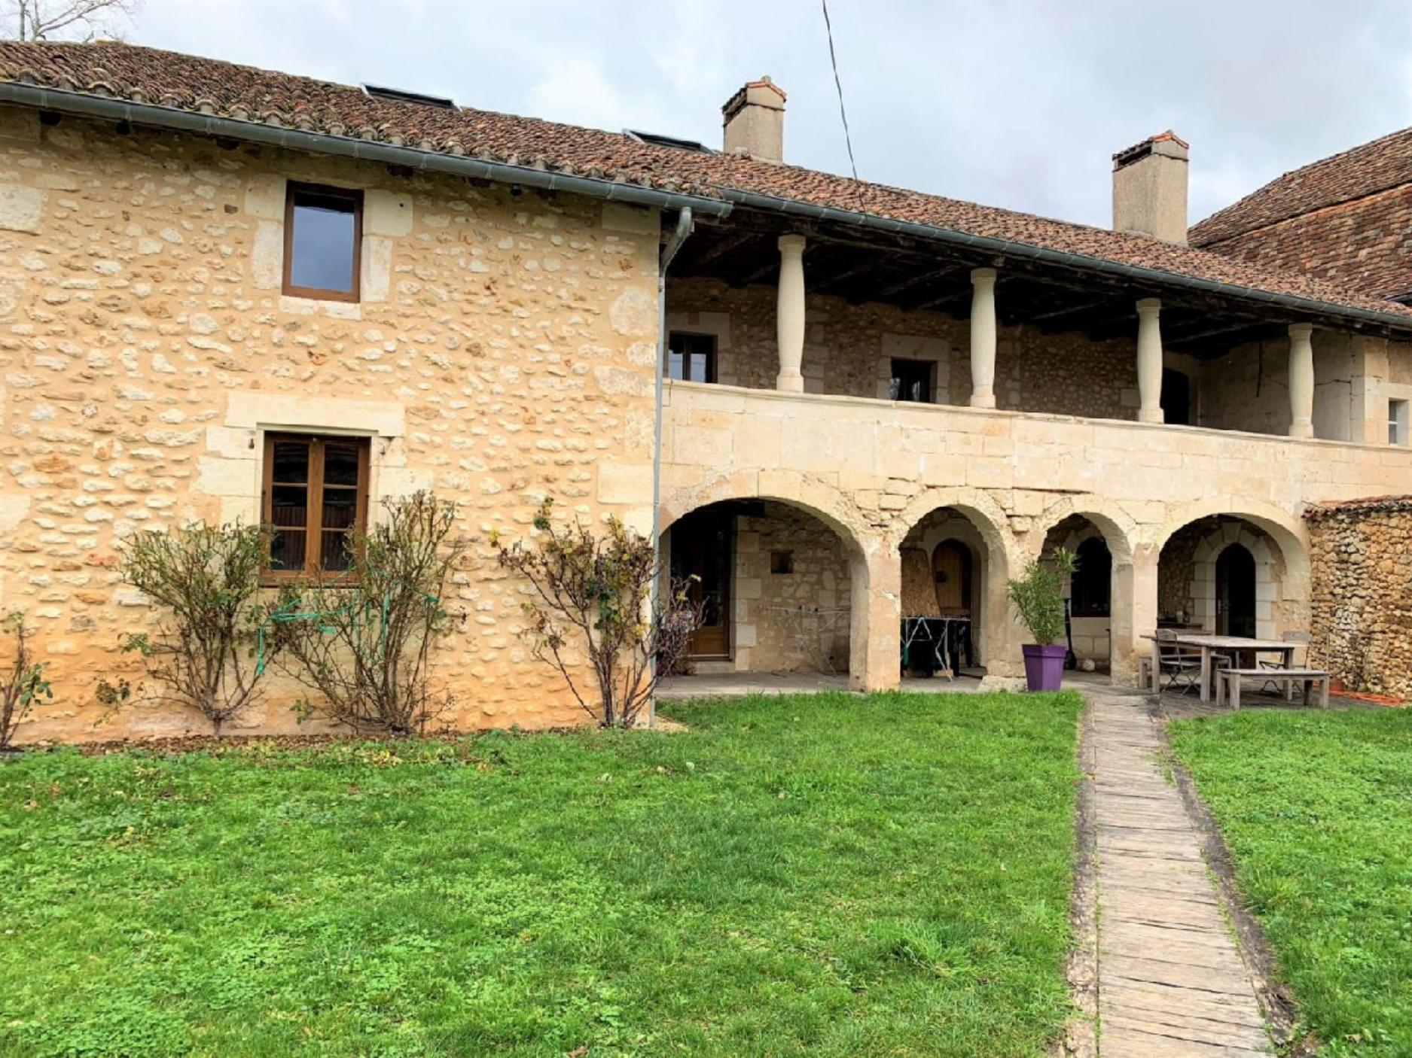 | 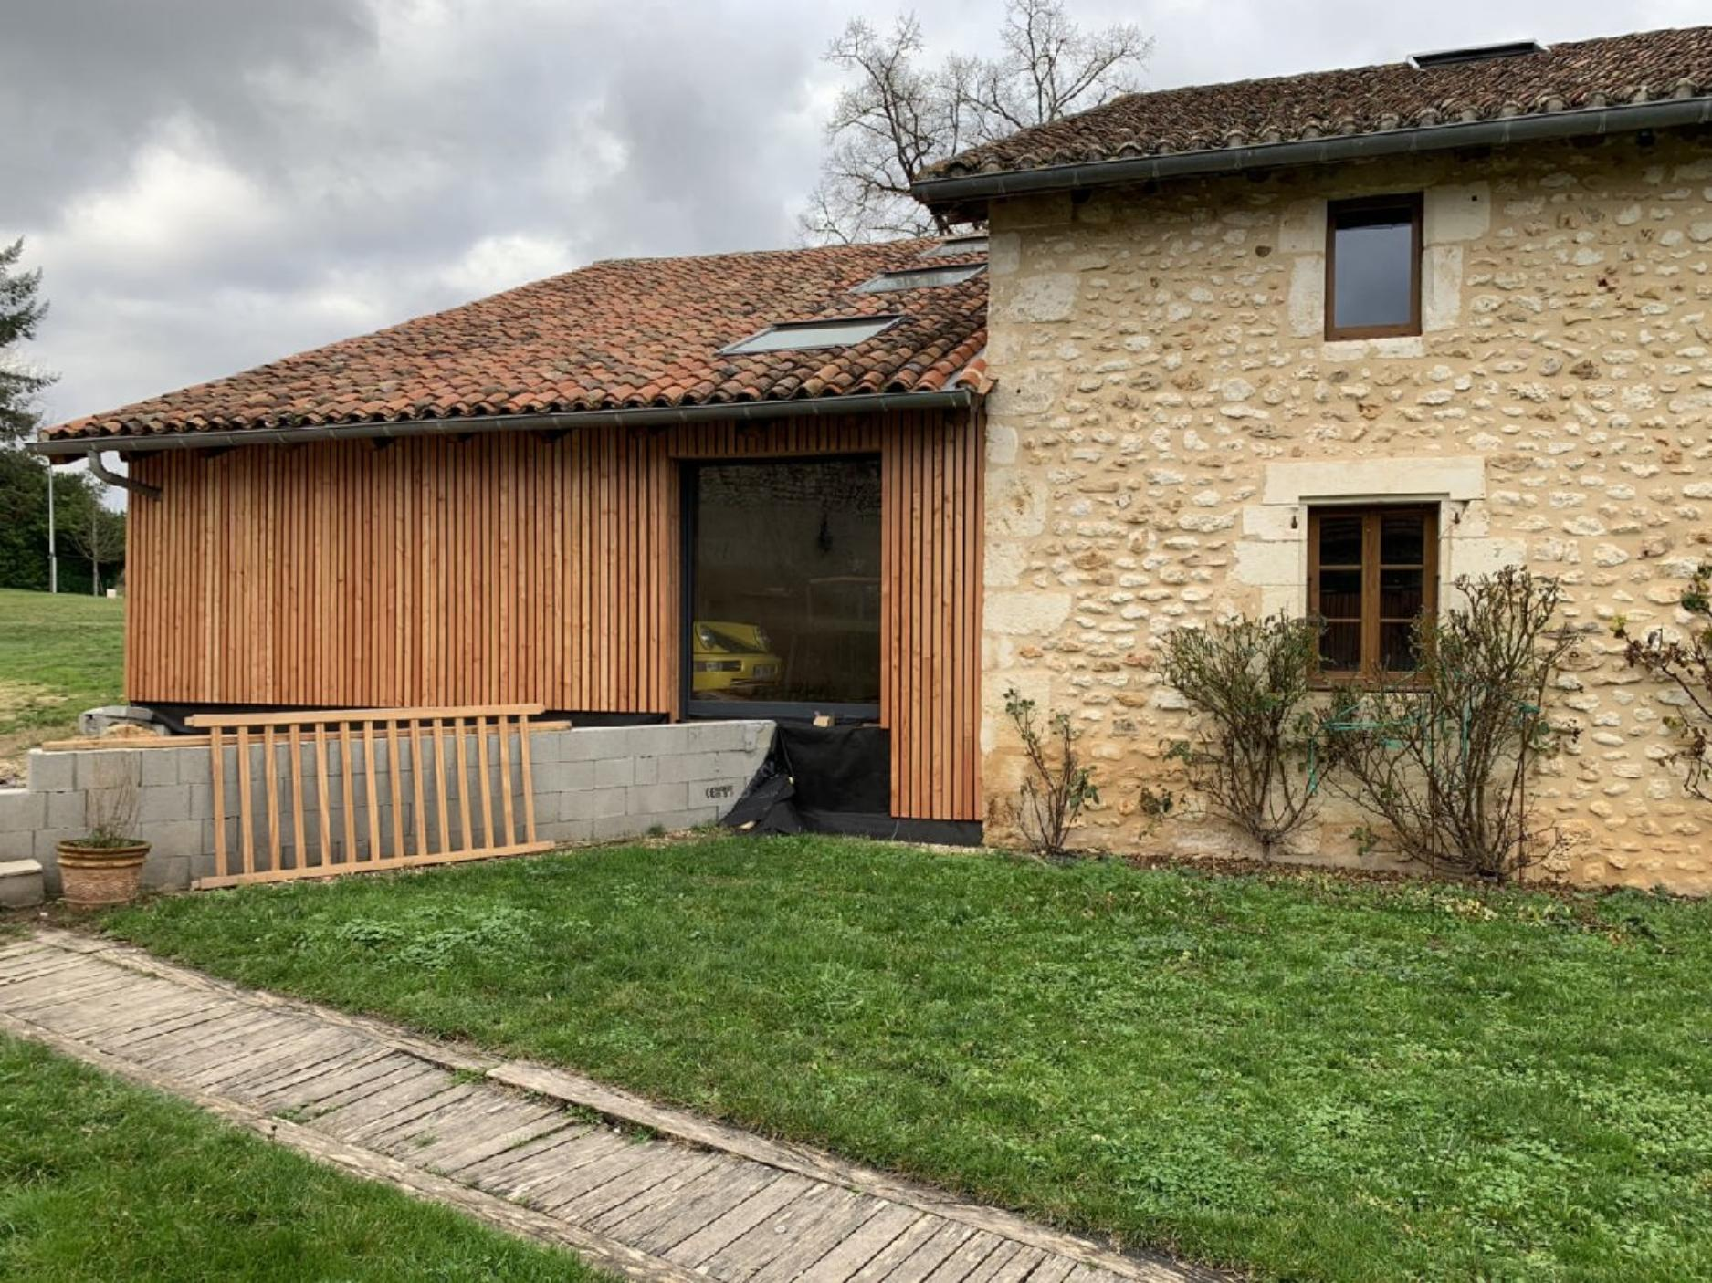
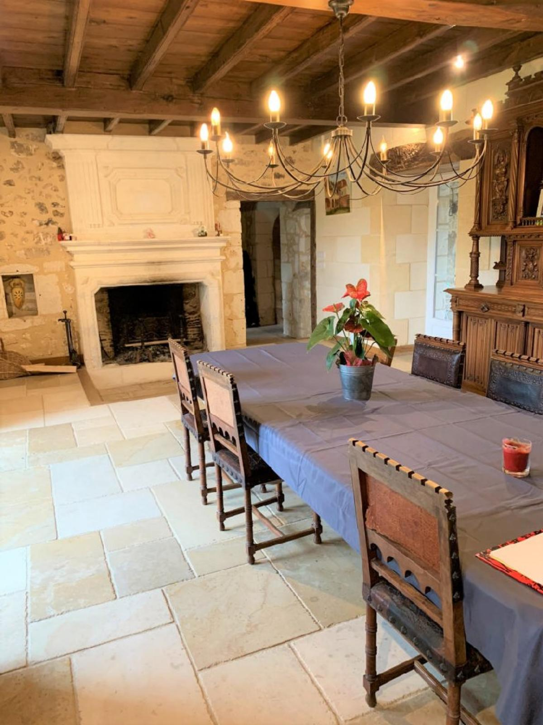 | 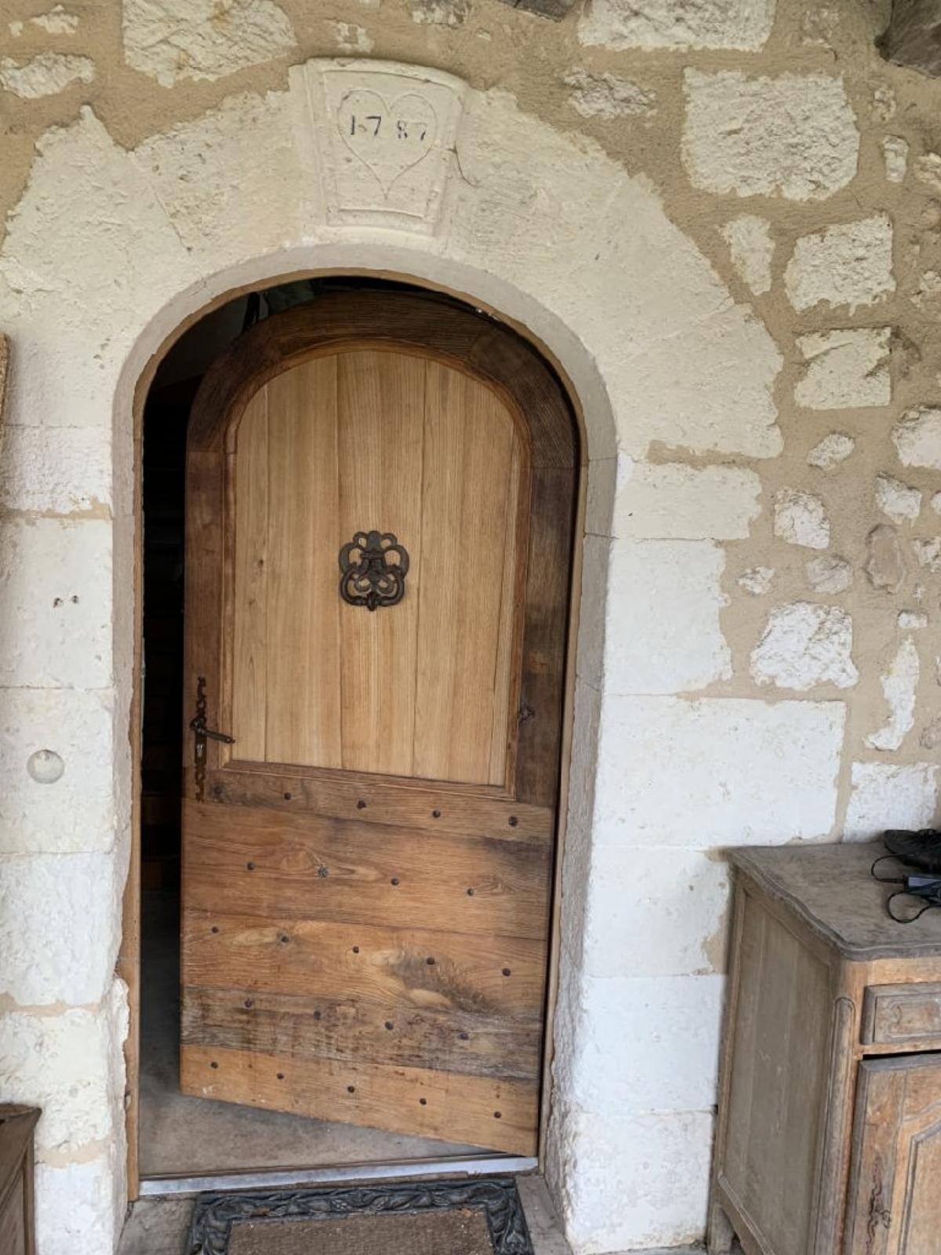
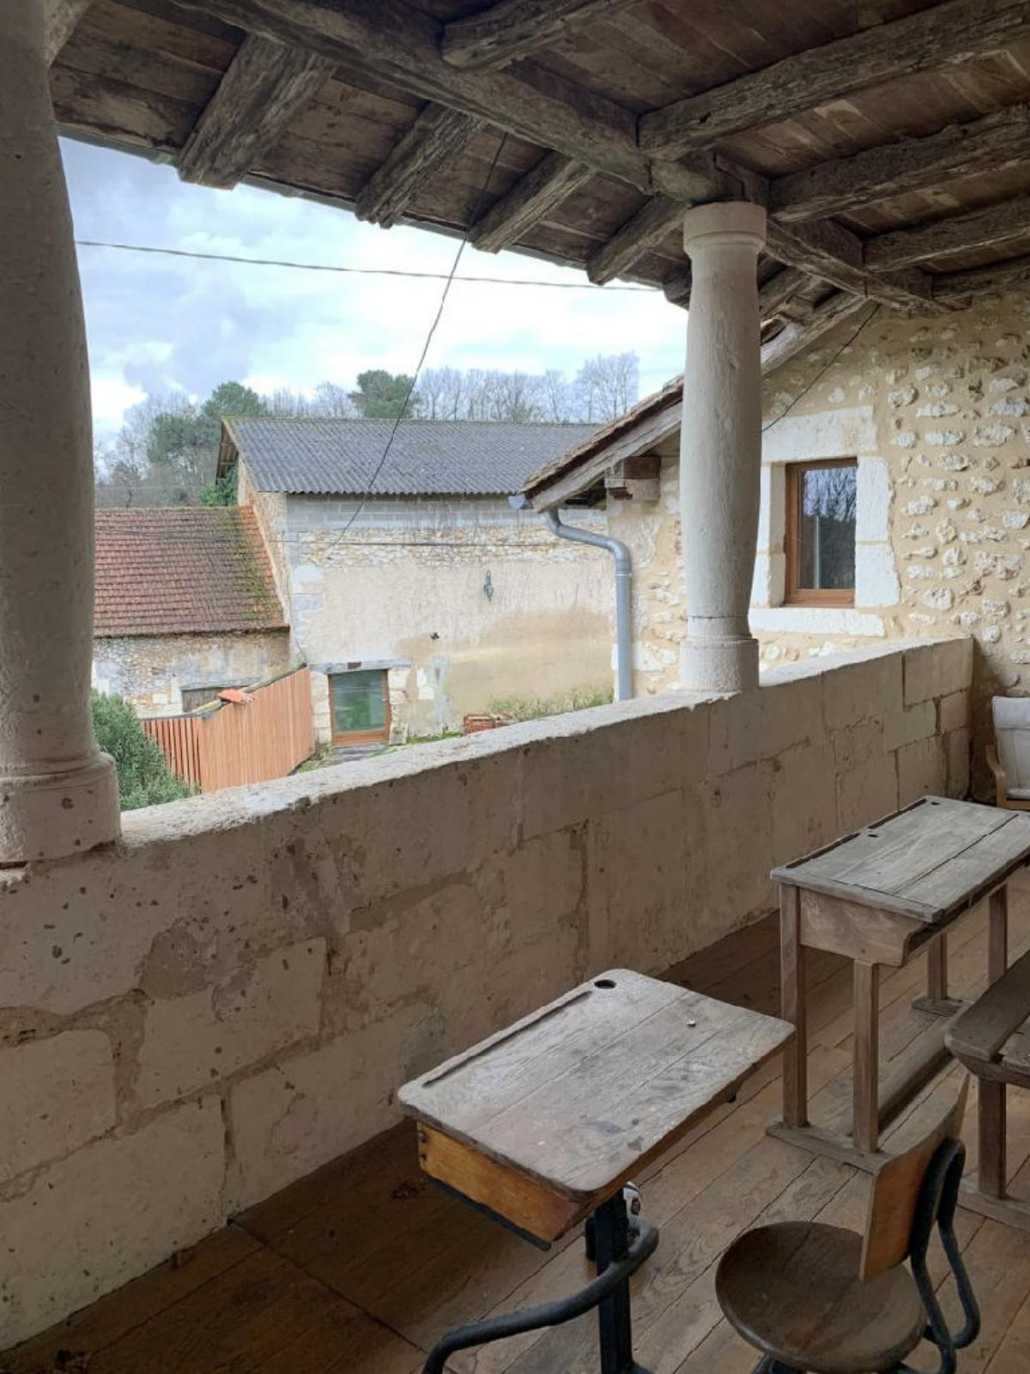 | 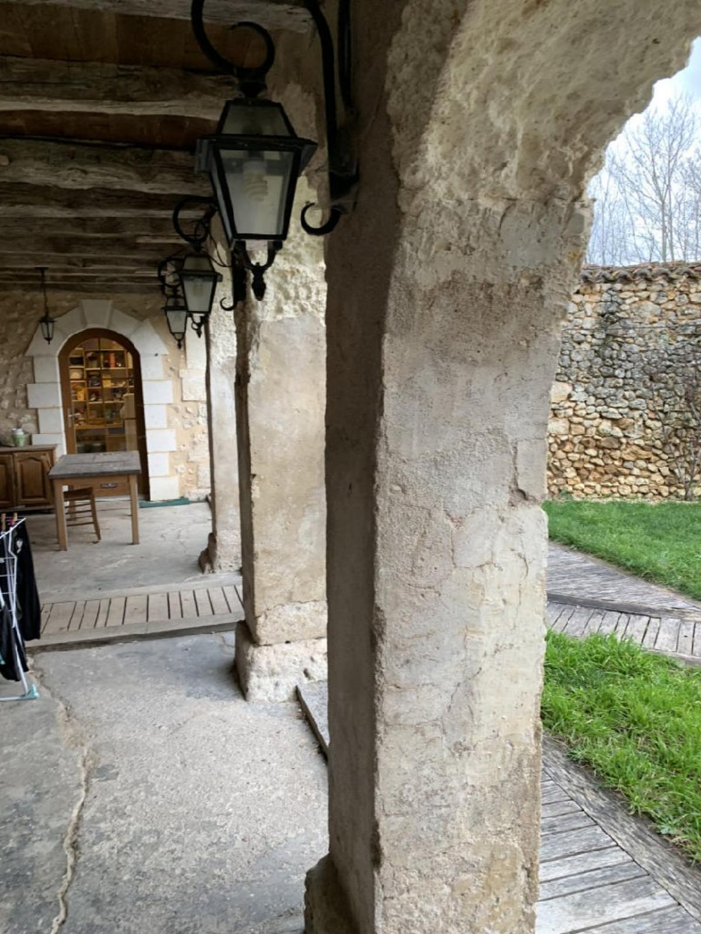
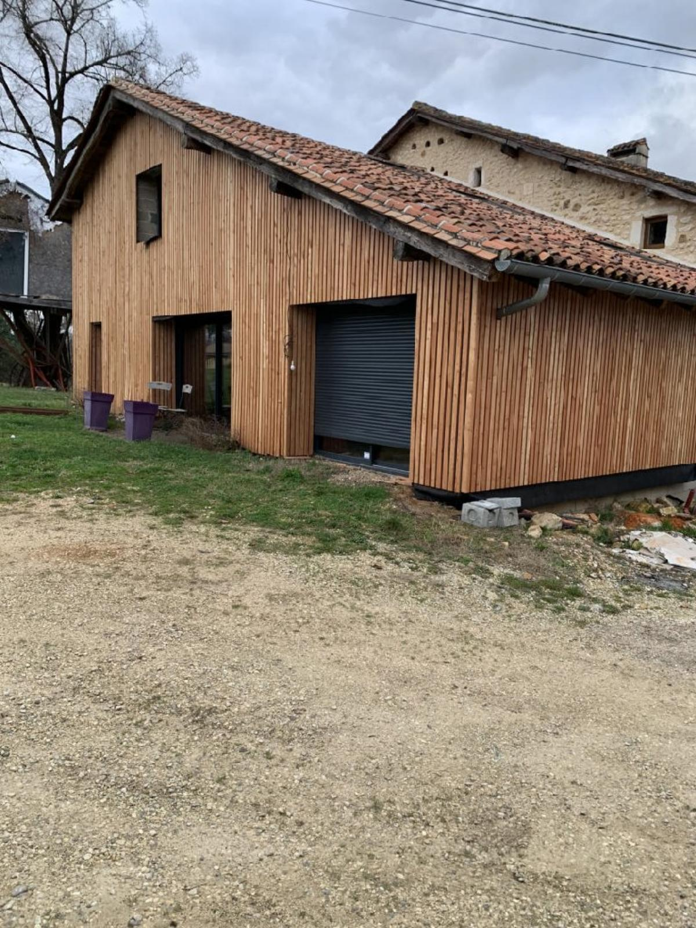 | 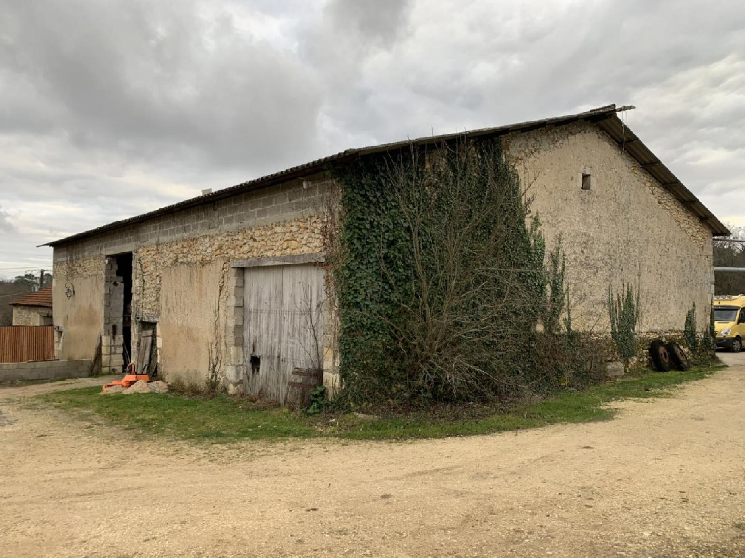
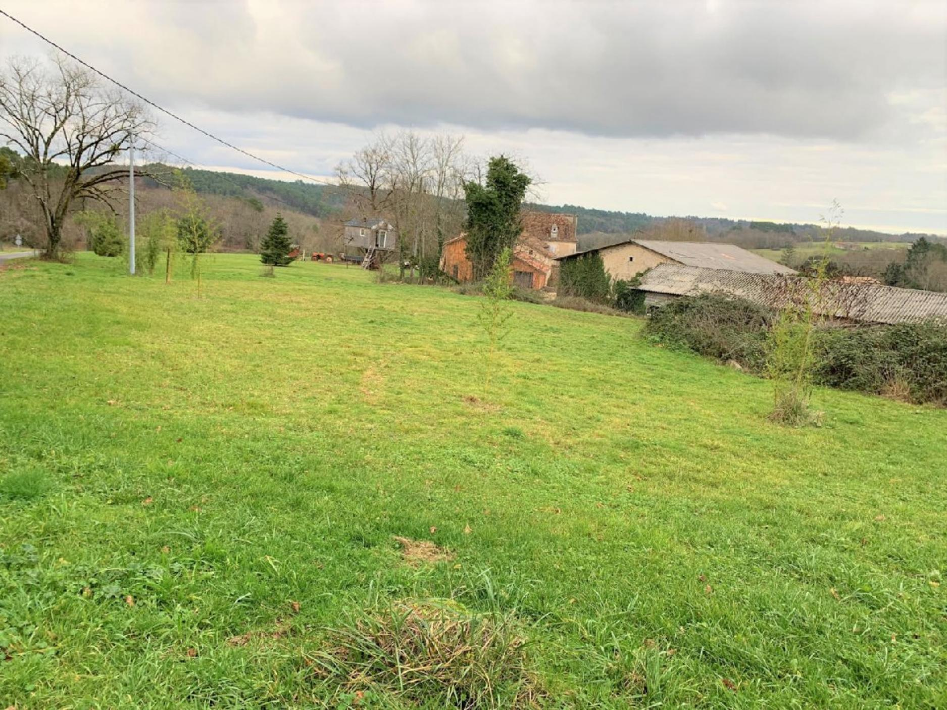 | 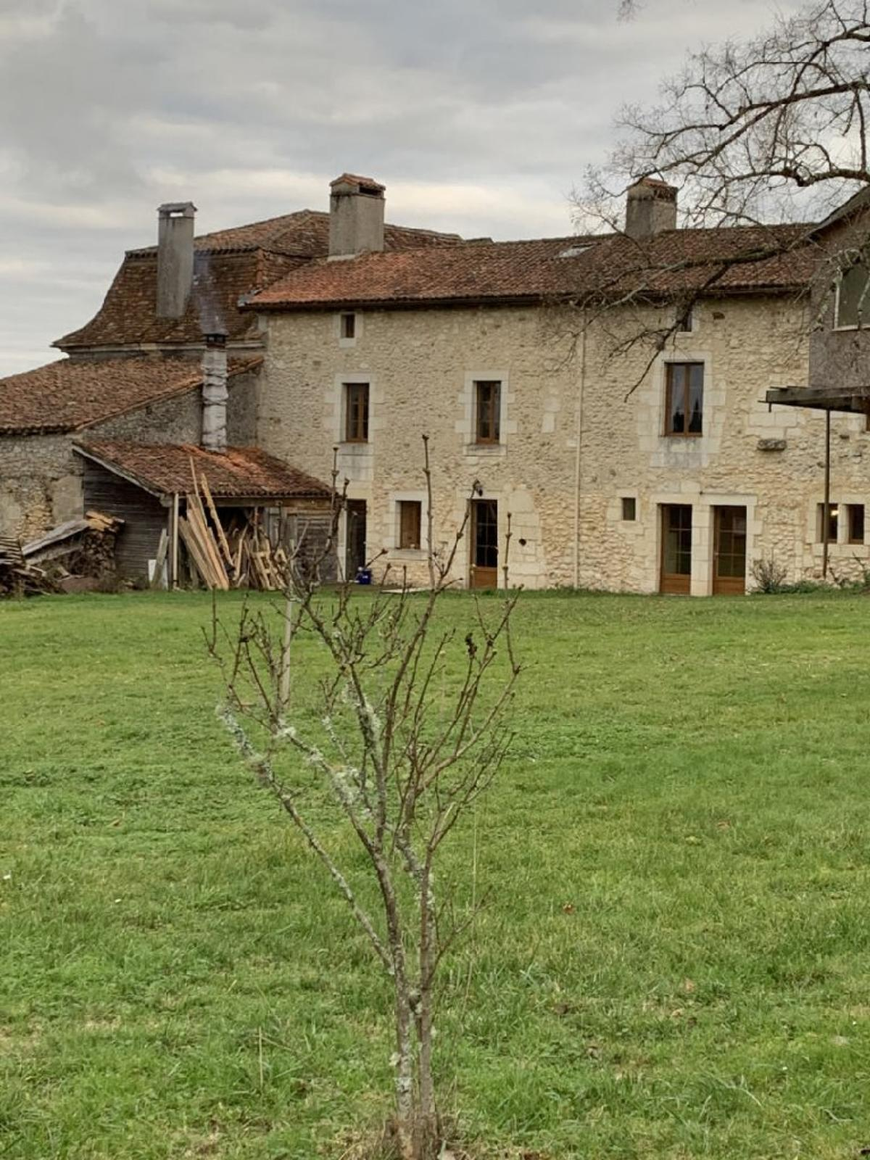
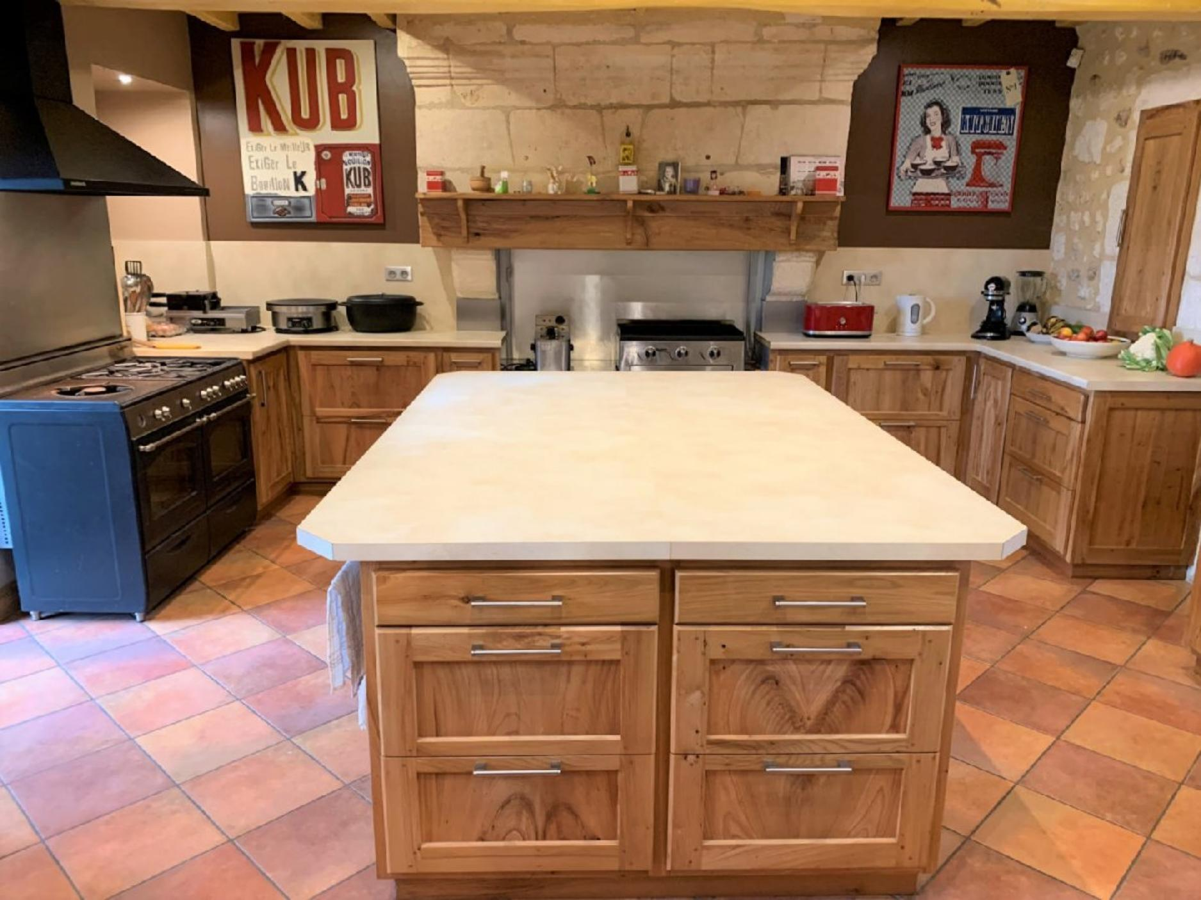 | 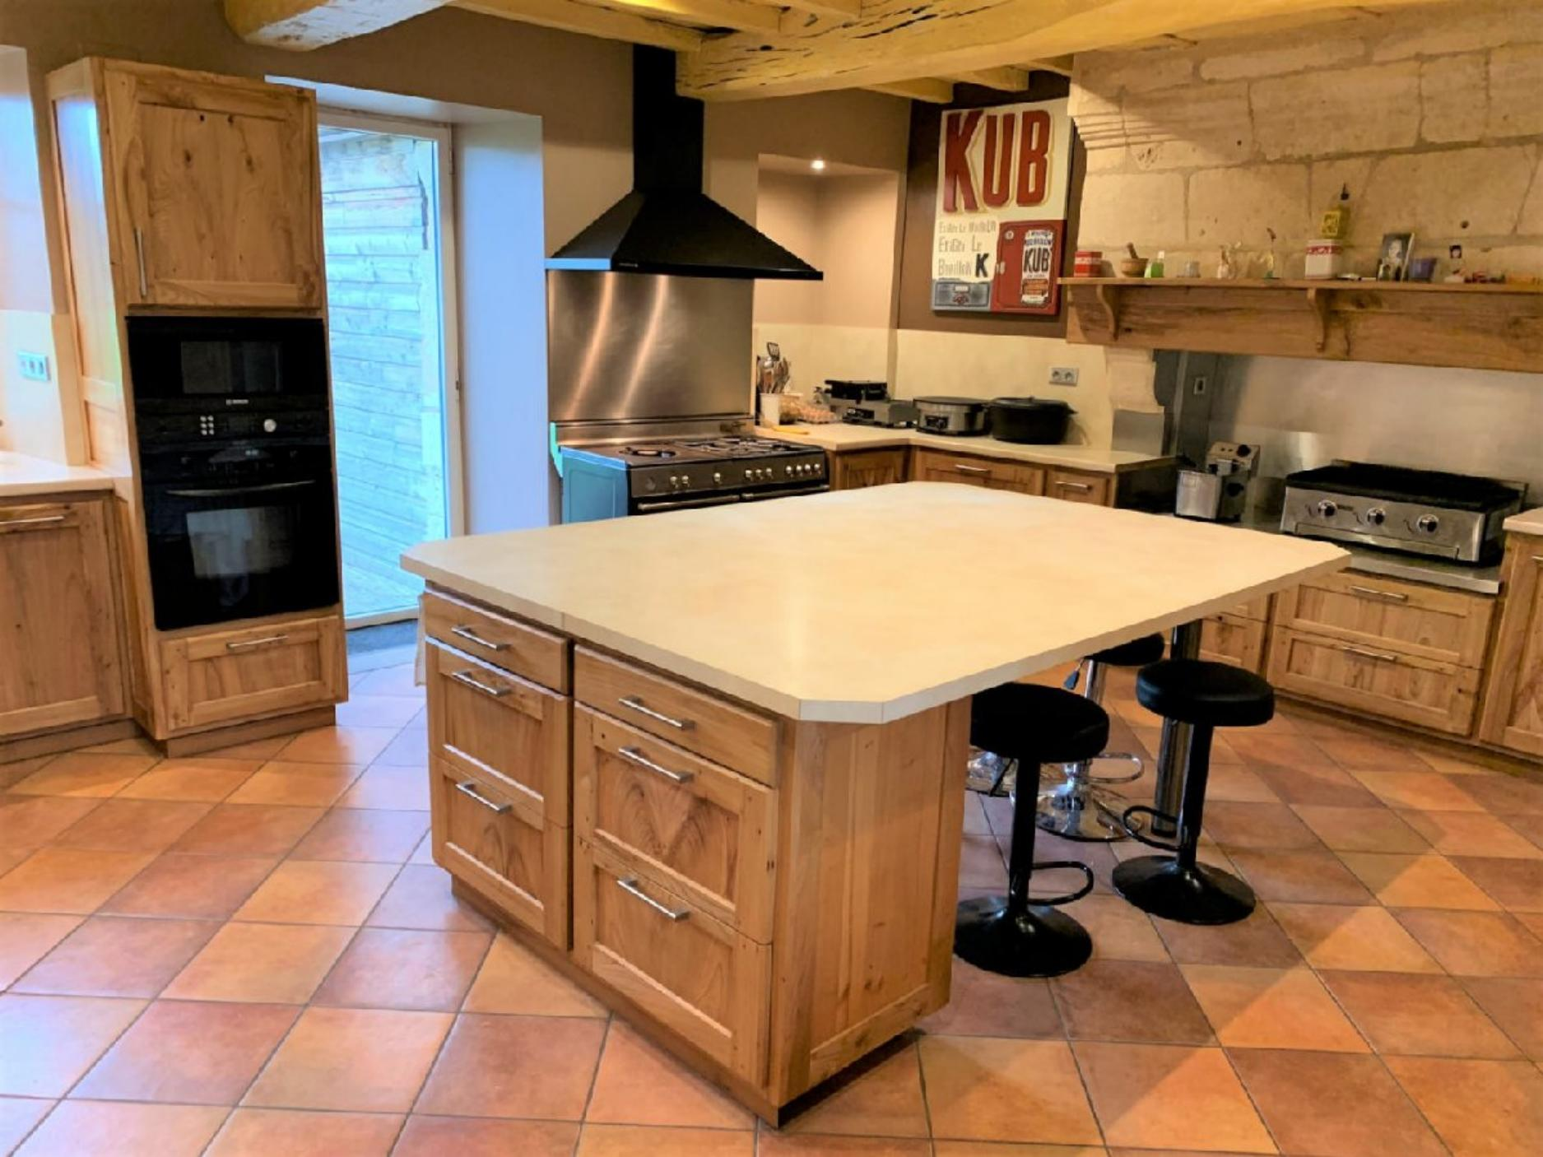
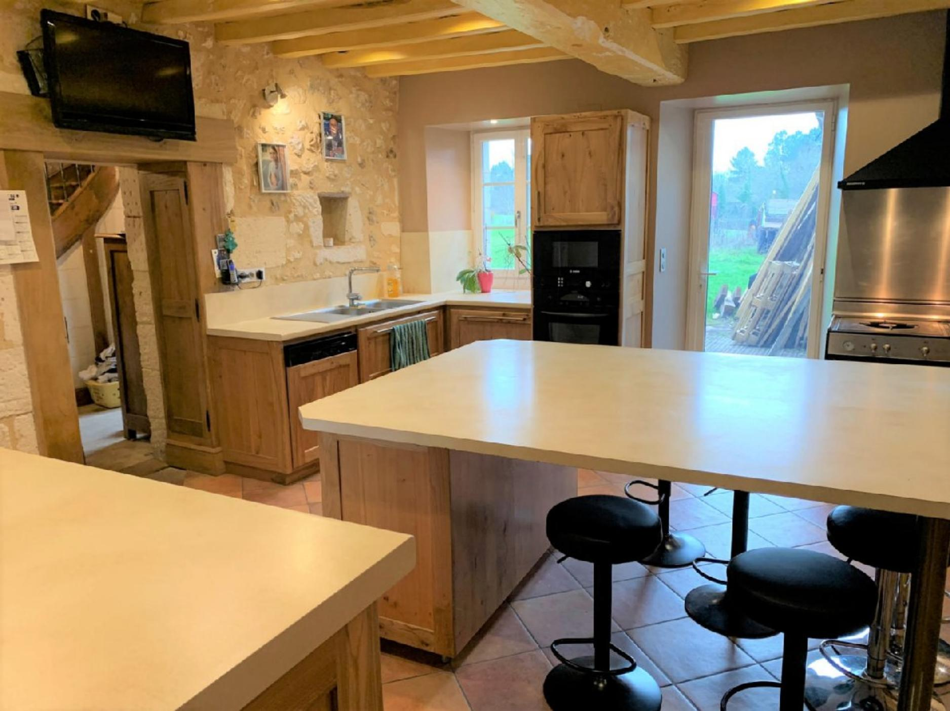 | 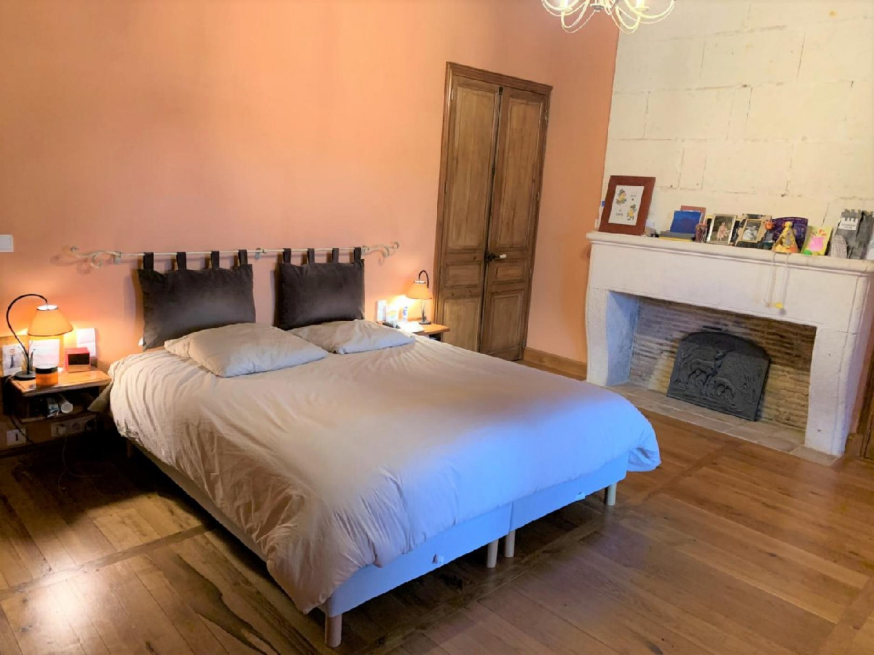
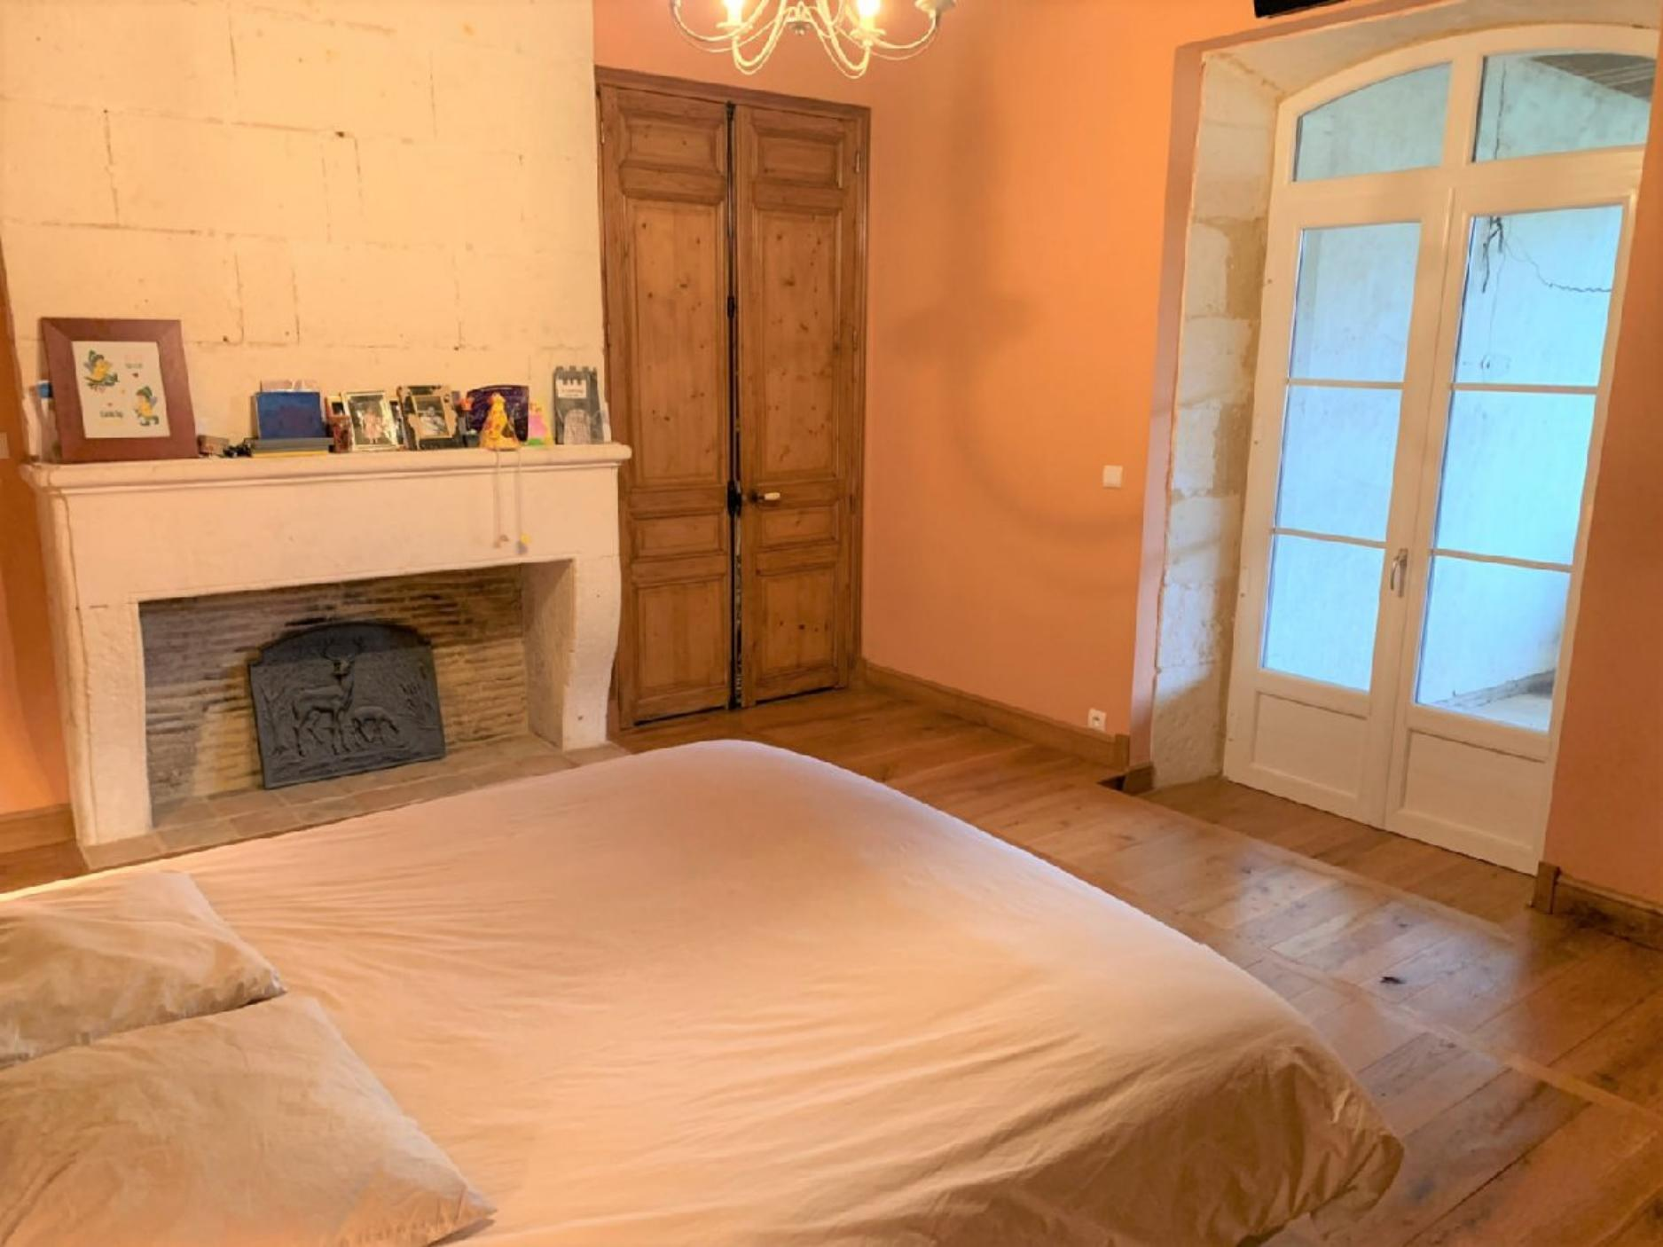 | 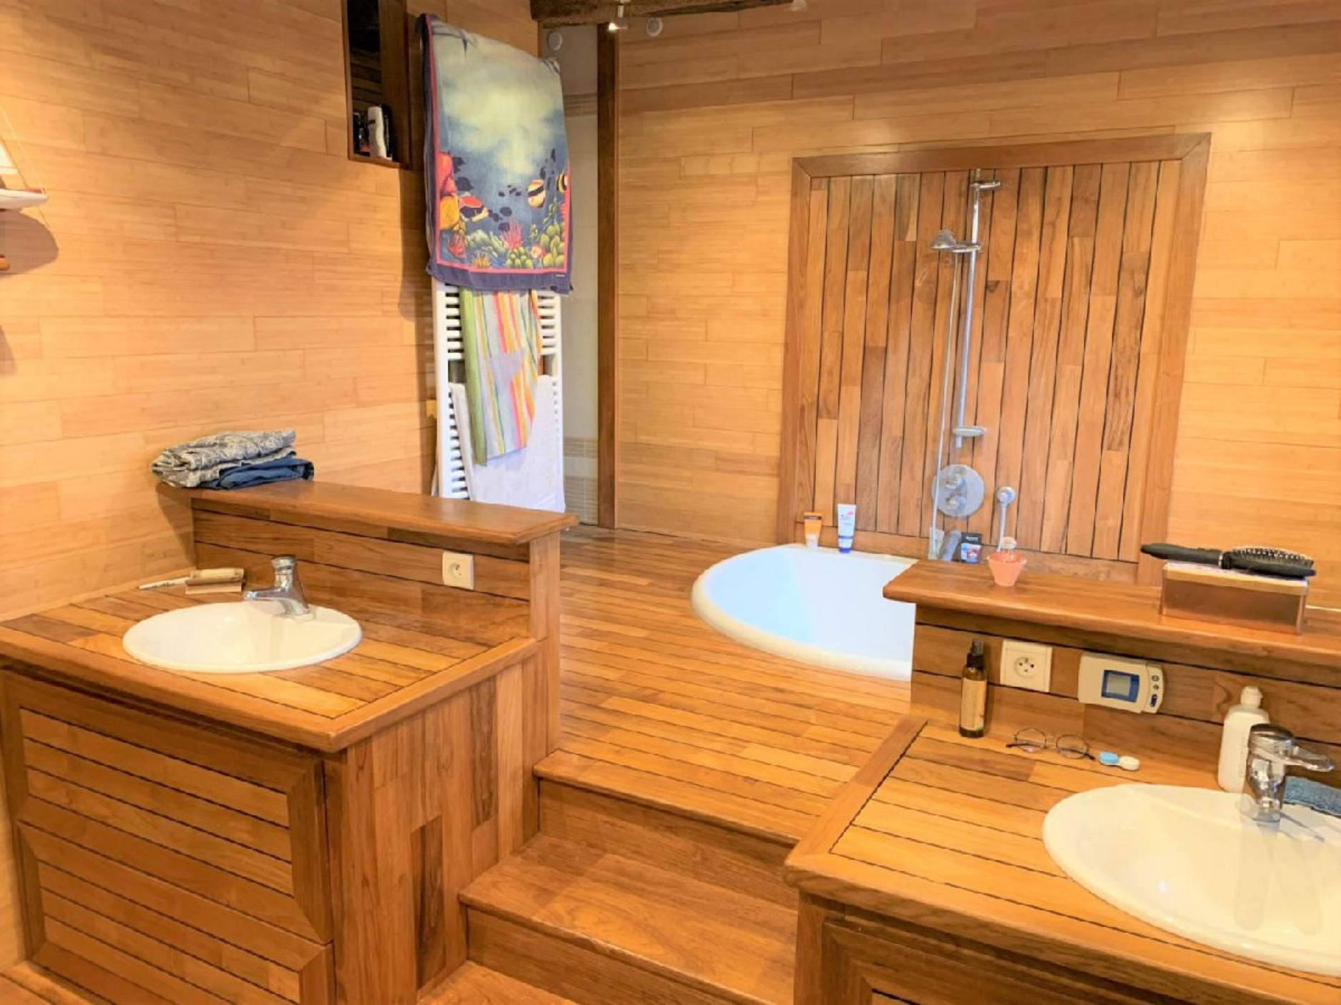
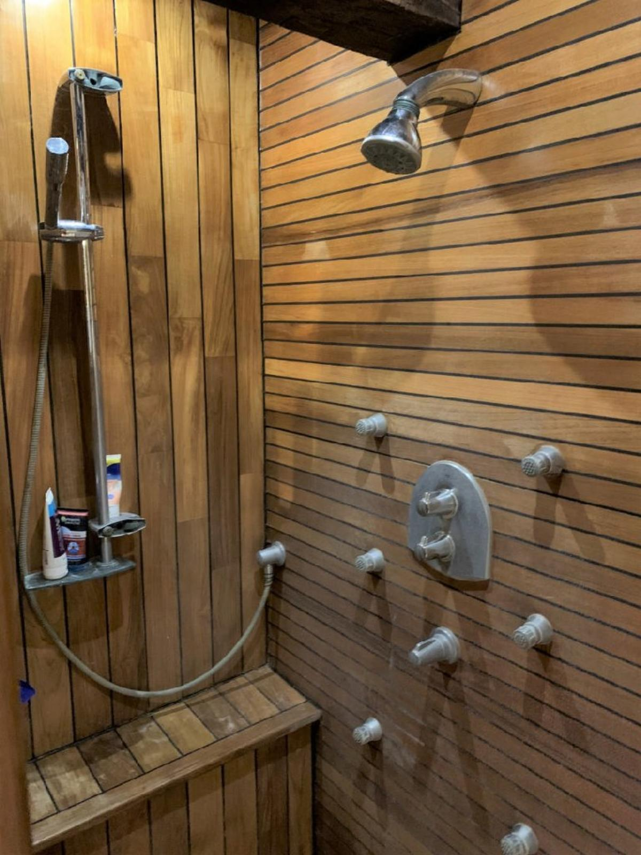 | 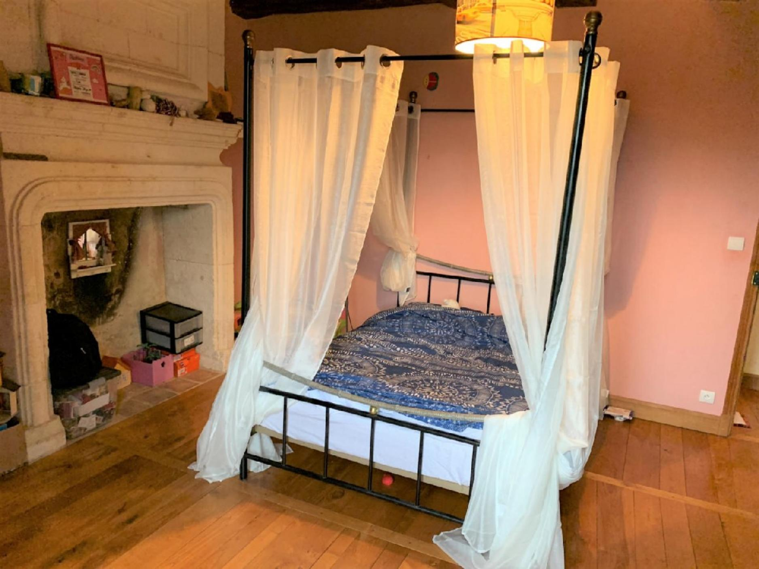
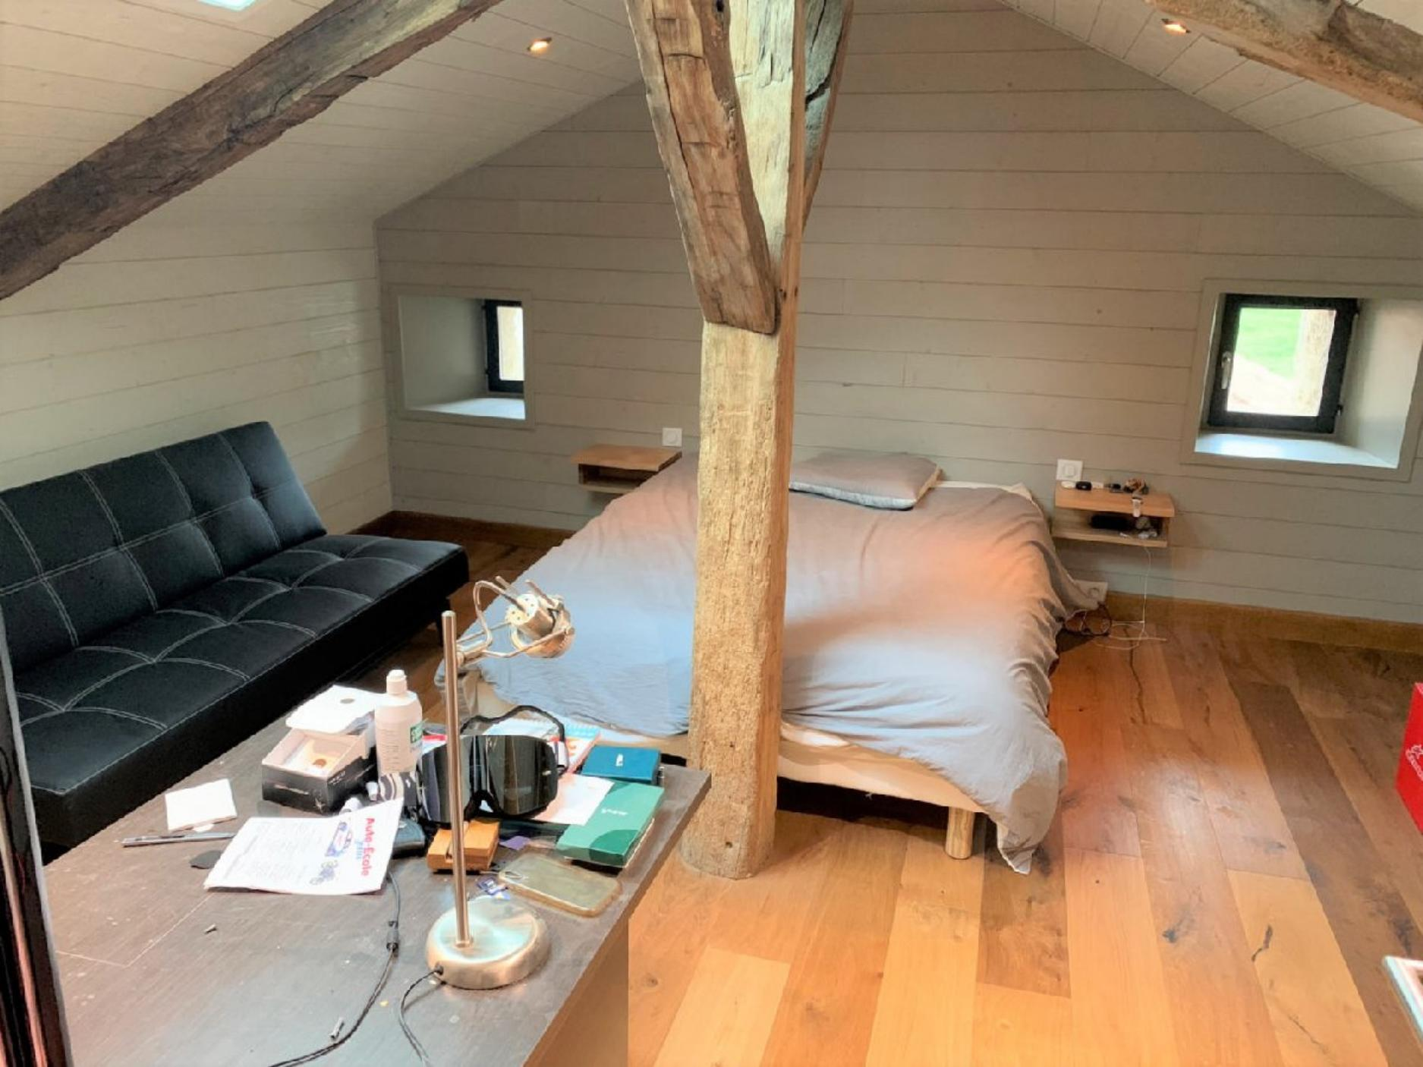 | 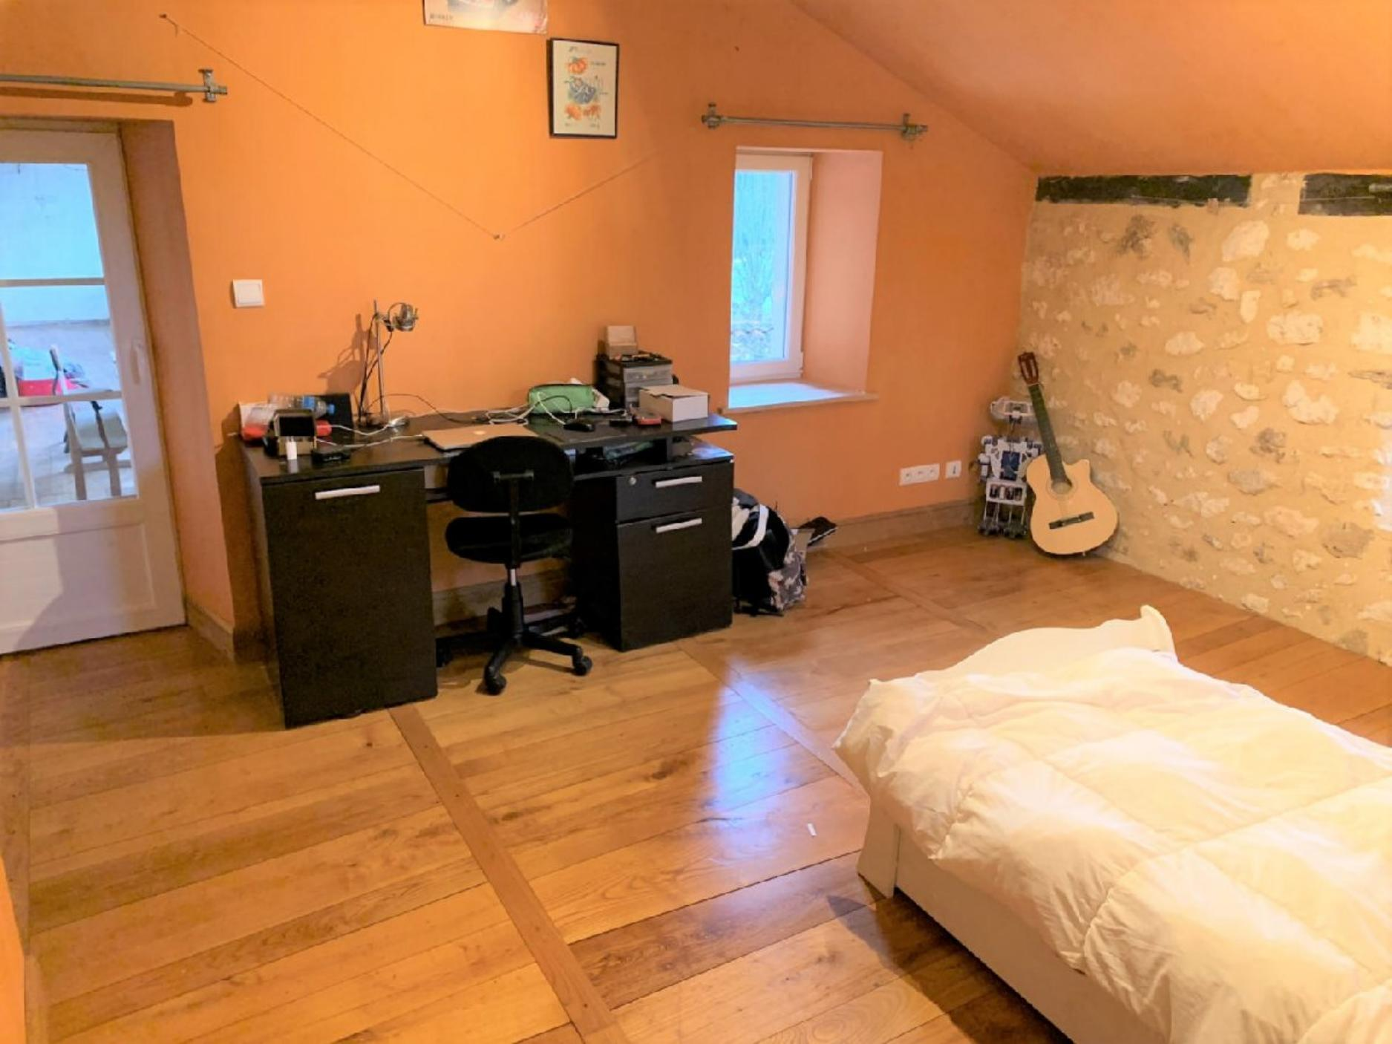
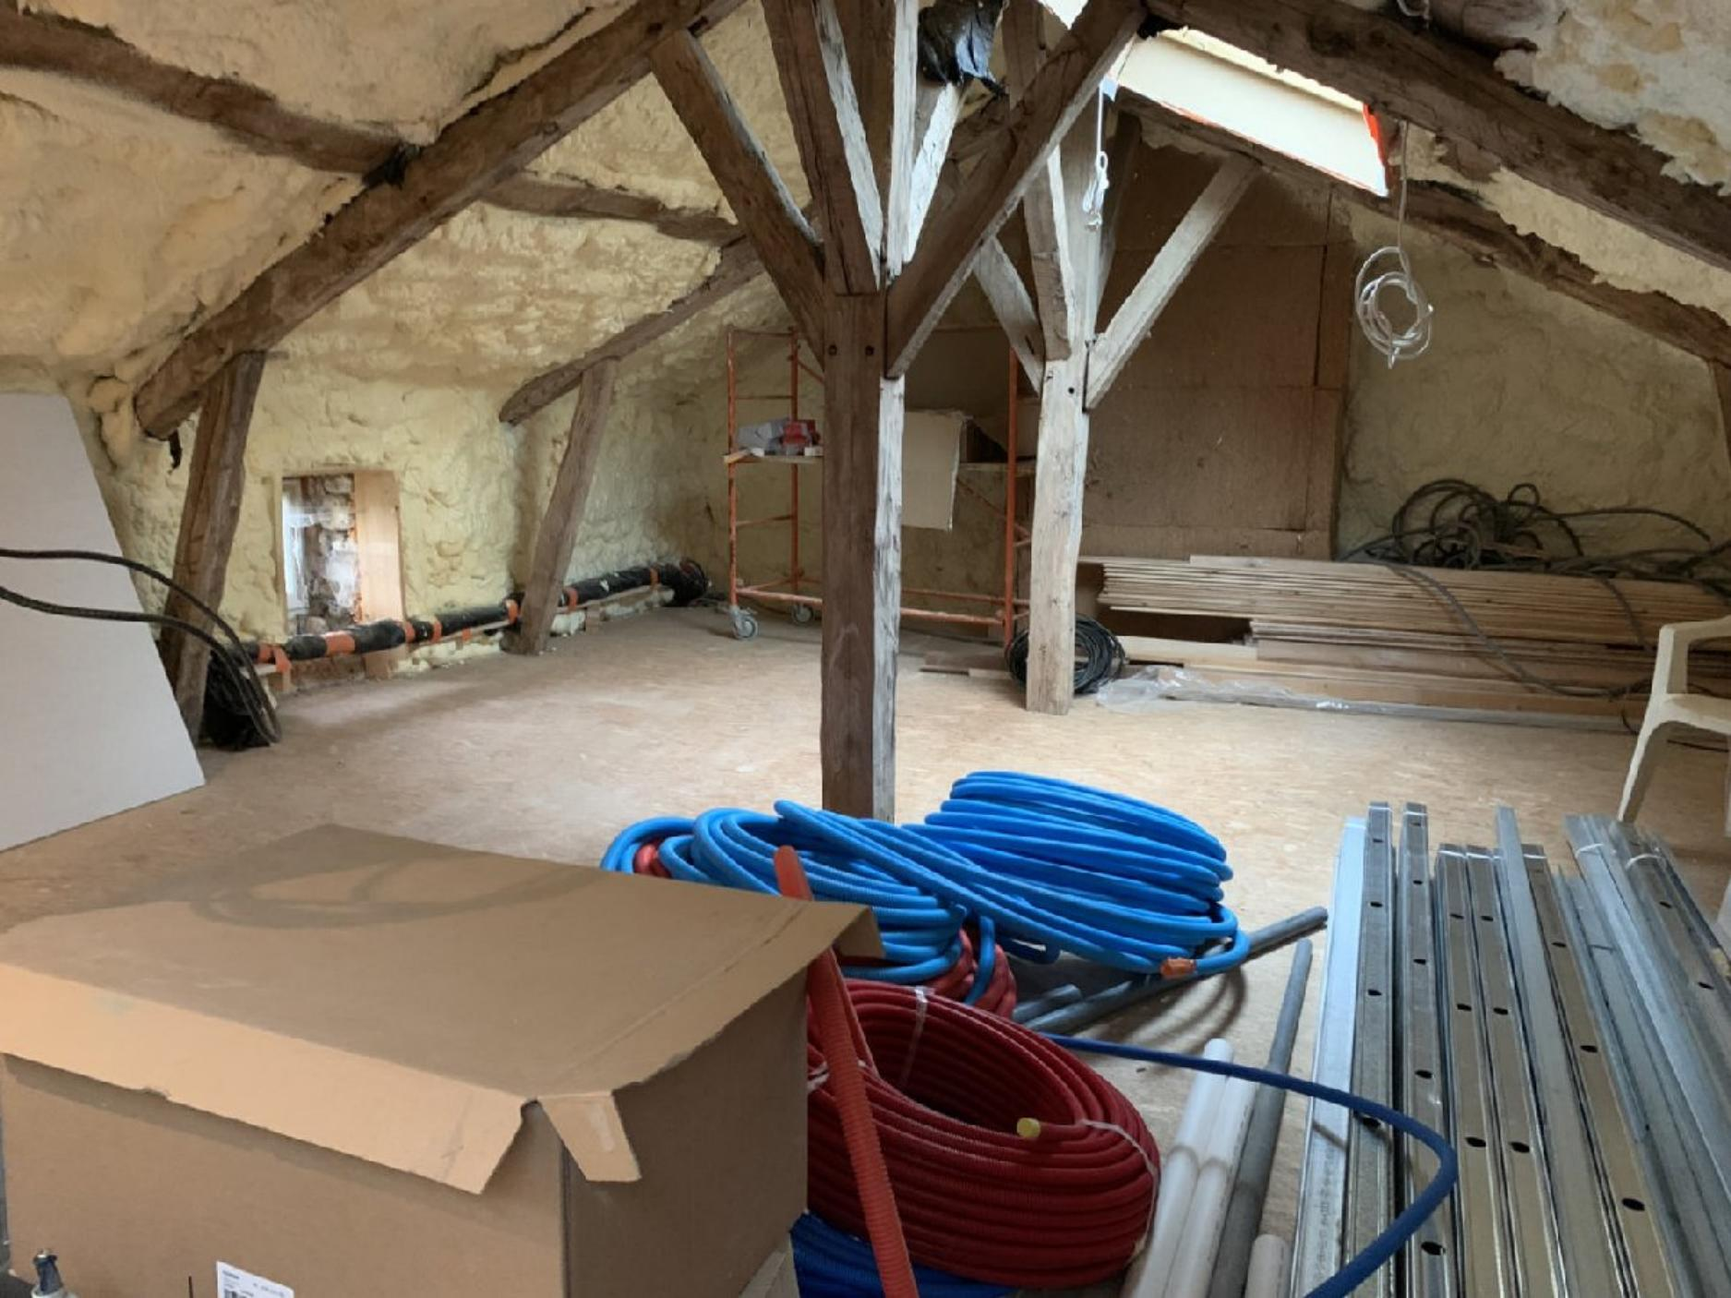 | 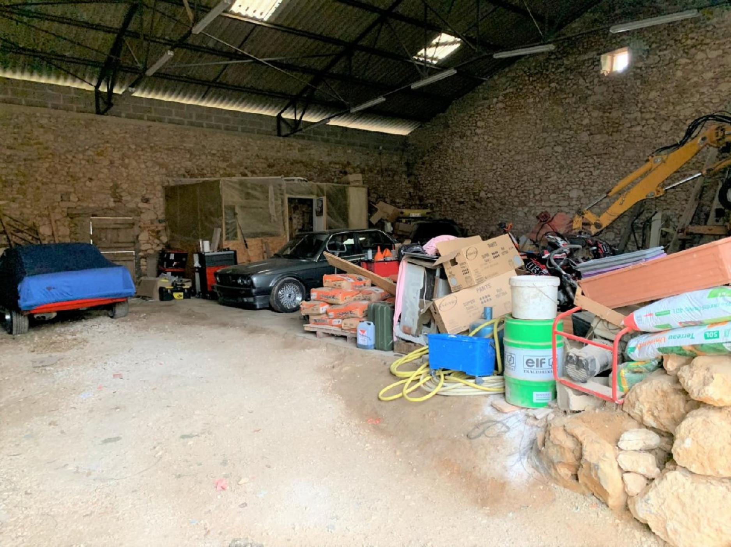
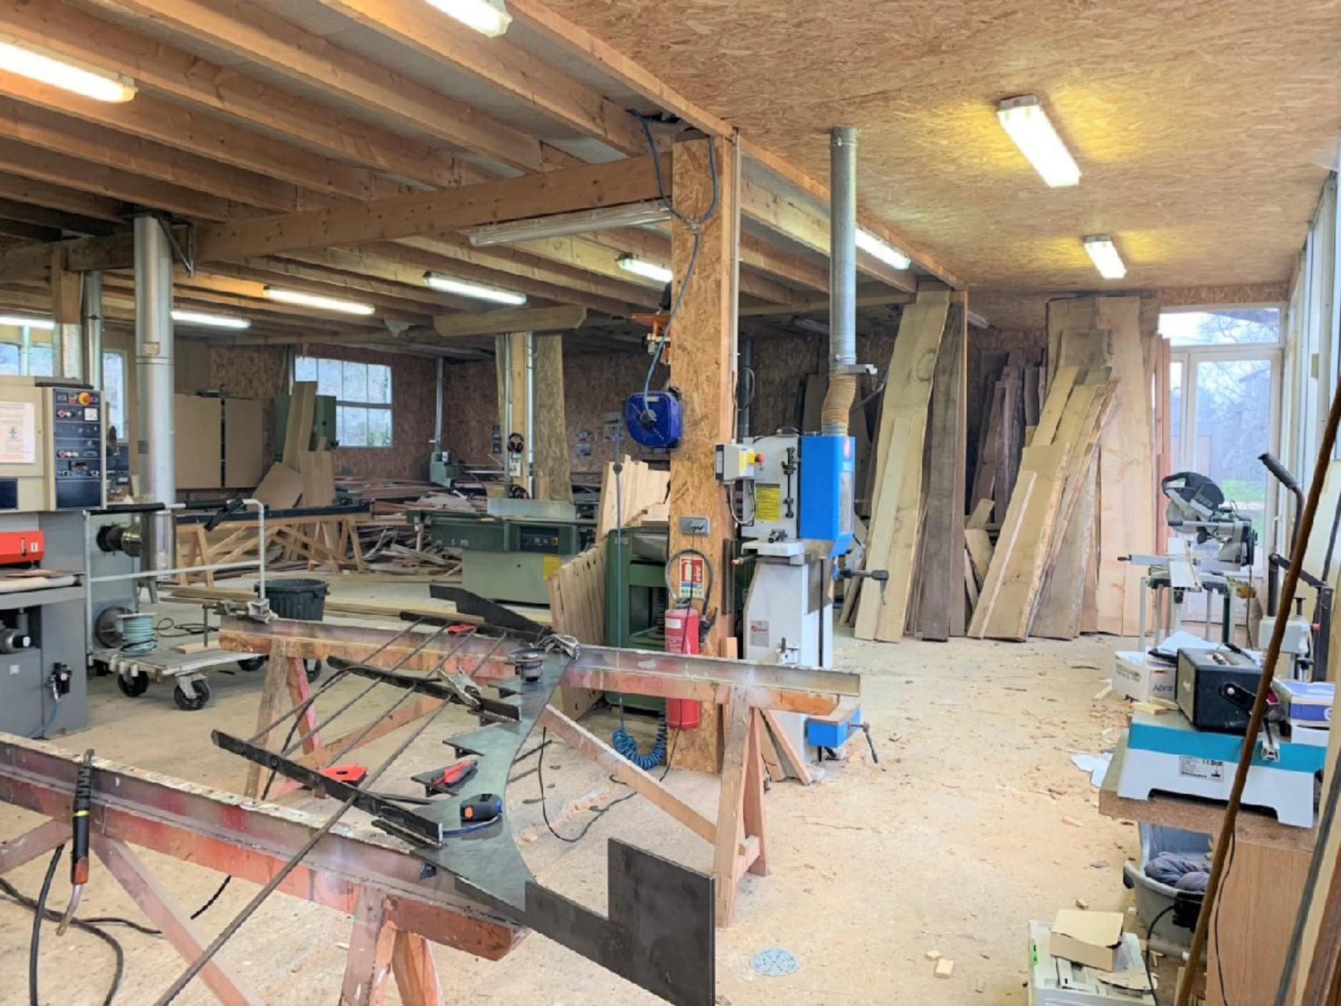 | 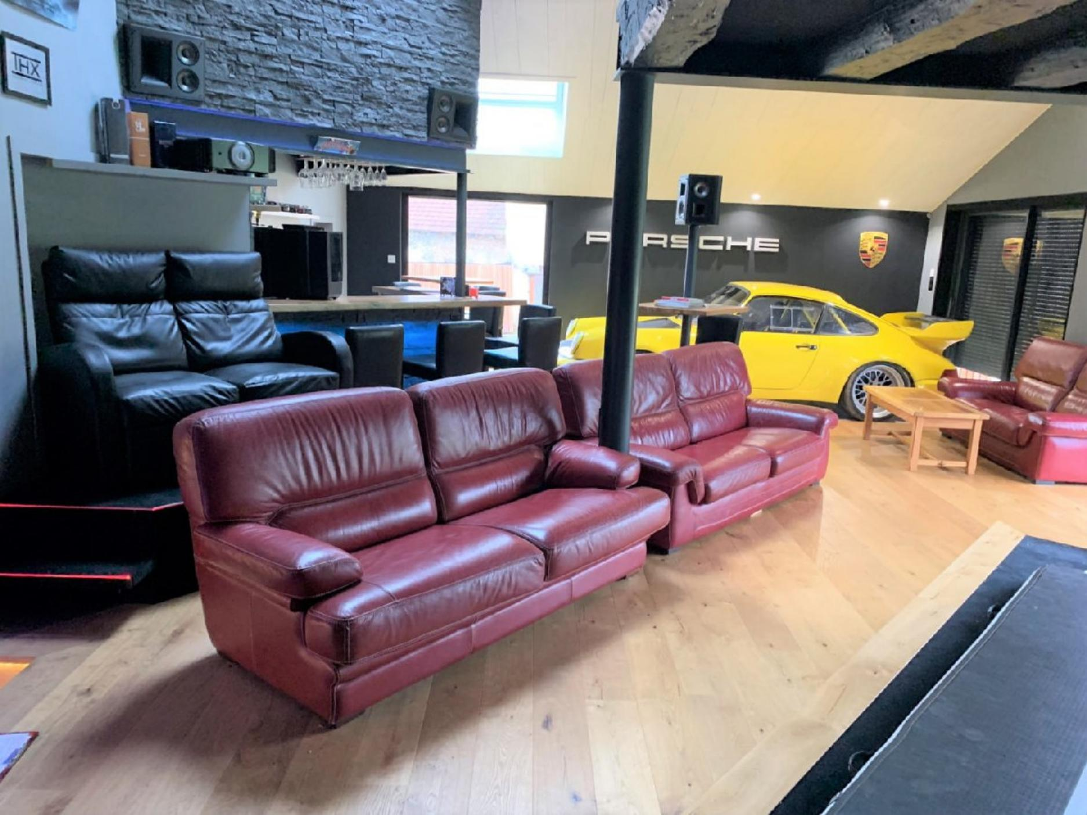
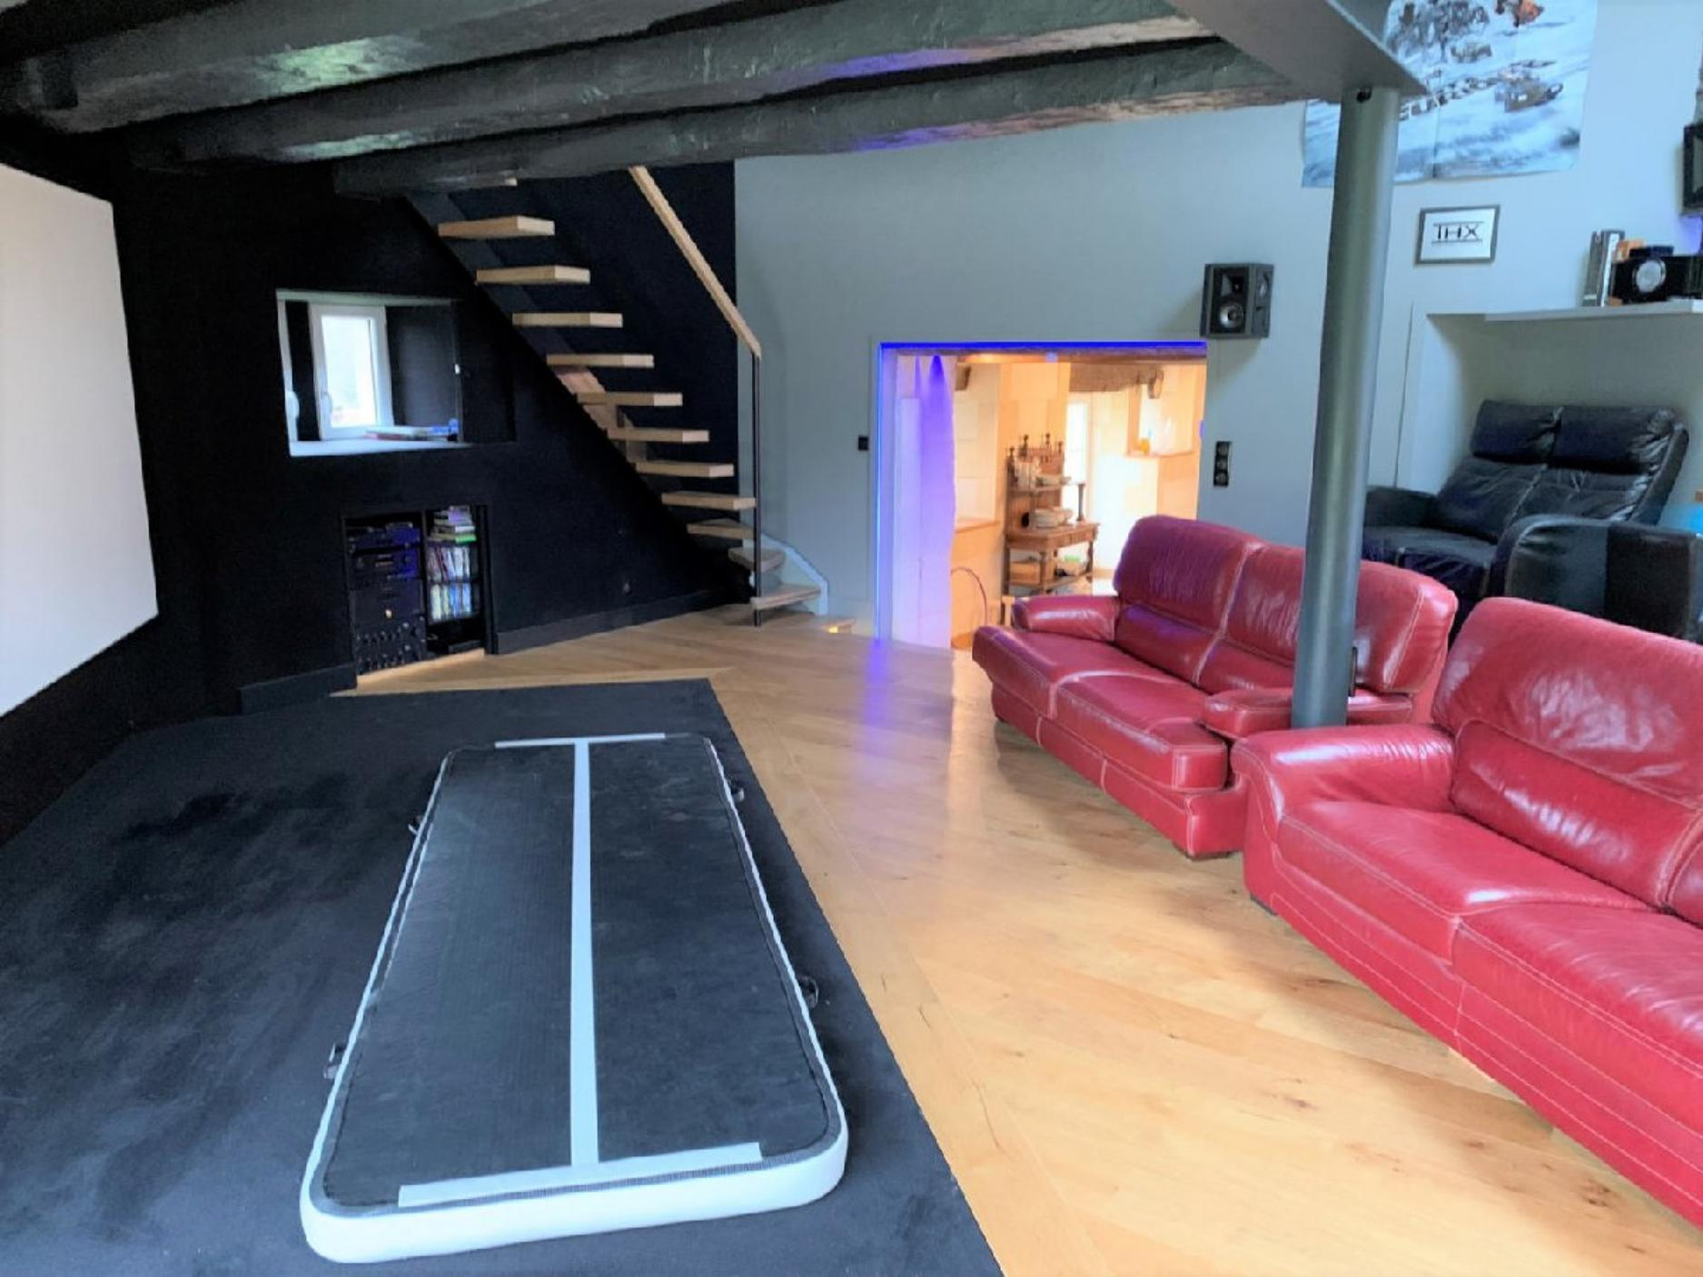 | 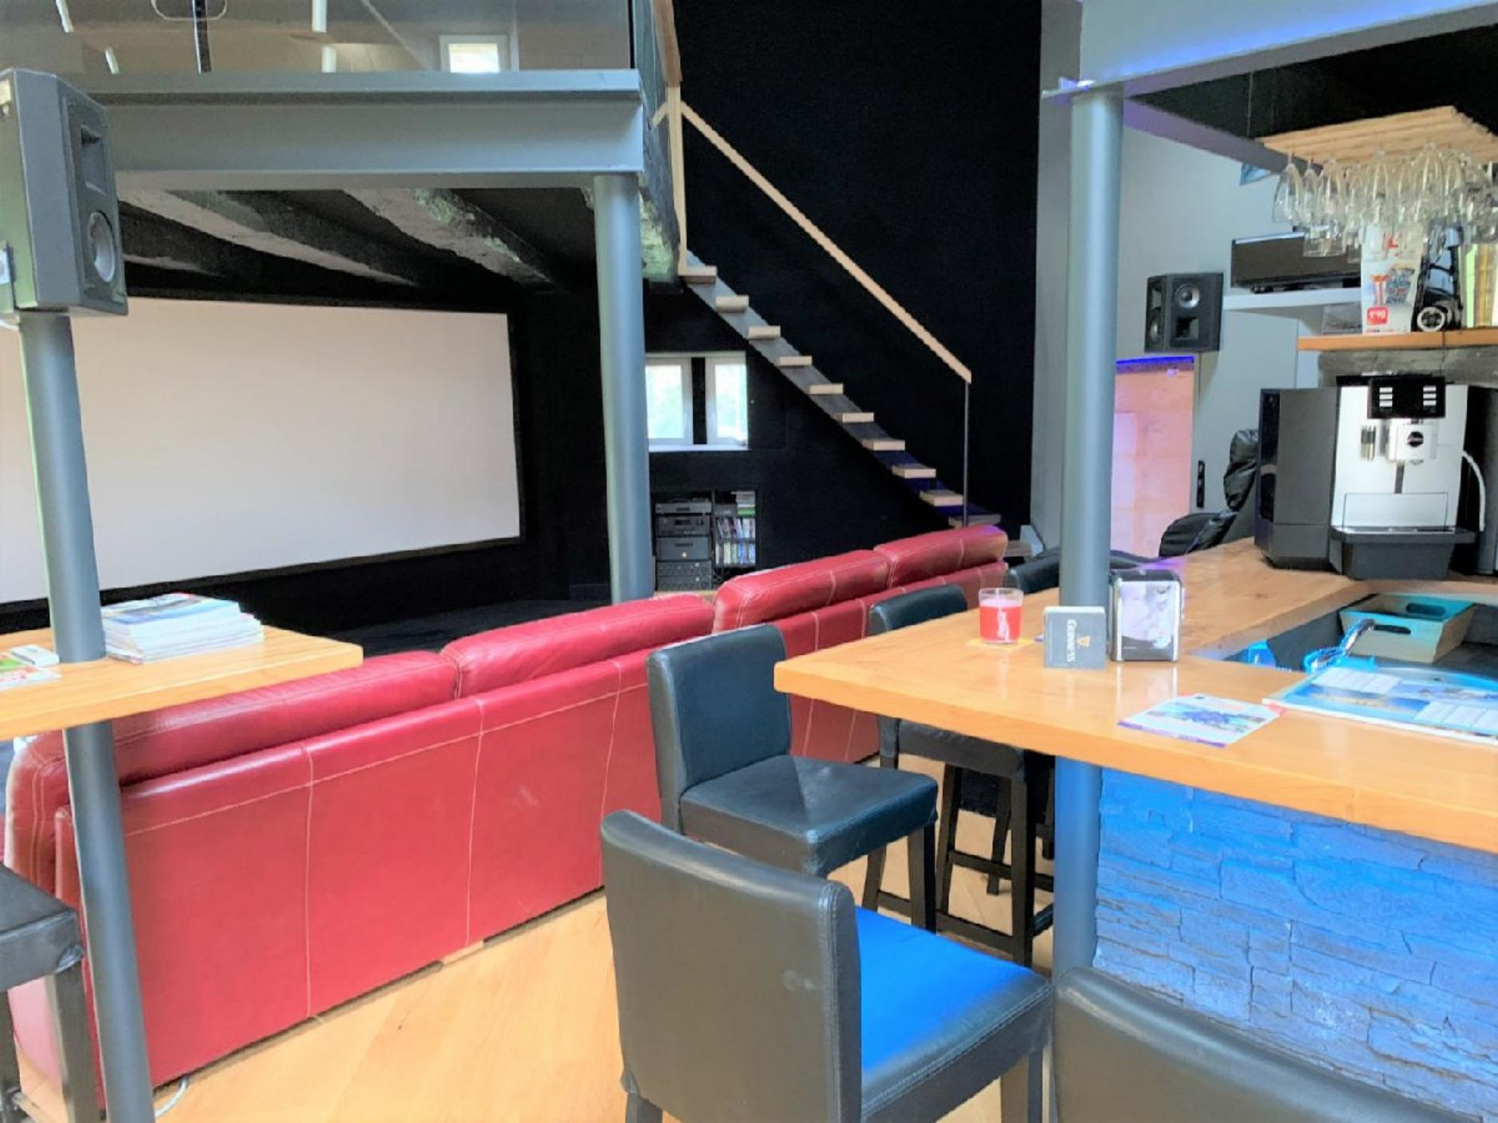
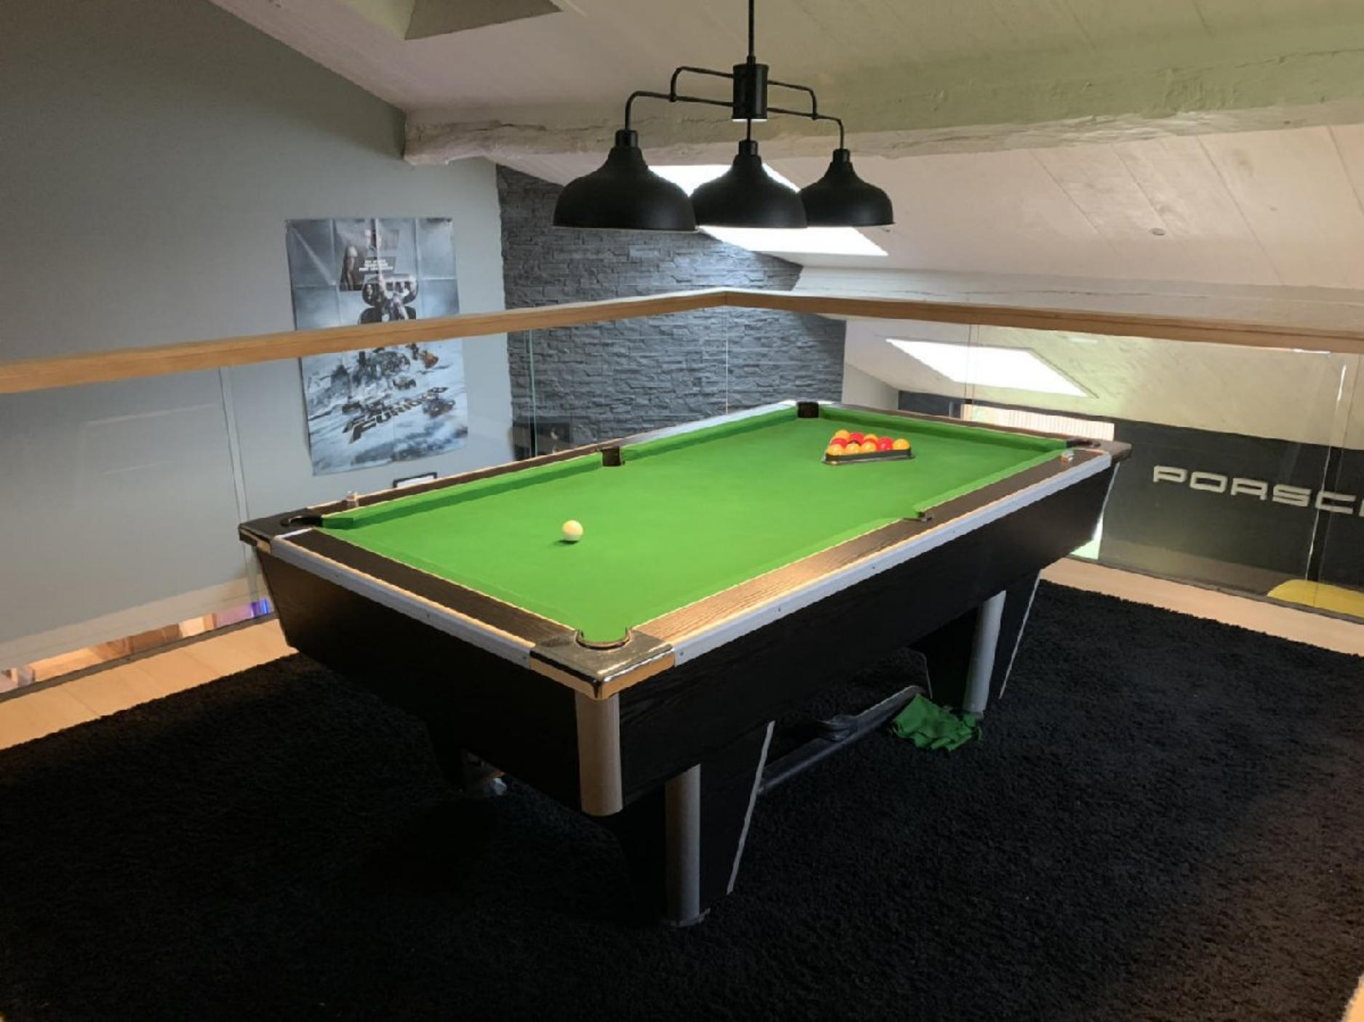 | 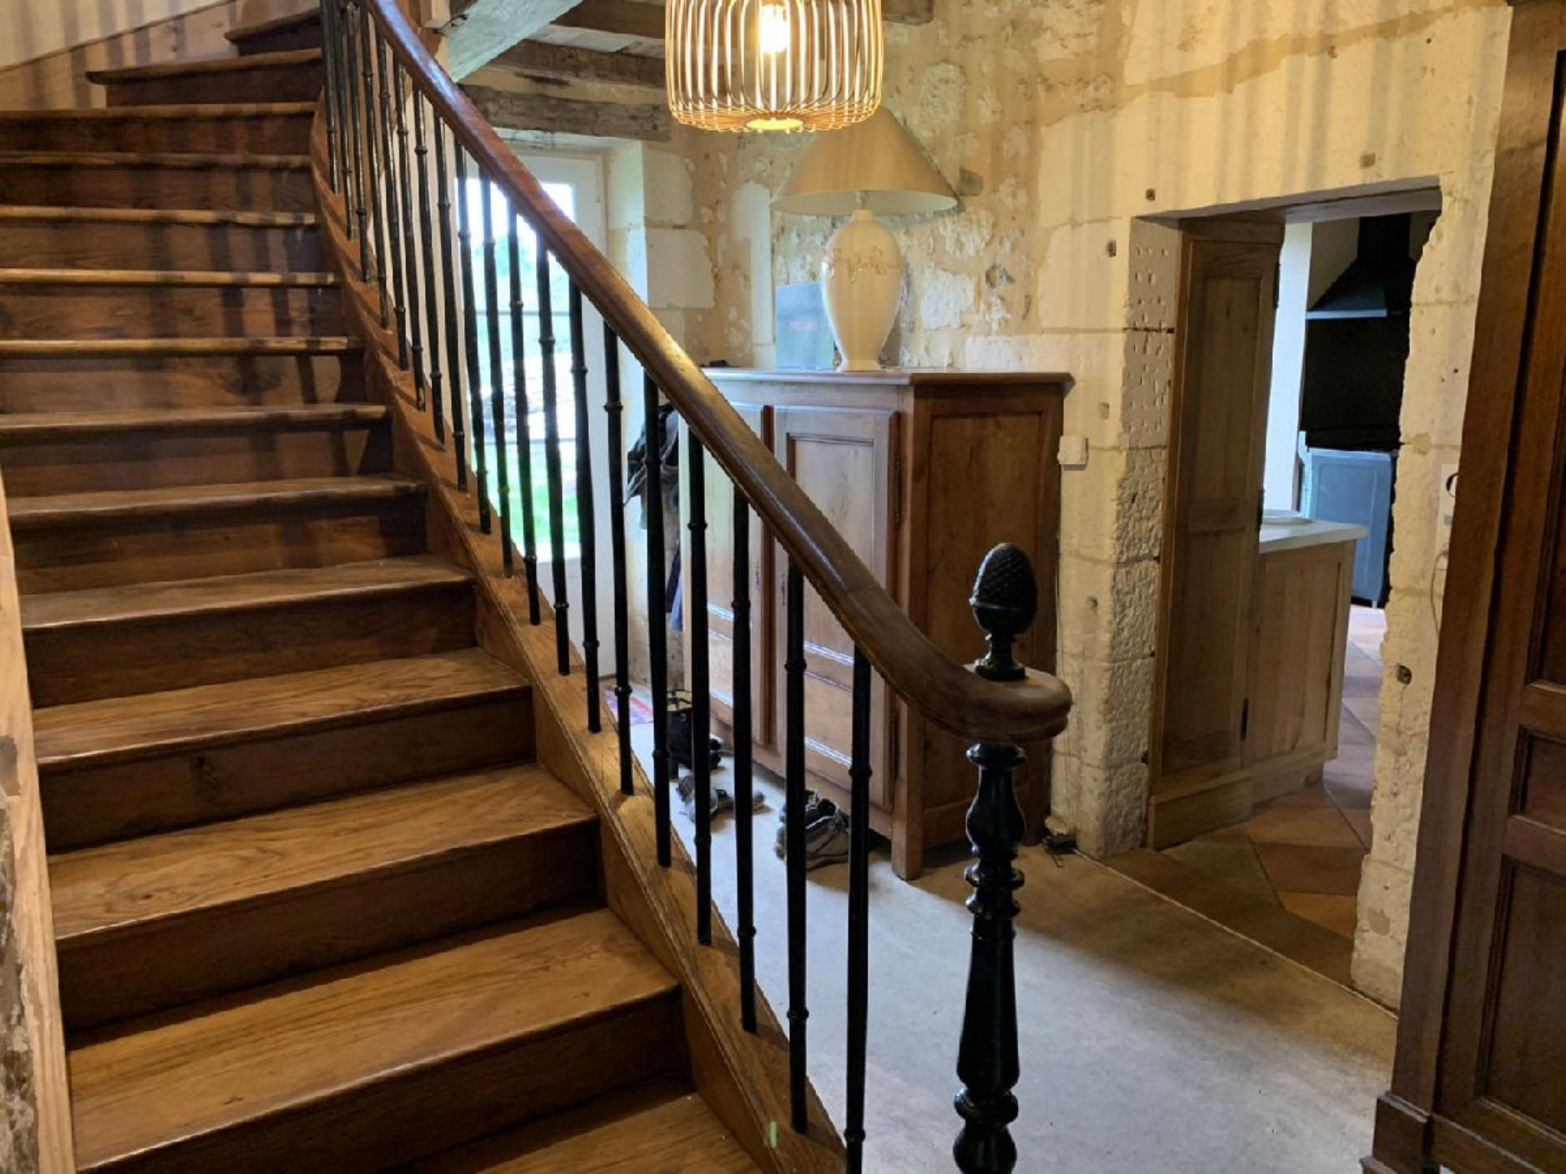
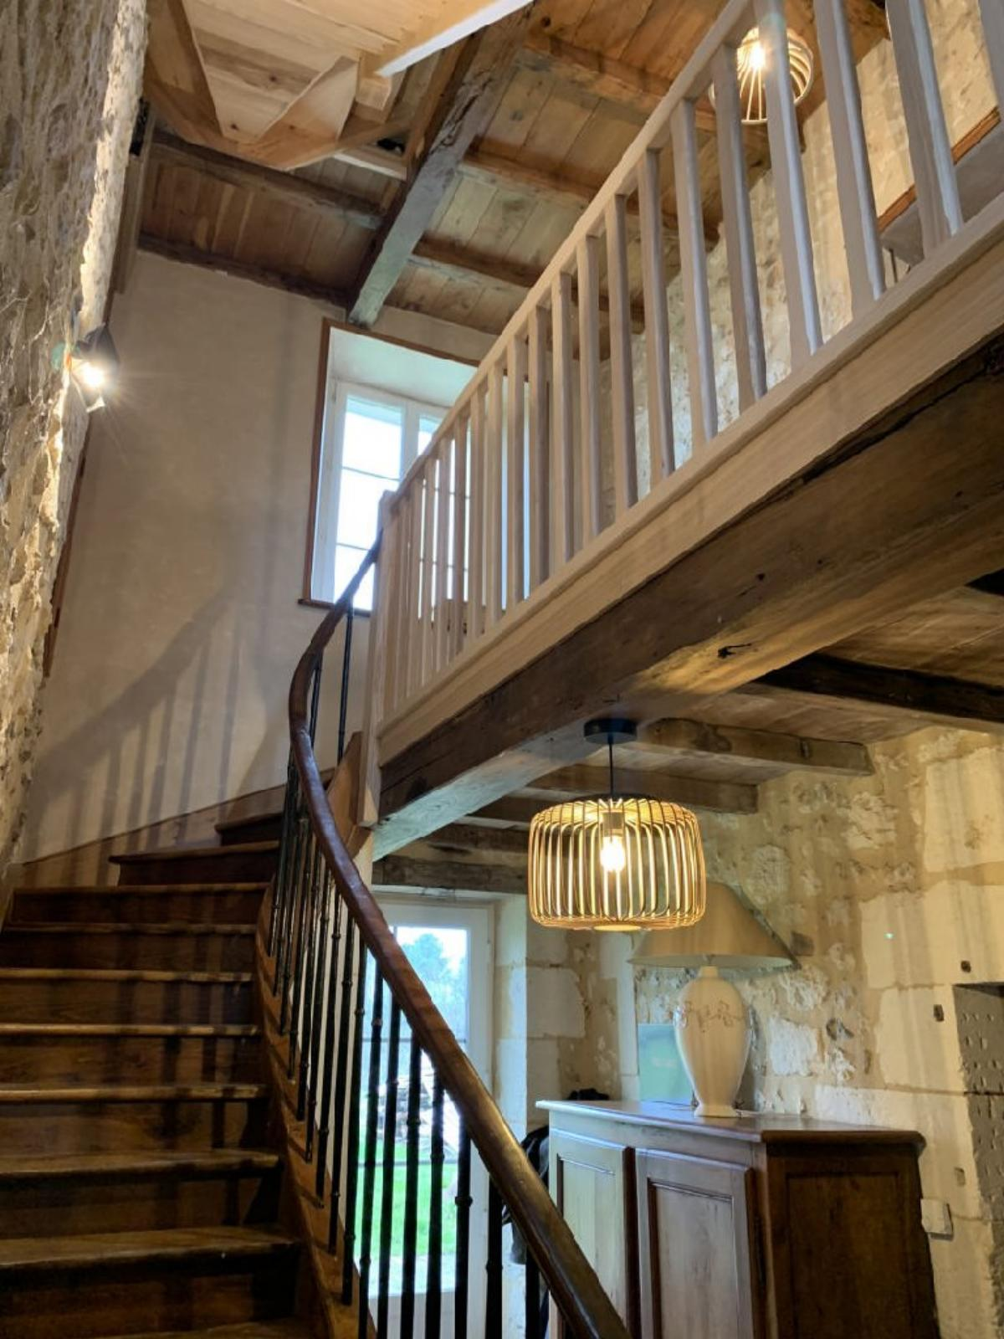 | 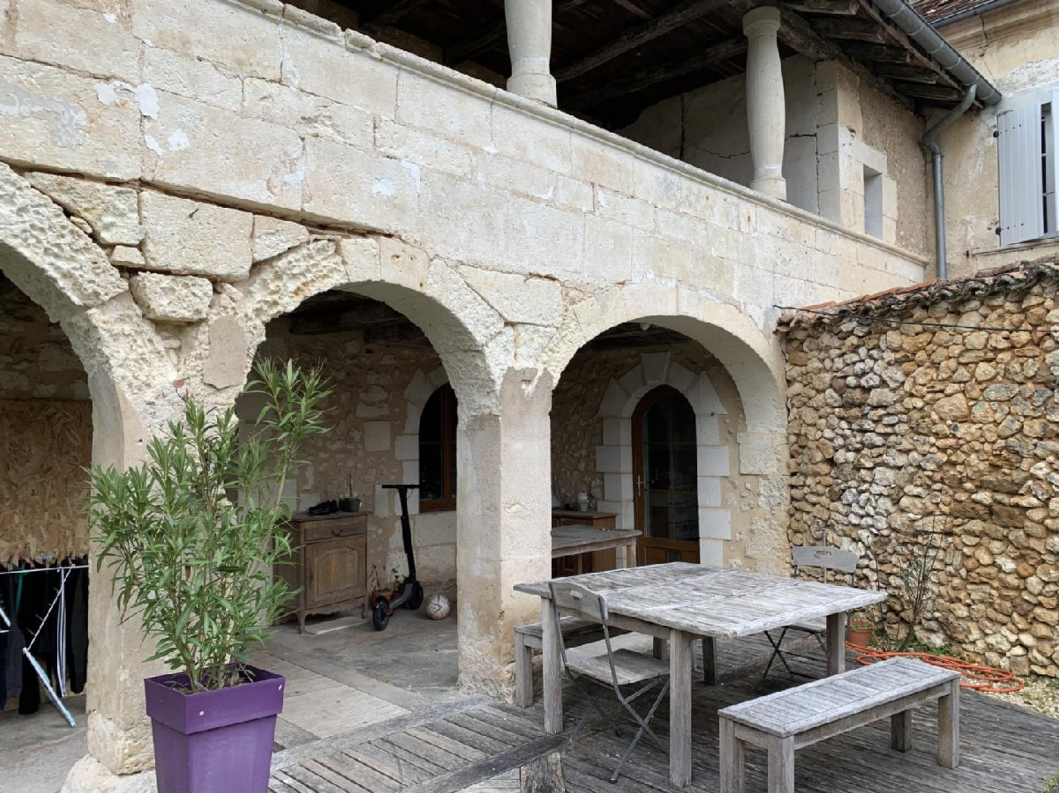

KEY DETAILS ( Ref . : PF90301) :
Total living space : 380 Sqm  Land area : 10,000 Sqm  Heating : Electricity & Wood  Energy Efficiency : | Nearest town : VILLAMBLARD 4KMS  Nearest commerce : 4MINS  Nearest autoroute : A89/A20 - 15MINS  Nearest airport : BERGERAC - 30MINS

PIONEER FRANCE CAN  ASSIST YOU WITH :  € Foreign Currency Exchange  the best rates : the best service  € Mortgage and Loan Facilities  pre-qualified, top lenders  € Your Total purchase process  a dedicated, fixed fee, total service from  initial offer through to post-completion  Call us or see our website  www.PioneerFrance.com   | PROPERTY LOCATION MAP :

