QUERCY TRANSACTIONS

|  |
| --- |
|  |

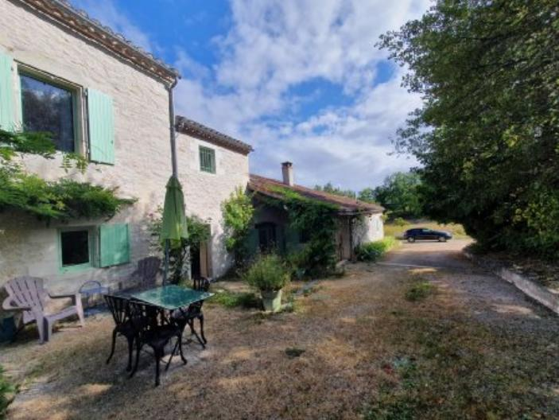 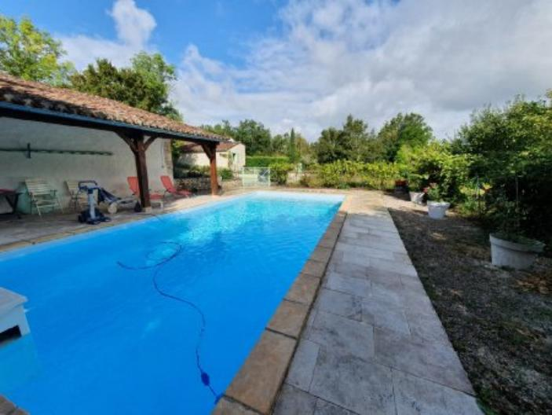 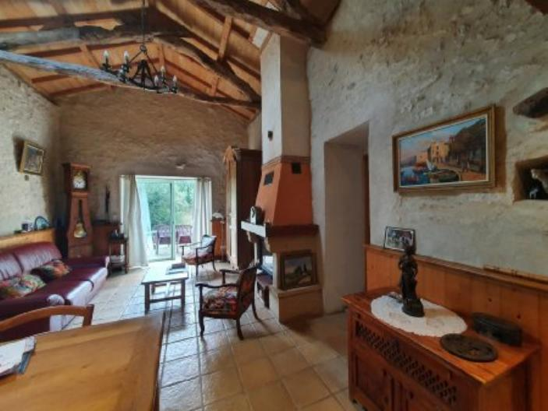 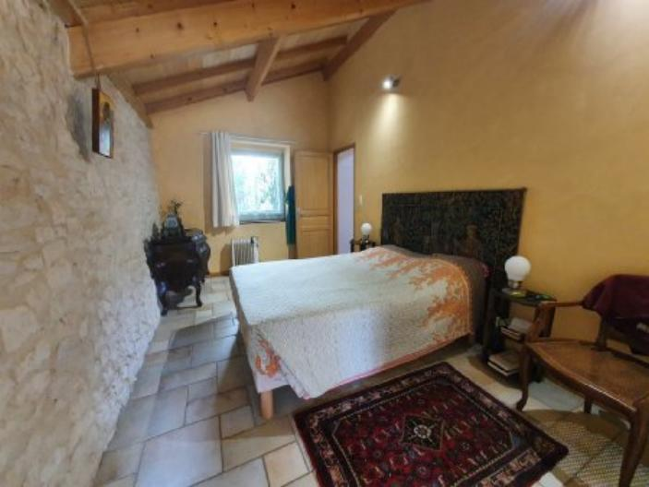

|  |  |  |
| --- | --- | --- |
| Description | Price : 96 250 € | Reference : CA6852 |

|  |
| --- |
| Main features |

**Living area** : 128 m² **Kitchen** : Independant

**Land surface** : 8 937 m² **Heating** : Wood & Oil

**Number of bedrooms** : 4 pièces **Bedrooms** : 3

Number of bathrooms : **2** Water rooms :

|  |
| --- |
| Details |

|  |  |
| --- | --- |
|  |  |
| Property location:   * Non isolated countryside   Ground floor:   * Utility Room * Bedroom * Kitchen * Entrance lobby * Living room   1st floor:   * 2 Bedrooms * Landing * Shower room * WC   Outbuildings:   * Barn   Energy report:   * Energy performance 255,00 KWHep/m²an * Gas emission 58,00 Kgco2/m²an * Date de réalisation DPE (jj/mm/aaaa) * Montant bas supposé et théorique des dépenses énergétiques 2 318,00 € * Montant haut supposé et théorique des dépenses énergétiques 3 136,00 €   Heating:   * Wood | Heating (continued):   * Oil central heating   Kitchen equipment:   * Gas Cooker * Fridge * Extractor fan * Dishwasher   Other equipment:   * Water Softener * Septic tank * Hot Water   Windows:   * Aluminium * Shutters   Services:   * Nearest airport : * Nearest motorway : * Nearest shops : * Outbuildings * School * Railway Station * Hospital * Broadband * Well/Spring/Pond * Bungalow   Land:   * Swimming Pool   Roof:   * Tiles |

We offer a SALE TERM of a house occupied, south of Cahors, stone of about 128m ² fully restored between 2002 and 2006 composed on the ground floor of an entrance, a kitchen and equipped (gas stove, hood, Siemens dishwasher, Fridge Whirpool), a laundry/ boiler room, a living room with fireplace and cathedral ceiling with mezzanine and terrace, a master bedroom with its bathroom and toilet and closet. Upstairs: a bathroom, a separate toilet, a 1st through bedroom overlooking another room with fireplace and exit to the external staircase. Oil heating (ground floor: floor and floor: radiators). Aluminum windows double glazing. Eversoft softener. Septic tank. Outbuilding: barn with open entrance of 42m² + workshop of 12m², carport on one side and covered terrace on the pool side. Swimming pool (Desjoyaux system) salt 10 x 4,50m (depth 1,60m), liner changed in 2020. 2 rainwater tanks of 3000l each. Adjoining closed ground of 3445m ² and not adjoining ground of 5492m ² near the house. CASH SIGNING: 96.250€ agency fees included 6.5% of the market value of the property. MONTHLY PAYMENTS LIMITED TO 120 MONTHS (10 years): 604 €/month indexed annually. House occupied by a 78 year old man with a maximum occupancy over 12 years. In case of early release of the property allowing you to take possession of the property or to rent it, the monthly payment is increased by 15%. REDUCED NOTARY FEES: 14.000€ (estimated on the occupied value, a saving of 5.600€). VENALE VALUE: 250.000€. That is a saving on the net market value of the property of about 39% (97.500 €). The purchase for sale at term is a responsible investment with the possibility of gradually building up real estate without recourse to a bank assistance and benefiting from a purchase price of reduced notary fees.