|  |
| --- |
| PERIGORD Noir - MONTIGNAC AREA |

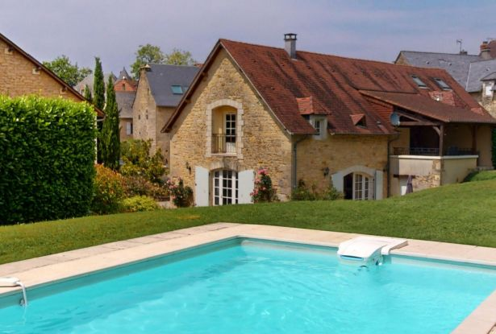

Réf: MP113821

439 900 €honoraires inclus à la charge de l'acheteur.

In the Périgord Noir, in the typical village of Beauregard, with bakery, beautiful barn renovated into a comfortable vacation home with swimming pool.

On a hilltop with a lovely view, in the small village of Beauregard, 15 minutes from Montignac-Lascaux, with easy access to main roads, this former barn, part of a larger, fully-renovated property complex, has now become a large, bright and comfortable vacation home. On two communicating levels, it offers two beautiful apartments, each with a large living room with terrace, two bedrooms (4 in total) and two bathrooms/water closets (4 in total). The property offers 166 m² of living space and is heated by a large heat pump. Beautiful heated swimming pool with lovely views. Quiet but not isolated location. Very versatile property with significant seasonal rental potential.

|  |  |  |  |  |  |  |
| --- | --- | --- | --- | --- | --- | --- |
| |  |  | | --- | --- | |  |  | |  |  | |  |  | |

|  |  |  |
| --- | --- | --- |
| Caractéristiques : | | |
| Type: House / Character property  Piscine : Swimming pool Private | Etat: Very good  Surf. hab: 166 m²  Terrain: 2,500 m²  Séjour: 50 m²  Terrasse: 20 m²  Hamlet  Exposition: North South | 4 chambres  4 s.d.b  10 pièces  Chauffage: Heating pump |

|  |  |
| --- | --- |
| Détails complémentaires: | |
| * PROPERTY LOCATION:  - Village   GROUND FLOOR:  - 2 Bedrooms   - Open plan living area   - Bathroom   - Washroom   1ST FLOOR:  - 2 Bedrooms   - Corridor   - Room   - Shower room   - Bathroom   - Terrace   OUTBUILDINGS:  - Shed   ENERGY REPORT:  - Energy performance: 58 KWHep/m²an  - Gas emission: 1 Kgco2/m²an  HEATING:  - | * OTHER EQUIPMENT:  - Double Glazing   - Mains drainage   SERVICES:  - Nearest airport :   - Nearest motorway :   - Calm   - Nearest shops :   - Outbuildings   - School   - Railway Station   - Hospital   - Broadband   - View   - Bungalow   LAND:  - Swimming Pool   VIEW:  - Panoramic view   WEB OPTIONS:  - Scrolling |

|  |  |
| --- | --- |
| Consommations énergétiques: | |
|  |  |
| **58** | **1** |
| **Classe DPE - B** | **Classe GES - A** |

**Taxe foncière:**

**Agent responsable du dossier**: Mr Ludovic MONS \ Email : mperigord@wanadoo.fr \ Tel :  **\** Mobile : 0672150964

Les informations sont données à titre informatif et non contractuel.