Phone : +33 (0)5 53 07 06 27  Email : info@pioneerfrance.com  Web : www.PioneerFrance.com  Domaine Le Ruisseau , 24580, Fleurac, Dordogne | 

THE DORDOGNE'S LEADING QUALITY PROPERTY AGENCY

REFERENCE  PF90909 | PRICE (inc.agency comm)  129,600 € | LOCATION  DORDOGNE -  LE BUGUE AREA | TYPE  House / Character property | LAND AREA  1,696 m2

160SQM STONE HOUSE WITH GARAGE REQUIRING COMPLETION. EDGE OF A PRETTY VILLAGE 10MINS FROM LE BUGUE. GARDENS OF 1696SQM. LOVELY STREAM AND WIDE COUNTRYSIDE VIEWS. PF90309

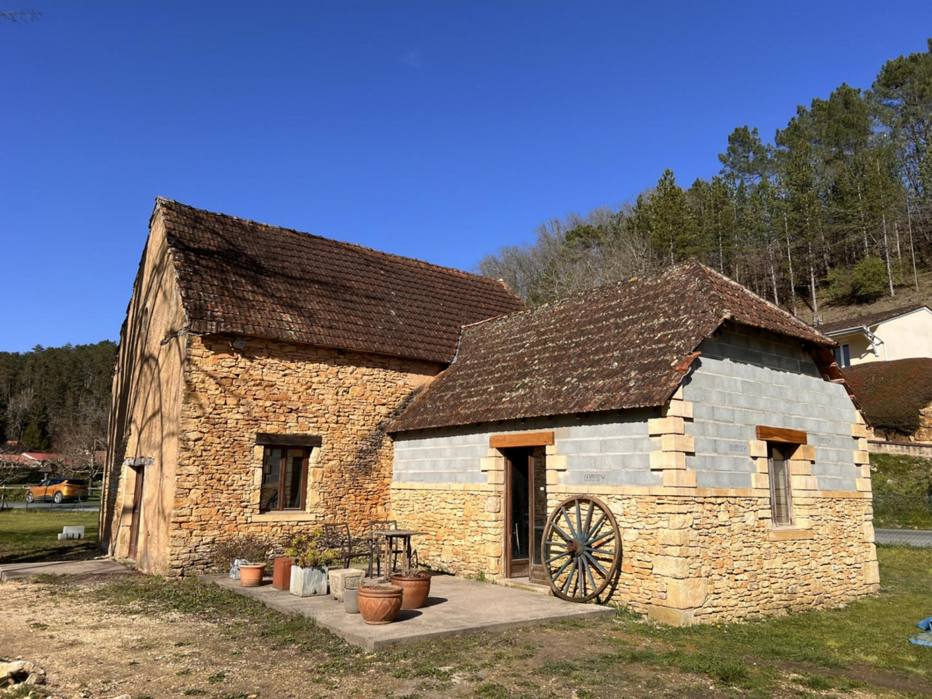

On the edge of a charming village and less than 10mins drive from the riverside market town of Le Bugue, this old stone property bordered by a stream needs completing. It will provide a superb and spacious 2-floor, 3-bedroom, 2-bathroom house with 2 large living rooms and a large eat-in kitchen room. Westerly facing with terracing. Garage also to complete. PF90308
PROPERTY DESCRIPTION ( Ref : PF90909)
160SQM STONE HOUSE WITH GARAGE REQUIRING COMPLETION. EDGE OF A PRETTY VILLAGE 10MINS FROM LE BUGUE. GARDENS OF 1696SQM. LOVELY STREAM AND WIDE COUNTRYSIDE VIEWS. PF90309
On the edge of a charming village and less than 10mins drive from the riverside market town of Le Bugue, this old stone property bordered by a stream needs completing. It will provide a superb and spacious 2-floor, 3-bedroom, 2-bathroom house with 2 large living rooms and a large eat-in kitchen room. Westerly facing with terracing. Garage also to complete. PF90308
THE MAIN HOUSE
Habitable Space: In current shell state, approximately160sqm
Bordered by a lovely stream.
The house has water and electricity (3-phase). Many lovely, exposed stone walls internally and externally. The house is in a shell state. A quantity of finishing materials are being included with the property.
Note: all measurements below are approximate floor measurements to bare walls.
Ground Floor:
Access via a terrace:
Proposed Kitchen/Dining Room: 29.43sqm
Stone archway through to:
Proposed Living Room 1 / Bedroom 3 / Bathroom 2: 55.38sqm Within this space, a living room area, study/bedroom 3, and shower-room/WC are proposed as well as a staircase to the 1st floor.
Stone archway through to:
Living Room 2: 19.56sqm
First Floor: 55.38sqm (into the eaves).
Currently a large space in which it is proposed to have 2 large bedrooms and a shower-room.
LAND AND GARDEN
1696sqm, currently fenced to one side and bordered by a stream on the other.
GARAGE
Floor and half walls in place (approx. 10mx3.5m). Requires completion.
GENERAL INFORMATION
Very pretty, countryside, edge-of-village location
Le Bugue less than 10 mins drive & Perigueux 30 mins drive
Full, authorised planning permissions, with all plans.
Areat opportunity to purchase a traditional property with huge potential at an excellent price.
REF: PF90309

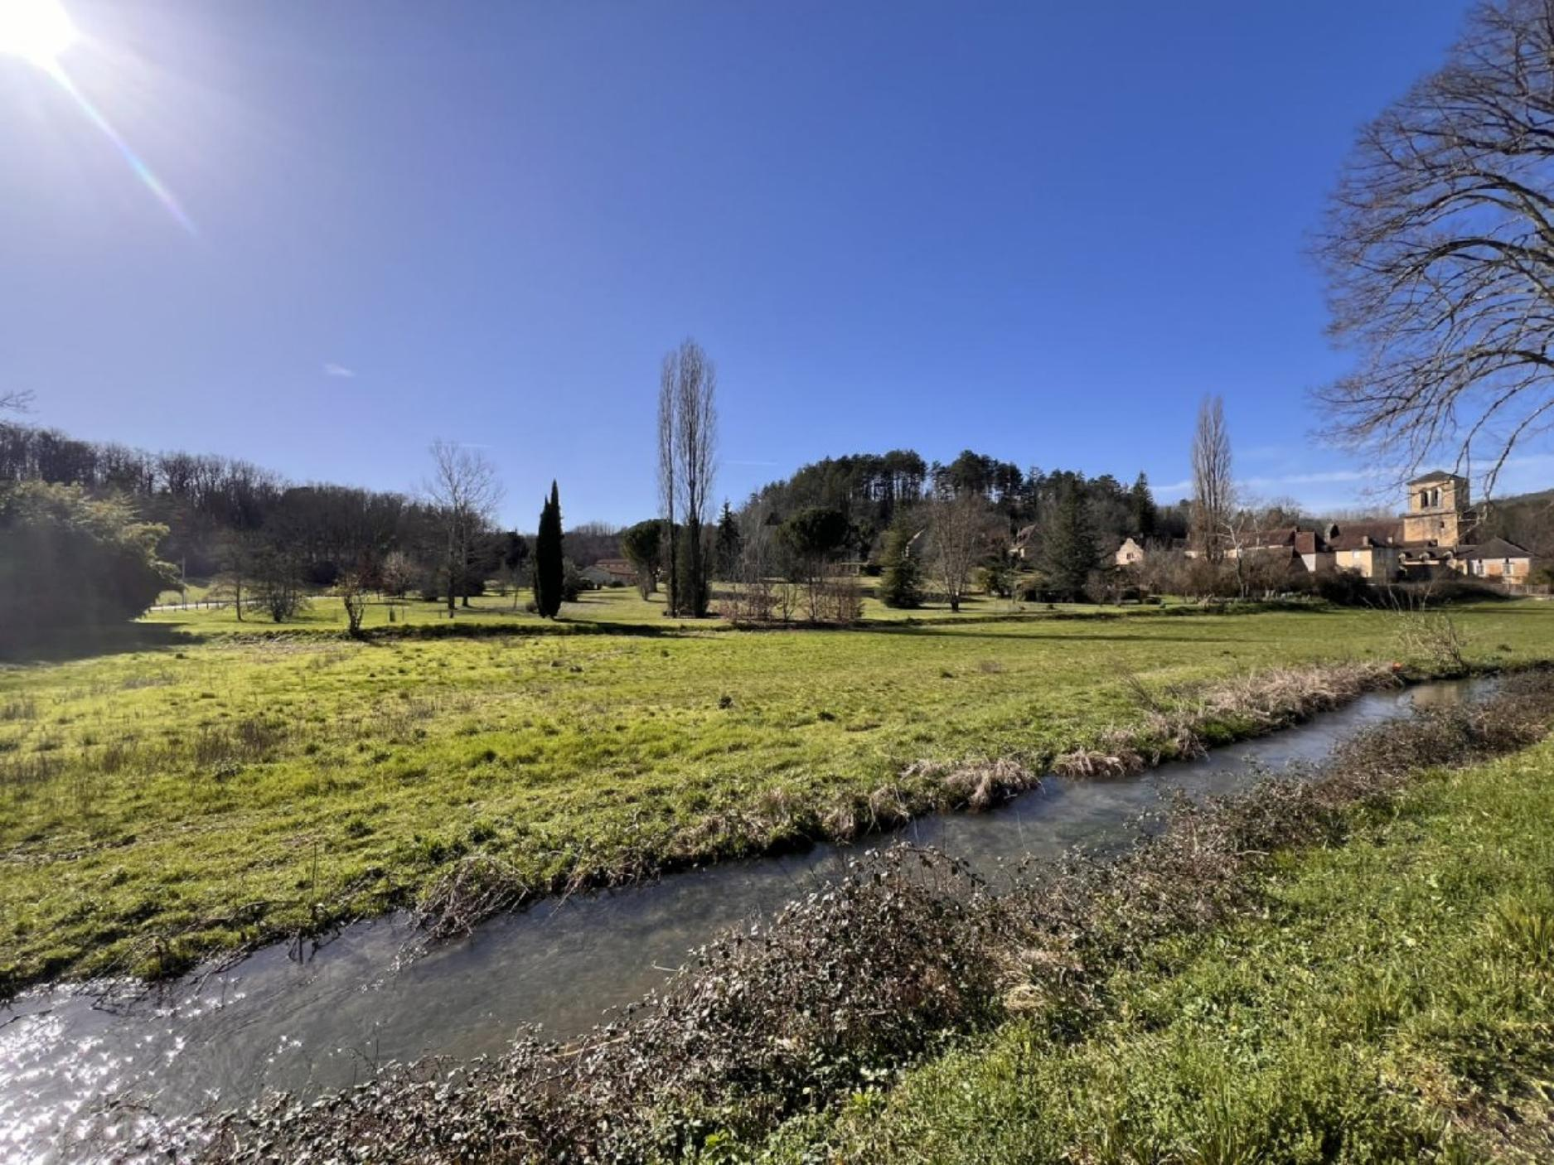 | 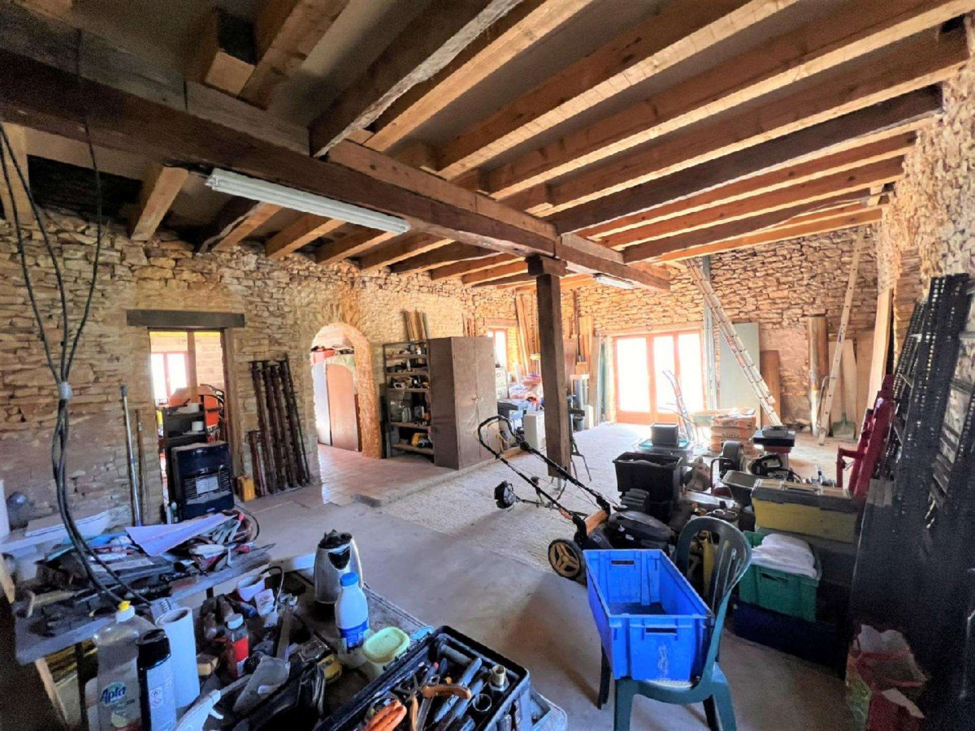
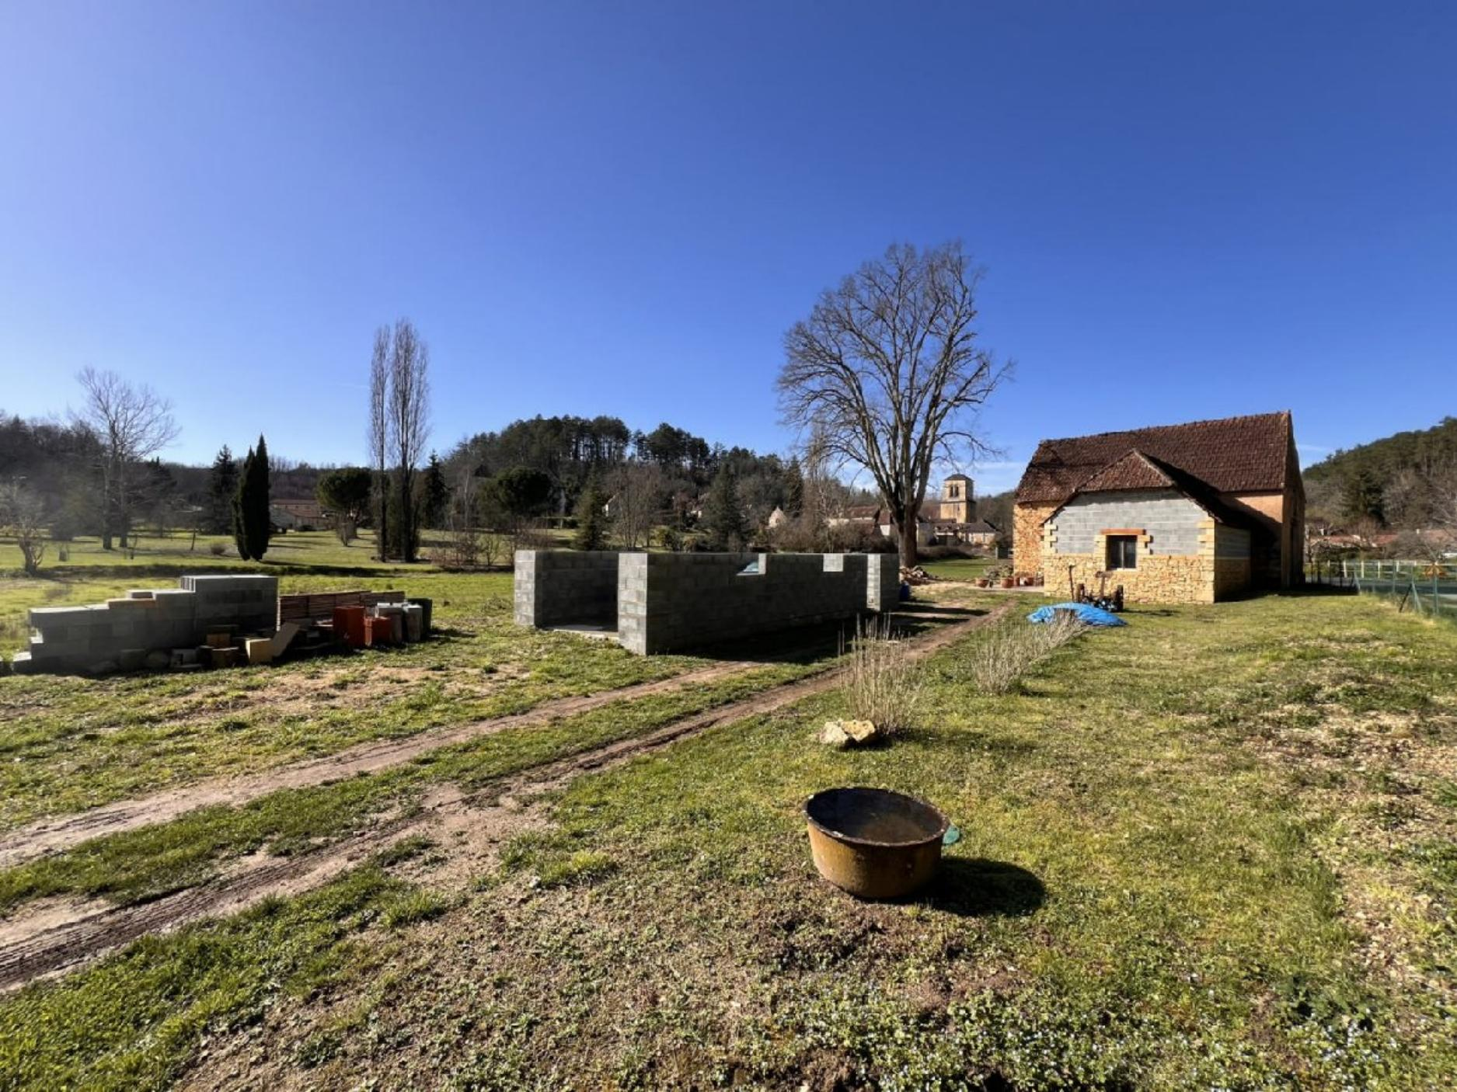 | 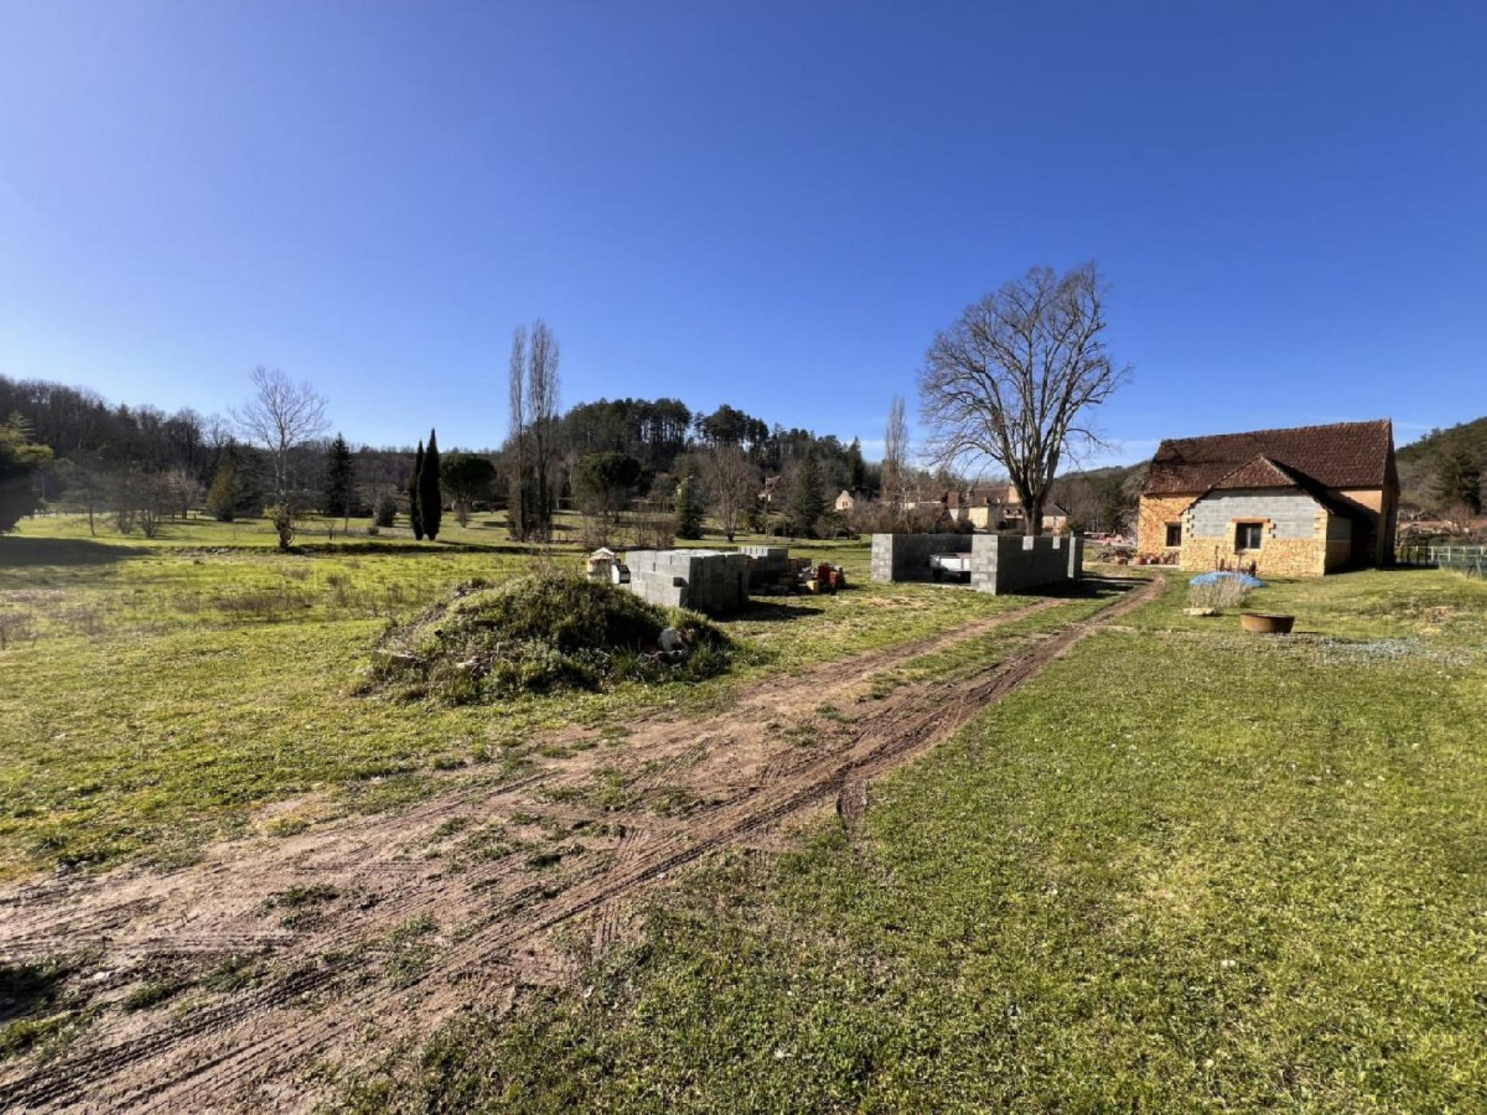
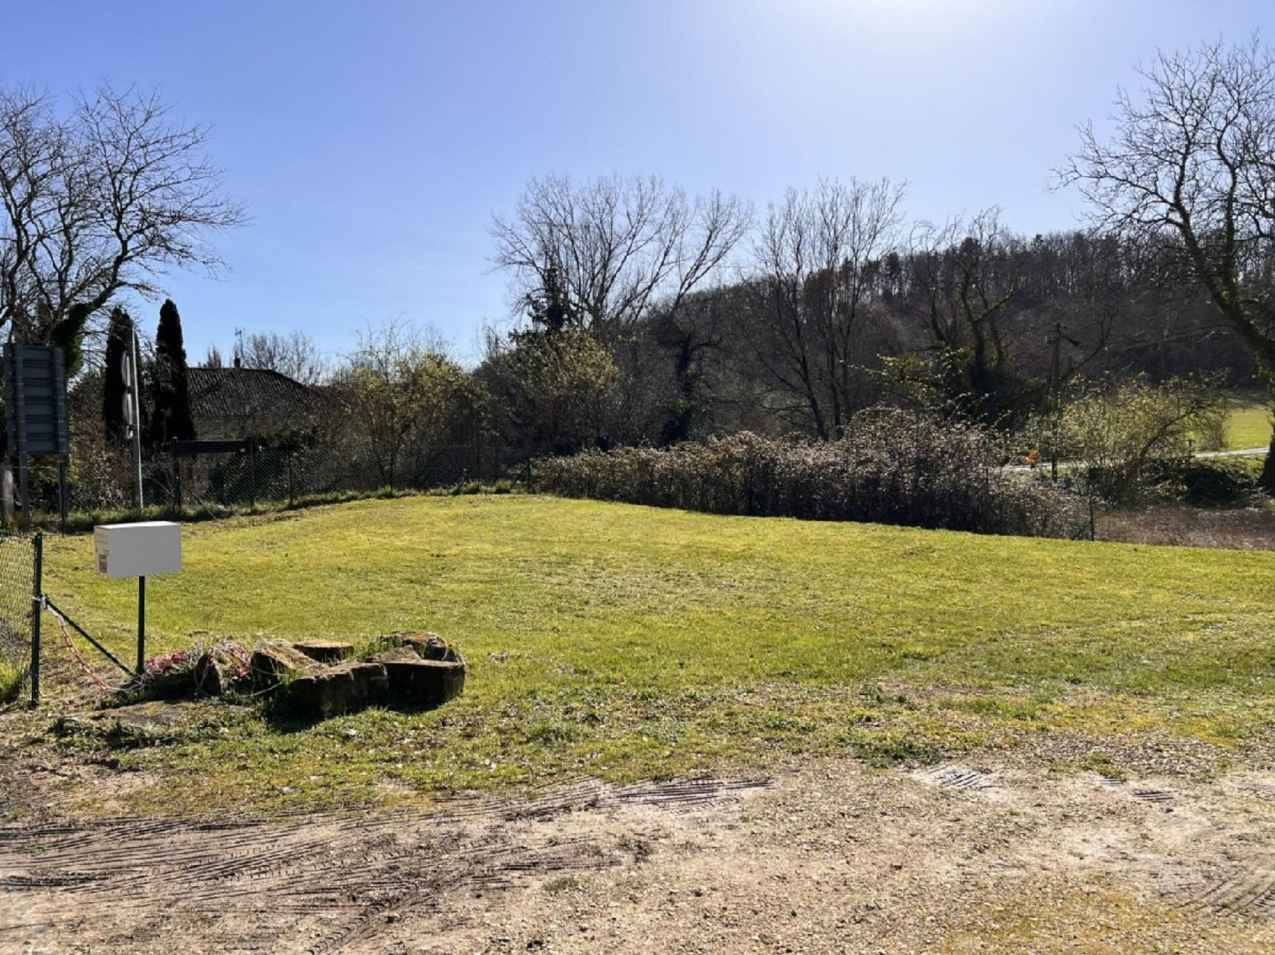 | 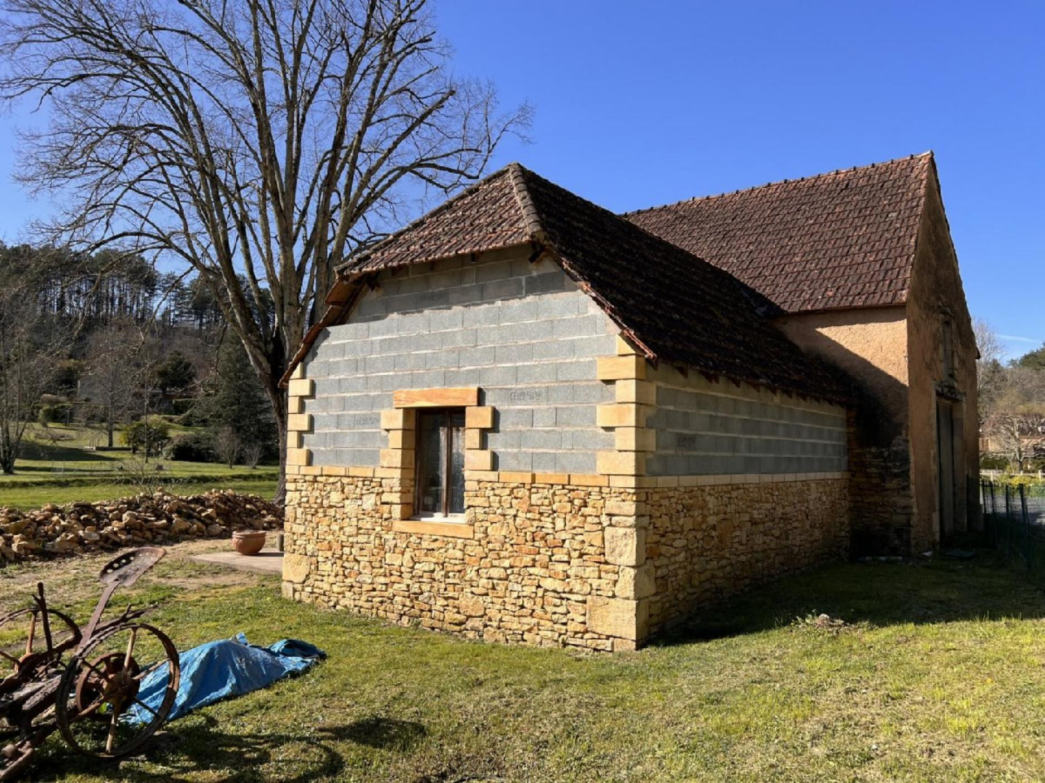
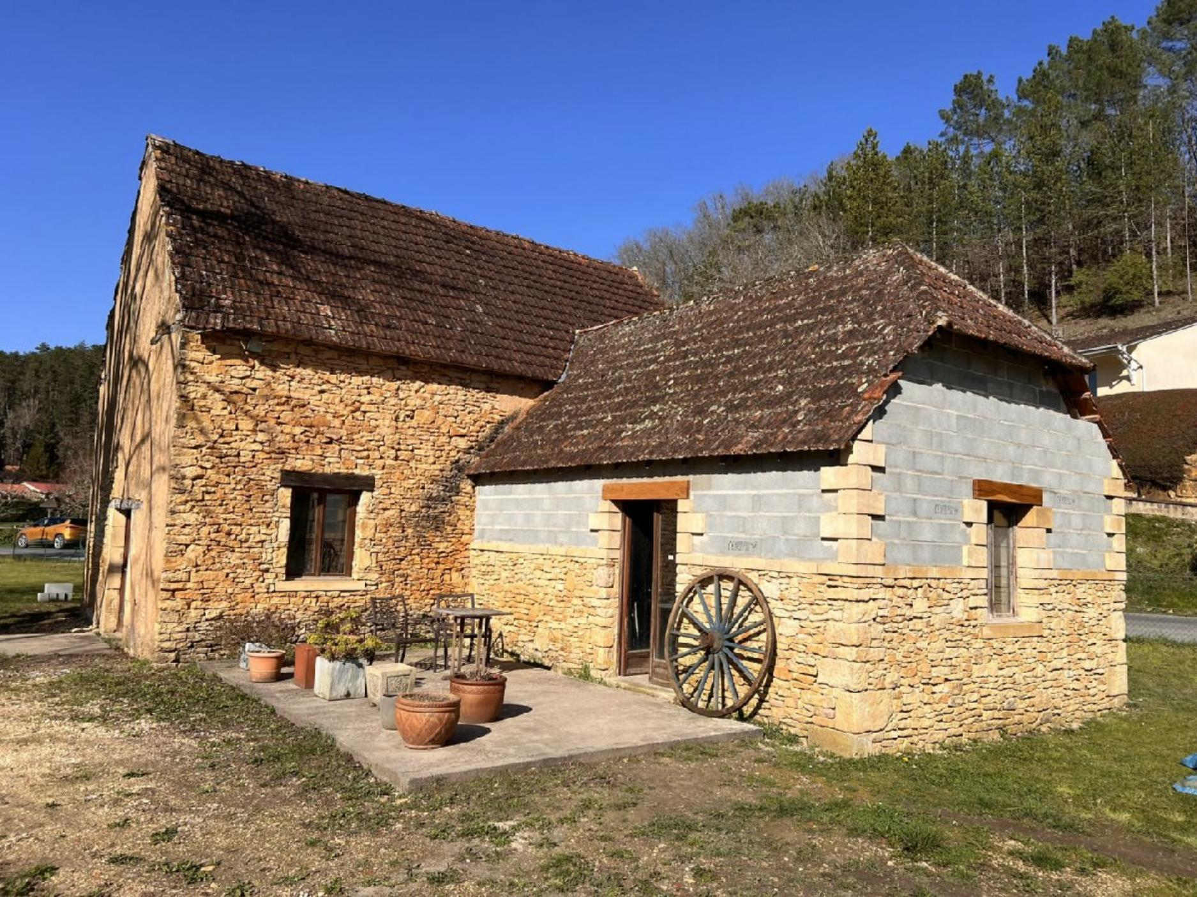 | 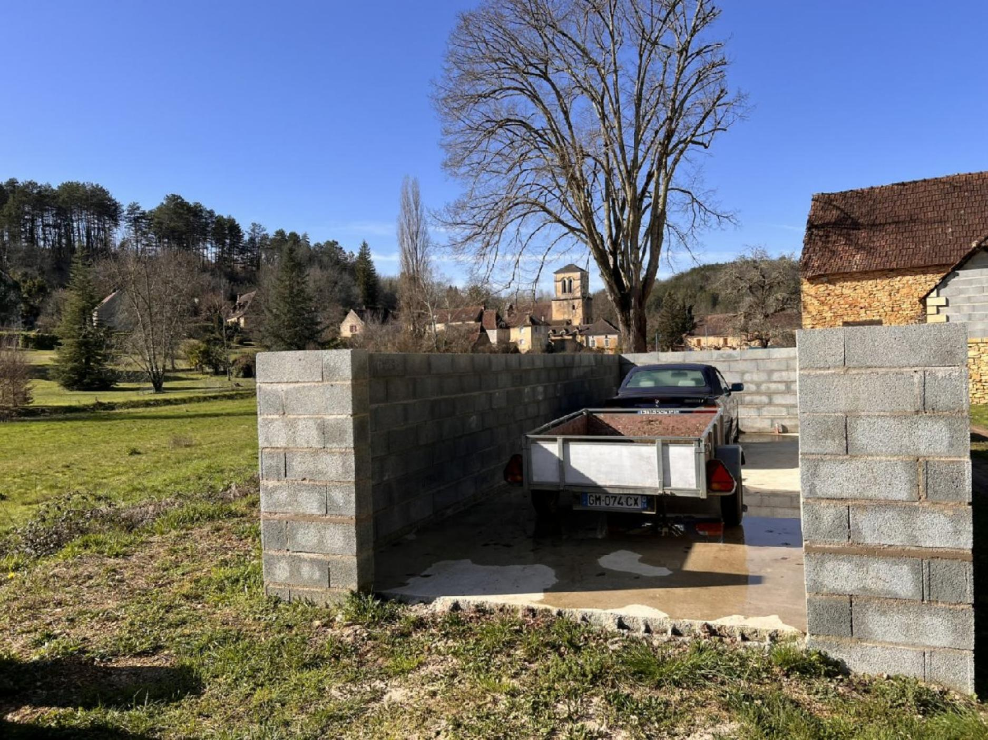
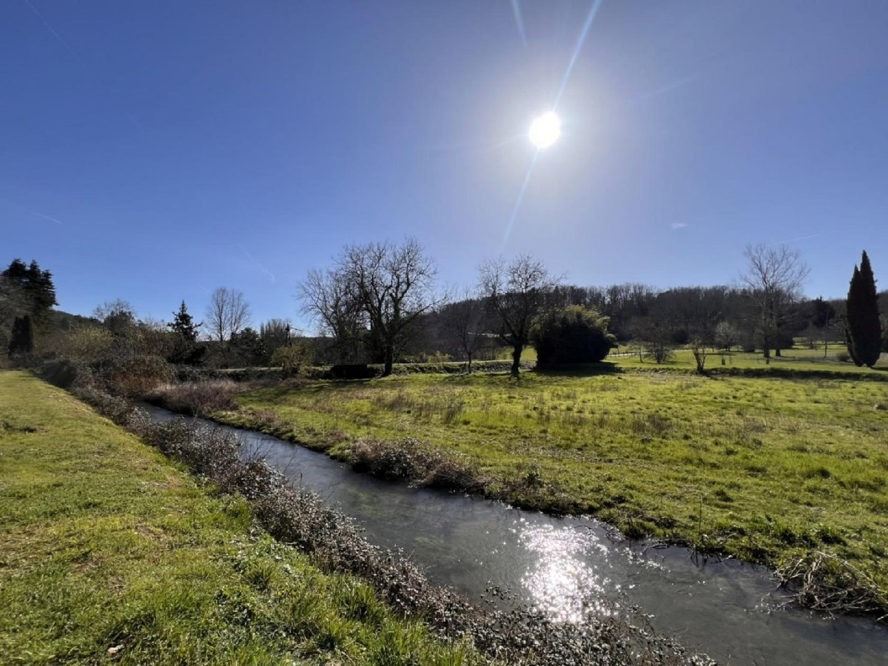 | 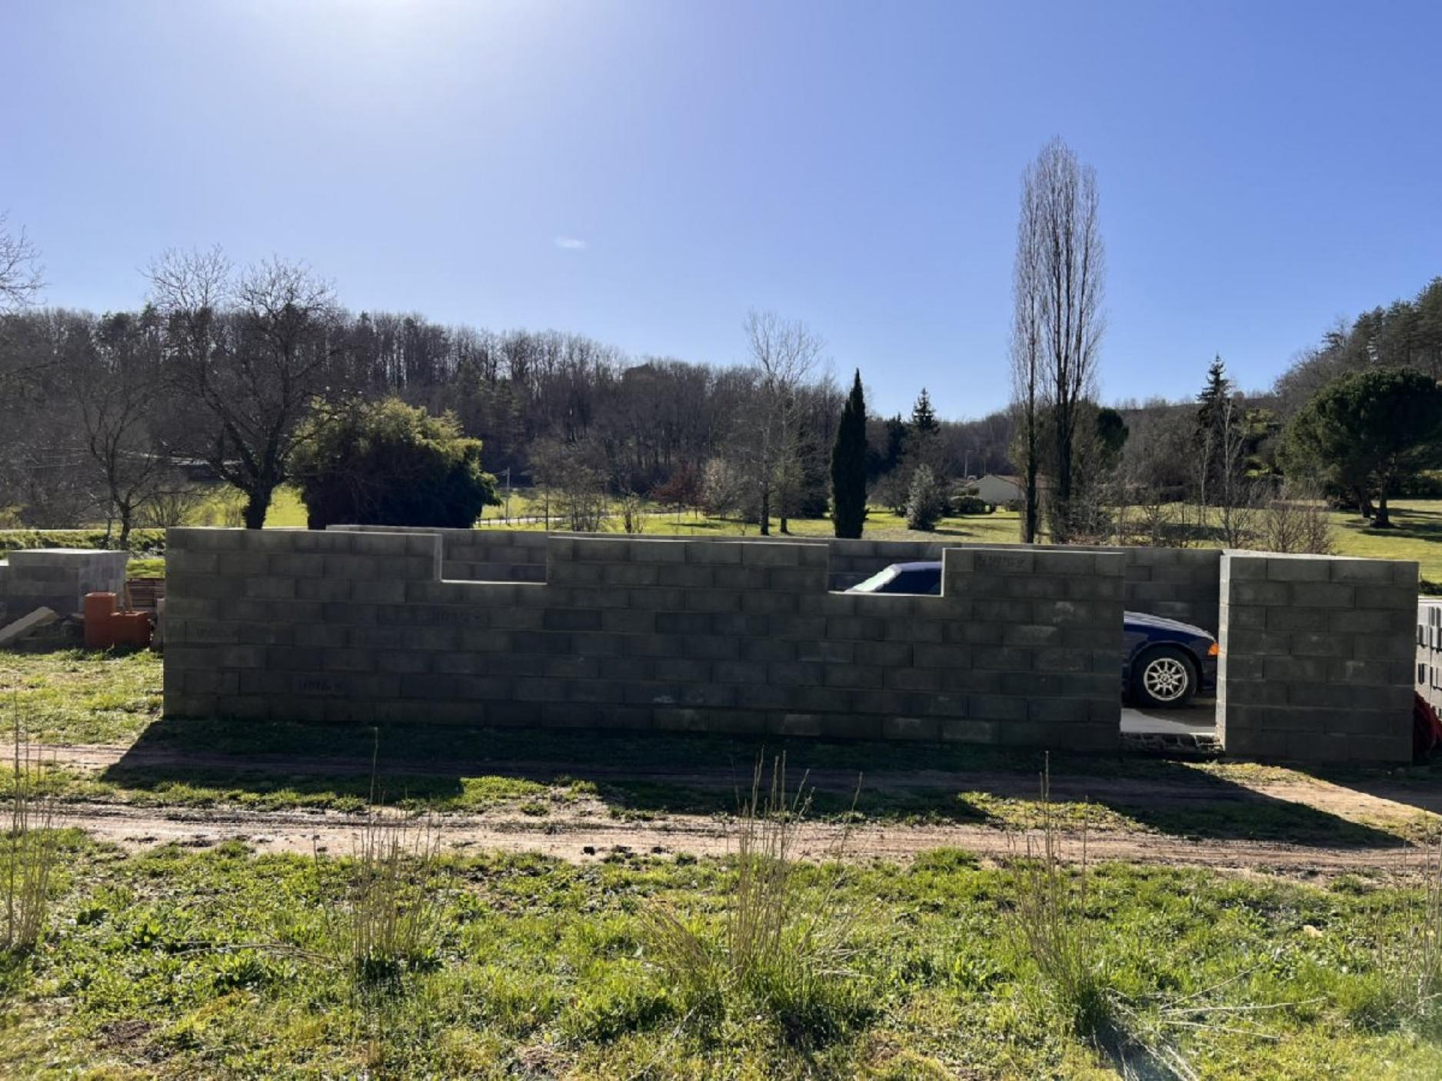
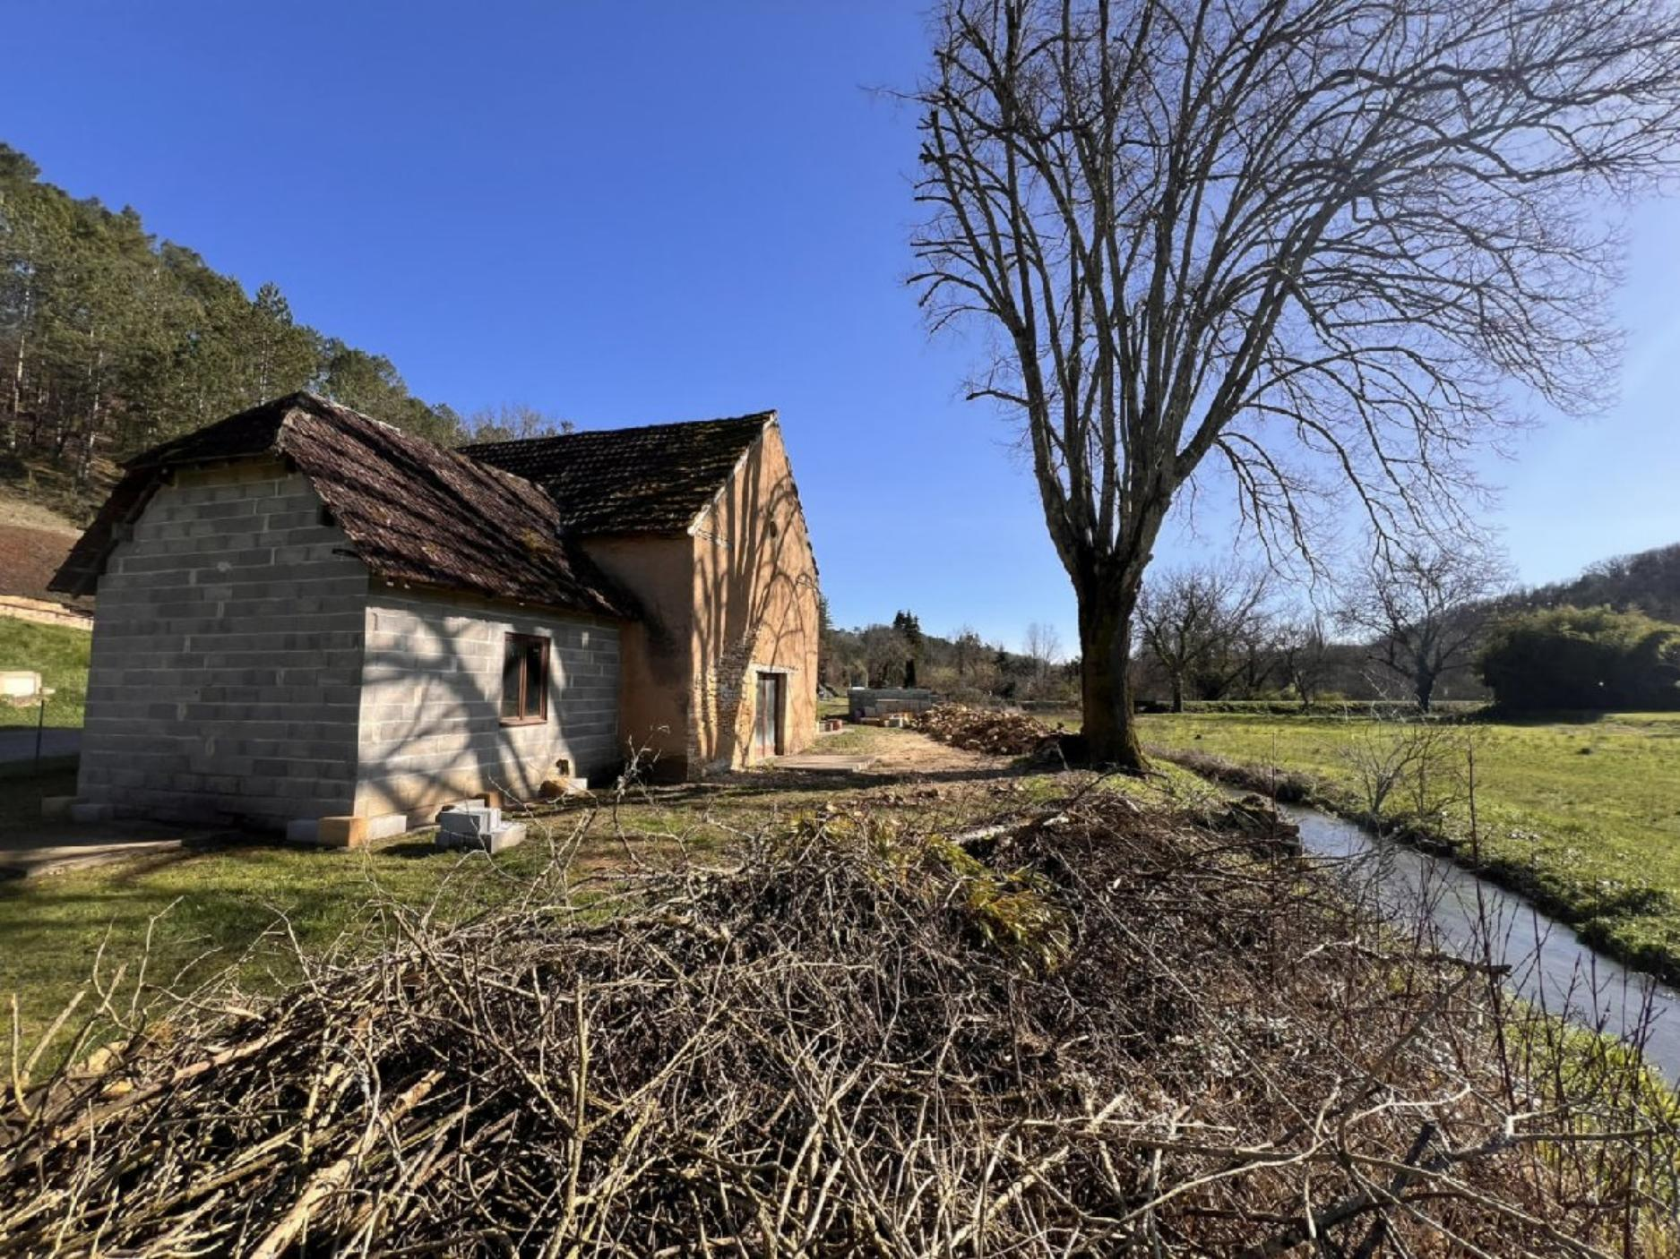 | 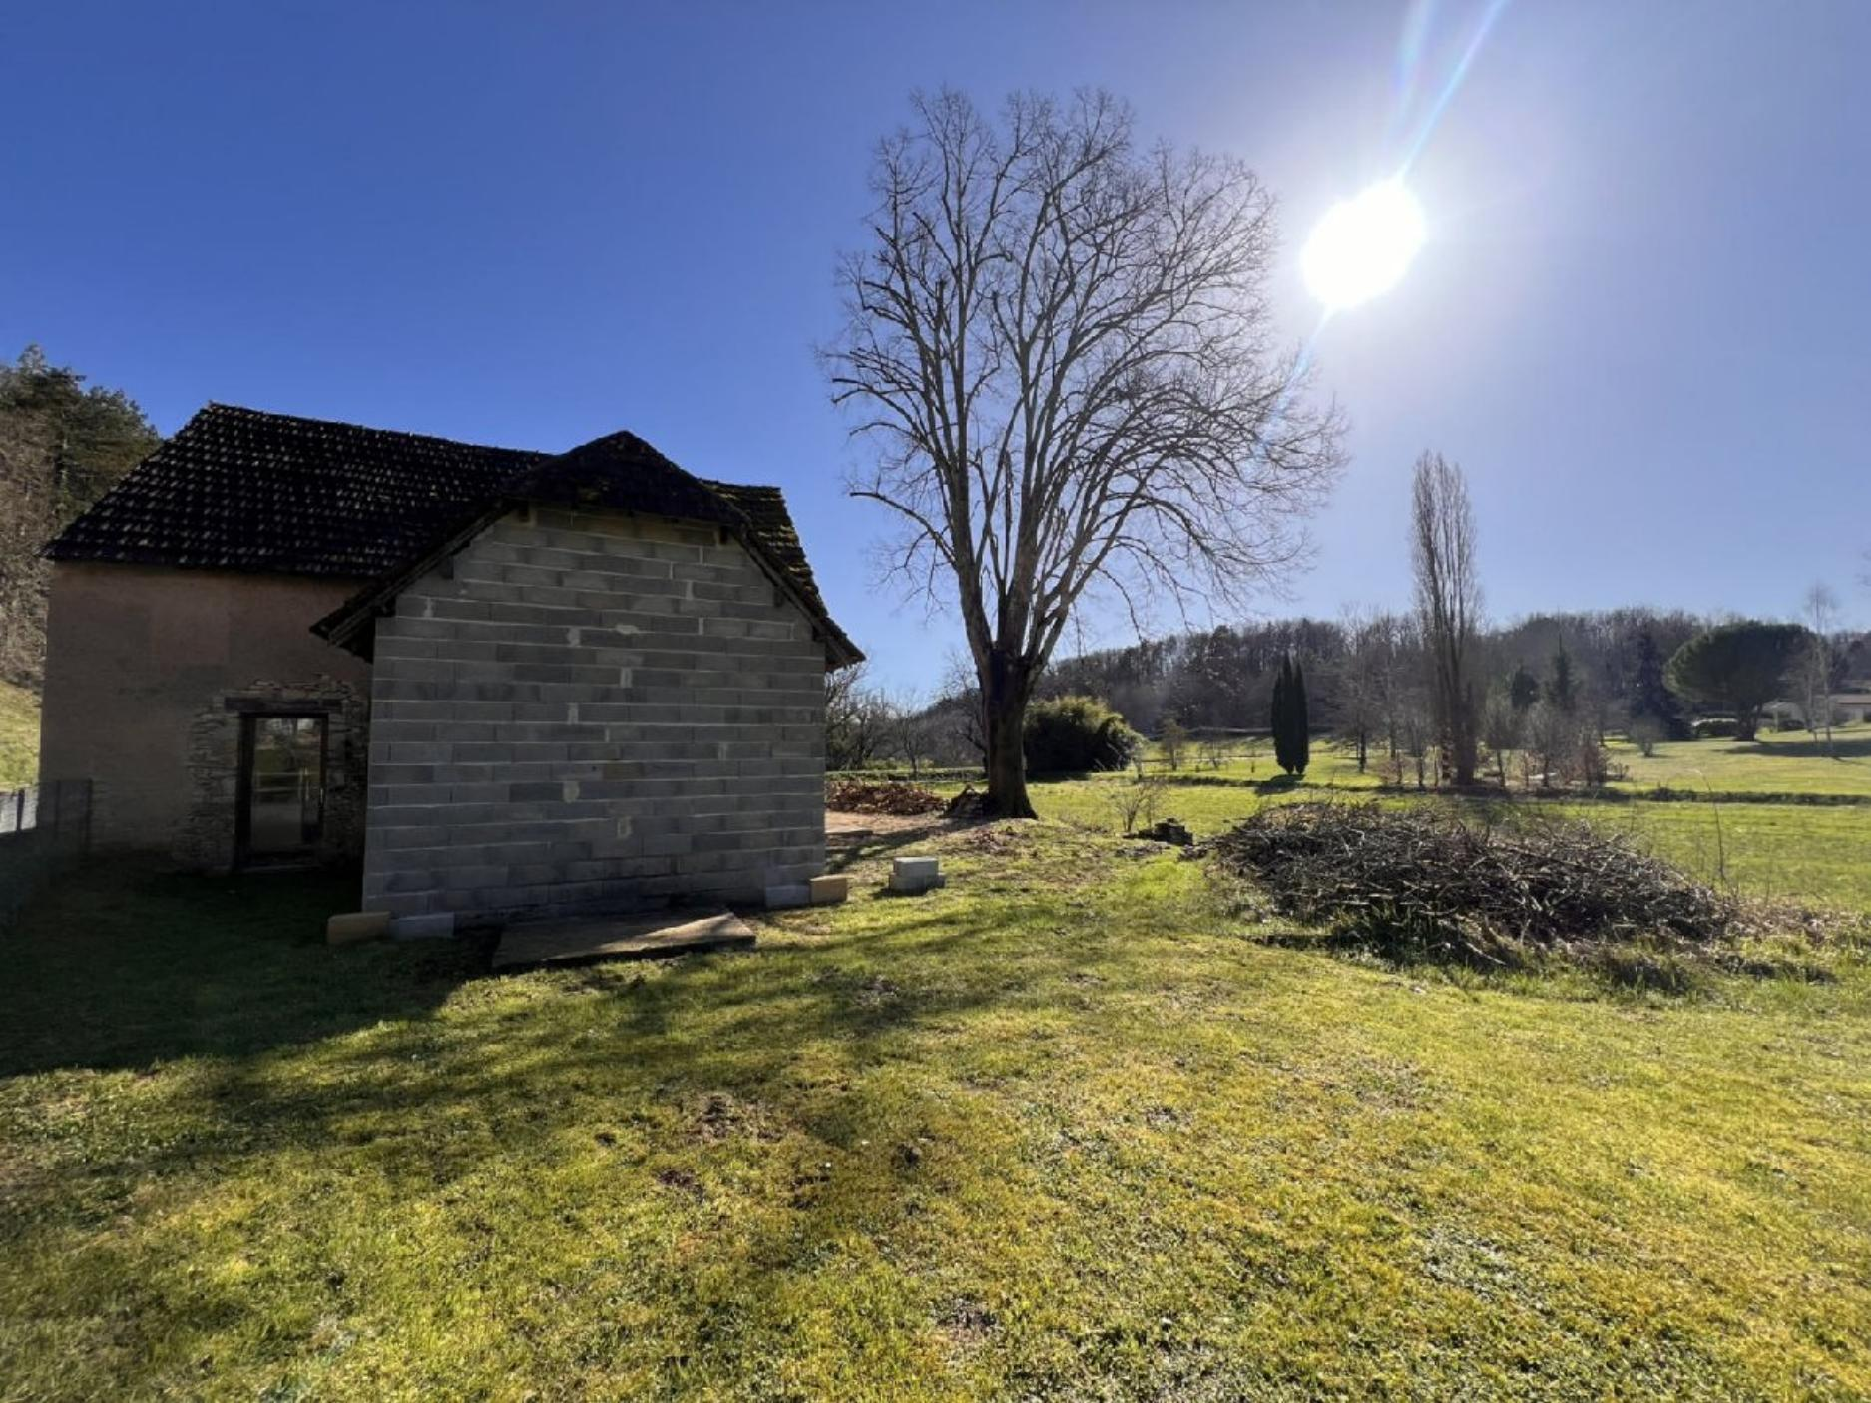
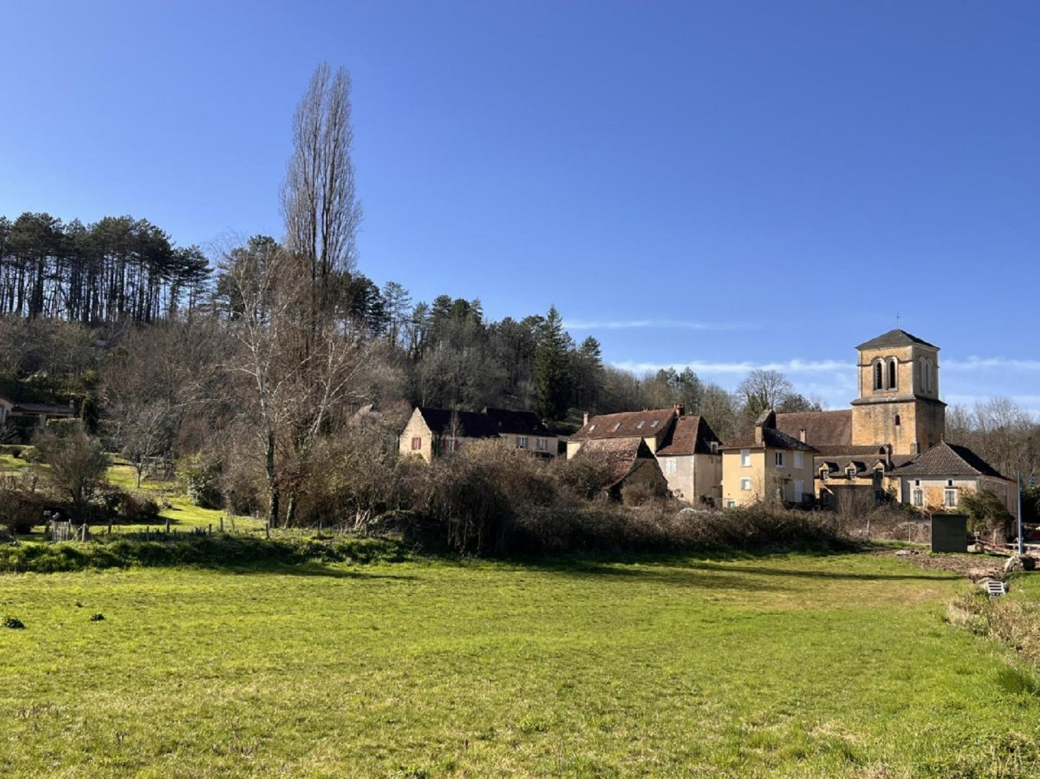 | 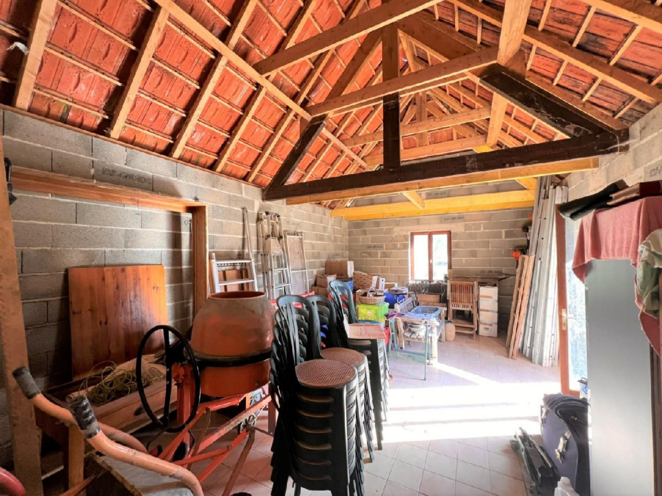
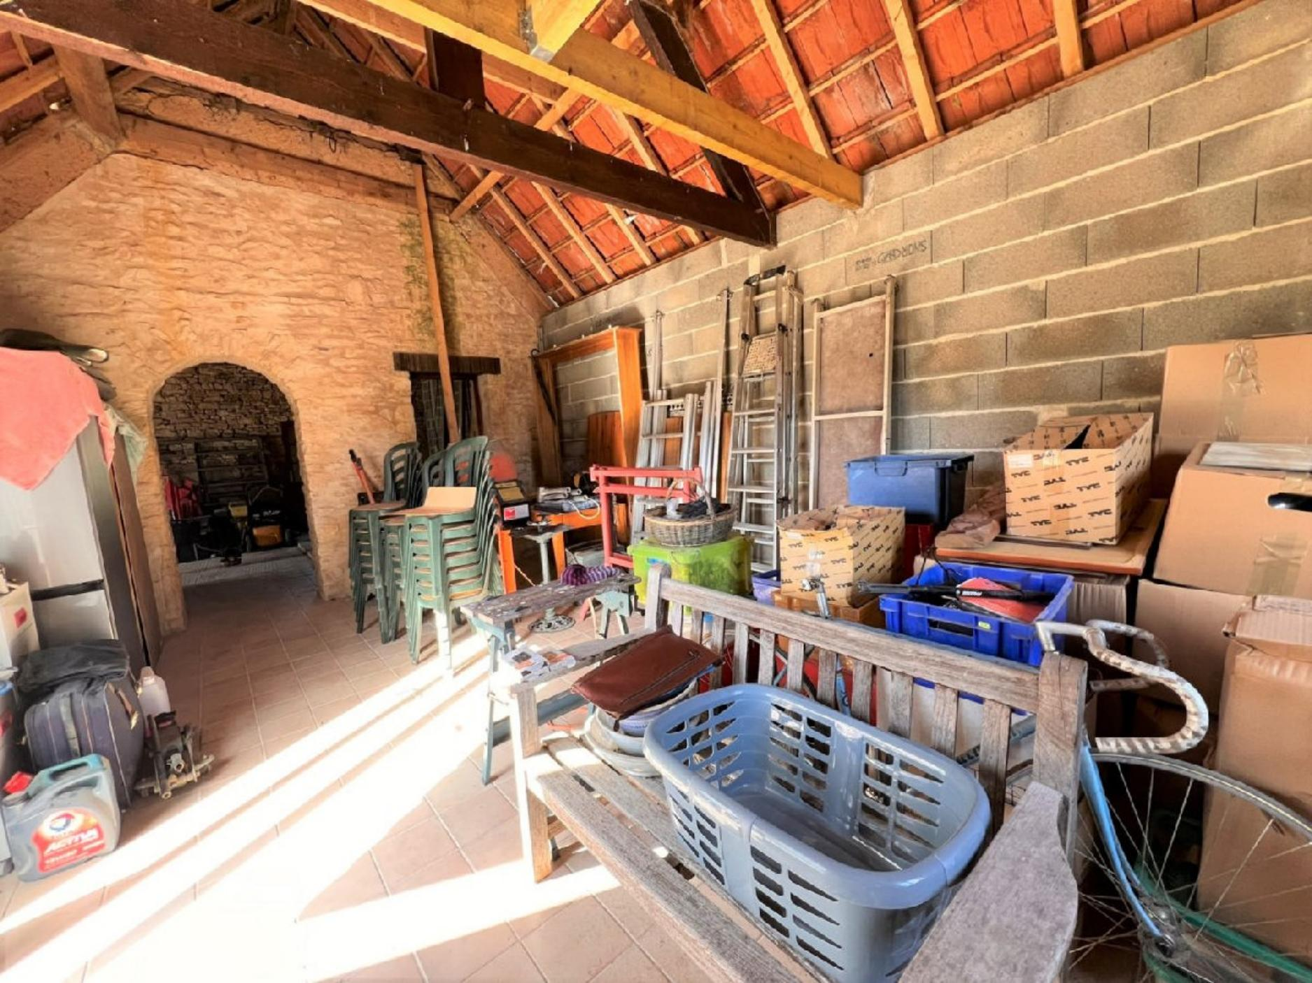 | 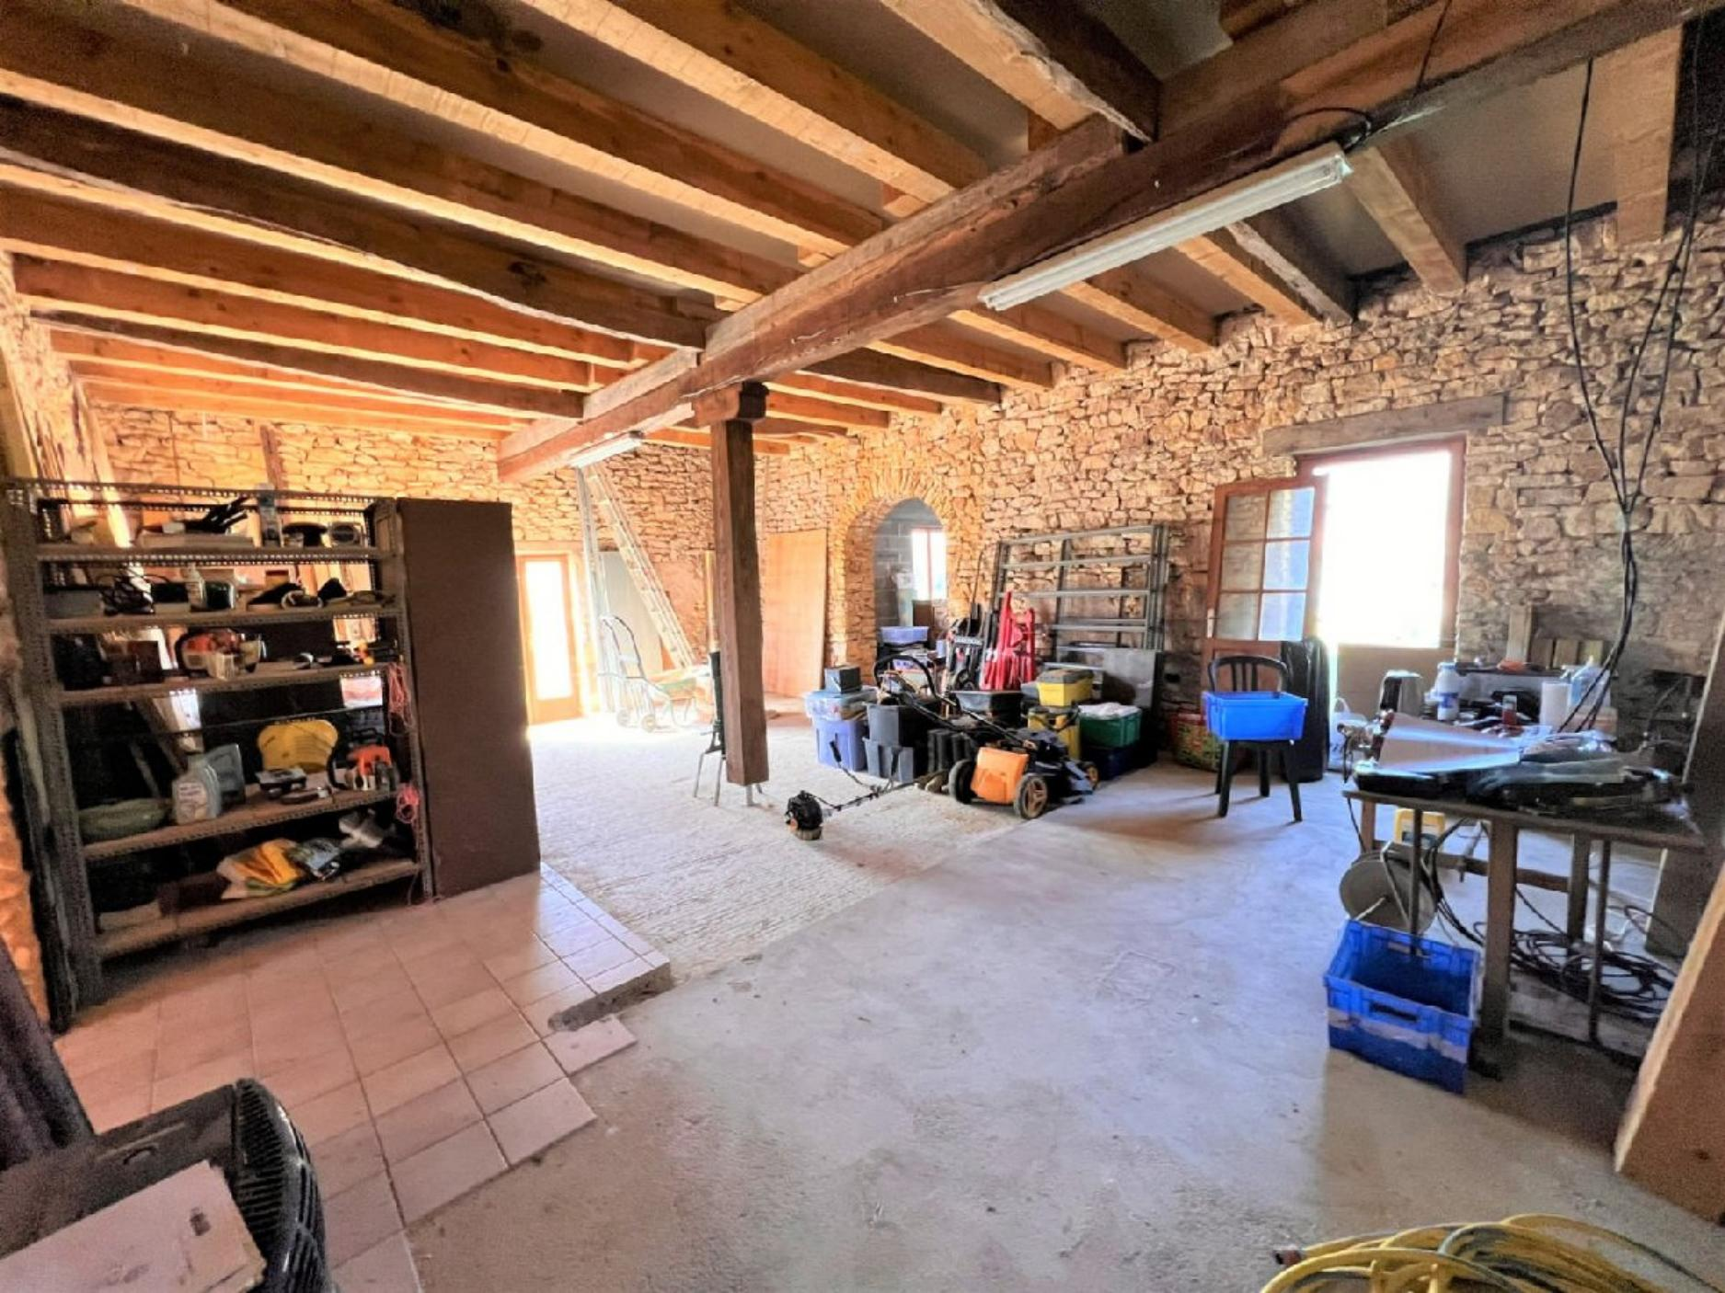
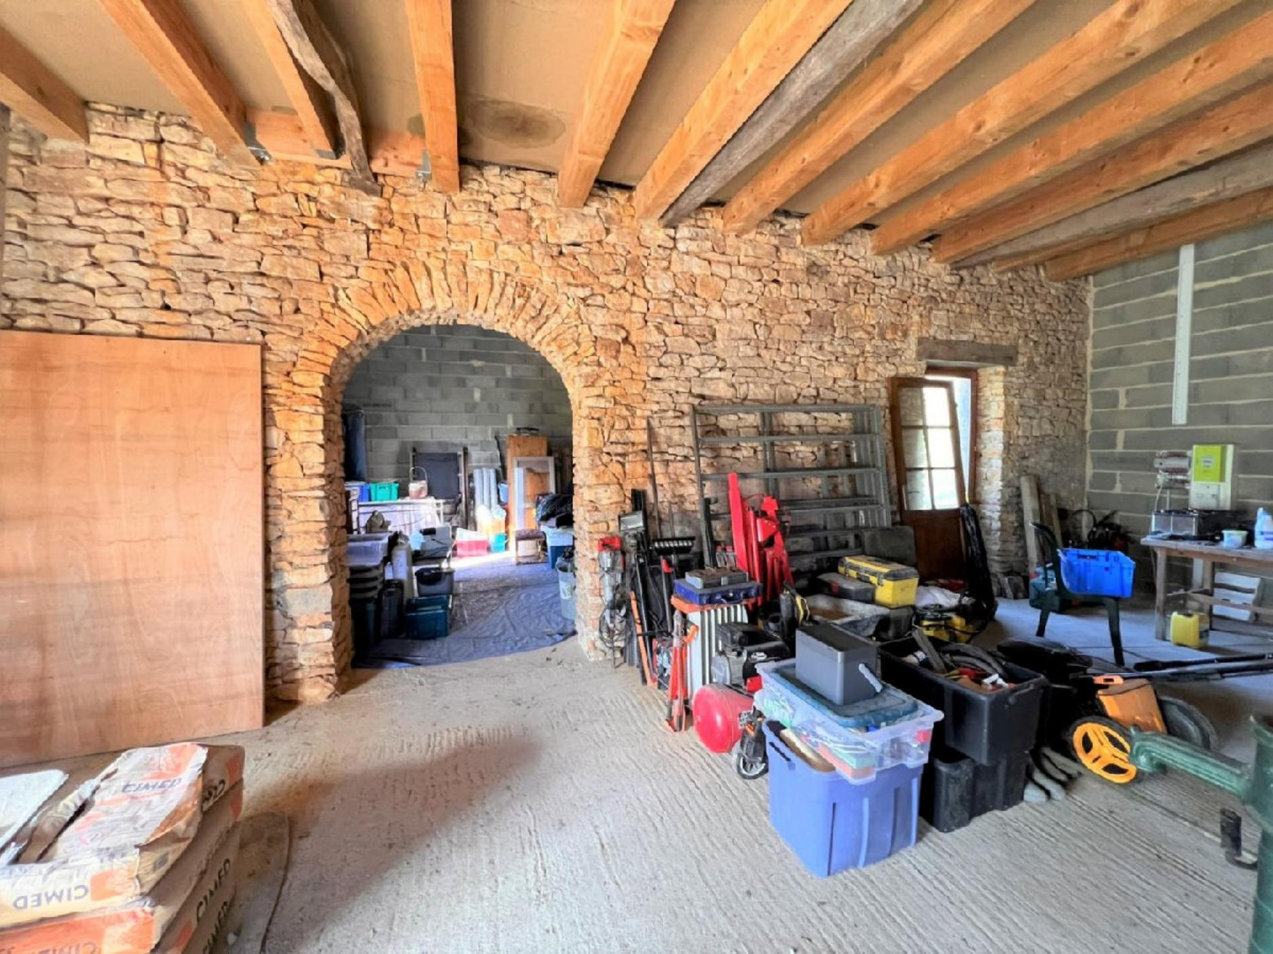 | 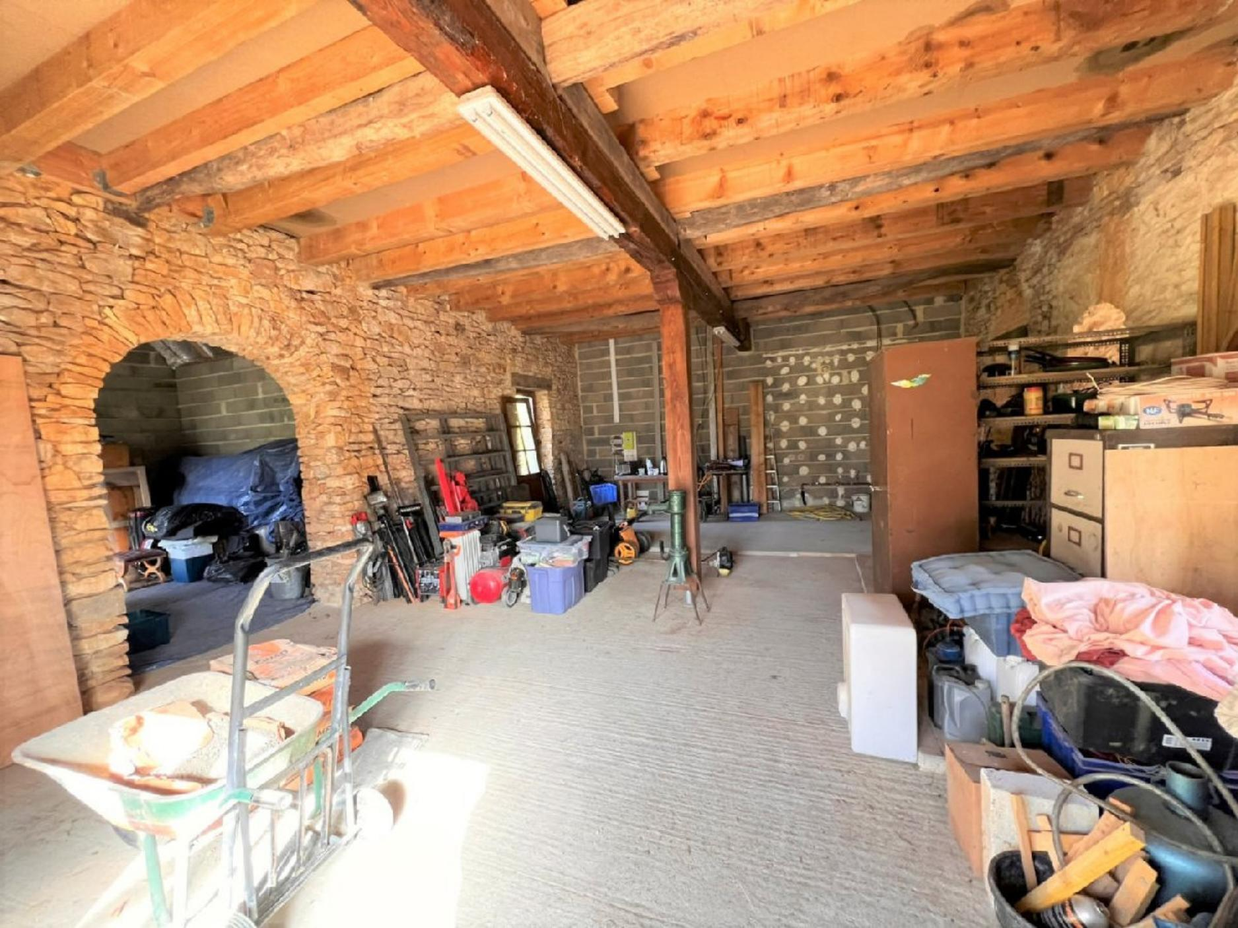
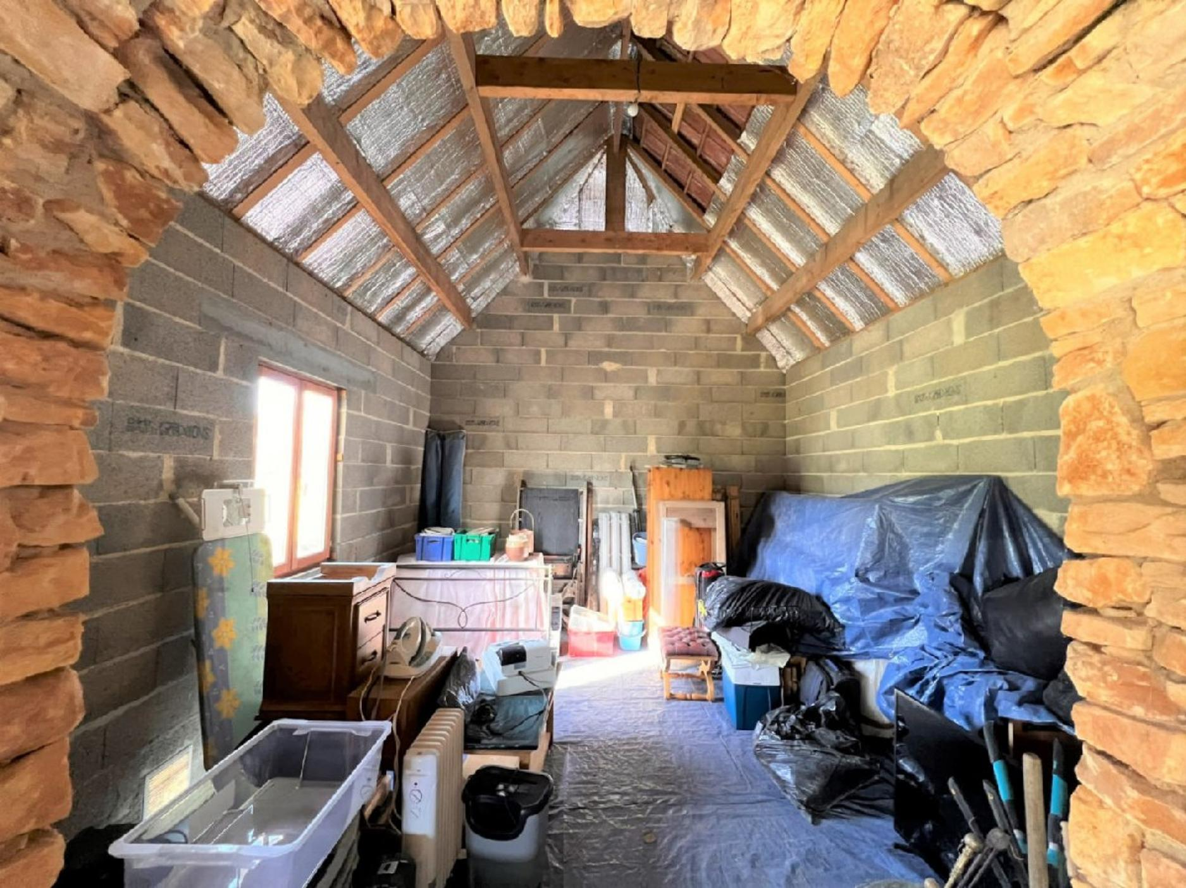 | 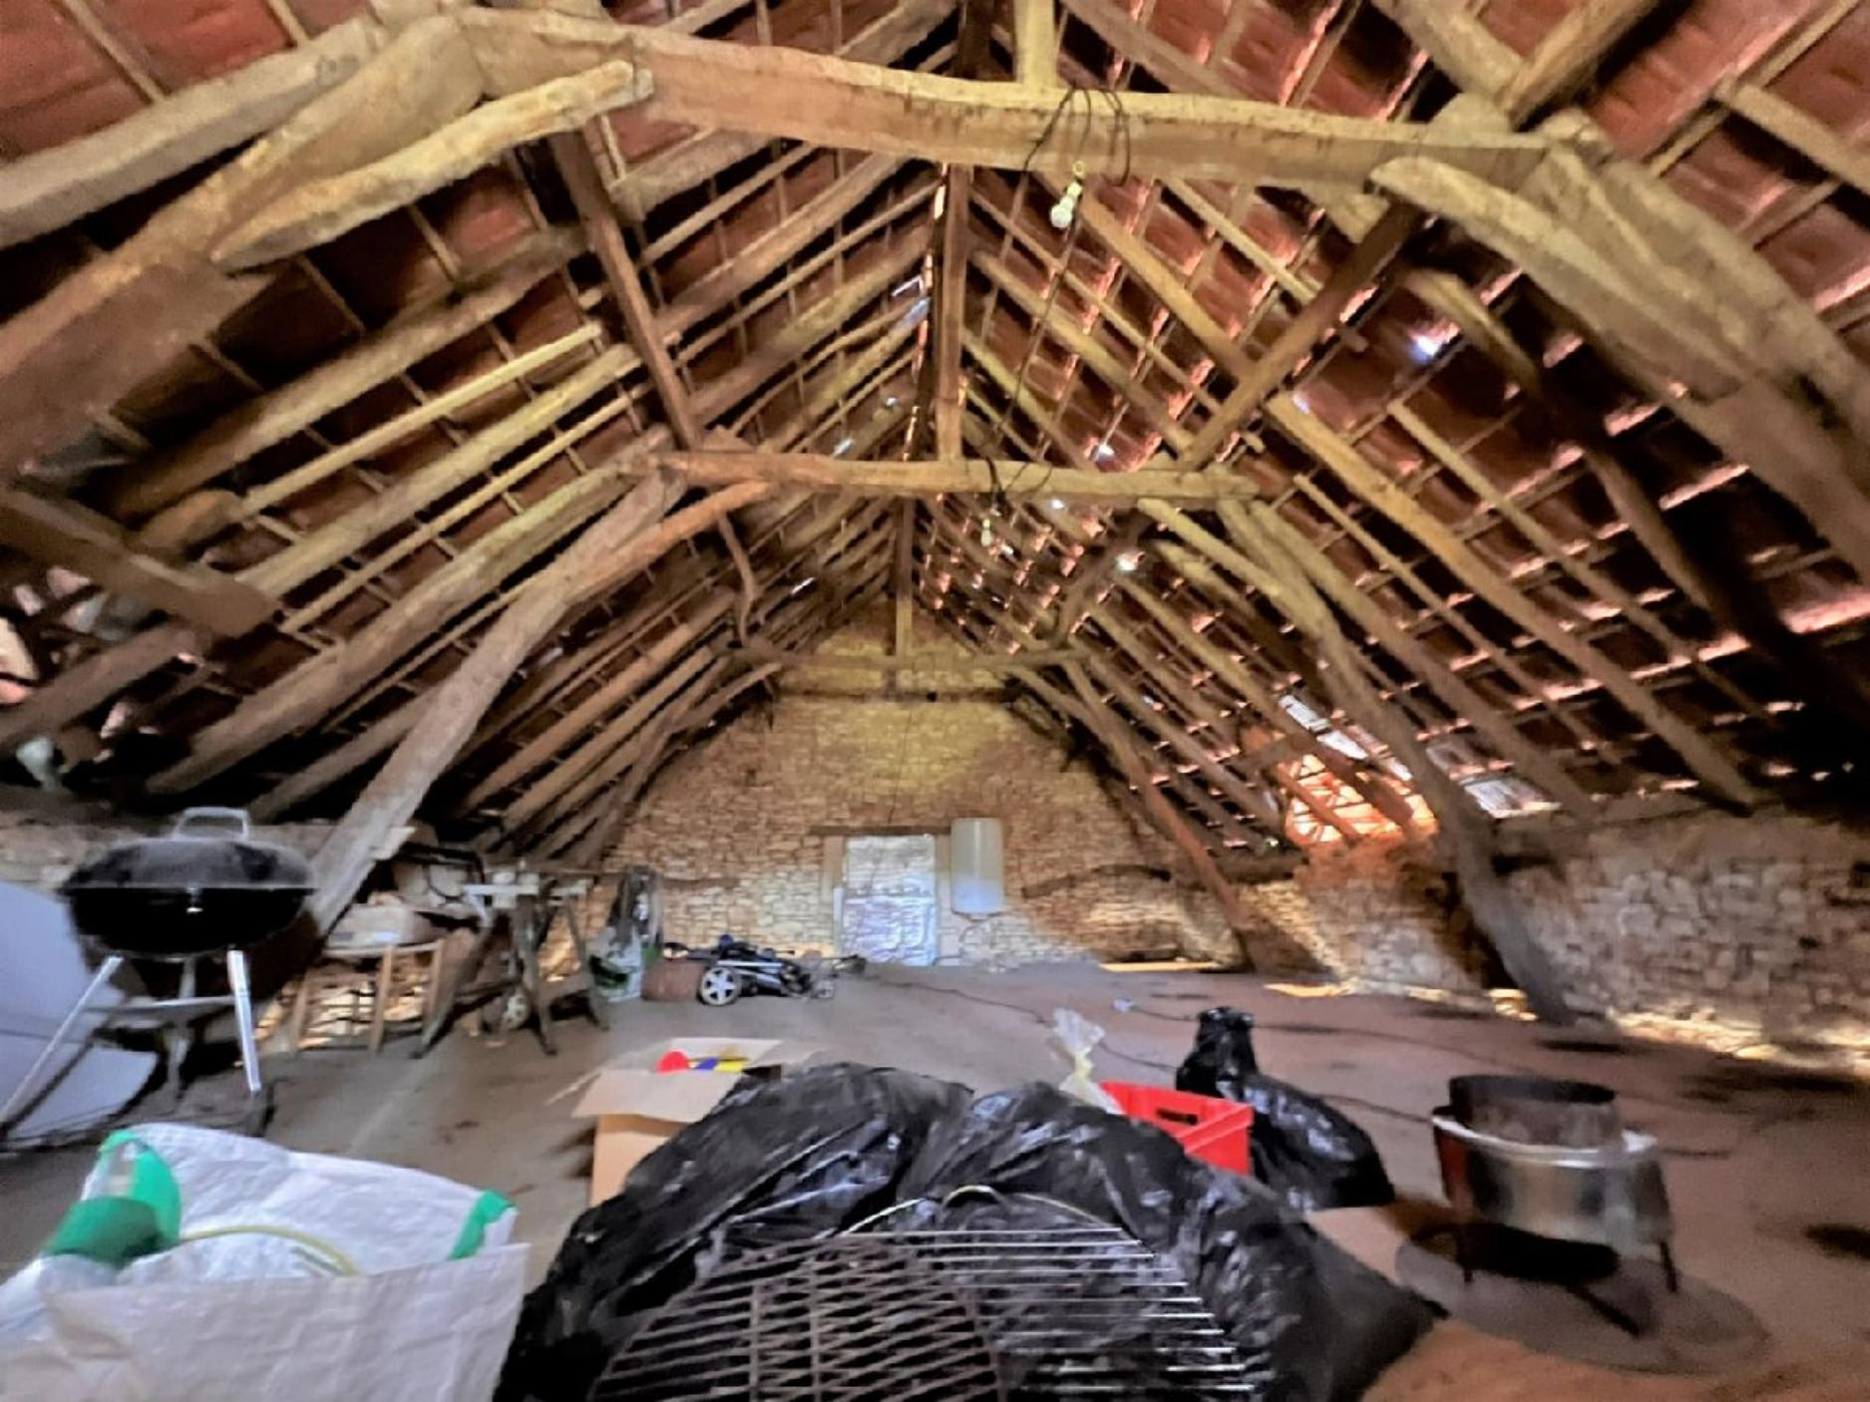
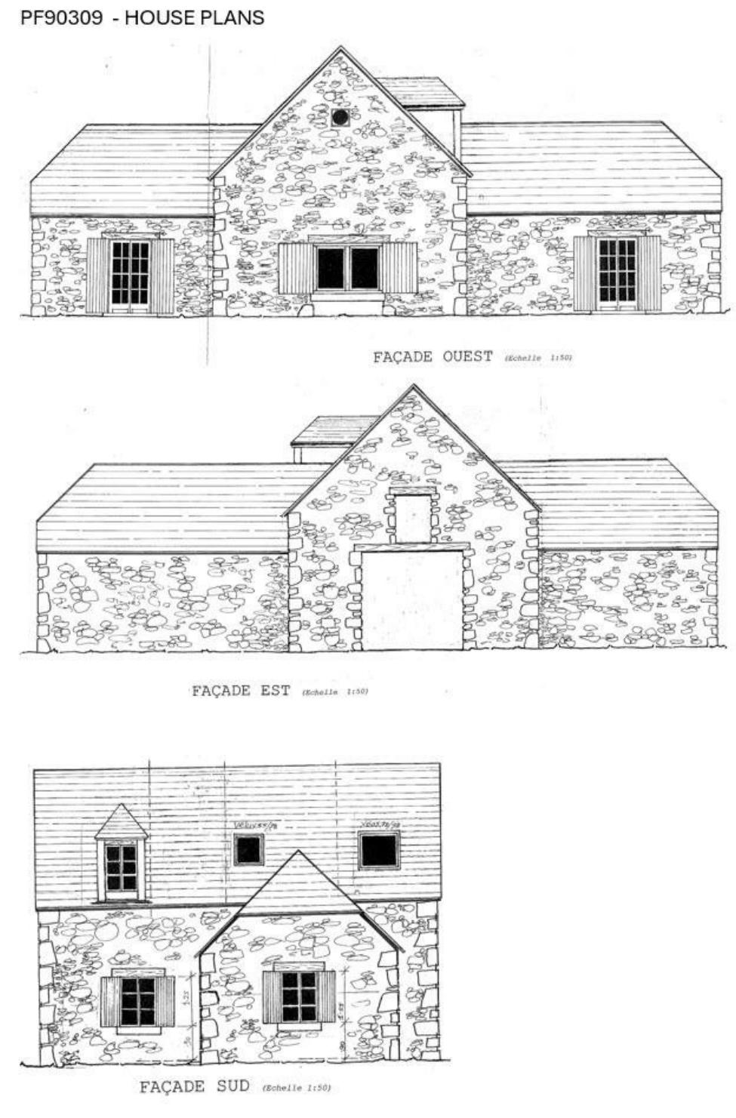 | 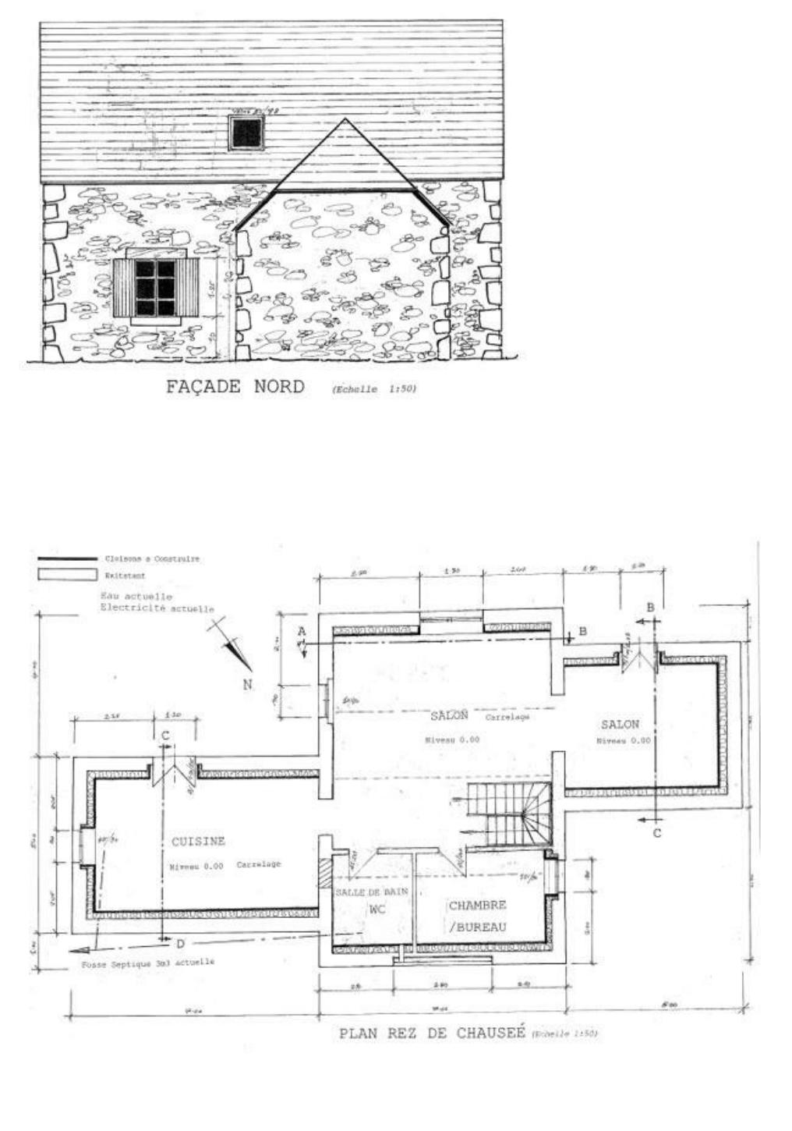
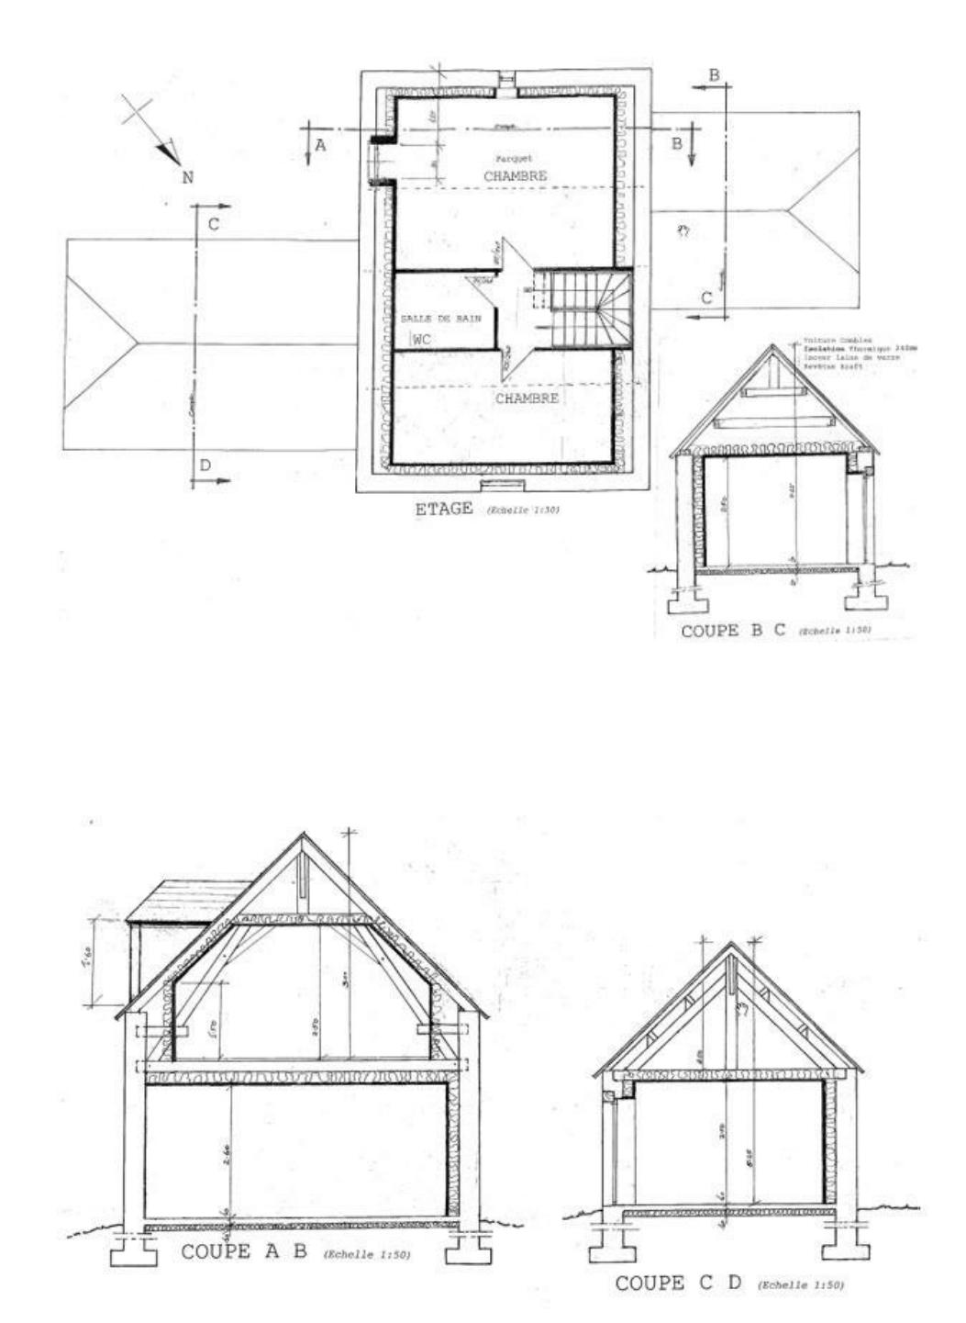 | 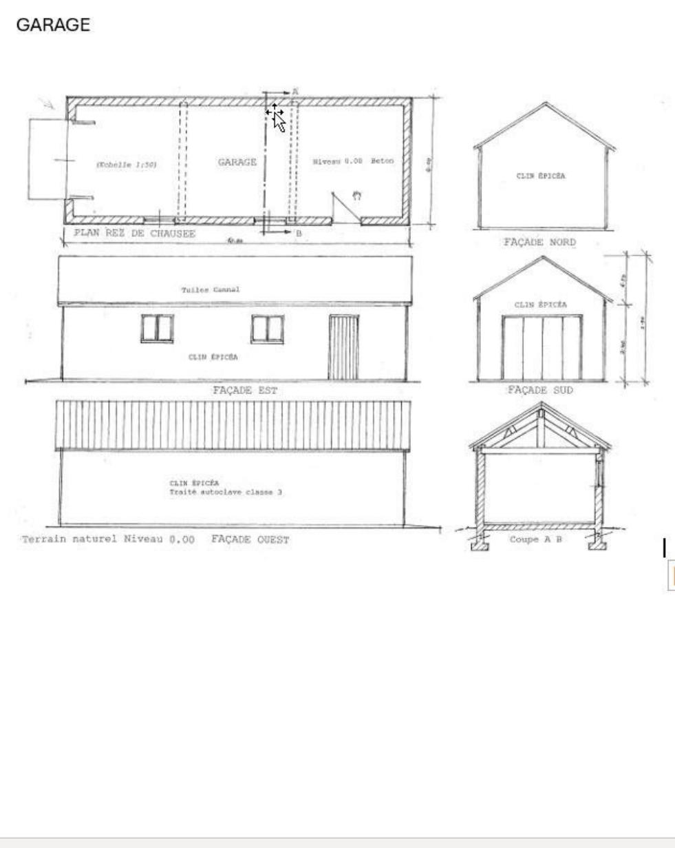

KEY DETAILS ( Ref . : PF90909) :
Total living space : 160 Sqm  Land area : 1,696 Sqm  Heating :  Energy Efficiency : - | Nearest town : LE BUGUE  Nearest commerce : 6MINS  Nearest autoroute : A20/A89  Nearest airport : BERGEREC

PIONEER FRANCE CAN  ASSIST YOU WITH :  € Foreign Currency Exchange  the best rates : the best service  € Mortgage and Loan Facilities  pre-qualified, top lenders  € Your Total purchase process  a dedicated, fixed fee, total service from  initial offer through to post-completion  Call us or see our website  www.PioneerFrance.com   | PROPERTY LOCATION MAP :

