THE DORDOGNE'S LEADING PROPERTY AGENCY +33 (0)5 53 07 06 27 info@PioneerFrance.com www.PioneerFrance.com  PF90306 385,000 € inc agency comm 6 % payable by buyer 0.27 ACRES MONPAZIER AREA  5 MINS EASY WALK INTO MONPAZIER. SUPERB, 3 ENSUITE BEDROOM HOUSE ON ONE FLOOR. IMMACULATE CONDITION. COUNTRYSIDE VIEWS. PF90306  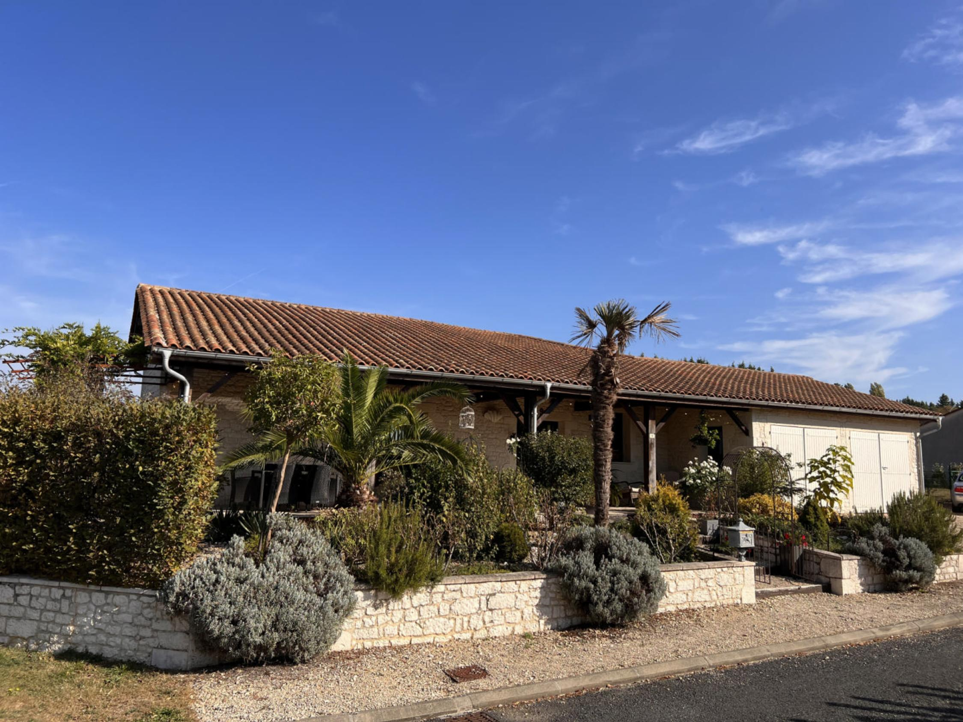 | 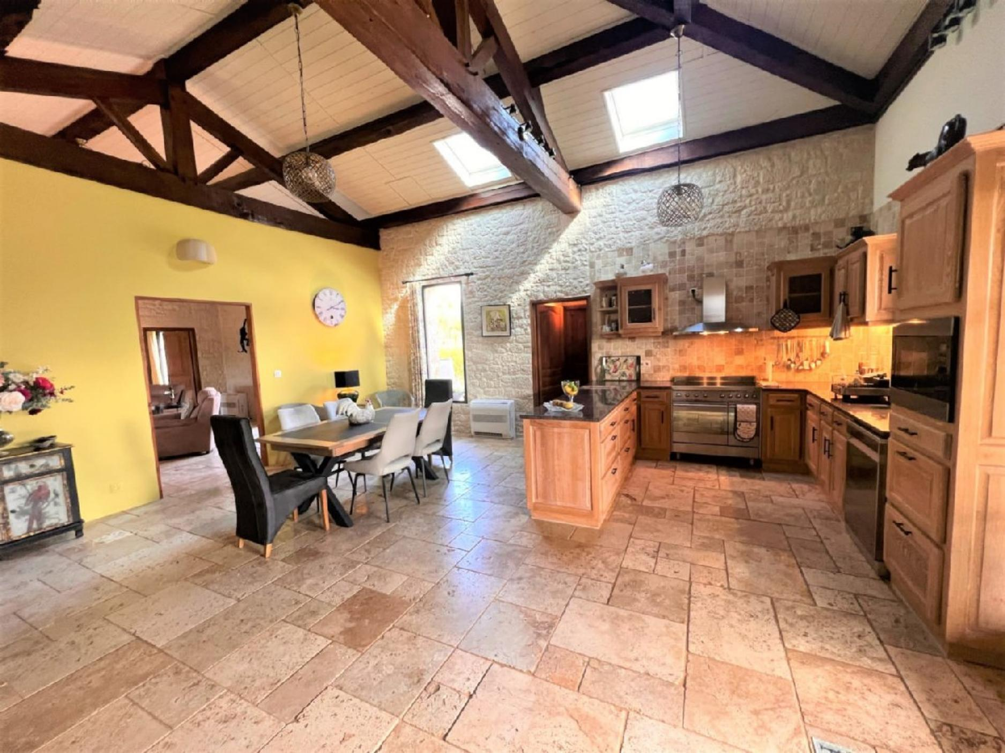  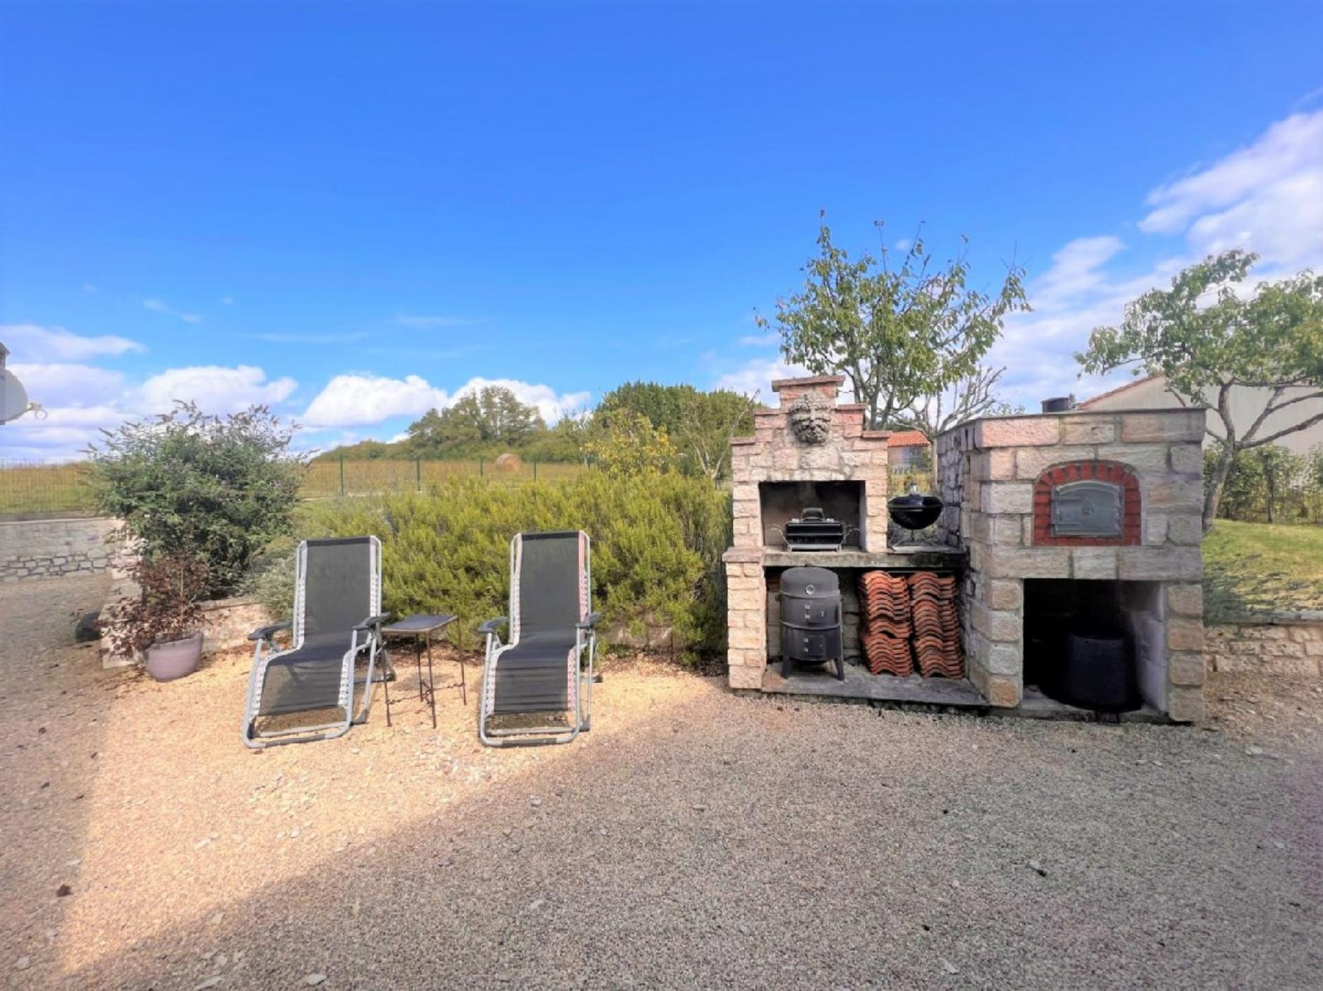  147 KWHep/m² an 2 Kg CO2/m² an

