THE DORDOGNE'S LEADING PROPERTY AGENCY +33 (0)5 53 07 06 27 info@PioneerFrance.com www.PioneerFrance.com  PF90304 130,000 € inc agency comm 6 % payable by buyer 0.24 ACRES LES EYZIES AREA  PRETTY, RENOVATED 1-BED STONE COTTAGE WITH INDEPENDENT STUDIO-ROOM, WITHIN WALKING DISTANCE TO A BEAUTIFUL RIVERSIDE VILLAGE WITH ALL COMMERCE. PF90304  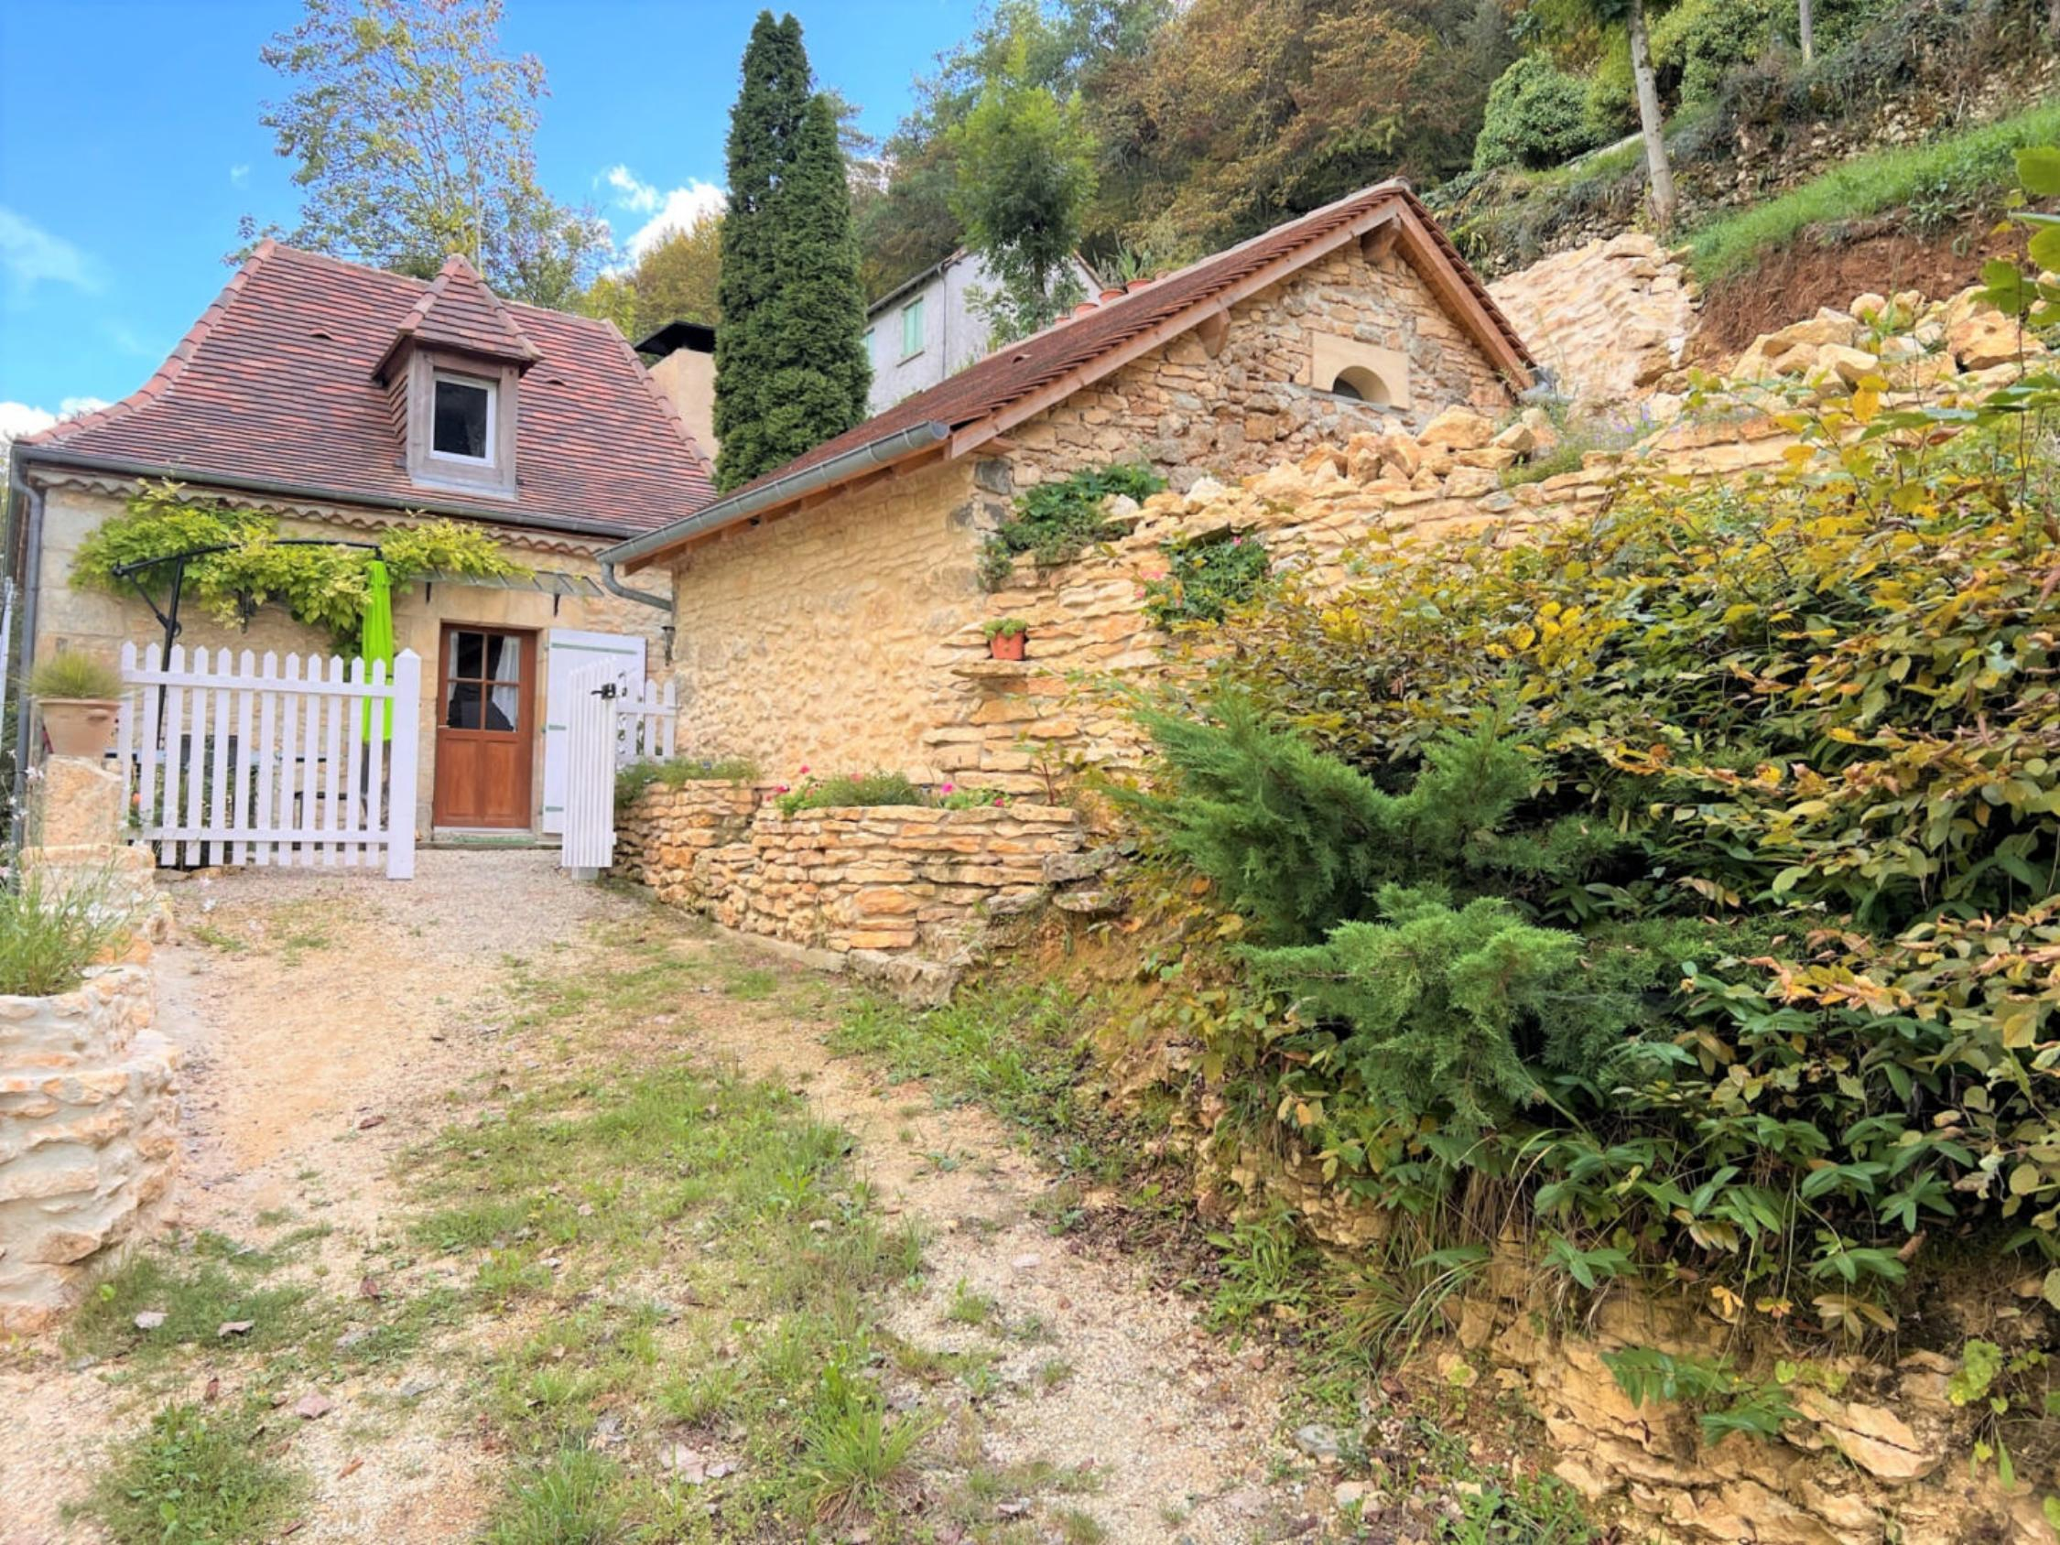 | 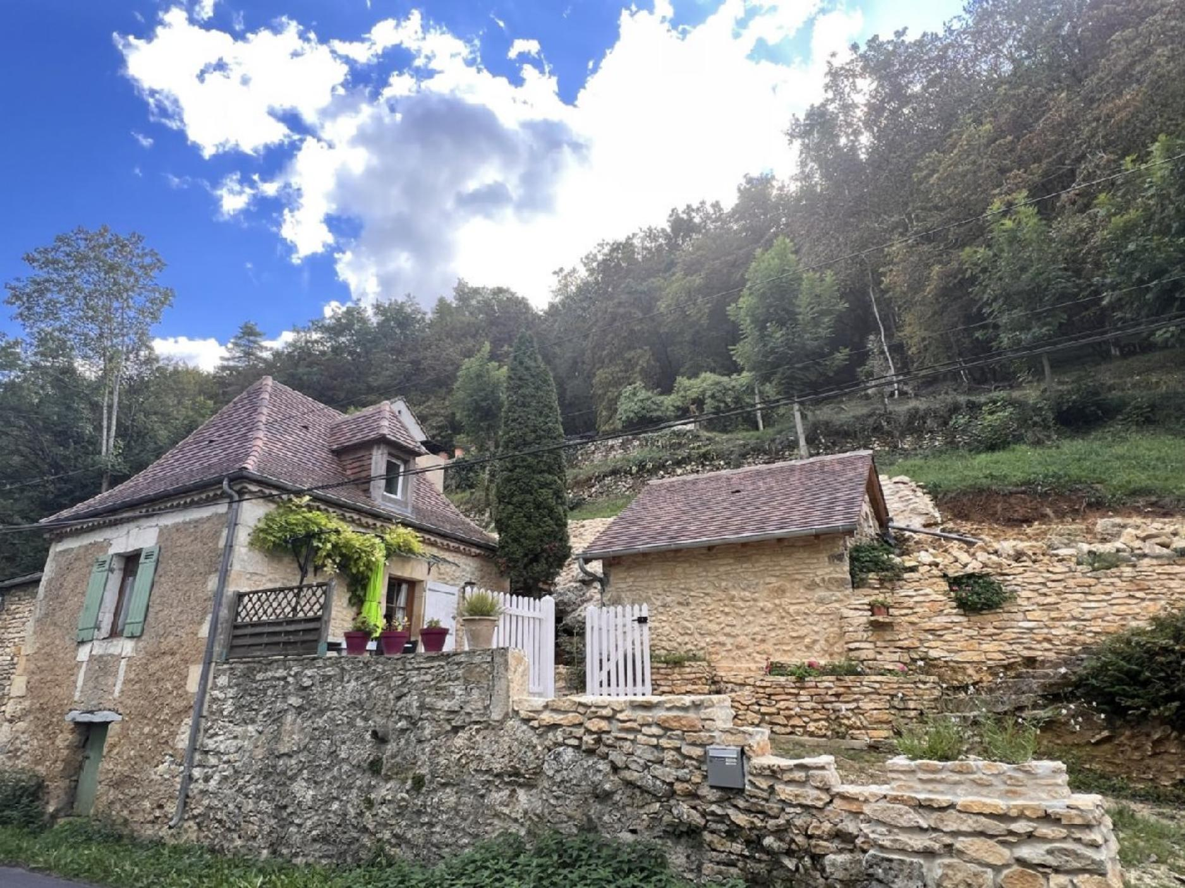  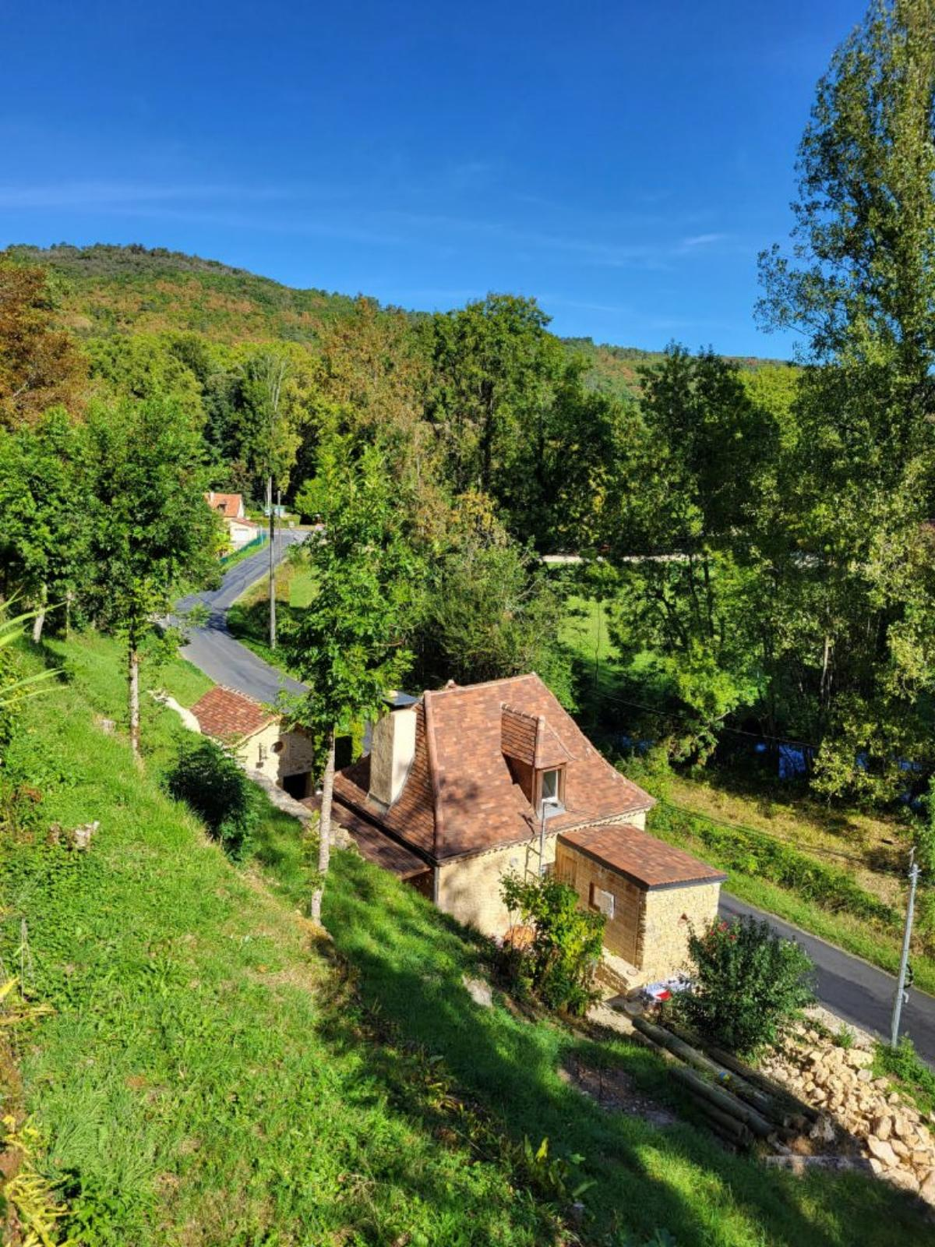  114 KWHep/m² an 14 Kg CO2/m² an

