THE DORDOGNE'S LEADING PROPERTY AGENCY +33 (0)5 53 07 06 27 info@PioneerFrance.com www.PioneerFrance.com  PF90305 780,000 € inc agency comm 6 % payable by buyer ACRES PARIS – 14th  PARIS - 14TH ARRONDISSEMENT - TOP FLOOR APARTMENT WITH A SUPERB TERRACE AND VIEWS OVERLOOKING THE PARK MONTSOURIS. PF90305  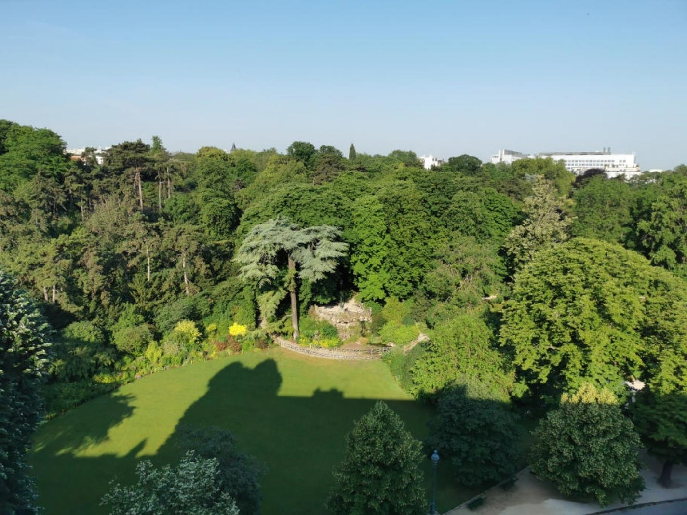 | 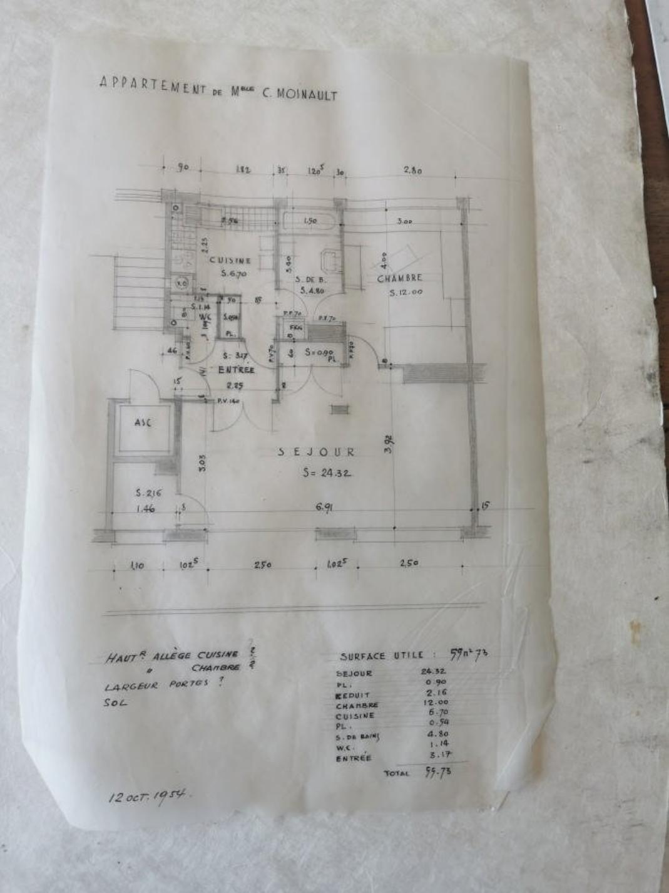  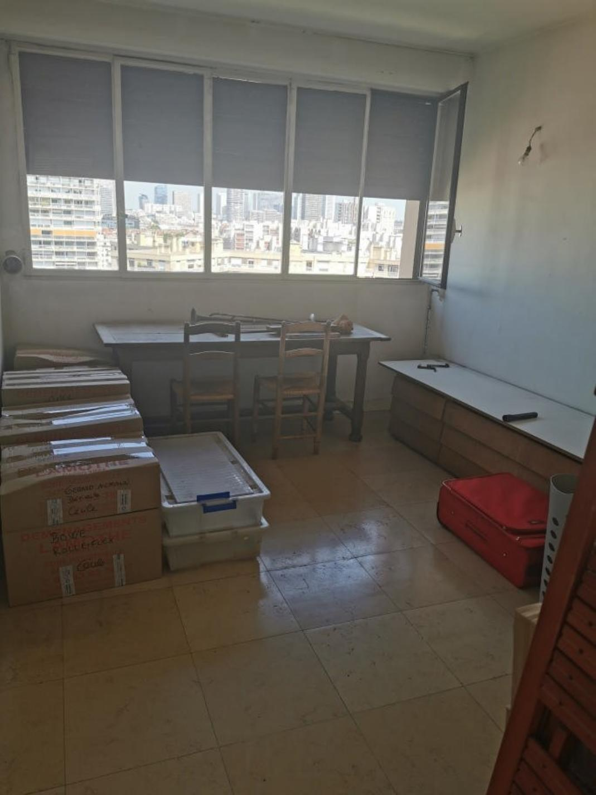  265 KWHep/m² an 65 Kg CO2/m² an

