Phone : +33 (0)5 53 07 06 27  Email : info@pioneerfrance.com  Web : www.PioneerFrance.com  Domaine Le Ruisseau , 24580, Fleurac, Dordogne | 

THE DORDOGNE'S LEADING QUALITY PROPERTY AGENCY

REFERENCE  PF90305 | PRICE (inc.agency comm)  780,000 € | LOCATION  PARIS – 14th | TYPE  Apartment | LAND AREA  m2

PARIS - 14TH ARRONDISSEMENT - TOP FLOOR APARTMENT WITH A SUPERB TERRACE AND VIEWS OVERLOOKING THE PARK MONTSOURIS. PF90305

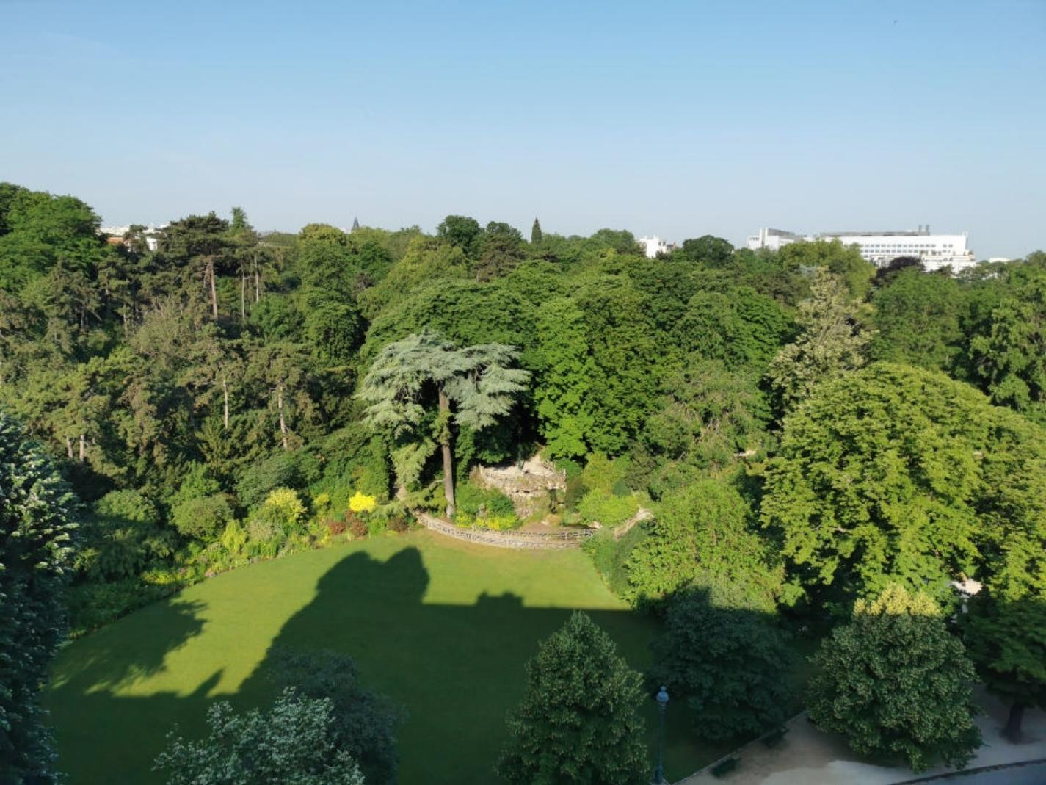

A RARE FIND – a lovely apartment requiring full internal refurbishment on the top floor of a desirable block with a lift. Superb views from its large terrace overlooking the 15H Montsouri Park in the sought-after 14th district. With 56sqm of living space, a 12sqm terrace and a 6sqm storage cave, the apartment is currently configured as a very large one-bedroom property but could be renovated as preferred. PF90305
PROPERTY DESCRIPTION ( Ref : PF90305)
PARIS - 14th ARRONDISSEMENT - TOP FLOOR APARTMENT WITH A SUPERB TERRACE AND VIEWS OVERLOOKING THE PARK MONTSOURIS. PF90305
A RARE FIND – a lovely apartment requiring full internal refurbishment on the top floor of a desirable block with a lift, with superb views from its large terrace overlooking the 15-hectare Montsouri Park in the sought-after 14th district.
With 56sqm of habitable area, a 12sqm terrace and a 6sqm storage cave, the apartment is currently configured as a very large one-bedroom property but could be renovated and adapted to the new owner’s requirements. PF90305
In the same ownership for many years, the apartment is a rare find into which a new owner can place their own layout and taste.
DPE F/F
Apartment: Current Configuration:
- Entrance Hall 3.20sqm with storage space
- Guest WC
- Kitchen 6.70sqm with sliding windows
- Very large 24.50sqm living room full height sliding glass doors on to the superb TERRACE of 12.78sqm overlooking the Park.
- Double bedroom 12.0sqm with cupboards
- Bathroom 4.80sqm
- Circa 3.50sqm of corridor and storage space
- There is also 6qm basement storage facility.
Main building
The main building was constructed in 1954 and is in good condition, the façade was refurbished around ten years ago.
The hot-water and fully-underfloor heating is communal, supplied by the Paris district heating system, which benefits from 50% renewable and recovered energy. The underfloor heating in the apartment needs to be fully updated.
There is a passenger lift to all floors.
Charges:
- Service Charges 22/23: €3108, including €1000 for the central hot water and heating.
- Tax Fonciere: €900
General
- The 14th arrondissement is a beautiful area of Paris, including a number of parks and cultural attractions, superb restaurants and shopping, and with very good transport links.
PF90305

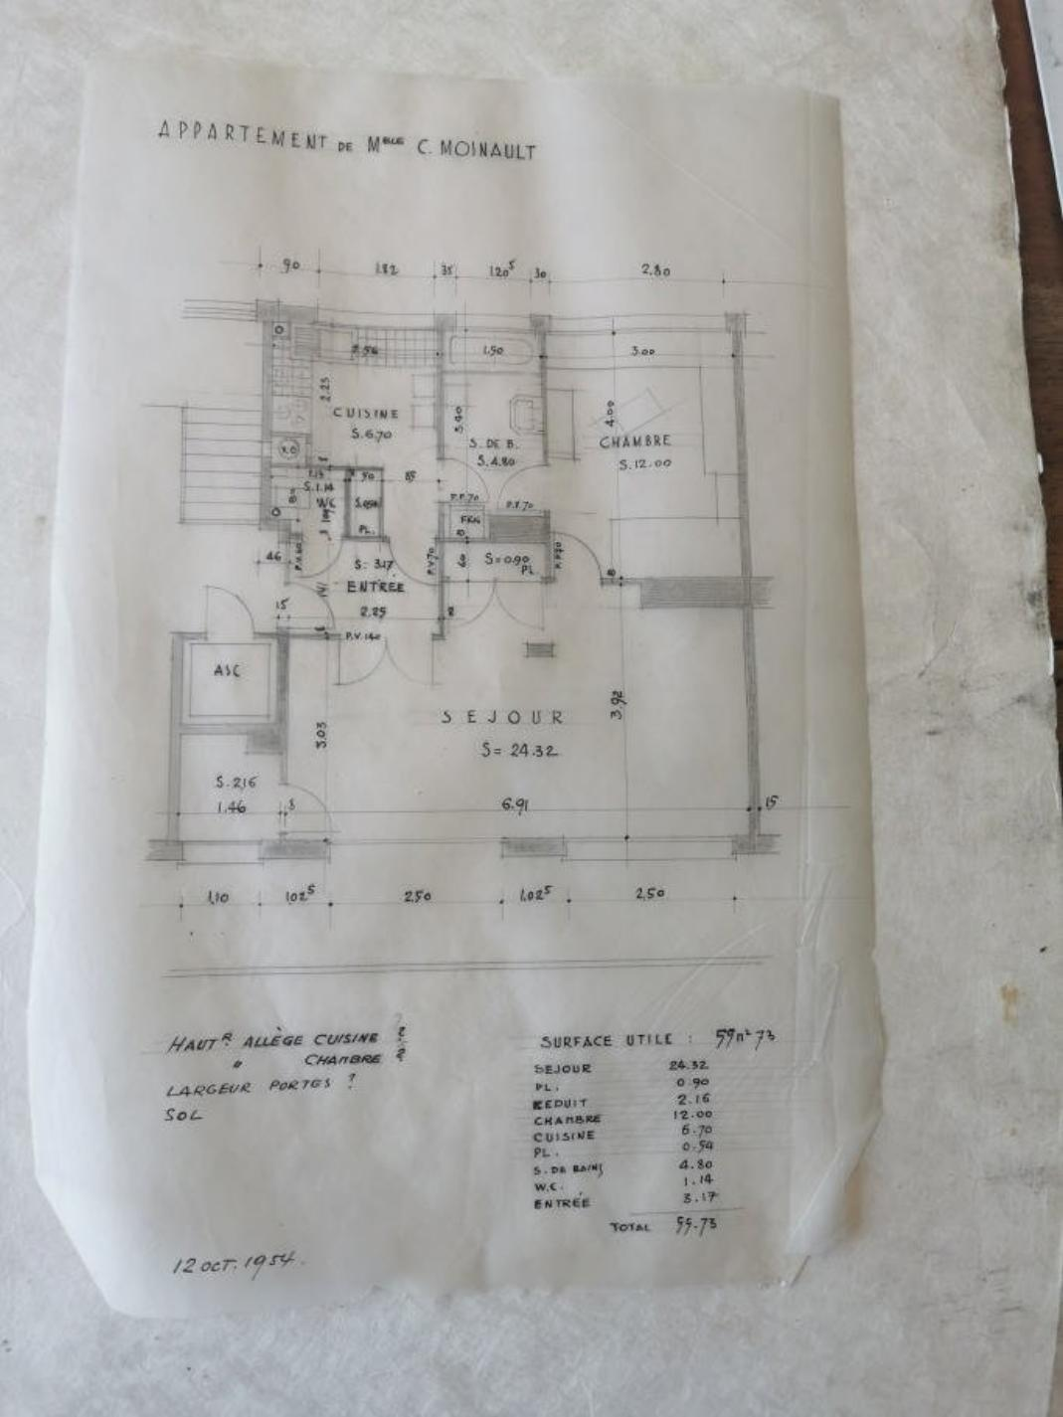 | 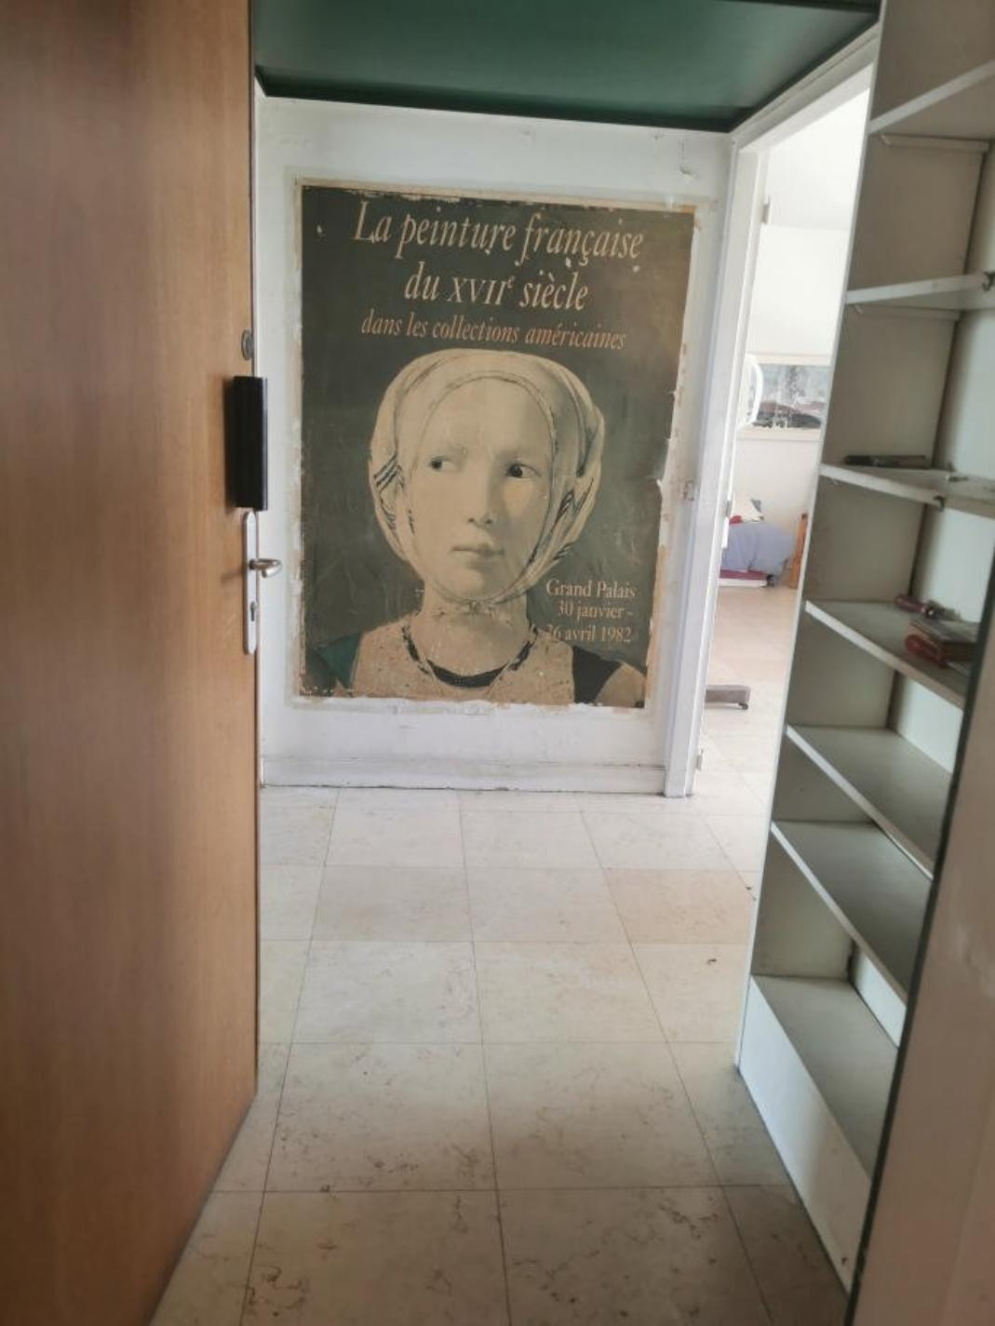
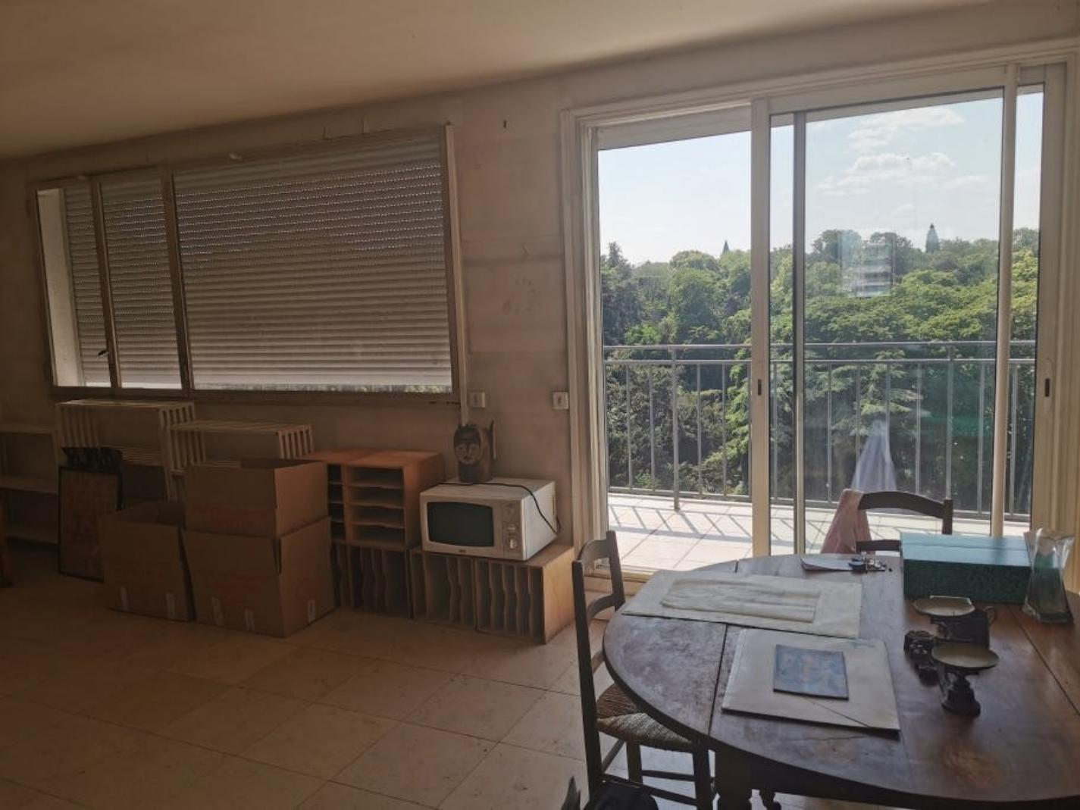 | 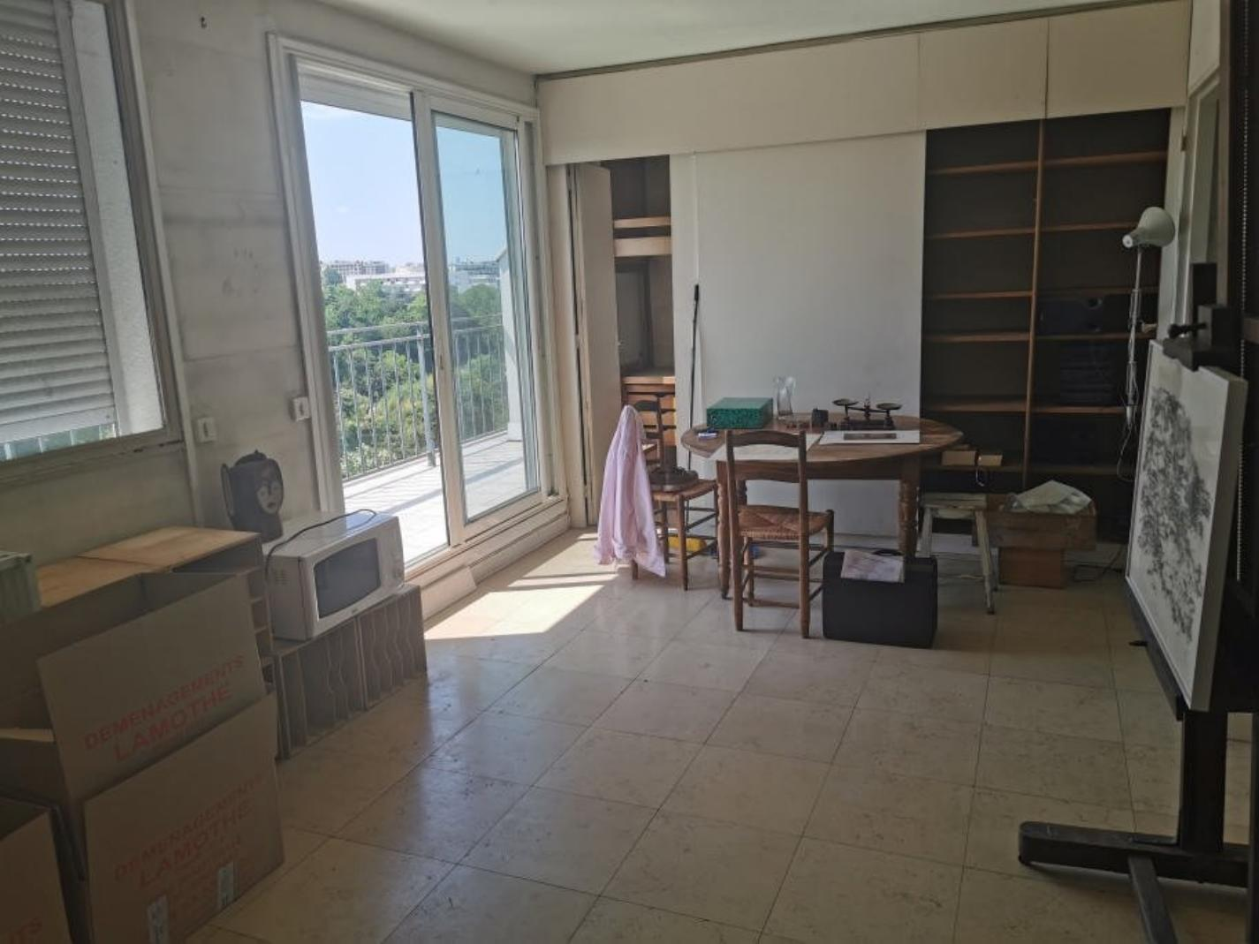
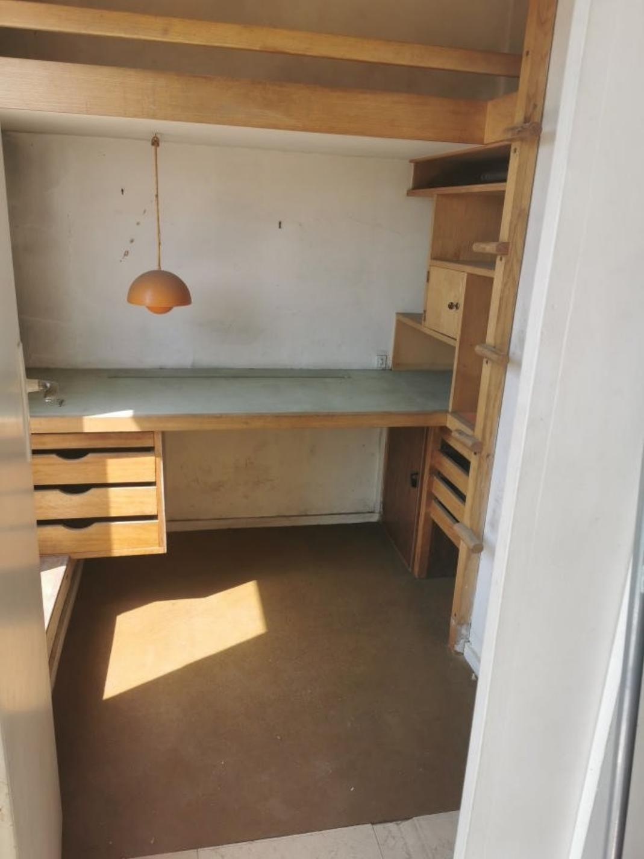 | 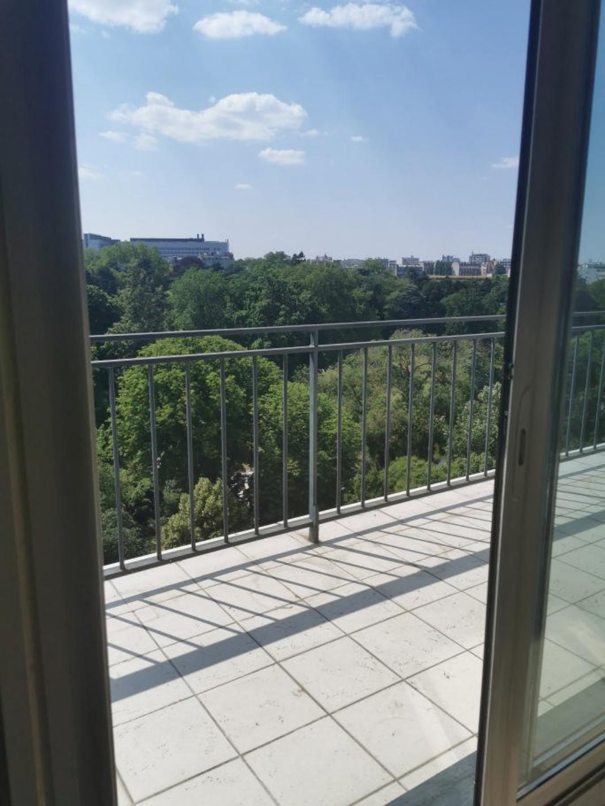
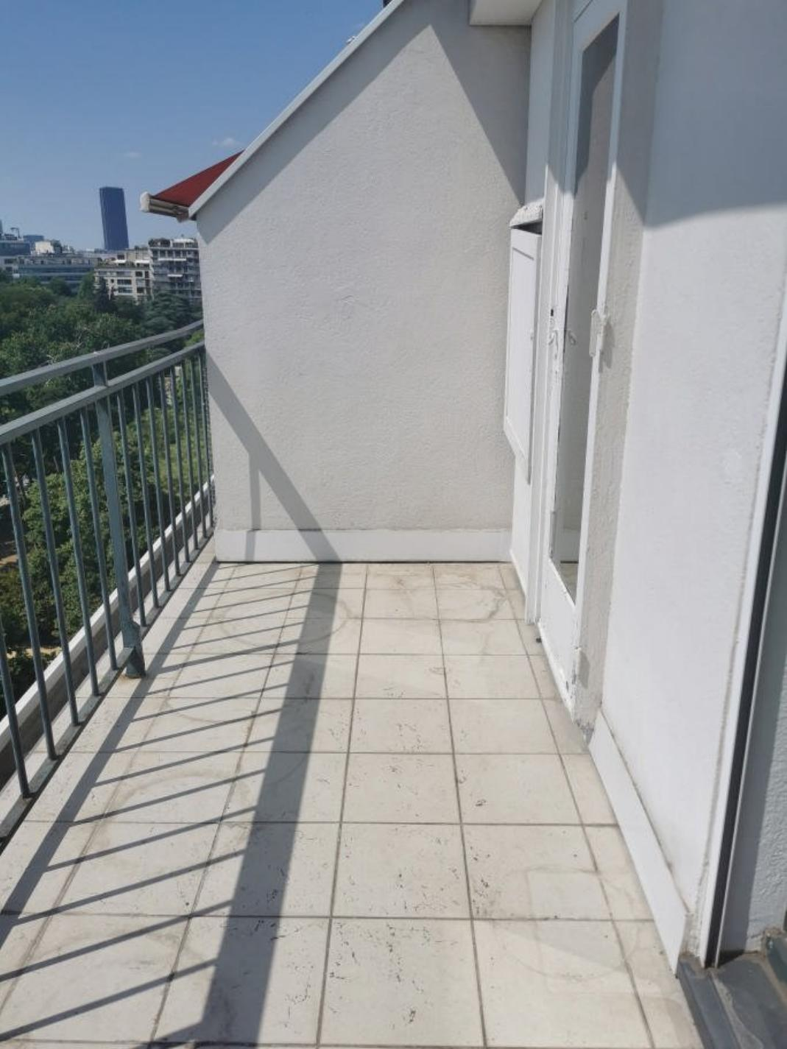 | 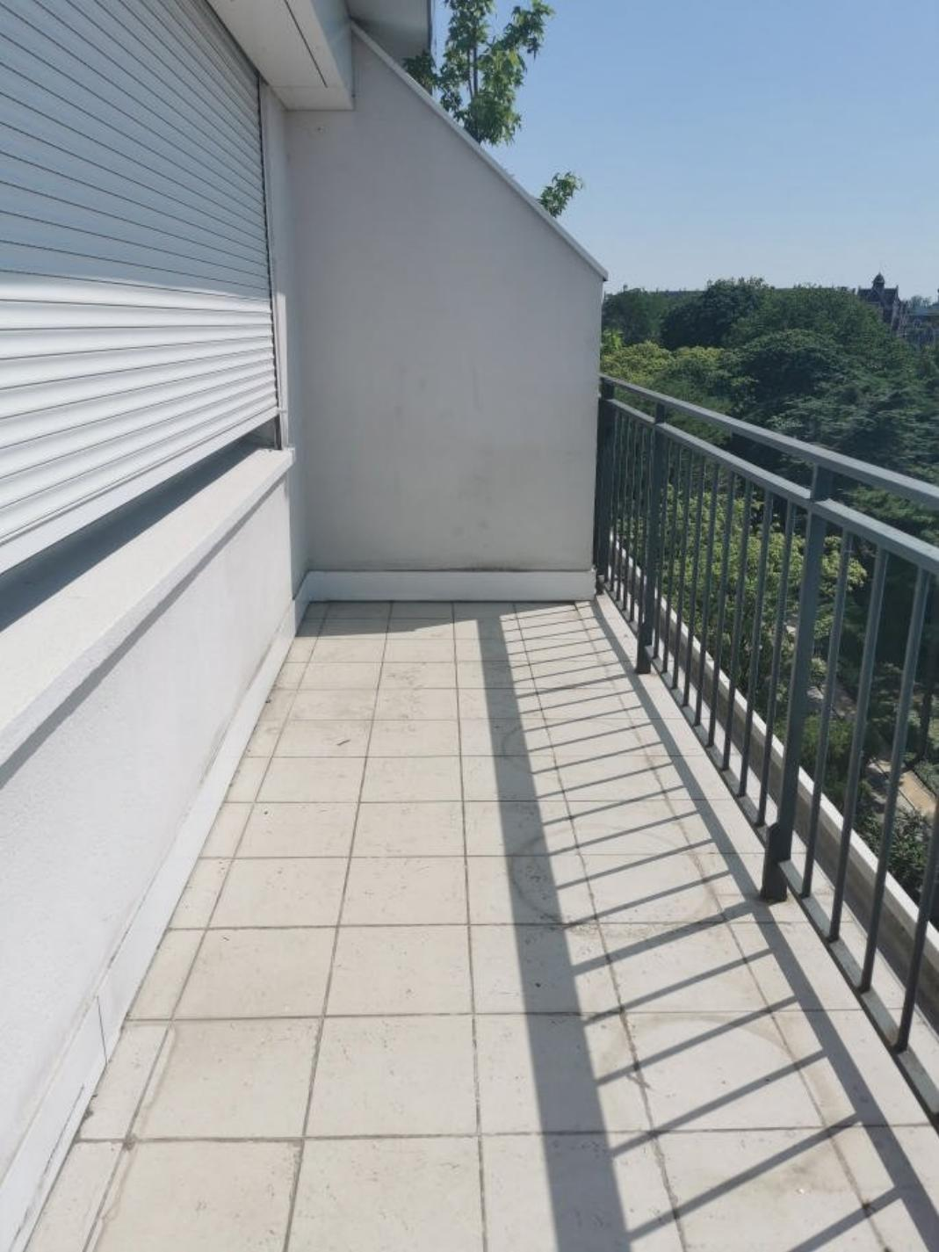
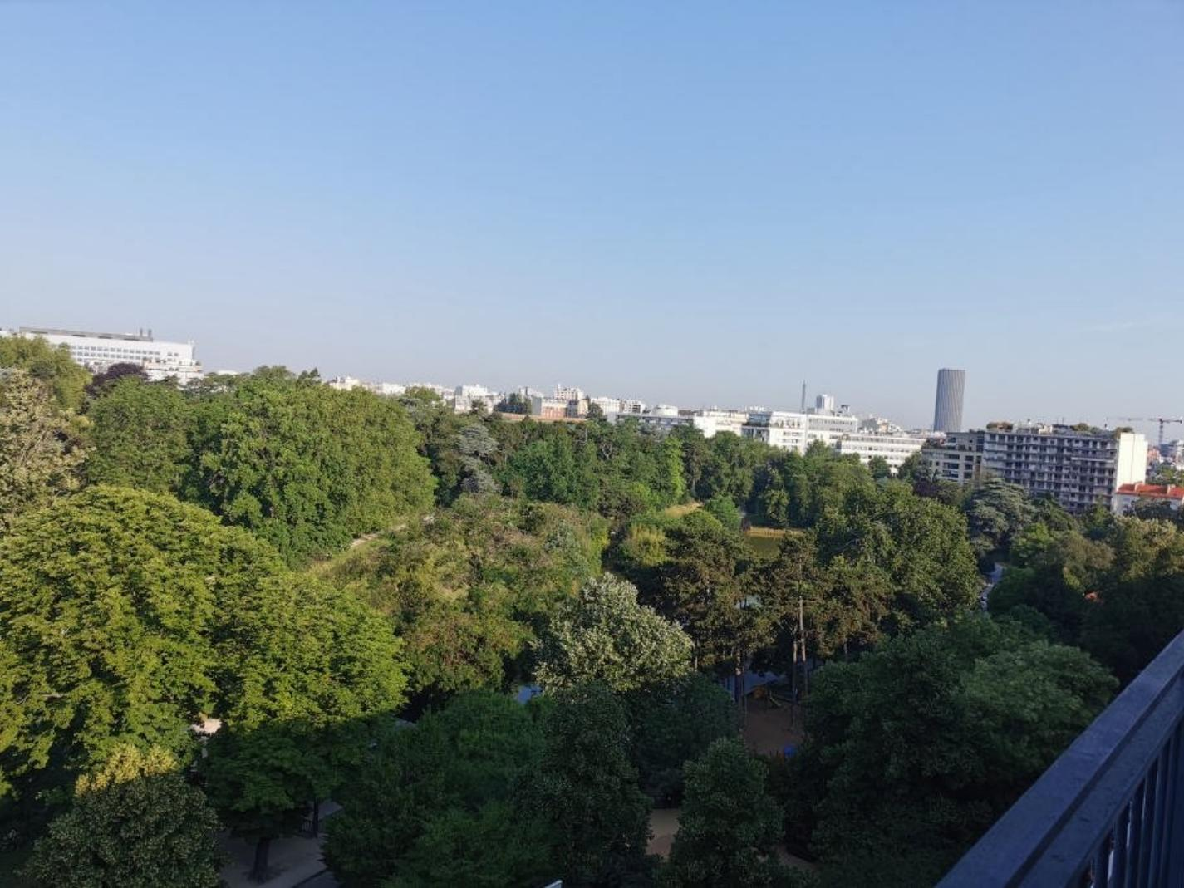 | 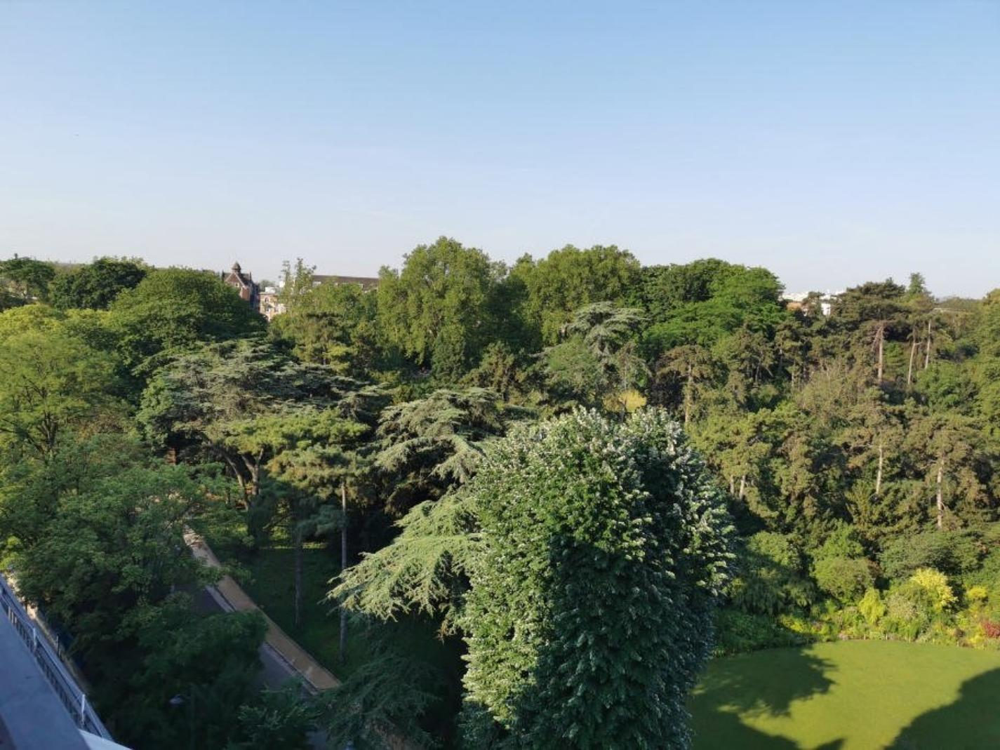
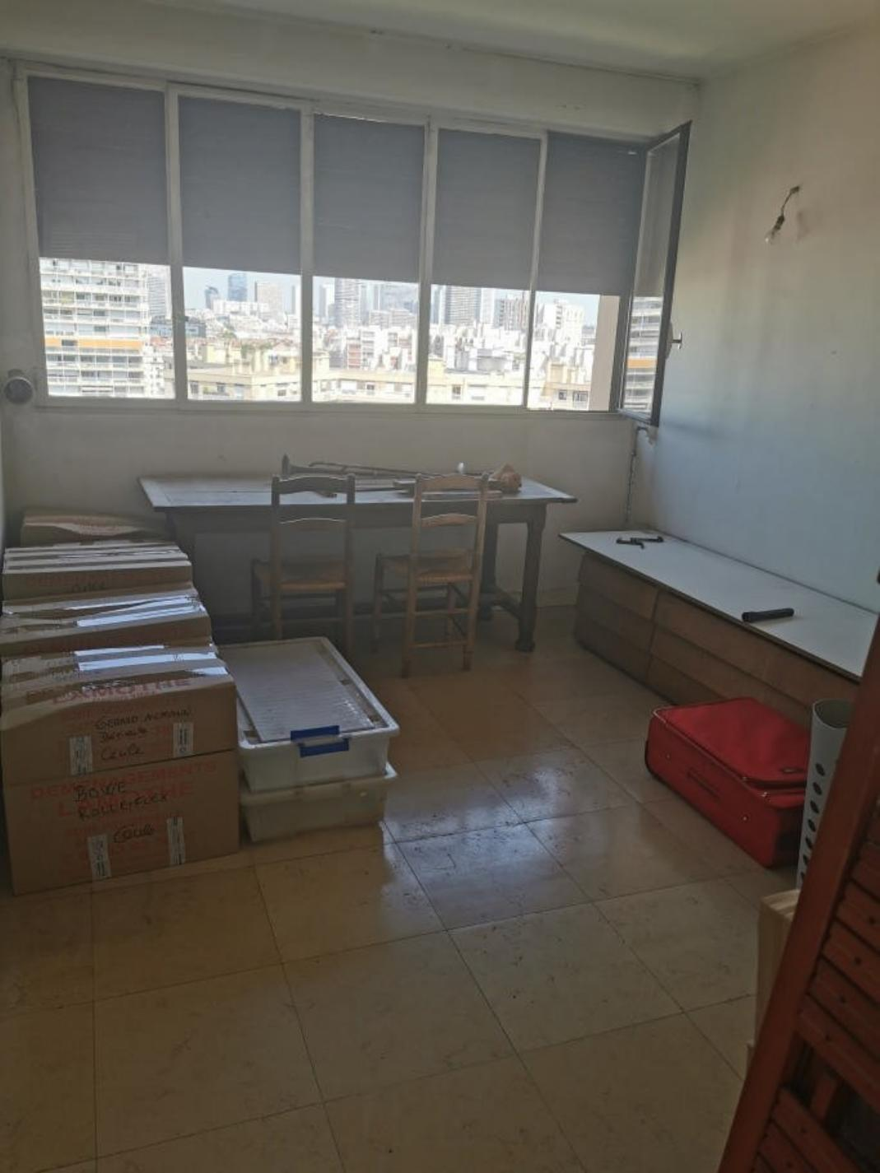 | 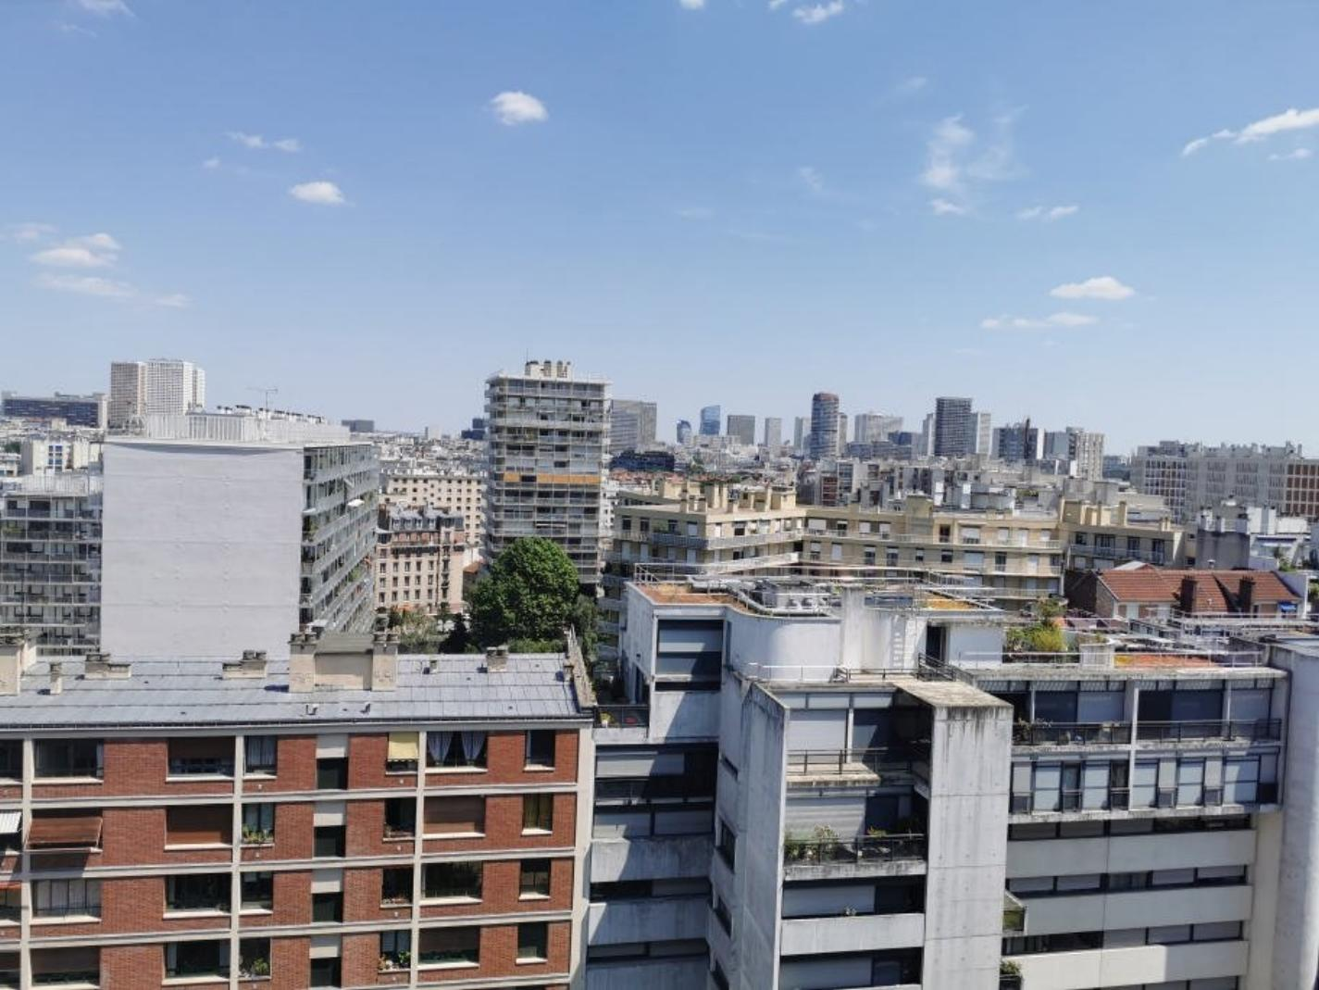
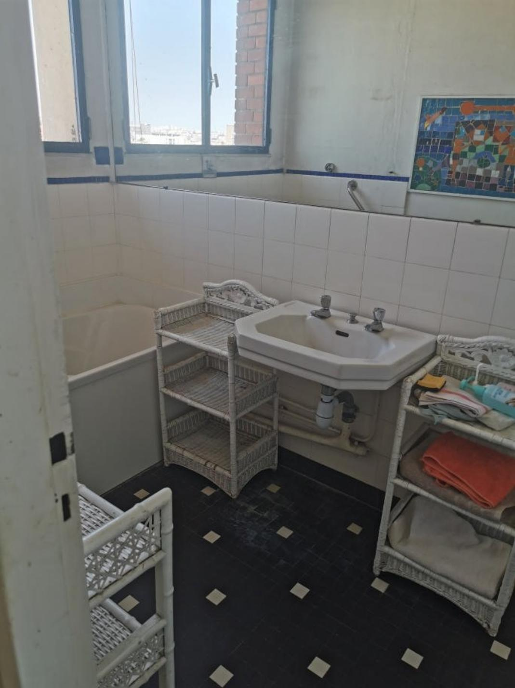 | 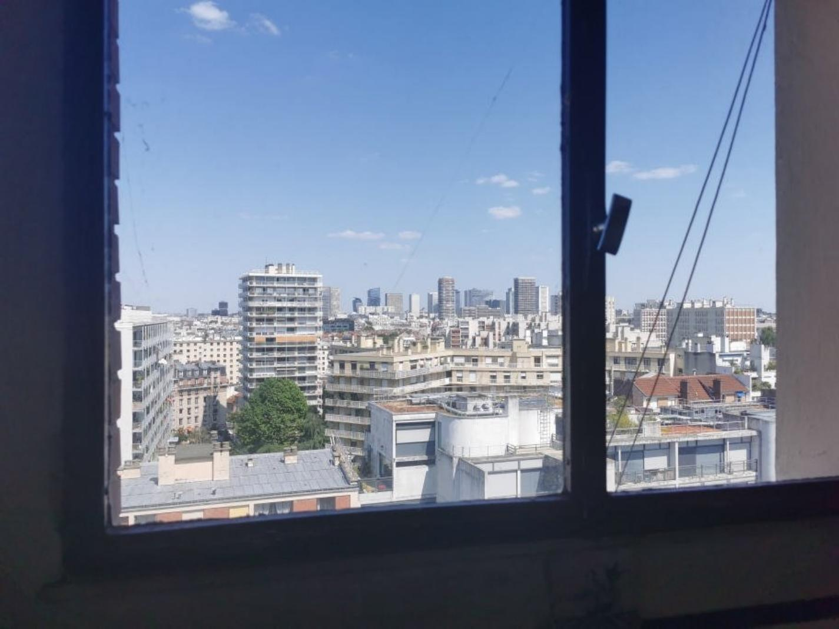
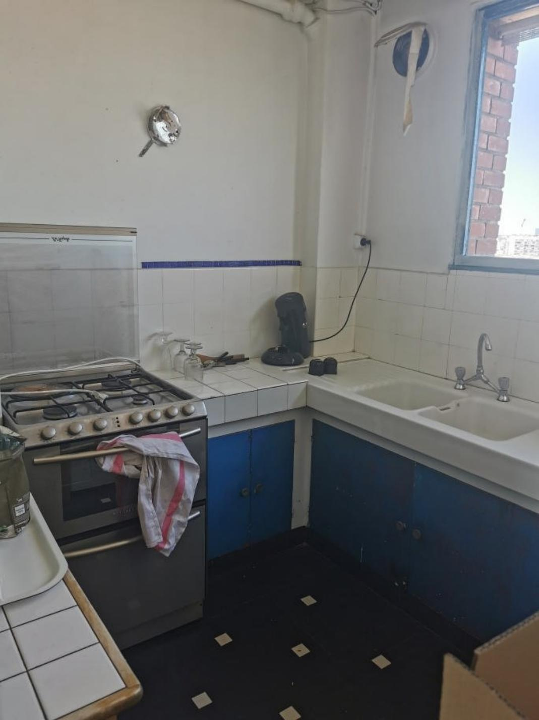 | 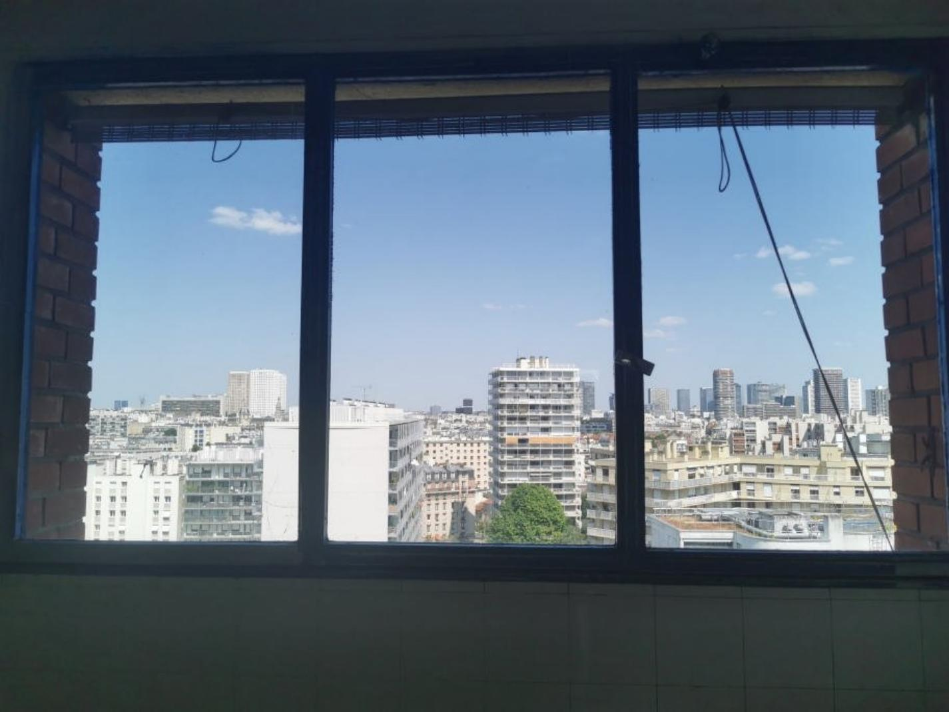
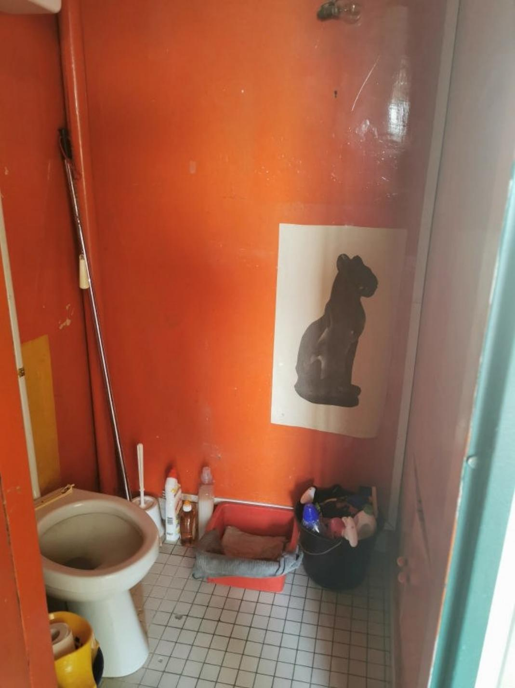

KEY DETAILS ( Ref . : PF90305) :
Total living space : 56 Sqm  Land area : Sqm  Heating : Electric central heating  Energy Efficiency : | Nearest town : PARIS  Nearest commerce : EASY WALK  Nearest autoroute :  Nearest airport : ORLY & DE GAULLE

PIONEER FRANCE CAN  ASSIST YOU WITH :  € Foreign Currency Exchange  the best rates : the best service  € Mortgage and Loan Facilities  pre-qualified, top lenders  € Your Total purchase process  a dedicated, fixed fee, total service from  initial offer through to post-completion  Call us or see our website  www.PioneerFrance.com   | PROPERTY LOCATION MAP :

