|  |
| --- |
| PERIGORD Noir - MONTIGNAC AREA |

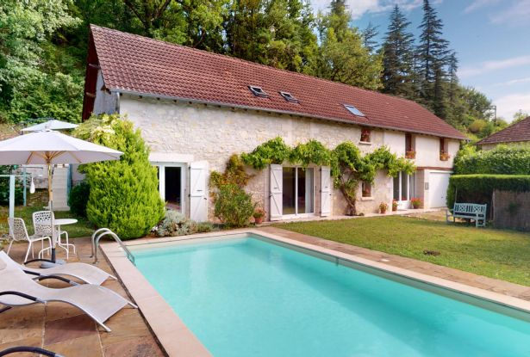

Réf: MP113826

299 900 €honoraires inclus à la charge de l'acheteur.

In Périgord Noir, near the village of Coly with its café-restaurant and not far from Saint-Amand-de-Coly and its superb abbey, 170 m² house with garden and swimming pool, ideal for vacations. Virtual visit on request.

This Périgord Noir vacation home with swimming pool is located on the outskirts of the village of Coly, near Saint-Amand-de-Coly, 15 minutes from Montignac and 25 minutes from Sarlat. This former barn now offers around 170 m² of living space, with ground floor: entrance hall, living room, kitchen, shower room/wc, storeroom/garage. Upstairs, a long landing leads to 4 bedrooms and two shower/bathrooms, wc. The 7 m x 3.5 m swimming pool in front of the house is well-placed and will enable you to rent out this house when it's not in use. The house is very bright for an old building and easy to maintain. Terrace to the rear. Small, low-maintenance flower garden. Connected to mains drainage.

|  |  |  |  |  |  |  |
| --- | --- | --- | --- | --- | --- | --- |
| |  |  | | --- | --- | |  |  | |  |  | |  |  | |

|  |  |  |
| --- | --- | --- |
| Caractéristiques : | | |
| Type: House / Character property  Année rénovation: 2010  Piscine : Swimming pool Private | Etat: Good  Surf. hab: 165 m²  Terrain: 1,329 m²  Séjour: 33 m²  Hamlet  Exposition: South East | 4 chambres  3 s.d.b  7 pièces  Chauffage: Electricity |

|  |  |
| --- | --- |
| Détails complémentaires: | |
| * PROPERTY LOCATION:  - Village   GROUND FLOOR:  - Kitchen of 23 m².  - Garage /15 m² shed  - Entrance lobby 20 m² with storage  - Lounge 33 m² with bay window and wood-burning stove.  - Washroom 7 m² with WC  - Terrace   1ST FLOOR:  - Bedroom 4 bedrooms of 24 m², 18 m², 13 m² and 12 m².  - Landing about 25 m².  - Shower room   - Bathroom   - WC | * ENERGY REPORT:  - Energy performance: 271 KWHep/m²an  - Gas emission: 8 Kgco2/m²an  - Date de réalisation DPE (jj/mm/aaaa)   HEATING:  - Electricity and wood   OTHER EQUIPMENT:  - Double Glazing   - Mains drainage   WINDOWS:  - Double Glazing   - PVC   LAND:  - Garden of around 1300 m².  - Swimming Pool 7 m x 3.5 m, chlorine, 1 m to 1.4 m deep.  ROOF:  - Tiles   WEB OPTIONS:  - Outstanding properties |

|  |  |
| --- | --- |
| Consommations énergétiques: | |
|  |  |
| **271** | **8** |
| **Classe DPE - E** | **Classe GES - B** |

**Taxe foncière:** **1 583 €**

**Agent responsable du dossier**: Mr Ludovic MONS \ Email : mperigord@wanadoo.fr \ Tel :  **\** Mobile : 0672150964

Les informations sont données à titre informatif et non contractuel.