|  |
| --- |
| PERIGORD Noir - TERRASSON AREA |

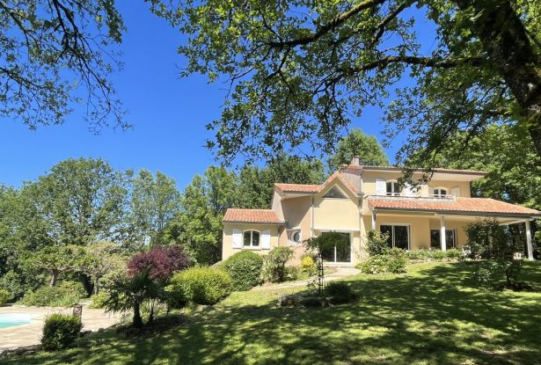

Réf: MP113794

545 900 €honoraires inclus à la charge de l'acheteur.

Superb location for this property in Périgord Noir with swimming pool and tennis court set in almost one hectare.

In the Périgord Noir, on the heights of a town close to the main roads with all shops, schools and services, this property benefits from a superb, peaceful setting, with no close neighbours, protected by pretty oak trees. Once through the wrought iron gate, you drive past the garage and tennis court to reach the top of the plot, where the house and swimming pool are located. The house is a very good craftsman's house, bright and comfortable, offering more than 200 m2 of living space, including a very beautiful living room, kitchen (and utility room), 5 bedrooms, 3 shower/bath rooms, a study, as well as generous storage space, a cellar and a garage on the garden level. The main rooms lead onto covered terraces and a large, heated swimming pool with sliding dome. Most of the grounds are wooded, with Causse oak trees providing shade in the summer months. Once again, a beautiful setting, waiting to be discovered.  
  
Information on the risks to which this property is exposed is available on the Géorisques website www.georisques.gouv.fr

|  |  |  |  |  |  |  |
| --- | --- | --- | --- | --- | --- | --- |
| |  |  | | --- | --- | |  |  | |  |  | |  |  | |

|  |  |  |
| --- | --- | --- |
| Caractéristiques : | | |
| Type: Modern house  Piscine : Swimming pool Private | Etat: Very good  Surf. hab: 225 m²  Terrain: 9,855 m²  Séjour: 72 m²  Non isolated countryside | 5 chambres  3 s.d.b  8 pièces  1 bureau  1 garage  Chauffage: Oil |

|  |  |
| --- | --- |
| Détails complémentaires: | |
| * GARDEN LEVEL:  - Office   - Basement / Cellar   - Bedroom   - Garage   - Shower Room   GROUND FLOOR:  - Office   - 2 Bedrooms   - Corridor   - Kitchen   - Living room   - Lounge   - 2 Bathrooms   1ST FLOOR:  - 2 Bedrooms   - Corridor   - Landing   - Bathroom   OUTBUILDINGS:  - Garage   ENERGY REPORT * gy performance: 114 KWHep/m²an  - Gas emission: 31 Kgco2/m²an  HEATING:  - Wood   - Oil central heating   OTHER EQUIPMENT:  - Double Glazing   - Septic tank   - Enclosed Fireplace   - Tennis | * SERVICES:  - Nearest airport :   - Nearest airport :   - Nearest motorway :   - Nearest motorway :   - Calm   - Calm   - Nearest shops :   - Nearest shops :   - Outbuildings   - Outbuildings   - School   - School   - Railway Station   - Railway Station   - Hospital   - Hospital   - Broadband   - Broadband   - View   - View   - Bungalow   - Bungalow   LAND:  - Private carriage-way   - Private carriage-way   - Wooded   - Wooded   - Woods   - Woods   - fenced   - fenced   - Swimming Pool   - Swimming Pool   - Entrance gate   - Tennis Court   - Terrace   WEB OPTIONS:  - Outstanding properties |

|  |  |
| --- | --- |
| Consommations énergétiques: | |
|  |  |
| **114** | **31** |
| **Classe DPE - C** | **Classe GES - D** |

**Taxe foncière:** **2 500 €**

**Agent responsable du dossier**: Mr Ludovic MONS \ Email : mperigord@wanadoo.fr \ Tel :  **\** Mobile : 0672150964

Les informations sont données à titre informatif et non contractuel.